Reference Output
docx-enhanced
2026-02-19

Heading 1
This document is a visual reference for what “correct” output should look like for a given style profile.
- Body text should use the profile’s default font, size, and spacing.
- Headings should follow the profile’s scale.

Heading 2
A short paragraph with inline code and an emphasized phrase.
Block quote / callout text should follow the profile’s quote style.

Heading 3

Table
Metric | Value | Notes
Sample A | 12.3 | Left aligned text
Sample B | 45.6 | Another row

Figure
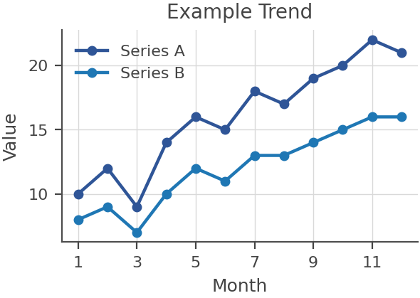
Sample figure caption.

