Sample Academic Manuscript
Author(s) | Jane Doe, John Smith
Affiliation | Example University
Date | 2026-02-19

Overview
This document was generated with docx-enhanced (academic style). It demonstrates headings, body text, lists, tables, and an embedded figure.

Key points
- All paragraph formatting is style-driven (no manual font fiddling).
- Tables have readable padding, header shading, and repeatable header rows.
- List numbering uses independent instances to avoid counter collisions.

Example process
- Define the document style system (business/academic/technical).
- Write content using semantic styles (Heading1, Body, Quote).
- Run QA (OOXML lint + PDF composition checks).

Example table
Table 1. Example dataset.
Metric | Value | Notes
Revenue ($M) | 12.3 | FY2025
Gross margin (%) | 42.1 | Audited
Headcount | 57 | End of Q4

Example figure
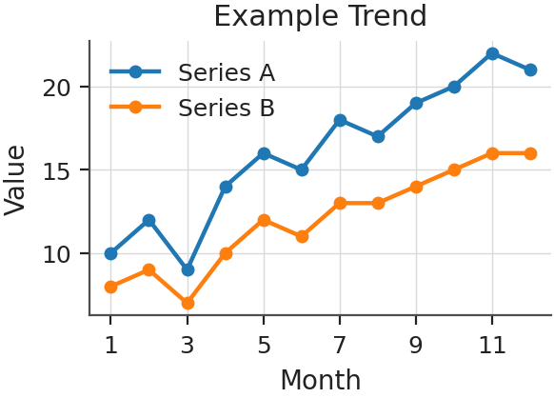
Figure 1. Example trend across months.

