**B. DESIGN OF CONTROLLED DC power supplies**

In section (A) was designed one unstabilized DC power supply using smoothing capacitor as presented in figure 6:

Figure 6. Uncontrolled rectifier, unstabilized

The voltage at the terminals (31, 32) is monopolar (+ 31, - 32).

**B1. Design of a Step-Down (BUCK) DC power supply using the unstabilized power supply (UO21)**

The design of switching mode, stabilized DC power supply (SMPS) cconsists of two steps:

1. The design of a DC- DC Converter which controls the output voltage (${\overline{U}}_{Ost}$), containing a “power” circuit and a duty cycle (µ) control circuit. The DC-DC converter plays the role of an actuator.
2. The design of an appropriate controller able to fulfill certain imposed performance specifications.

The conventional structures for DC-DC step-down converter are given in figure B1.

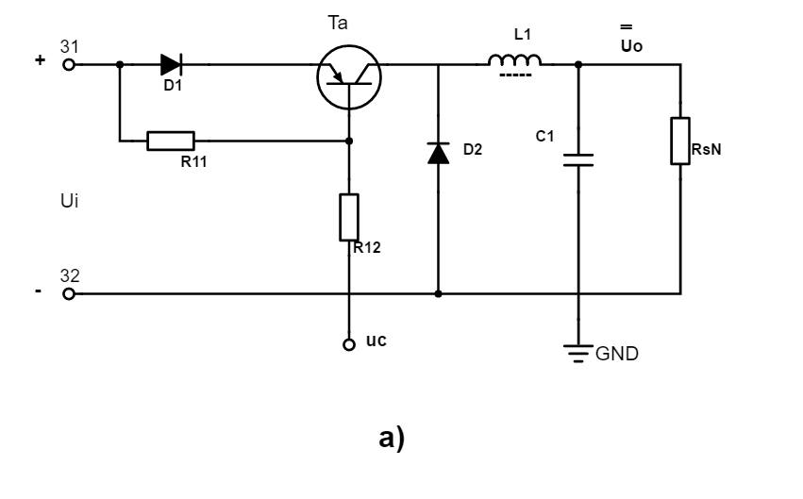

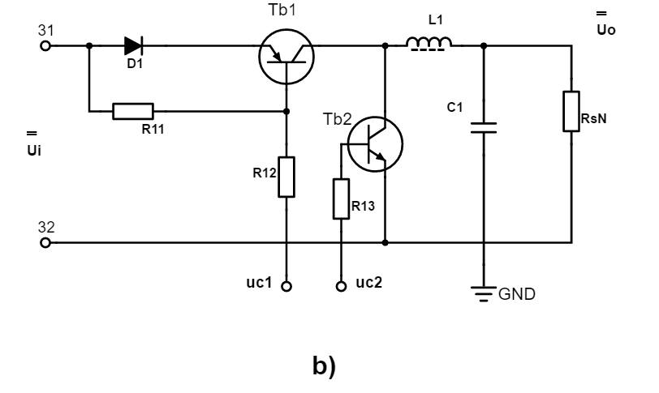

Figure B1. Switched model step-down DC-DC converter: a) with diode; b) with tranzistors

**B1a. Design of the step-down DC-DC converter**

A series of initial data are imposed for the design:

1. µ=µo=0.5=constant
2. Nominal load resistor

$$R_{SN}=\frac{{\tilde{U}}_{2}}{{\tilde{I}}_{2}}[Ω]$$

For which (${\tilde{U}}_{2i}$, ${\tilde{I}}_{2i}$) are given as initial data for the project.

1. Supply voltage (Ui)

where (ku) is the no load working regime voltage coefficient (A.3.2.3)

1. Maximum supply voltage
$${({\overline{U}}_{})}_{max}=\sqrt{2}∙{\tilde{U}}_{2}$$

2. Nominal output voltage
$${\overline{V}}_{o}=μ_{o}∙{\overline{U}}_{}==0,5∙{\overline{U}}_{}[V]$$

3. Nominal load current:
$${({\overline{I}}_{o})}_{N}=\frac{{\overline{V}}_{o}}{R_{S}}[A]$$

4. The current variation limit through the filtering coil:
$$∆{\tilde{I}}_{L}≅\left(0,20÷0,30\right){\left({\overline{I}}_{o}\right)}_{N}[A]$$

5. The voltage variation limit ($∆{\tilde{V}}_{O}$) due to the alternative component (ripple voltage)
$$∆{\tilde{V}}_{O}≅\left(2÷5\right)\%∙{\overline{V}}_{o} [V]$$

6. Swithching frequency

fc=20[kHz]

Using the presented initial data the elements of the DC-DC converter must be chosen:

1. Knowing that

$$∆{\tilde{I}}_{L}≅\frac{{(({\overline{U}}_{})}_{max}-{\overline{V}}_{o})∙μ_{o}}{f_{c}∙L}$$

with $∆{\tilde{I}}_{L}≅\left(0,20÷0,30\right){\left({\overline{I}}_{o}\right)}_{N}=\left(0,20÷0,30\right)\frac{{\overline{V}}_{o}}{R_{S}}$

will give the minimum necesarry value of the filtering coil (L):

$$L≥\frac{{(({\overline{U}}_{})}_{max}-{\overline{V}}_{o})∙μ_{o}}{f_{c}∙∆{\tilde{I}}_{L}}[H]$$

1. Knowing the AC component equilibrium ($∆{\tilde{I}}_{L}$, $∆{\tilde{V}}_{O}$) results:

$$∆{\tilde{V}}_{O}≅∆{\tilde{I}}_{L}∙\frac{t_{ON}}{C}=∆{\tilde{I}}_{L}∙\frac{μ_{o}∙T_{C}}{C}=∆{\tilde{I}}_{L}∙\frac{μ_{o}}{f_{C}∙C}$$

which gives:

$$C=\frac{∆{\tilde{I}}_{L}∙μ_{o}}{f_{C}∙∆{\tilde{V}}_{O}}=\frac{0,5∙∆{\tilde{I}}_{L}}{f_{C}∙∆{\tilde{V}}_{O}}$$

For the solution presented in figure B1a, the diode (d2) is a Shottky diode which must handle:

* Reverse voltage : $U_{A}≥1,25∙{({\overline{U}}_{})}_{max}$
* Rectified current: $I_{A}≥1,5∙{({\overline{I}}_{o})}_{N}$

considering a safety coefficient of (1,25) for voltage and (1,5) for current.

Diode (d1) is a low frequency diode (rectifier diode) which has to handle the current (IA) previously computed.

Tranzistors (Ta), (Tb1) and (Tb2) for switching frequencies up to 20 (kHz) may be:

* Bipolar tranzistors
* MOSFET tranzistors
* IGBT tranzistors

and must handle:

* A load voltage: $U_{tranzistor}=2∙\sqrt{2}∙{\tilde{U}}_{21}$
* A load current: $I_{tranzistor}=1,5∙{({\overline{I}}_{o})}_{N}$

The resistors (R12, R13) can be chosen considering the appropriate control current.

**B1b. Design of the control circuit for the step-down DC-DC converter**

The structure given in figure 7 corespunde unei prime variante

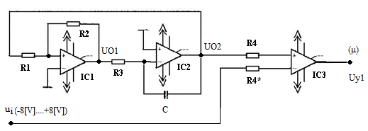

Figure 7. The structure of the PWM modulator (version)

The operational amplifier (IC1) is used as a Schmidt Trigger and the operational amplifier (IC2) is used as an integrator. (IC3) operational amplifier, with no feedback, is used as a comparator. The considered supply is of (+/- 16 V). In order to generate the triangular wave voltage (UO2) with the amplitude of **(**A=8V) is necessary that R2=2∙R1. By choosing R2=20[kΩ], will result that R1=10[kΩ].

The switching frequency is given by the following relationship:

$$f_{c}=\frac{1}{2∙R_{3}∙C}=>R3=0,00021 [Ω]$$

By choosing at first the capacitor value (C), at an imposed value of the switching frequency, can be computed the value of resistor R3. The comparator (IC3) will generate a rectangular bipolar wave with an amplitude of 16[V], with a duty cycle (μ), controlled by the voltage (ui) and which can be computed by:

$$μ=\frac{u_{i}+8}{2∙A}$$

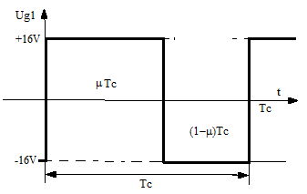

Figure 8. The evolution of the PWM voltage

The static characteristic of the PWM modulator is given in figure 8.

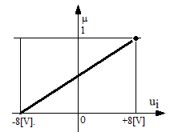

Figure 9. The variation of the duty cycle (μ)

In the following design steps, the PWM modulator can be considered as an amplification element with an amplification factor of:

$$K=\frac{∆μ}{∆u_{i}}=\frac{1}{2A}$$

The voltage (ui), figure 7 is generated by the controller attached to the circuit.

Observations:

1. The conventional structure of the PWM modulator presented in figure 7 implies a fairly complex practical implementation, beeing the reason why other versions of PWM modulator can be considered and tested.
2. PWM modulator using LM324 integrated circuit (description in Anexa B1)
3. It is recommended to chose a integrated circuit to implement the PWM modulator and include the structure description, the operating mode and application.

Examples of dedicated integrated circuits:

1. TL 494/ TL 594 ("Texas Instruments”)
2. MAX 666 (“Maxim”)
3. LTC 6992-1 (“Linear Technology”)

**B1c. The step- down DC-DC converter mathematical model**

The structure of the stabilized DC power supply is based on the fixed part presented in figure 10.

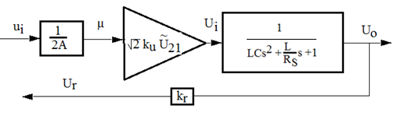

Figure 10. The fixed part of the switched mode stabilized DC power supply

A resistive voltage divider is considered on the feedback with a factor of kr=0,2.

The reference value of the DC power supply wil be $V_{0}^{*}=μ_{0}∙k_{r}∙U_{i}$.