**D.3.1/2 Output disturbance on the P controller (compared):**

Used the same disturbance characteristics as in 3.1 but now we see the compared responses.

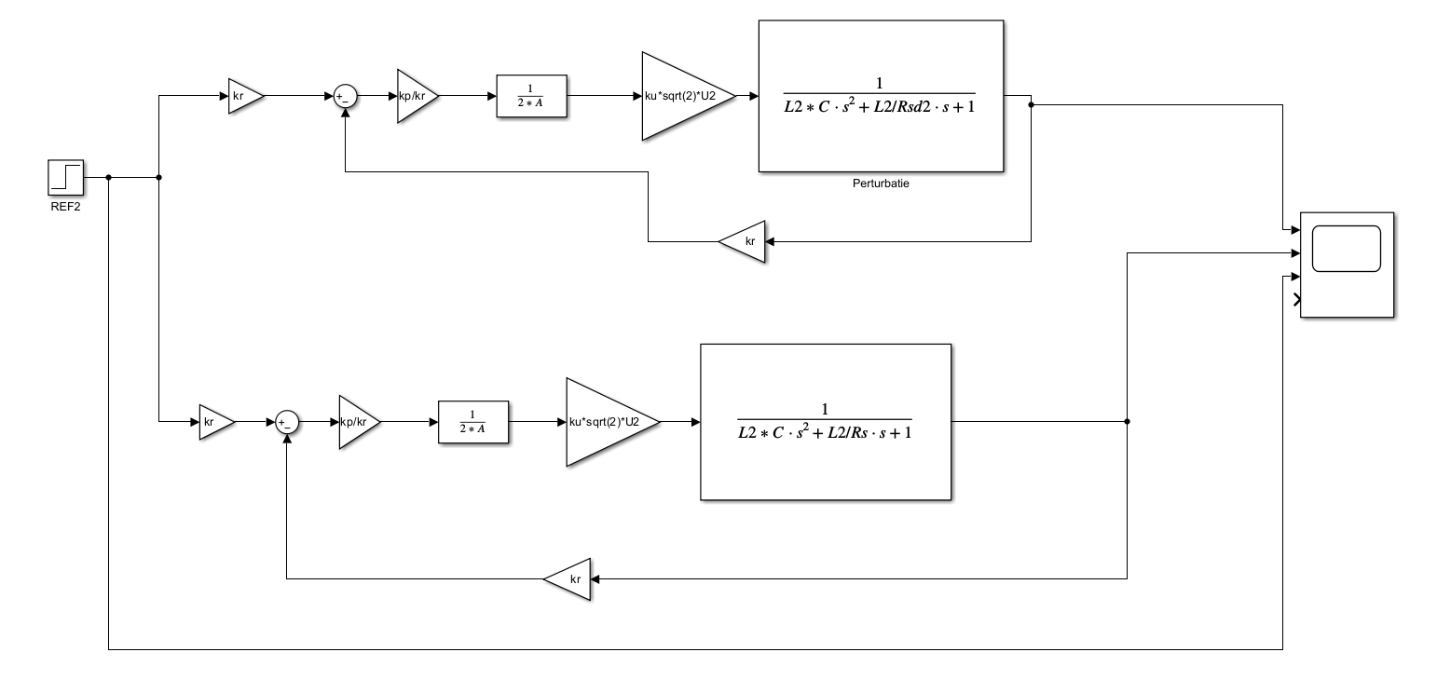

The P controller shows a lower overshoot.

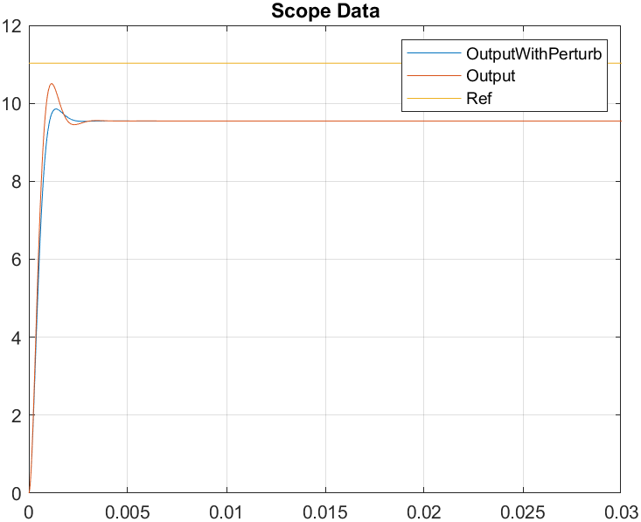

**D.3.2/2 Output disturbance on the PI controller (compared):**

Used the same disturbance characteristics as in 3.2 but now we see the compared responses.

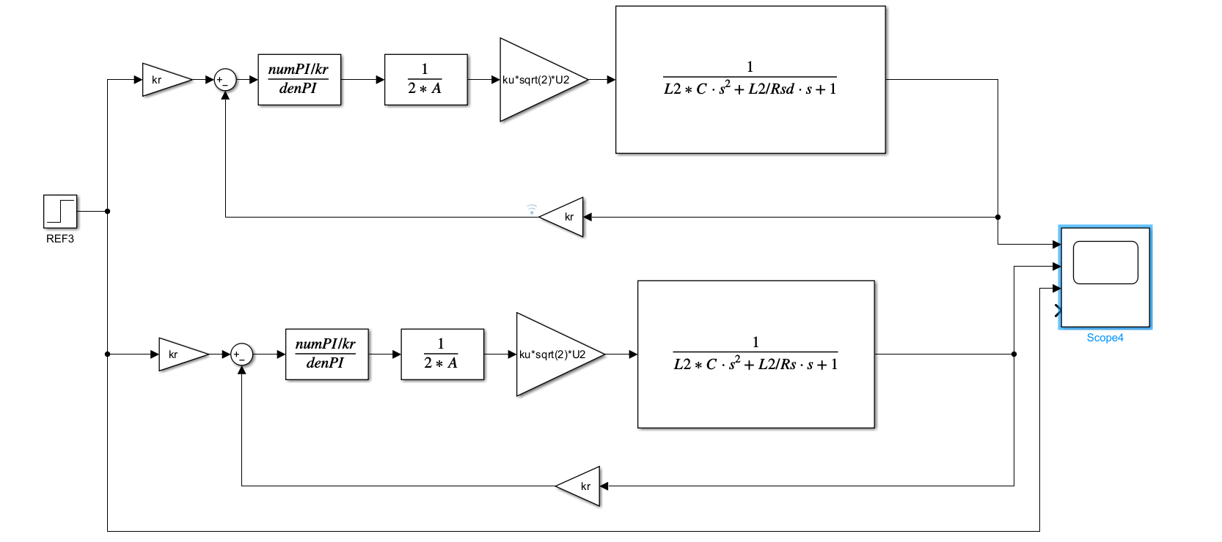

The PI controller gives us a longer settling time.

