Technical University of Cluj-Napoca
Faculty of Automation and Computer Science

Subject:

POWER ELECTRONICS IN AUTOMATIC CONTROL

Project:

DC STABILIZED SWITCHED MODE POWER SUPPLY

Student:_____________________

Group:________

2023-2024
Technical University of Cluj-Napoca
Faculty of Automation and Computer Science

Project:

DC STABILIZED SWITCHED MODE POWER SUPPLY

A.
The design of a DC uncontrolled power supply

Student Name:______________________
Group:________
2023-2024

A. THE DESIGN OF UNCONTROLLED DC POWER SUPPLY

A.1. Design and analysis of the line transformer
A.2. Design of the rectifier circuit
A.3. Design of the smoothing filter

A.1. Design and analysis of a line transformer

Initial data:

- Primary supply voltage (U₁=….)
- Secondary nominal voltages and currents
  - U_{21N}=……
  - I_{21N}=…….
- Data on the magnetic core: the use of laminated silicon steel sheets, coated with insulating layer; the shape of the sheets is (E+I)
- Winding data: enameled copper wire for coil with round section

A.1.1. Electric scheme of a line transformer

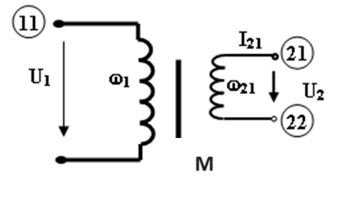

Fig. 1.

Where:
M = iron core,
w1 = primary winding,
w2 = secondary winding.

A.1.2. Line transformer design steps

A.1.2.1. Total power in the secondary winding (for 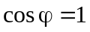)

=.......... [W]

A.1.2.2. Global power of the transformer
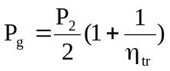=………….. [W]

where the estimated efficiency of the transformer (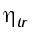) of the transformer and the permissible current density J[A/mm2] are given in Table no.1.

Table no.1
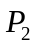[W] | 10 | 20 | 30 | 50 | 70 | 100 | 200 | 300 | 500 | 700 | 1000
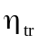 | 0,78 | 0,81 | 0,83 | 0,85 | 8,87 | 0,88 | 0,92 | 0,93 | 0,94 | 0,945 | 0,95
J  [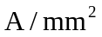] | 4 | 3,8 | 3,6 | 3,2 |  | 2,4 | 1,40 | 1,25 | 1 |  | 0,90

In order to determine the value of the efficiency (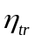) corresponding to the computed secondary power (P₂), an interpolation may be necessary.

A.1.2.3. Approximation of the iron core section is given by the equation:

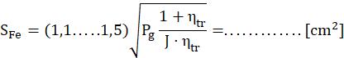

A.1.2.4. Selection of the laminated sheets of the magnetic core

For the usual line transformer, the core is made of (E+I) silicon-steel laminated sheets with the rated value of induction B=1,1 [T]. In the specialized literature, these laminated sheets (toles) are classified in turn, depending on certain dimensional characteristics, there are nomenclatures that make it much easier to choose the desired type and to calculate the transformer. The main dimensions of the sheet are: the width of the sheet (l*) and the height of the window (h), resulting from this and the other dimensions. Obviously, it is assumed that the nature of the material from which the sheets are made is known, in our case iron-silicon sheet. Knowing the section is mandatory, because the maximum power that a transformer transfers (from primary to secondary) is dependent on the core section.

A 1.2.5 Calculus of the primary winding current:
I₁ = P_{g}/U₁
I₁ = ………..
A 1.2.6 Calculus of nominal (secondary) load resistance:
R_{2N} = U_{2N}/ I_{2N}
R_{2N} = …….
A 1.2.7 Calculus of secondary winding resistance:
R₂ = (0,5….1,5)%* R_{2N}
R₂ = ……
A 1.2.8 Calculus of primary winding resistance:
R₁ = (0,5…0,7)%*(U₁/I₁)
R₁ = ……
A1.2.9 Calculus of reported secondary resistance (equivalent, total):
R₂* = R₂ + R₁*( U_{2N}/U₁)²
R₂* = …..
A.2. Design of the rectifier circuit

Electrical power generation and distribution is usually accomplished as alternating current due to simplicity and economical aspects. However, many types of electrical equipment operate with DC power supplies. The A.C. voltage must be, therefore, rectified and in most cases filtered to provide a desired D.C. output voltage at a required current or power level and quality.

Initial data:
- rectifier topology;
- secondary voltage and current supplied by the line transformer
- estimated values of smoothing capacitor

A.2.1. Rectifier topology
Full-wave rectification converts both polarities of the AC input waveform to DC (direct current), and yields a higher mean output voltage.
For the secondary winding () (terminals 21, 22) it is recommended a full-wave rectifier using four diodes in a bridge configuration, figure 6.
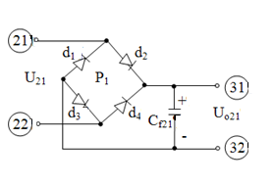
Fig.6

In order to choose the rectifier diodes or the rectifier bridges it is necessary to know the rectifiers electrical stress: the maximum voltage and the rectified currents (mean value). Based on these values, the necessary types of diodes or bridges can be chosen ,based on catalog data given in the table no 6.

Table no. 6

RECTIFIER BRIDGE
TYPE |  | I_{d}[A] | U_{inv} max[V] | Ip²∆t [A²s] | Uef max [V]
1PM | 0,5 | 1,2 A | 50 | 4.5 | 35
1PM | 1 | 1,2 A | 100 | 4.5 | 70
1PM | 2 | 1,2 A | 200 | 4.5 | 140
1PM | 4 | 1,2 A | 400 | 4.5 | 280
3 PM | 0,5 | 3,2 A | 50 | 24 | 35
3 PM | 1 | 3,2 A | 100 | 24 | 70
3 PM | 2 | 3,2 A | 200 | 24 | 140
3 PM | 4 | 3,2 A | 400 | 24 | 280
10 PM | 0,5 | 10 A | 50 | 162 | 35
10 PM | 1 | 10 A | 100 | 162 | 70
10 PM | 2 | 10 A | 200 | 162 | 140
10 PM | 4 | 10 A | 400 | 162 | 280

A.2.2. Rectifier design steps
A.2.2.1 Factor of safety:

A safety factor is imposed: 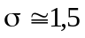.

A.2.2.2. Voltage stress of the rectifiers

The maxim value of the voltages arising in the rectifier circuits depends on the secondary voltages and on the rectifier version.
The maxim value of the voltage applied on the reverse biased rectifier for a high value of the smoothing capacitor is approximated by the usual formulas:
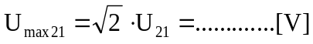

For the rectifiers selection, taking into account the factor of safety (σ≈1.5), the maximum voltage accepted by the reversed biased rectifiers is given by the equations:

for the rectifier bridge.

A.2.2.2. The current stress of the rectifiers:
In order to choose the appropriate type of rectifier, the following equations are considered:
,

The following rectifiers are chosen from catalog:
- bridge rectifier of type ...................................... with
..............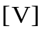>
...............>
.......... (A².sec– from the datasheet

A.2.2.3. Testing the rectifiers characteristics considering the starting current

The „starting” current, is the current delivered right after the power source is powered-on and the smoothing capacitors is uncharged.
In table no. 7 are presented the estimated values (mF) (usual values for laboratory power supplies) of the smoothing capacitors for different values of the rectified voltage and current, (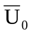,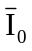).

Table no. 7
[A]  [V] | 0.2 | 0.4 | 0.6 | 0.8 | 1.0 | 1.2 | 1.4 | 1.6 | 1.8 | 2 | 2.2 | 2.4 | 2.6 | 2.8 | 3
10 | 0.75 | 1.5 | 2.25 | 3 | 3.75 | 4.5 | 5.25 | 6 | 6.75 | 7.5 | 8.25 | 9 | 9.75 | 10.5 | 11.25
20 | 0.4 | 0.8 | 1.2 | 1.6 | 2 | 2.4 | 2.8 | 3.2 | 3.6 | 4 | 4.4 | 4.8 | 5.2 | 5.6 | 6
30 | 0.25 | 0.50 | 0.75 | 1 | 1.25 | 1.5 | 1.75 | 2 | 2.25 | 2.5 | 2.75 | 3 | 3.25 | 3.5 | 3.75
40 | 0.2 | 0.4 | 0.6 | 0.8 | 1 | 1.2 | 1.4 | 1.6 | 1.8 | 2 | 2.2 | 2.4 | 2.6 | 2.8 | 3
50 | 0.15 | 0.3 | 0.45 | 0.6 | 0.75 | 0.9 | 1.05 | 1.2 | 1.35 | 1.5 | 1.65 | 1.8 | 1.95 | 2.1 | 2.25
60 | 0.1 | 0.2 | 0.3 | 0.4 | 0.5 | 0.6 | 0.7 | 0.8 | 0.9 | 1 | 1.1 | 1.2 | 1.3 | 1.4 | 1.5
The „starting” current is approximated using:
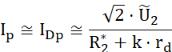
where (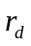) is the „equivalent” resistance of the diode and (k) is the number of diodes working simultaneously in the circuit:
- k=2 for figure 6.a (bridge rectifier)
The estimated values for the rectifiers, equivalent dynamic resistances for low voltages () are given in table no.8.
Table no.8
I_{D} [A] | 0.3 | 0.7 | 1 | 3 | 5 | 10
r_{d} [] | 4 | 1.7 | 1.2-3.75 | 0.4 | 0.24 | 0.12
The “initial” charging time of capacitors can be determined based of the following relation:
,
For which:
= ….. [sec];
The “thermal capacity” of the rectifier at the initial charging is:
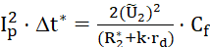,

This value must be smaller than the datasheet values for the “thermal capacity” (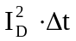) for the chosen rectifier bridge

A.3. Design of the smoothing filter

A.3.1. Design of the filter capacitor

The design steps are used to determine the necessary values of the capacitive filters (C_{f21}), (C_{f22}) and (C_{f23}). The filter quality is estimated using the ripple factor (p) and the filtering coefficient (q).
If we consider the voltage obtained after rectifying an AC voltage, we will observe a DC component (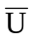), equal to the mean value of the rectified voltage, over which overlaps the alternating component (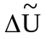). Due to the fact that the alternating component („ripple”) presents a complex form, difficult to describe analytically, it is approximated to the first harmonic (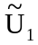) , whose amplitude is close to the amplitude of the alternating component. The input ripple factor (p) is defined by:
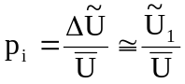
In the case of full wave rectifier (ideal), without capacitor
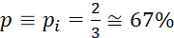.
If an effective voltage (U_{ef}) is rectified and if the rectifier voltage drop is neglected, the mean value of the output voltage (without filter) is:
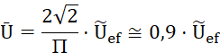
If () is the rectifier voltage drop (considered 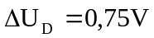), for the bridge rectifier presented in figure 6.

The filter capacitor will reduce the alternative component and will increase the mean value, depending on the value of the filter capacitor and also of the load resistance:

; ; k = 1 or k = 2.

For high values of load resistance and filter capacitor, we will choose the value (1,41), while for small values of load resistance and filter capacity, (0,9) will be chosen (without capacitor).

It is assumed that the ripple coefficient must be reduced from p_{i}=67% to
p_{o} = (8 – 10)%
for nominal load resistances (R_{SN} = )

A.3.2. Design steps for filter capacity value

A.3.2.1. The filtering coefficient is computed as
q = 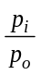=………. (>>1)
A.3.2.2. Equivalent resistances

Based on the nominal load resistances (R_{SN}), and the rectifier overall resistances
k = 1 (single rectifiers) or 2 (bridge rectifiers)

the necessary value of the filter capacitor can be computed.

A.3.2.3. Smoothing capacitor values

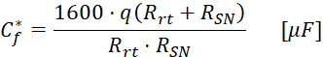
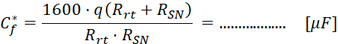
The computed value can be compared with the estimated values from table no.7, (C_{f}).

A.3.2.4. Behavior analysis of the rectifier with smoothing filter

In order to determine the exact value of the rectified mean voltage considering a load and a filter capacitor, a complex calculus is necessary. In order to avoid complex calculus, the diagrams presented in figure 9 can be used, where:
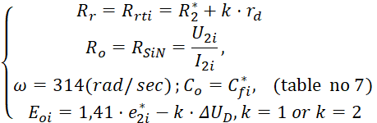
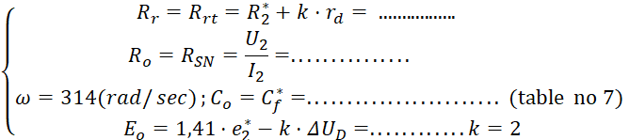

The previously presented relations are applied for each secondary winding and so that the voltage coefficient is obtained:
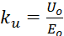 based on (ωC_{o}R_{o}) and on 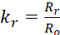
so that, with load, (for 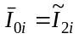), the smoothing capacitor voltage is described by:

;

The linearized load characteristics are described in figure 7
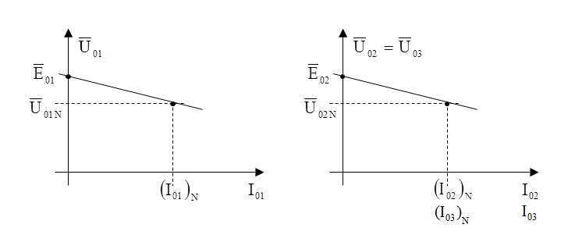
Fig 7. Linearized transformer load characteristics

A.3.2.5. Design of the filter capacity value (), using diagrams

Starting from the imposed value of the ripple factor (p_{o}), and based on the values of the equivalent resistances

and

and using the diagram presented in figure 10, the value of the product (ωC_{o}R_{o}) can be determined so that

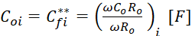,
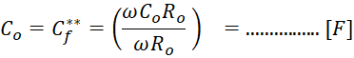

A.3.2.6. The final value of the filter capacitor is determined as the mean value of
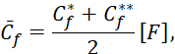
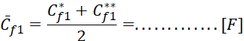

The working voltage of the capacitors will be equal to the datasheet value for the maxim value of the voltage applied on the reverse biased rectifier.
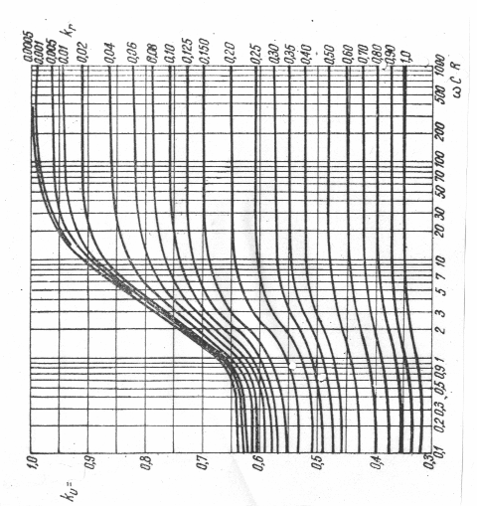
Fig 9. The no load voltage coefficient variation depending on ωC₀R₀
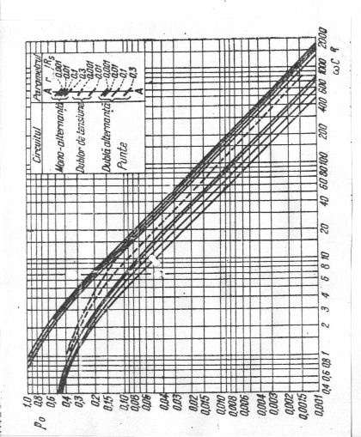
Fig. 10. The ripple factor variation for different types of rectifiers.

