REFERENCE IMAGES

11

Shade Storage
10

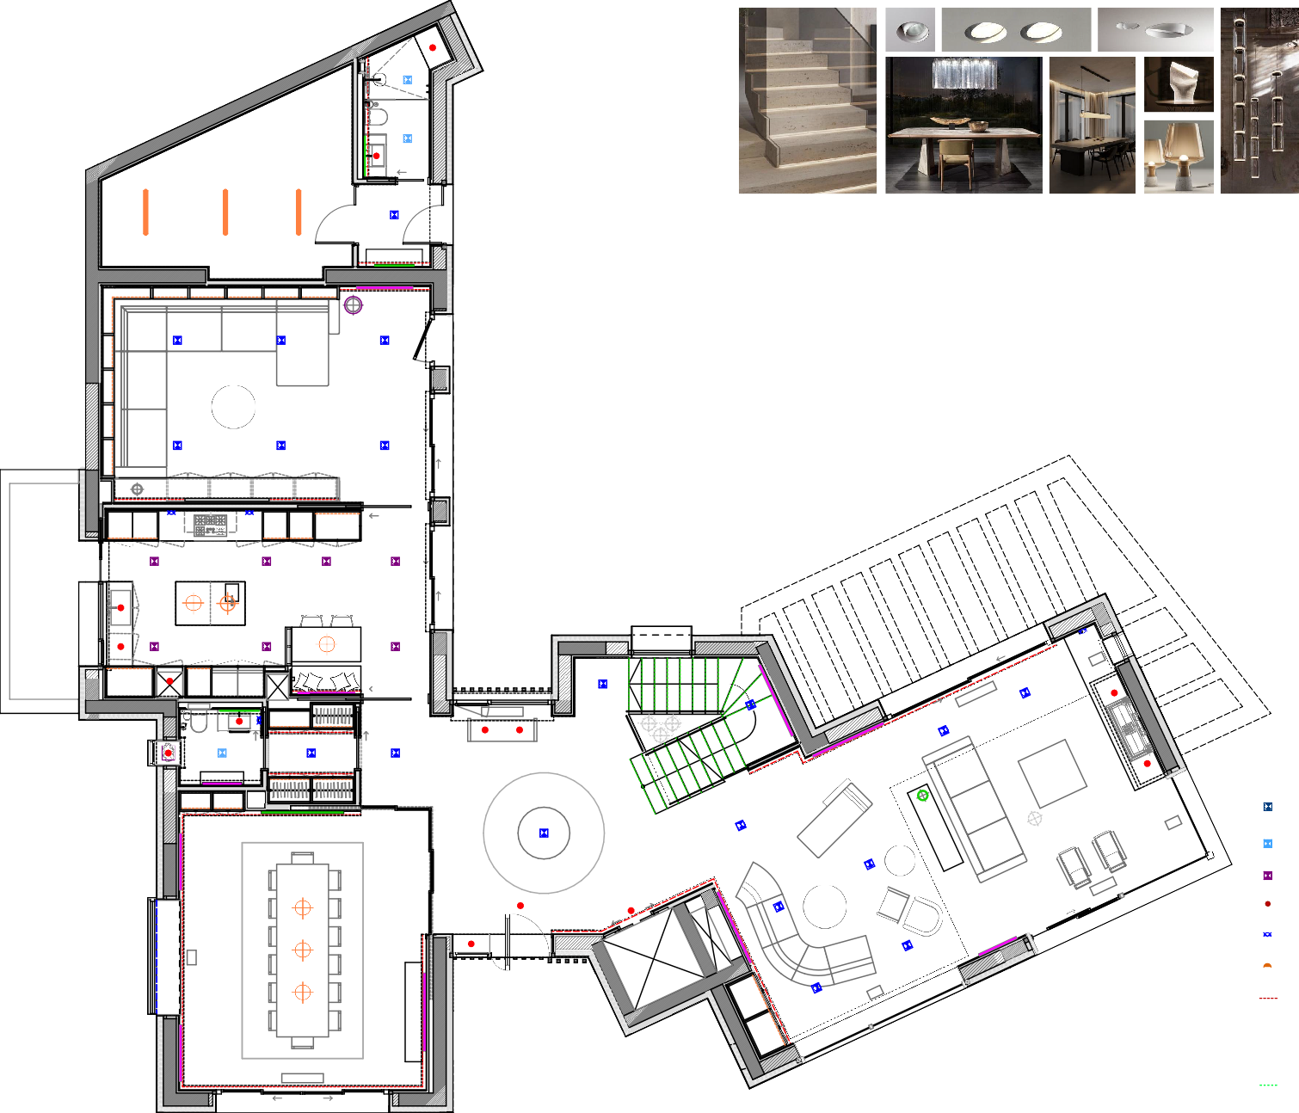
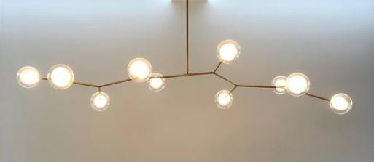
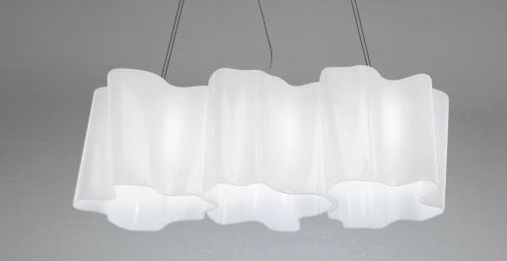
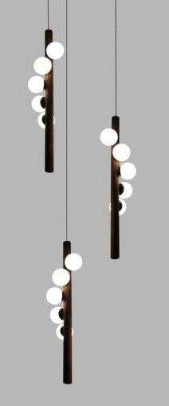
Shade Bathroom

P9

P8

09


Family Room
IR + M + ER
IR + M + ER
R
R
LIGHTING PANELS - CONTROL ELEMENTS
( + dimmer)
P lighting panels
P1 - entrance hall ceiling techinical lighting & decotative / staircaises technical & decoratice lighting
P2 - entrance hall/ staircaises ceiling techinical lighting & decotative / staircaises technical & decoratice lighting/ interior rollers & mosquito net
P3 - living room techinical lighting & decotative / interior rollers & exterior rollers & mosquito net
P4 - dining room ceiling techinical lighting & decotative / fixed furniture lighting & entrance closet ceiling techinical lighting / fixed furniture
P5 - entrance bathroom techinical lighting & decotative & backlit mirror / interior rollers & mosquito net
P6 - kitchen ceiling techinical lighting & decotative / fixed furniture lighting / interior rollers & exterior rollers & mosquito net
P7 - family room ceiling techinical lighting & decotative / fixed furniture lighting / interior rollers & exterior rollers & mosquito net
P7 - shade storage ceiling techinical lighting
P8 - shade bathroom techinical lighting & backlit mirror
M mosquito net
E.R. exterior roller
I.R. interior roller

DECORATIVE LAMPS
decorative ceiling lamp
decorative floor lamp
decorative table lamp
NOTE:
OPTION A: DALI System for regulation of Domotic lighting or similar
OPTION B: regulation lighting system (dimmer) - with posibility of different lighting ambients

TV
P7

08
IR + M + ER
R

Kitchen
IR + M + ER
R

lift truck
23
22
21
20
19
18
17
R R

07

Toilet

P5

P6

06

Closet

P4

05

Dining Room

IR + M + ER

R

F

M + IR

01

Entrance Hall

P1
F
IR

04

Lift

02
P2
Stairs
M

03
Living Room



LEGEND TECHNICAL INTERIOR LIGHTING
Lighting System DALI (Domótica) or similar
lighting type | power | feeder | reference images
ceiling light - general light recessed ceiling fixed LED  DIRO TRIMLESS LED 202 144 811 932 W_DELTALIGHT  M.K. R82 TRIMLESS  O.F.A. 202 11 82 OFA_DELTALIGHT ALIMENTADOR 123403_TCI | 10'4W | 500mA-DALI | 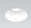
ceiling light - bathrooms, water areas recessed ceiling fixed LED  DIRO TRIMLESS LED IP44  202 146 811 932 W_DELTALIGHT M.K. R82 TRIMLESS O.F.A.  202 11 82 OFA_DELTALIGHT ALIMENTADOR  123403_TCI | 10'4W | DALI | 
ceiling light - kitchen recessed ceiling fixed LED  DIRO SBL L  202 297 83 W_DELTALIGHT | 17'5W | DALI | 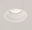
ceiling light - focos recessed ceiling fixed LED  MINI DEEP RINGO TRIMLESS 415 312  831B_DELTALIGHT M.K. 60 415 91 60_ DELTALIGHT  ALIMENTADOR 127490_TCI | 3'3W | 1050mA-DALI | 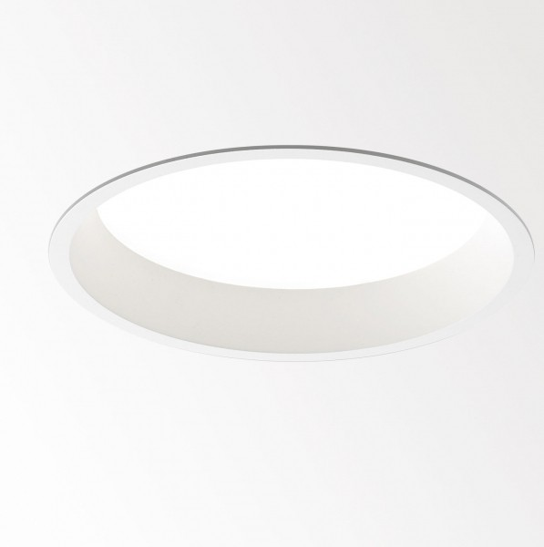
wall lighting - decorative appliques  2.00m desde pavimento  TAGLINE TR +TAGLINE LEDLINE PROFILE_DELTALIGHT | 10'4W | DALI
wall lighting - signaling lighting  0.30m desde pavimento  LOGIC MINI W R 304 30 12 W_DELTALIGHT CONCRETE  BOX 188 270 11 188_DELTALIGHT | 0'6W | 24V | 
ceiling light - perimetral LED LED lineal flexible  LEDFLEX IN HP  (Roll 5M -Superface ceiling) 300 92 54 93_DELTALIGHT | 22W/M | 24V-DALI | 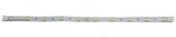
lineal light for fixed furniture  LED lineal flexible  LEDFLEX OUT IP65  (Roll 5M-inside furniture) 300 92 6393 DELTALIGHT | 14'4W/M | 24V-DALI | 
lineal light inside the bow windows  LED lineal flexible  LEDFLEX OUT IP65  (Roll 5M-inside furniture) 300 92 6393 DELTALIGHT | 14'4W/M | 24V-DALI | 
integrated profile LED under the steps LED lineal flexible  LEDFLEX OUT IP65  (Roll 5M-inside furniture) 300 92 6393 DELTALIGHT | 14'4W/M | 24V-DALI
NOTE: Interruptor/tkeyboars Jung modelo LS990 . color based on walls color

LIGHTING PLAN GROUND FLOOR
LEGEND DECORATIVE OBJECTS - TV
TV
painting
mirror
sculpture
s sensor

0 0,5 1 1,5 2 2,5 m
1/50 A1 1/100 A3

