Terminology

Class:
A class is a description of a possible set of run-time objects. It only exists in the software text.

Object:
An object is a software machine that allows program elements to access and modify a collection of data. It's an actual representation (instance) of a class (generating class). Objects only exist at runt-time and are visible in the program text through names. We can apply features to an object in the following way (fundamental mechanism of software execution):
Polyterasse.highlight

Client:
A client of a software mechanism is a system of any type (for example humans, software, …) that uses it.

Supplier:
For a client this mechanism is a supplier.

Interface:
An interface of a software mechanism is a description of the features that a client can use (API).

Information hiding principle:
The designer of every class must specify which features are accessible to the client and which are not. The client can only use public properties.

Feature:
An operation available to a certain class of objects. There are three different type of features: command, query and creation procedure. A query is like a question, it returns the answer and should not change the state of any objects (command-query separation principle). On the other hand a command doesn't return anything but performs a change on several objects.

A routine is also known as a method. It's a feature that actually compute something. The structure of a routine is

r (arg: TYPE; …): RESULT_TYPE
--header comment
require
--preconditions
do
--body
ensure
--postconditions
end
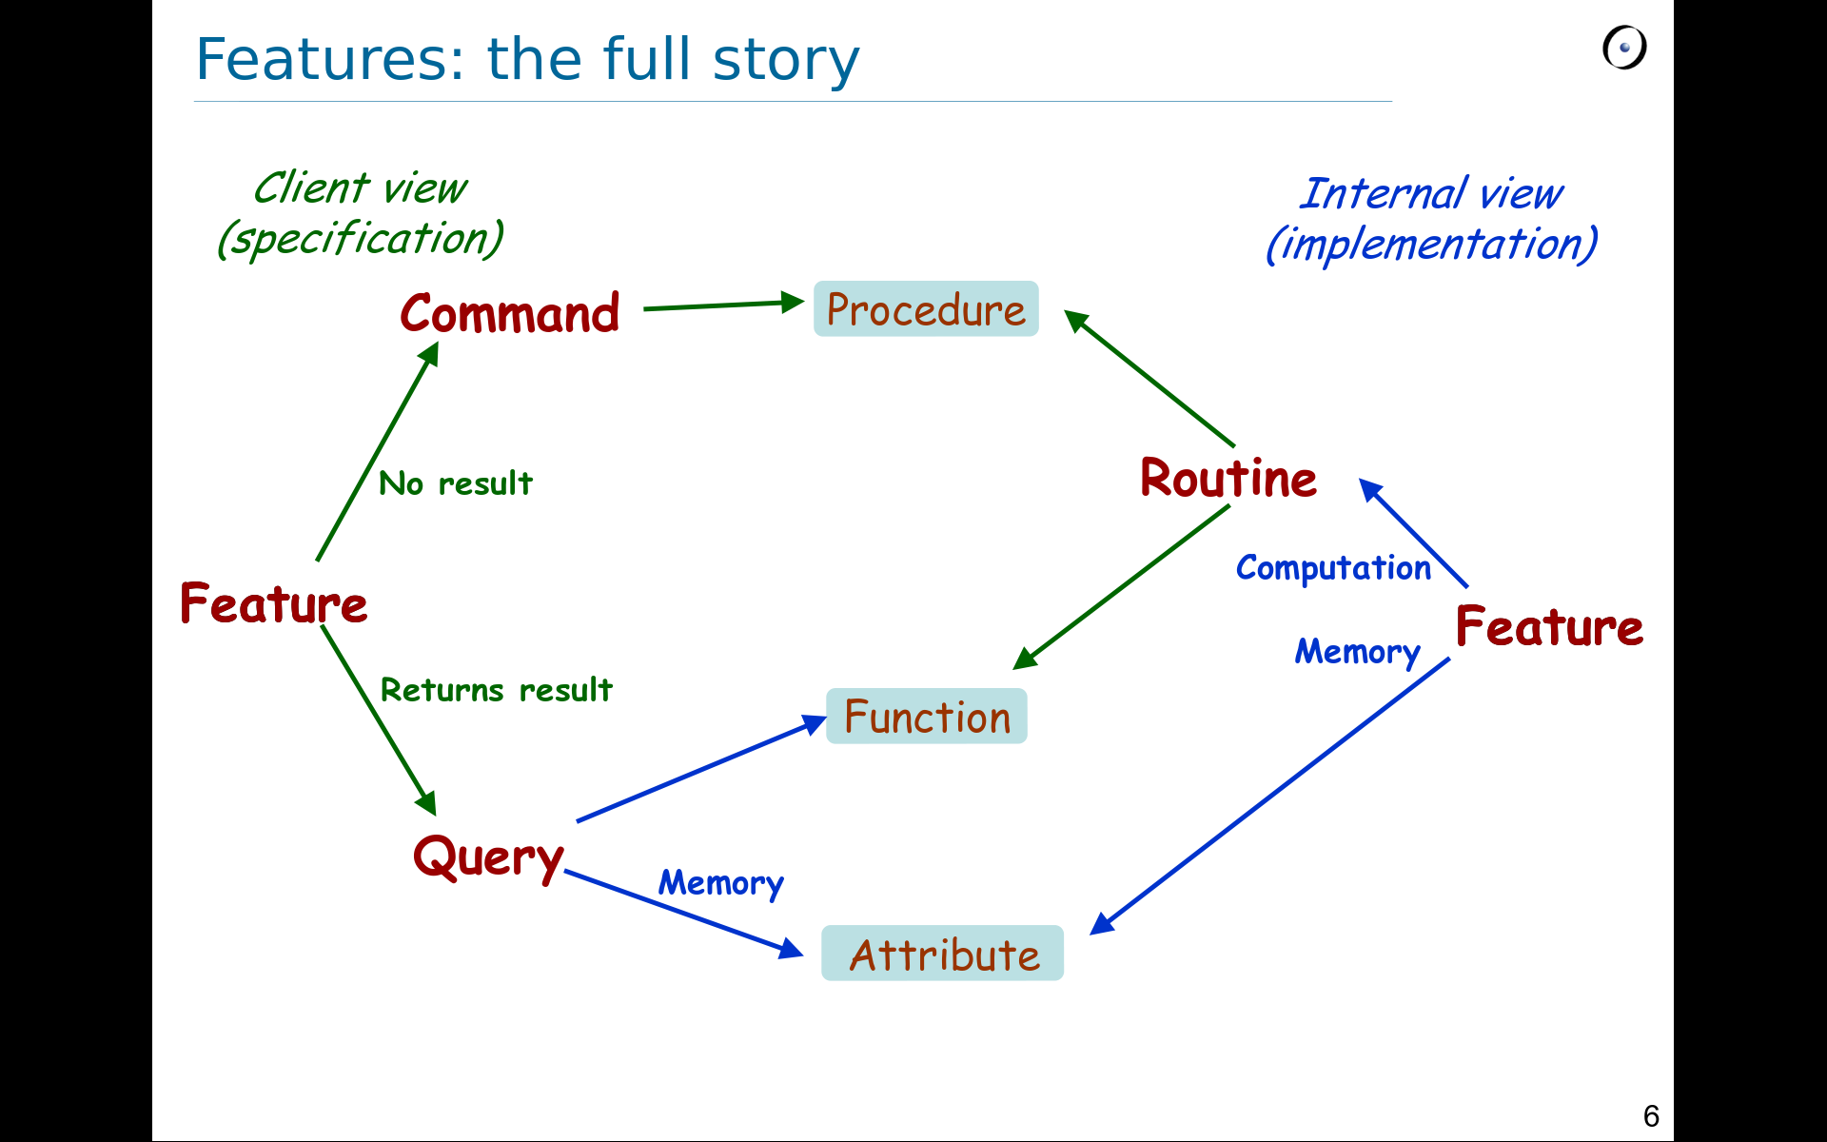

Uniform access principle:
It doesn't matter to the client if the query is an attribute or a function. Both are accessible to the client in the same way, although they are implemented in different ways (storage or computation).

An identifier is a name to represent a value at run time (called an entity). If that value changes during the execution it's called a variable. A run time entity may become attached to an object.

Object creation:
Every entity (only a name in the program that denotes a possible run time value) is declared with a certain type (ex.: leg1: LEG). A creation instruction produces at runtime an object of that type (create leg1). We can have more than one creation procedure, we only need to declare them in the generating class.

Void reference:
During an execution a reference is either attached or void. By default all reference are void.

Current object:
To execute a system we create a root object, which is the instance of a root class, using the root procedure. At any time during the execution there is a current object on which the current feature is being executed. At the beginning the current object is the root object. During a qualified call (for example x.f(...)) the new current object is the one attached to x. At the end of that call the previous current object resumes his role.

Extendibility and reusability:
Extendibility is the ease with which it's possible to adapt the system to changing user needs.
Reusability is the ease of reusing existing software for new applications.

Expanded value and references:
An object is made of fields. Each fields is a value, which is either a basic value (also called expanded type or primitive type) or a reference to another object. In Eiffel basic type are described in expanded classes. They are: INTEGER, BOOLEAN, CHARACTER and REAL. The automatic initialization values are: 0 for numbers, the empty character for characters, false for boolean and void for references. A String is an array of character, thus it's a reference object. Fields reflect attributes of the class. We can set these values through routines.

Qualified and unqualified calls:
Qualified calls are explicit (x.f(...)) and apply to the object attached to x. Unqualified calls (f(...)) apply to the current object.

Reference assignment may make some objects unreachable. In some languages like C++ we have to delete these objects manually, but in Eiffel (also in Java) there is an automatic garbage collection that does this work.

Algorithm:
An algorithm is the specification of a process to be carried out by a computer. It must respect the following points:
- defines data to which the process will be applied
- every elementary step is taken from a set of well defined operations
- describes the ordering of execution
- properties 1 and 2 are based on precisely defined conventions, suitable for automatic machines
- it's guaranteed to terminate after finite number of steps
A program contains many algorithms and object structures. An algorithm is made up from basic control structures. There are three fundamental control structures: sequence, conditional and loops.
Sequence/compound:
The postconditions of the ith instruction imply the preconditions of the (i+1)-th instruction.
Conditional:
We split the problem in more parts. In each part we use a specific technique to solve it. We can nest more conditionals using the elseif keyword or the multi-branch statement (similar to switch() in Java):
inspect expression (Integer or char)
when value1 then
...
...
else
--default action
end
Loop:
Structure:
from
...
invariant
...
variant
...
until
...
loop
--body, don't forget i++
end
There is also another type of loop: across iterable structure as variable loop/all ... end.
We can use loop as an approximation strategy: at every iteration we are closer to the solution (guaranteed by the loop invariant).
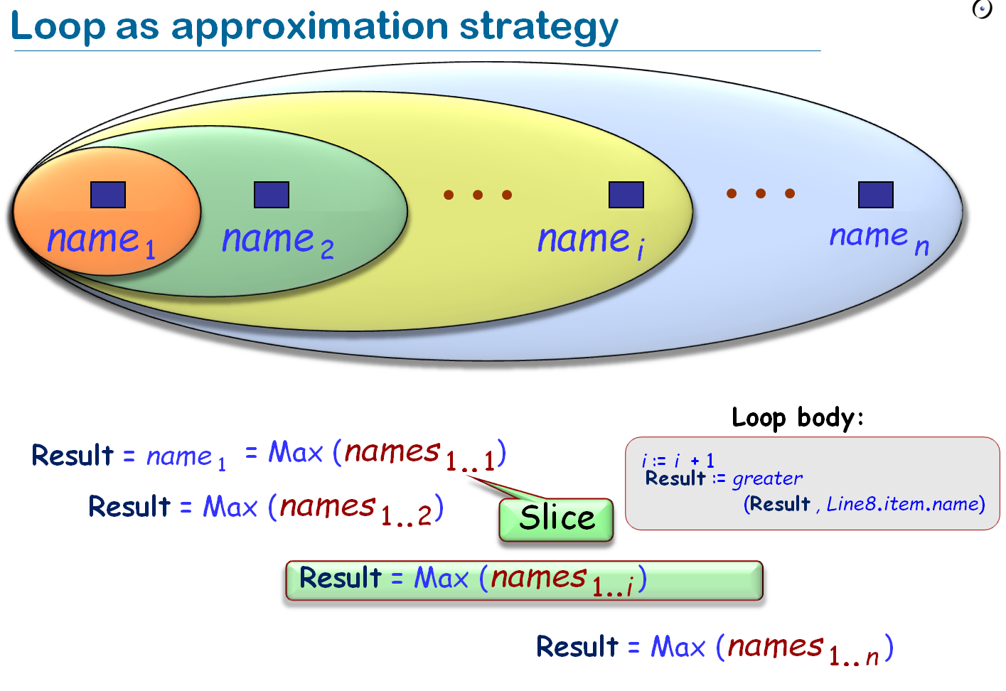
The loop invariant is satisfied after the initialization (from clause) and holds at every iteration. At the end the invariant and exit condition are both satisfied.
The loop variant is an integer positive number. It must decrease at every iteration and be non-negative until the end of the loop. Thus it's impossible to write a program that finds whether another program will end (halting problem, see discrete mathematics) loop variants are important.

Inheritance:
If A inherits from B all modules of B are available in A (as class). As type whenever an instance of B is required an instance of A is acceptable.
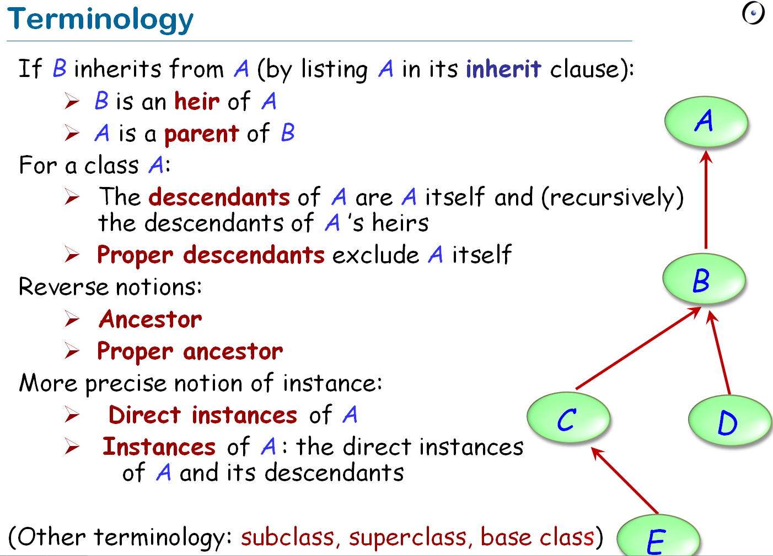
A class can be either deferred (abstract in Java, in the diagram notation is indicated with a *) or effective (+). If a feature is redefined we indicate it with ++. A feature of a class is iherited or immediate (declared in the class for the first time). In this case a class is said to introduce the feature.
Note: target:=source, where the target is a variable and the source an expression. With polymorphism the source must be a descendant of the type of target. An attachment (assignment or argument passing) is polymorphic if its target variable has a different type from the source expression. An entity or expression is polymorphic if at runtime may become attached to objects of different types. Polymorphism is the existence of this possibilities. A static type is the type of an entity declared in the class, a dynamic type is the type of an object at runtime. The dynamic type will always conform to its static type.
Static typing:
- Type safe calls: x.f(), x has a feature f.
- static type checker: a tool that guarantees that every call in a program is type safe
- in statically typed languages it's possible to write a static type checker.
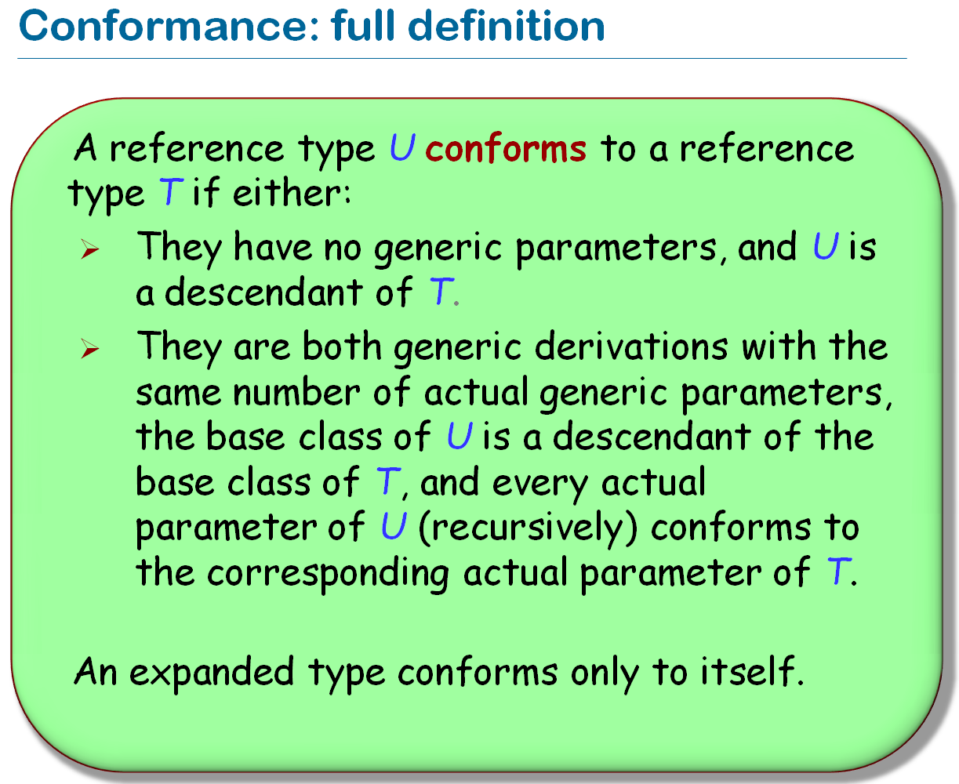
Syntax:
class NAME inherit ...
redefine
...
end
Dynamic binding: every call to the feature will use the version of the feature best adapted to the type of the target object.

Genericity:
We can write a generic class in the following way:
Class NAME[FORMAL GENERIC PARAMETER]. We can also choose which kind of parameters we want, for example: SORTED_LIST[G -> COMPARABLE] (G inherits from COMPARABLE).

Selective export and deferred classes:
Thus an assignment like a.v:=c is illegale, we ned a setter procedure. Exporting an attribute in Eiffel (for the client can also be a query, uniform access principle) make it read-only visible to the client. By default features are public in Eiffel, but we can make them visible only to some client in this way:
feature {A,B,...} ← list of classes in which the feature is visible/callable
feature {NONE} → this feature isn’t visible anywhere, but can be called through an unqualified call by the own class.
A class is deferred if it has at least a deferred feature, declared in the following way:
Name
require
...
deferred
ensure
...
end
Deferred class must be declared as deferred and cannot be instantiated.

Design by contracts
Writing two different lines is equivalent to concatenate logical formulas with “and”. If a contract is violated we get an exception (error). For the post conditions we can use the special keyword old, which indicates the old state of a variable (before the feature call). The invariant of a class indicates properties that all object of the class must satisfy. It’s ok to break the invariant before a creation procedure and in the body of a routine. Contracts are also inherited. Let A be an ancestor of B, then:
-preconditions of B must be same ore weaker than the one of A --> require else
-postconditions of B must be same or stronger than the one of A --> ensure then
-the invariant must be same or stronger --> added invariants are and-ed to these of the ancestor
If we are happy with the old contracts we just omit them.
Advantages of design by contracts: better to debug, better documentation, automatic testing, proof theorem. Don’t use contracts for: replacing if/else, I/O, user inputs.
We say that a condition is complete when contains all possible correct values. A condition is sound when every accepted value is correct.
Example: we require that x> 1
- x> 0 is an over approximation, too weak
- x> 2 is an under approximation, too strong

Recursion
Something is recursive if involves an instance of itself (for example a data structure is recursive if is built from smaller pieces of the same data structure). There exist two type of recursion: direct (routine r calls itself) or indirect (r calls s that calls r).

Data structure
Pay attention to the terminology. Open hashing=Verkettung der Überläufer, closed hashing=offene Hashverfahren!

Multiple inheritance
Rename: it could be that two classes have feature with the same name. We need to rename one of them:
inherit
A
rename f as A_f (redefine A_f end)

end
A name clash is acceptable only if: every feature has a compatible signature or if at most one is effective (i.e. the others are deferred). To come to this scenario we can use the following syntax:
undefine f end -- which means that feature f inherited from class A will become undefined. If more than one is effective, then they must all come from a common ancestor feature under repeated inheritance.
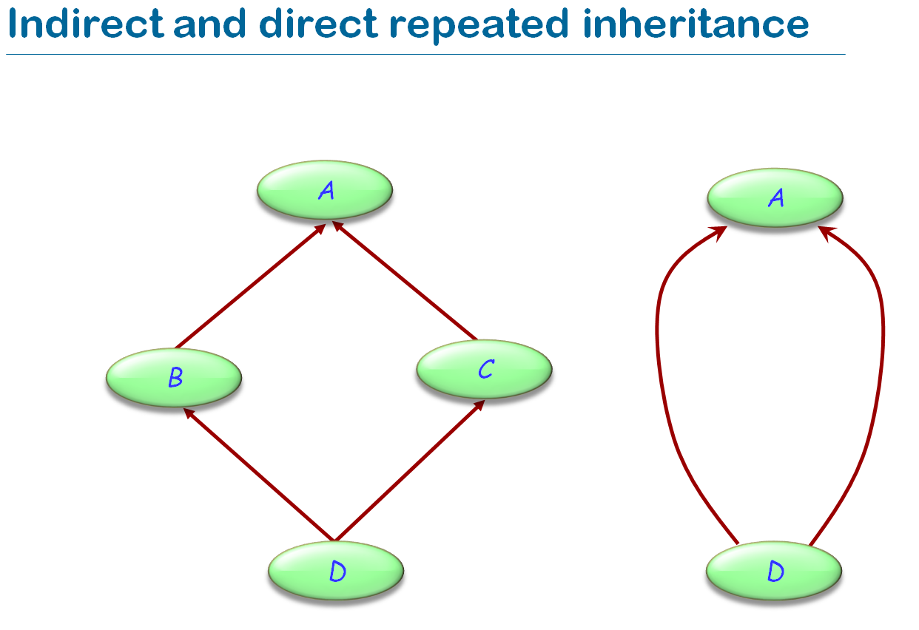
In the left case we assume that the feature f inherited from A is redefined in B. Then we have an ambiguity in D. To solve this problem we can do as follows:
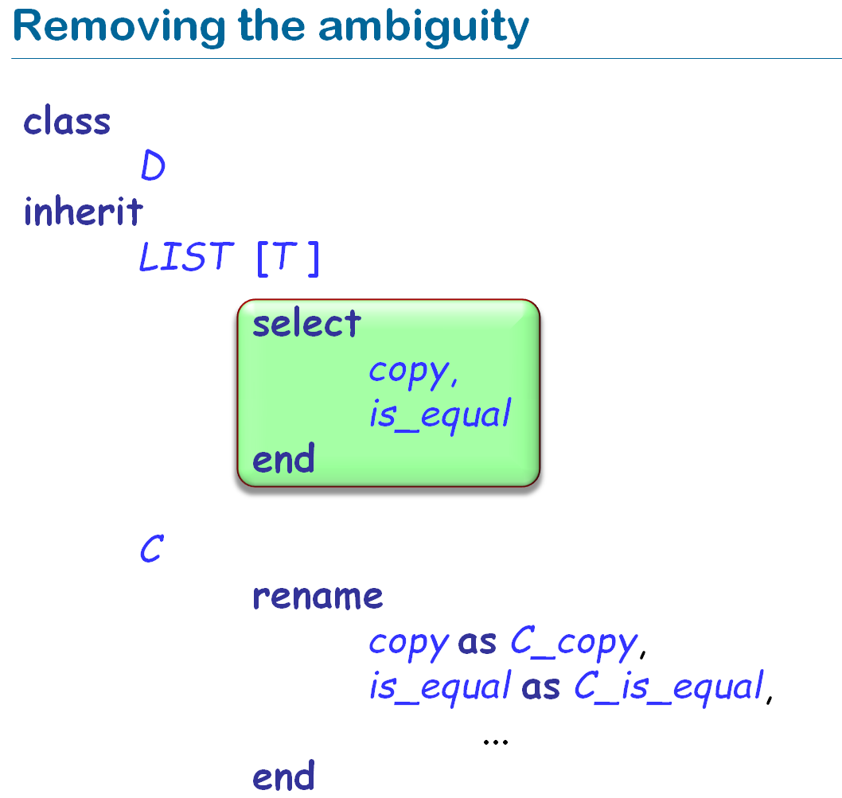
Model view controller pattern
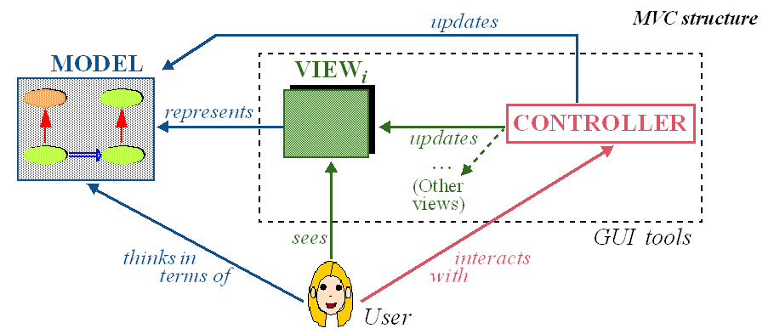

Event driven programming
The program reacts to certain events, for example if a user press a button, ... The publisher determines when an event is raised, the subscriber what action is taken.

Agent
Example: Zurich_map.on_left_click.extend_back(agent find_station). Agent type
click: EVENT_TYPE[TUPLE[...]], where EVENT_TYPE can be, for example PROCEDURE, FUNCTION, ...
If the agent represent a procedure we can call it with click.call(tuple_arg), if it's a function click.item(tuple_arg). An agent can have closed argument (determined at declaration time) and opened argument (which will be determined at "call time"). An example is: x:=agent a0.f(a,?,b).

