I used < awk ‘$6 != “0”’ tile1.txt>file2.txt > to get rid of rows with zero central pressure

I removed all the names (strings) in the second column with:

awk ‘{for (i=1; i<=9; i++) if (i!= 2) printf $i “ “; print””}’ file1>file2

A list is not an array.

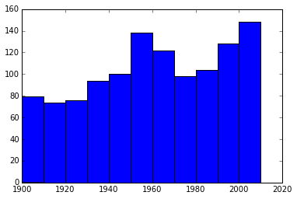

Histogram of Hurricanes per decade:

Since there weren’t satellites before the 1960’s, hurricanes before then might have been under reported. Considering data after 1980, there were 74 hurricanes in the 2000’s, increasing linearly by 8 hurricanes per decade, my estimate is 98 hurricanes in the 2030’s, but then again I don’t know how to use /if I should trust, the peak in the 60’s.

For the next part I eliminated all the data in the text file with 0 as the central pressure

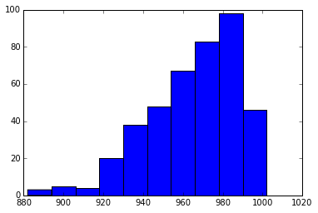

Histogram of minimum storm pressures in MB

The mean was 964.76

Standard deviation was 22.69

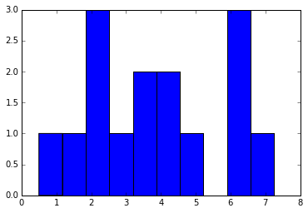

Spin up time.

The data was pretty bad, since not all of the storm ID’s started above 1000MB or ended below 970 MB, so a lot of the storms were ignored. Also, the most of the storms don’t have exactly 970 or 1000, so I have to be a little rough with my if statements, otherwise I would have gotten even less occurrences.

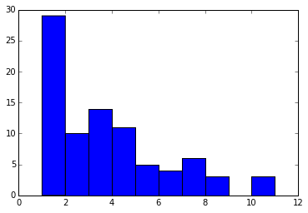

Time at category 3 or above.



Average Time at category 3 or above per decade(Mathematica).

I didn’t get any data for the 1930’s since I ignored all data with 0 central pressure.



Hurricanes Passing through Florida per decade. Seems wrong.