Group: Mohamad, Caleb, Julian S. ,Michael D., Ignas

Full code python code on GitHub ilekavic

Part 1: All events within 100m of Seattle

technique year lat long depth scale

1724 EHB 1949 47.1 -122.392 30.0 6.5

2766 EHB 1965 47.3 -122.333 65.7 6.5

6735 EHB 1980 46.3 -121.994 15.0 5.5

11028 EHB 1996 47.8 -121.745 8.7 5.8

11785 EHB 1999 47.0 -123.234 48.9 5.6

12171 EHB 2001 47.0 -122.580 54.0 6.8

Part 2

I used numerous awk commands to remove the name/string description of each earthquake, but I couldn’t figure out how to change “r1940” to “1940”. So I had to go into notepad, “Find and Replace” individual letters out of the text document, I stopped getting “converting string to float” errors in python, so I assumed it worked.

My original idea for the clustering was first, run two for loop, adding numbers to a 2d array (initially zero) which represent the indices of the earthquakes within a certain radial distance (calculated using the haversine formula) and within 2 years of each other. It would look like:

[[1,3,7,0,0,…],

[2,5,10,15,0,0,..],

…]

Afterwards, I would iterate through the other indices in a row to find more events,

[[1,3,7,19,21,25,…],

[2,5,10,15,24,26,31,0,0,..],

…]

(here, events 19 and 21 were close to 3, so they were added to 1’s cluster, and so forth)

This would have been very computationally intensive, depending on how many iterations I would have run. Additionally, there was a problem with getting repeat events in each column, I would get:

[[1,3,7,1,1,7,0,…],

…]

Eventually, I just decided to add on elements of one cluster/row onto another if they shared more than 2 of the same events.

Afterwards, I defined a new array (13500\*3). Each row represents a cluster’s central latitude, longitude and the number of events that took place. I plotted this in a scatterplot:

My method is biased since I can only really get an initial cluster within a circle. Not sure how I would do ellipses, which might be more physical since earthquakes tend to occur along a fault line

sdgasdf

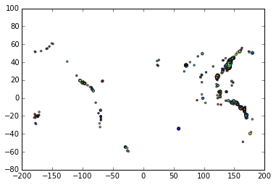

This is a tenth of the data(roughly a decade), I used a minimum distance of 100 mile and events in a cluster needed to have occurred at least within 1 year of each other. The radius of the cirlces represents the number of events within the cluster.

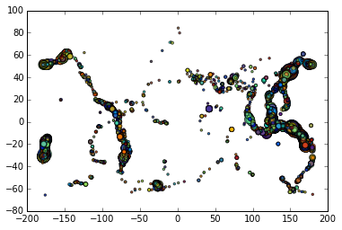

This is the full data. Still with a 100m threshold

.

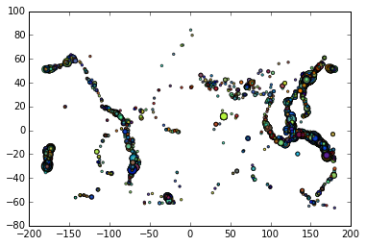

Full data with a 50m threshold.

Part 3-4

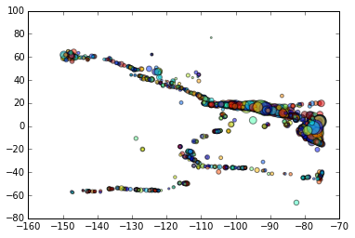

Events in a certain range of longitude. Radius of circle given by their magnitudes. This looks weird but I think it’s just a stretched out west coast.

