**Kod bölüm**

Gurnalmaly kitaphanalar:

pip install flask

pip install RPi.GPIO

pip install Adafruit-DHT

**app.py faýlyň içine girizilmeli kod:**

import time

import Adafruit_DHT

import Rpi.GPIO as GPIO

from flask import Flask, render_template, request

RELAY_PIN = 18

DHT_PIN = 17

DHT_SENSOR = Adafruit_DHT.DHT11

app = Flask(__name__)

GPIO.setmode(GPIO.BCM)

GPIO.setup(RELAY_PIN, GPIO.OUT)

GPIO.output(RELAY_PIN, GPIO.LOW)

def read_dht11():

humidity, temperature = Adafruit_DHT.read(DHT_SENSOR, DHT_PIN)

if humidity is not None and temperature is not None:

return temperature, humidity

else:

return None, None

@app.route(“/”, methods=[“GET”, “POST”])

def index():

temperature, humidity = read_dht11()

if request.method == “POST”:

if “relay_on” in request.form:

GPIO.output(RELAY_PIN, GPIO.HIGH)

elif “relay_off” in request.form:

GPIO.output(RELAY_PIN, GPIO.LOW)

return render_template(“index.html”, temperature=temperature, humidity=humidity)

@app.before_first_request

def before_first_request():

GPIO.setwarnings(False)

@app.teardown_appcontext

def teardown(exception):

GPIO.cleanup()

if __name__ == “__main__”:

app.run(host=”0.0.0.0”, port=5000, debug=True)

**templates/index.html içine girizilen kod:**

<!DOCTYPE html>

<html lang=”en”>

<head>

<meta charset=”UTF-8”>

<meta name=”viewport” content=”width=device-width, initial-scale=1.0”>

<title>Raspberry Pi Web Control</title>

<style>

body {

font-family: Arial, sans-serif;

text-align: center;

padding: 20px;

}

.status {

font-size: 24px;

margin-top: 20px;

}

.button {

padding: 10px 20px;

font-size: 18px;

margin: 10px;

cursor: pointer;

}

.button-on {

background-color: #4CAF50;

color: white;

}

.button-off {

background-color: #f44336;

color: white;

}

</style>

</head>

<body>

<h1>Raspberry Pi Web Dolandyryjy ulgam</h1>

<div>

<h2>Temperature: {{ temperature if temperature else “Error” }} °C</h2>

<h2>Humidity: {{ humidity if humidity else “Error” }} %</h2>

</div>

<div class=”status”>

<h2>Relay Status:

{% if GPIO.input(RELAY_PIN) == GPIO.HIGH %}

<span style=”color: green;”>ON</span>

{% else %}

<span style=”color: red;”>OFF</span>

{% endif %}

</h2>

</div>

<form method=”POST”>

<button class=”button button-on” type=”submit” name=”relay_on”> Relay ON</button>

<button class=”button button-off” type=”submit” name=”relay_off”> Relay OFF</button>

</form>

</body>

</html>

**Kody işe goýbermek:** python3 app.py

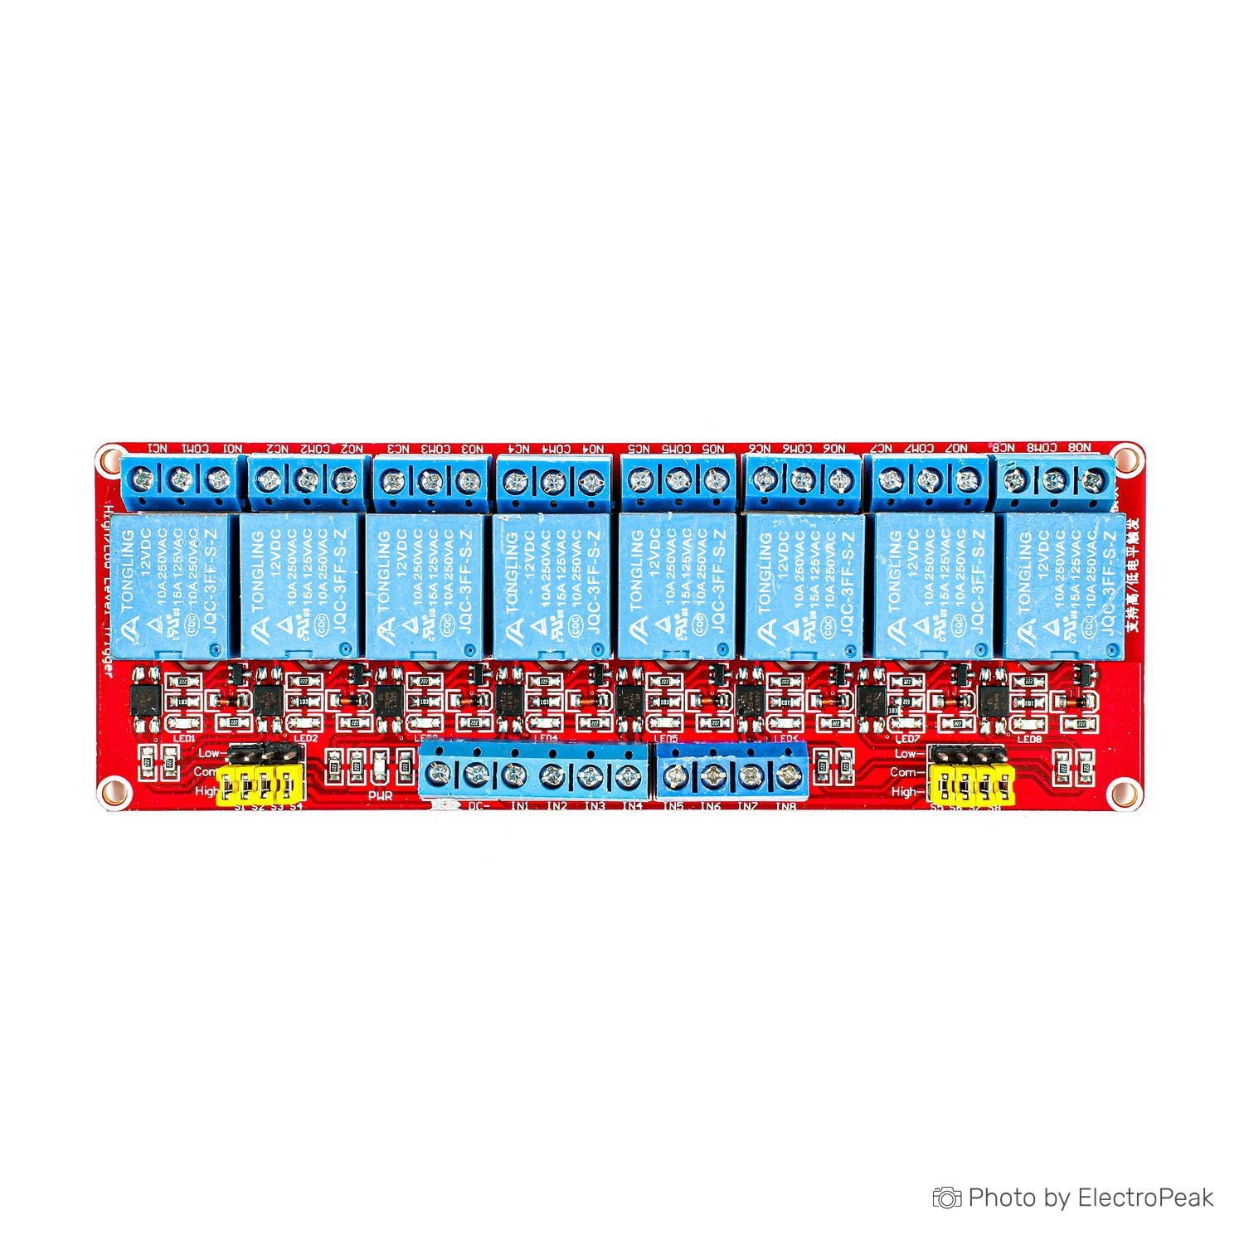**Web sahypa ýüzlenmek:** <http://192.168.1.100:5000>

*2-nji surat*

*5v dolandyryjy rele*

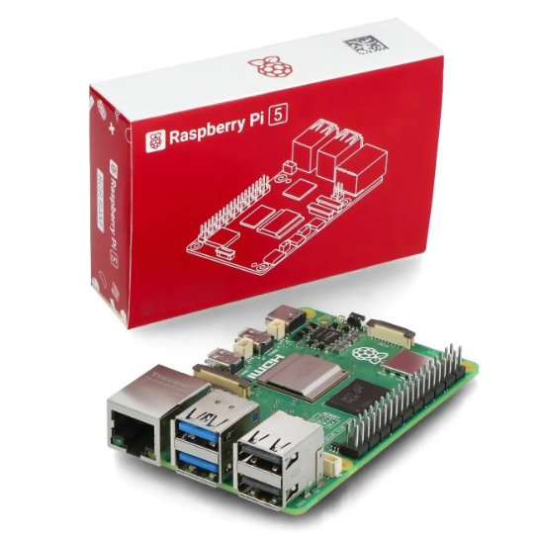*2-nji surat*

*Raspberry pi 5 4Gb*

***Raspberry pi5 tehniki häsiýetnamasy***

|  |  |
| --- | --- |
| **SoC** | Broadcom BCM2712 |
| **CPU** | ARM Cortex-A76 (ARM v8) 64-bit |
| **Clock speed** | 4x 2.4 GHz |
| **GPU** | VideoCore VII (800 MHz) |
| **RAM** | 4 GB LPDDR4X (4267 MHz) |
| **WiFi** | IEEE 802.11b/g/n/ac (2.4 GHz/5 GHz) |
| **Bluetooth** | Bluetooth 5.0, BLE |
| **Ethernet** | Gigabit Ethernet (with PoE+ support) |
| **USB** | 2x USB-A 3.0 (5 GBit/s), 2x USB-A 2.0 |
| **PCI Express** | 1x PCIe 2.0 |
| **GPIO** | Standard 40-pin GPIO header |
| **Video** | 2x micro-HDMI ports (4K60) 2x 4-lane MIPI (DSI/CSI) |
| **Multimedia** | H.265 (4K60 decode), OpenGL ES 3.1, Vulkan 1.2 |
| **SD card** | microSD |
| **Power** | 5 V/5 A (via USB-C),Power over Ethernet (PoE+) |

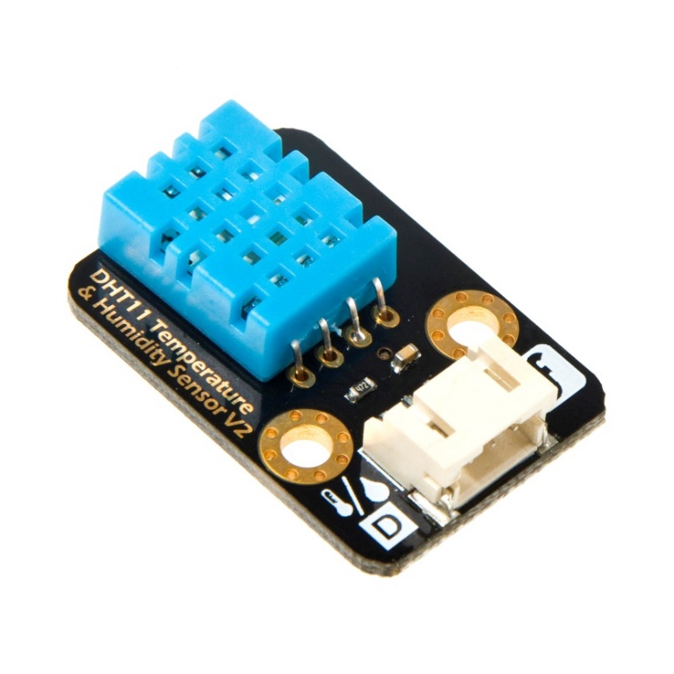*2-nji surat*

*Temperatura we çyglylyk datçigi*

1. Pip.raspberrypi.com
2. https://habr.com/ru/companies/ru_mts/articles/766922/
3. https://www.raspberrypi.org
4. https://www.raspberrypi.org/products/raspberry-pi-5
5. https://www.raspberrypi.org/documentation/usage/iot/
6. https://projects.raspberrypi.org/en/projects?software=raspberry-pi-os&category=IoT
7. https://www.microsoft.com/en-us/azure/iot
8. https://www.ibm.com/internet-of-things
9. https://cloud.google.com/solutions/internet-of-things