**Features**

* 64-bit quad-core ARM Cortex-A76 processor (2.4 GHz)
* VideoCore VII GPU (800 MHz)
* 4 GB of LPDDR4X RAM (4267 MHz)
* Raspberry Pi silicon RP1 I/O controller chip
* Real-time clock
* On/off button
* PCIe 2.0
* UART connector
* Fan connector

**Specifications**

|  |  |
| --- | --- |
| SoC | Broadcom BCM2712 |
| CPU | ARM Cortex-A76 (ARM v8) 64-bit |
| Clock speed | 4x 2.4 GHz |
| GPU | VideoCore VII (800 MHz) |
| RAM | 4 GB LPDDR4X (4267 MHz) |
| WiFi | IEEE 802.11b/g/n/ac (2.4 GHz/5 GHz) |
| Bluetooth | Bluetooth 5.0, BLE |
| Ethernet | Gigabit Ethernet (with PoE+ support) |
| USB | 2x USB-A 3.0 (5 GBit/s) 2x USB-A 2.0 |
| PCI Express | 1x PCIe 2.0 |
| GPIO | Standard 40-pin GPIO header |
| Video | 2x micro-HDMI ports (4K60) 2x 4-lane MIPI (DSI/CSI) |
| Multimedia | H.265 (4K60 decode) OpenGL ES 3.1, Vulkan 1.2 |
| SD card | microSD |
| Power | 5 V/5 A (via USB-C) Power over Ethernet (PoE+) |

**Raspberry Pi 4 vs Raspberry Pi 5**

|  |  |  |
| --- | --- | --- |
|  | [Raspberry Pi 4](https://www.elektor.com/products/raspberry-pi-4-b-4-gb-ram) | Raspberry Pi 5 |
| SoC | Broadcom BCM2711 | Broadcom BCM2712 |
| CPU | ARM Cortex-A72 (ARM v8) 64-bit | ARM Cortex-A76 (ARM v8) 64-bit |
| Clock speed | 4x 1.5 GHz | 4x 2.4 GHz |
| L2 cache | 1 MByte shared | 4x 512 KByte |
| L3 cache | N/A | 2 MByte shared |
| GPU | VideoCore VI (500 MHz) | VideoCore VII (800 MHz) |
| RAM | 4 GB LPDDR4 (3200 MHz) | 4 GB LPDDR4X (4267 MHz) |
| WiFi | IEEE 802.11b/g/n/ac (2.4 GHz/5 GHz) | IEEE 802.11b/g/n/ac (2.4 GHz/5 GHz) |
| Bluetooth | Bluetooth 5.0, BLE | Bluetooth 5.0, BLE |
| Ethernet | Gigabit Ethernet (with PoE support) | Gigabit Ethernet (with PoE+ support) |
| USB | 2x USB-A 3.0 2x USB-A 2.0 | 2x USB-A 3.0 (5 GBit/s) 2x USB-A 2.0 |
| I/O controller chip | N/A | Raspberry Pi Silicon RP1 |
| PCI Express | N/A | 1x PCIe 2.0 |
| Real Time Clock (RTC) | N/A | RTC and RTC battery connector |
| On/off button | N/A | Onboard power button |
| Cooling | N/A | Fan connector |
| GPIO | Standard 40-pin GPIO header | Standard 40-pin GPIO header |
| UART | via GPIO | 1x UART connector |
| SD card | microSD slot (DDR50) | microSD slot (SDR104) |
| Video | 2x micro-HDMI ports (4K60) 1x 2-lane MIPI DSI port (display) 1x 2-lane MIPI CSI port (camera) | 2x micro-HDMI ports (4K60) 2x 4-lane MIPI (DSI/CSI) |
| Audio | 4-pole 3.5 mm audio jack (stereo audio and composite video) | N/A |
| Multimedia | H.265 (4K60 decode) H.264 (1080p60 decode, 1080p30 encode) OpenGL ES, 3.0 graphics | H.265 (4K60 decode) OpenGL ES 3.1, Vulkan 1.2 |
| Power | 5 V/3 A (15 W) Power over Ethernet (PoE) | 5 V/5 A (25 W), USB PD Power over Ethernet (PoE+) |

Specification Processor Broadcom BCM2712 2.4GHz quad-core 64-bit Arm Cortex-A76 CPU, with Cryptographic Extension, 512KB per-core L2 caches, and a 2MB shared L3 cache Features: • VideoCore VII GPU, supporting OpenGL ES 3.1, Vulkan 1.2 • Dual 4Kp60 HDMI® display output with HDR support • 4Kp60 HEVC decoder • LPDDR4X-4267 SDRAM (options for 2GB, 4GB and 8GB) • Dual-band 802.11ac Wi-Fi® • Bluetooth 5.0 / Bluetooth Low Energy (BLE) • microSD card slot, with support for high-speed SDR104 mode • 2 × USB 3.0 ports, supporting simultaneous 5Gbps operation • 2 × USB 2.0 ports • Gigabit Ethernet, with PoE+ support (requires separate PoE+ HAT) • 2 × 4-lane MIPI camera/display transceivers • PCIe 2.0 x1 interface for fast peripherals (requires separate M.2 HAT or other adapter) • 5V/5A DC power via USB-C, with Power Delivery support • Raspberry Pi standard 40-pin header • Real-time clock (RTC), powered from external battery • Power button Production lifetime: Raspberry Pi 5 will remain in production until at least January 2036 Compliance: For a full list of local and regional product approvals, please visit pip.raspberrypi.com

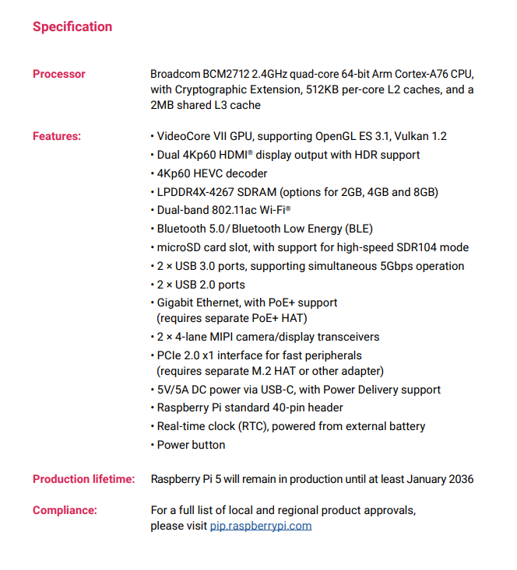

### Malina Pi 4 - Pi 5 deňeşdirme

|  |  |  |
| --- | --- | --- |
|  | **Malina Pi 4** | **Malina Pi 5** |
| **Arhitektura (bitler)** | 64 | 64 |
| **SoC** | Broadcom BCM2711 | Broadcom **BCM2712** |
| **CPU** | 1.5 GGs dört ýadroly ARM Cortex-A72 | **2.4 GGs** dört ýadroly ARM **Cortex-A76** |
| **GPU** | VideoCore VI - 500 MGts OpenGL ES 3.0 | **VideoCore VII - 800 MGts** **OpenGL ES 3.1, Vulkan 1.2** |
| **RAM** | 1 gitmek / 2 gitmek / 4 gitmek / 8 gitmek | 2 gitmek / 4 gitmek / 8 gitmek |
| **Birikdirmek** | • 2.4 GGs we 5.0 GHz 802.11 ac simsiz • Bluetooth 5.0, BLE • Gigabit Ethernet • 2 USB 3.0 porty (5 Gb / sek çenli) • 2 USB 2.0 porty • Standart 40 pinli GPIO • 2 Micro HDMI porty (4Kp60 çenli)  • 2 -lane MIPI DSI, 2 zolakly MIPI CSI  • Stereo ses we birleşdirilen wideo portlary (4 polýus) | • 2,4 GGs we 5.0 GHz simsiz 802,11 ac • Bluetooth 5.0, BLE • Gigabit Ethernet • 2 USB 3.0 porty ( **bir wagtyň özünde 5 Gb / sek** ) • 2 USB 2.0 porty • Standart 40 pinli GPIO • 2 Micro HDMI porty (4Kp60 çenli) • **2 x 4 MIPI zolak (DSI / CSI)** • **PCIe 2.0 interfeýsi** |
| **Saklamak** | Micro-SD | Mikro-SD ( **ýokary geçiriş tizligi - SDR104 re modeimi** ) |
| **RTC** | N / A. | **RTC batareýa birleşdirijisi** |
| **Elektrik üpjünçiligi** | 5V / 3A (USB-C ýa-da GPIO birleşdirijisi arkaly) | 5V / **5A** (Elektrik üpjünçiligi açyk) |
| **PoE** | Aýry-aýry PoE HAT arkaly | Aýry-aýry PoE HAT arkaly ( **täze wersiýa** ) |
| **Işletmek** | Elektrik togundan soň dessine | **ON / OFF düwmesi** |