In this Alloy analysis, we first show some examples of the model and argue for some of the choices taken. We then proceed to show the system's evolution, and lastly, some assertions will be verified.

The defined model is the following:

Let’s argue some of the choices:
- Once a BikePath is public it remains public. It can be used to other users to make their own record. Delete a BikePath would mean to destroy the recorded session of all users that used it.
- “ Obstacle” indicate a generic type of obstacle and not a specific one. So an obstacle is present in the physical universe only when it has coordinates and a street associated to it.
- Since a Street exist into the system only when someone use it to create a BikePath the set of BikePaths od which a road is part can only increase.
- A MeteoData has mean to exist only if associated to a Record.

Now we model a scenario where an obstacle appear on a certain street and than get removed:

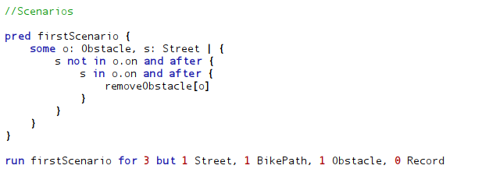
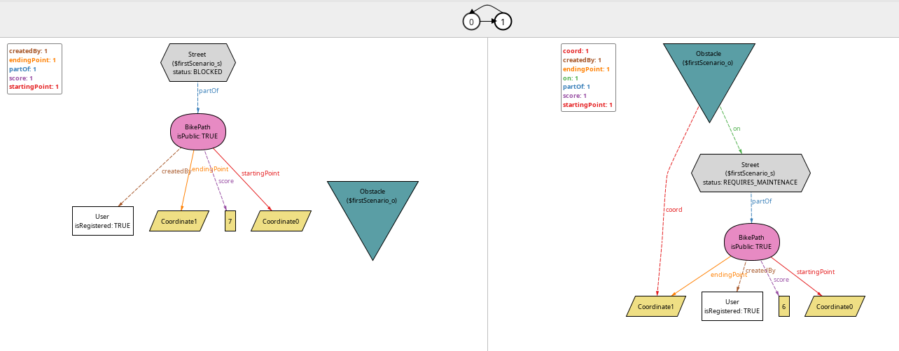
We can observe the followings:
The model allows that a street can be BLOCKED also when there are no obstacles. This is perfectly fine because streets may be closed for other reasons. Also, the presence of obstacle do not necessarily means that the street gets blocked: the obstacle may not affect the road's status to a point that makes it unusable.

The following scenario shows a situation where an User publish a private BikePath.

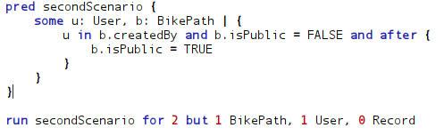
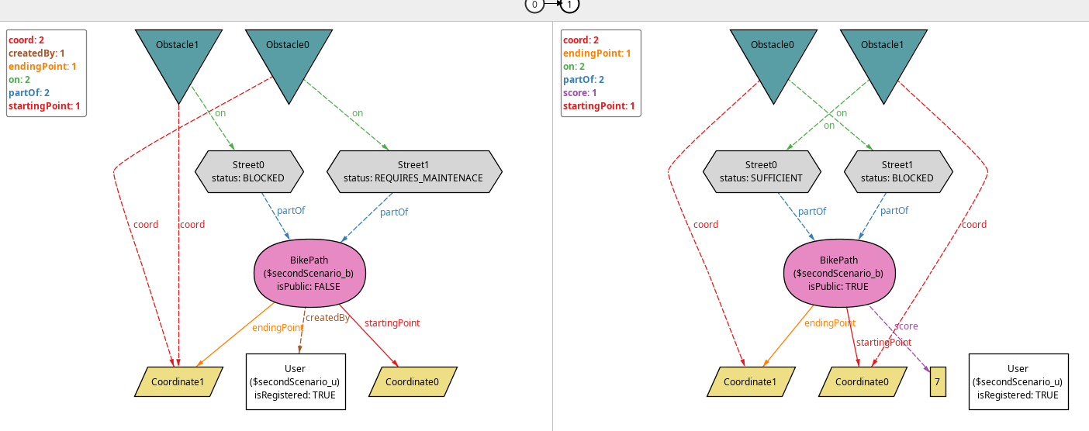
We can observe that the BikePath is correctly updated, i.e. it gets a score.
We can Also observe that a BikePath can lose its creator. What happens will be explained in the fourth scenario.

Let’s see now a scenario where an User deletes its account, let’ s observe how their record changes
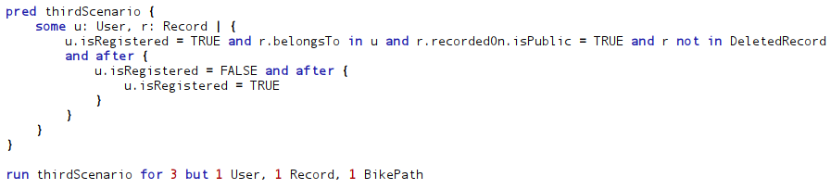
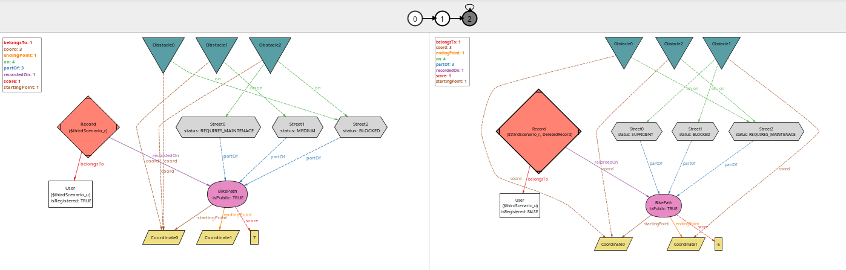
The Record is correctly deleted. Now we can observe that if the User create a new Account:
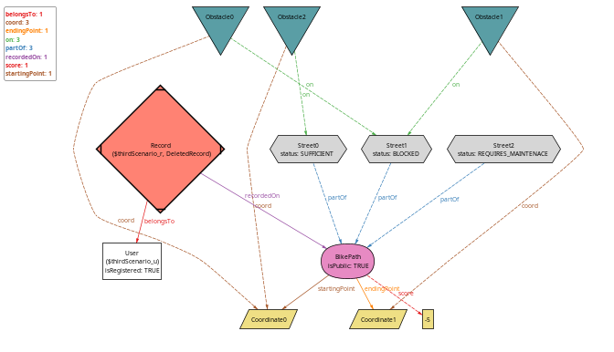
The Record does not get Recovered.

The following scenario expands the situation briefly shown in the Second Scenario:
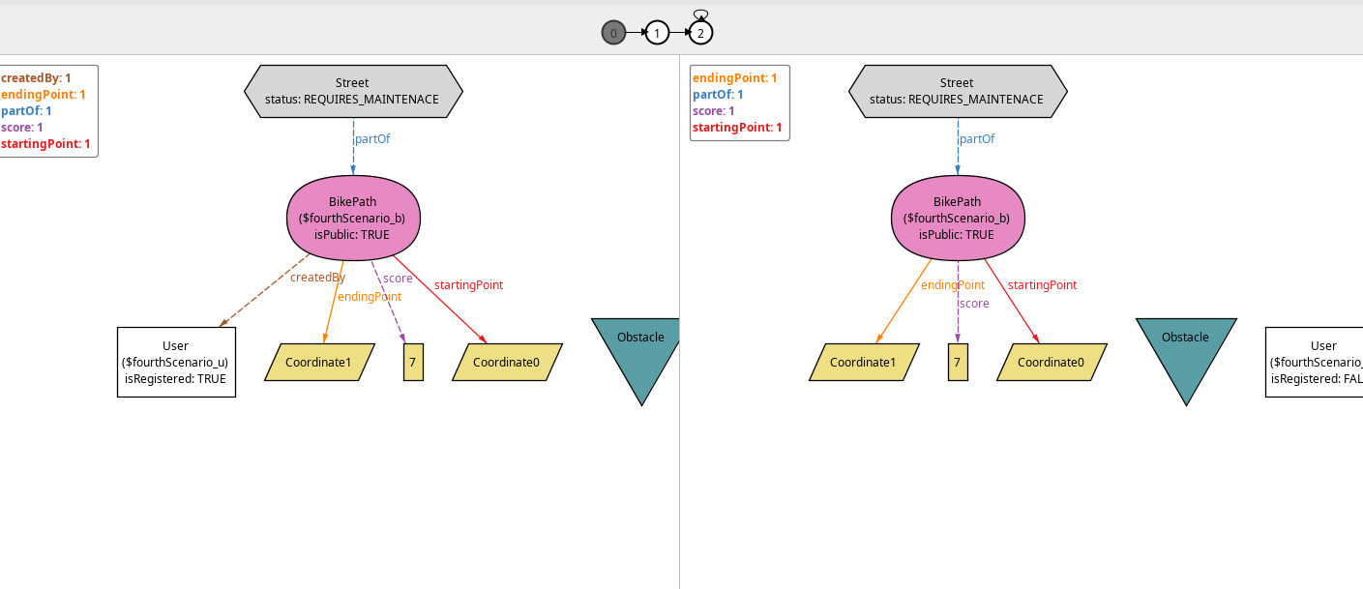
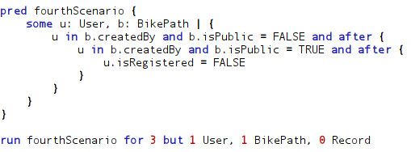
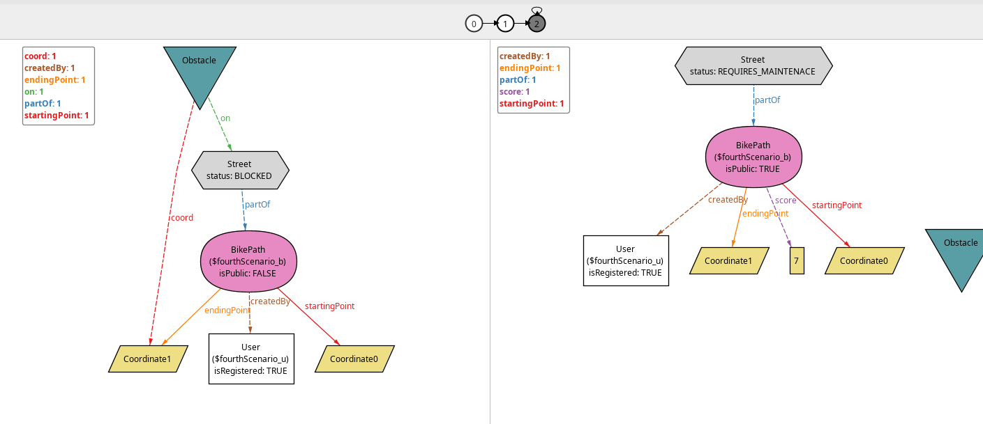
We observe the following:
For a registered User it is obviously possible to create and Publish a BikePath. If the user decide to delete the account, the public BikePath remain available and only lose the reference to the user that created it.

The following scenario shows how a particular situation is allowed in the model:
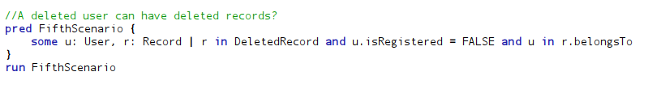

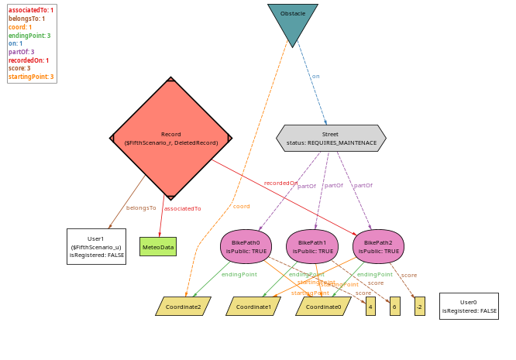

A Deleted Record can Belong to a Deleted User.
So far we have seen that a Deleted Record can belong to a Non-Registered User and a Registered User. We will prove that a non-deleted record cannot belong to a non-registered user in the following assertion:

Let’s now take a look to some assert:
