2307-BSE

Integrated Design Document

CS201.1

Alexander Legner

# Document Outline

## Table of Contents

Document Outline 2

Table of Contents 2

Table of Figures 2

Table of Tables 2

Proposal 4

Introduction 4

Game Concept 4

Unique Selling Points 4

Time Constraints 4

Software/Hardware 4

Target Platforms 4

Target Audience 4

Game Features 5

Core Functionality 5

Levels 5

Objectives 5

Reward and Progression System 5

Game Mechanics 5

Gameplay Overview 5

Controls 5

User Interface Design 6

Timeline/Schedule 7

**References** 8

## Table of Figures

Figure 1: UI - HUD 6

Figure 2: UI - Pause Screen 6

Figure 3: UI - Title Screen 7

Figure 4: Timeline Gantt Chart 7

## Table of Tables

Table 1: Target Platforms 4

Intentionally Blank

# Proposal

## Introduction

### Game Concept

A 3D tower defence style game where you must defend your homeland from the evil below. You have borrowed some super-secret towers to defend your home from ‘Earth’, but they won’t mind ;) technically it never existed right? Your newly acquired turrets will be used to defend your home from these attacks!

### Unique Selling Points

* The theme for the game is based on a celestial vs underworld. It will be a 3D cartoon art style to keep it fun and unique.
* The towers will be upgradable with different paths with unique stats and abilities which allows the have the choice/strategy on how to destroy the enemy. Ultimately their choices will determine whether they will survive.
* There will also be a unique story line. This will include unlocking new towers and increase in difficulty as you progress. There will be unique bosses and enemies in each region of the campaign. There will also be an endless version which the games alpha will consist of.

### Time Constraints

Project duration: 24/07/2023 - 15/09/2023 (8 weeks)  
Refer to Timeline/Schedule for specifics.

### Software/Hardware

Game Engine: Unity   
Primary Programming Language: C#

### Target Platforms

Table 1: Target Platforms

|  |  |
| --- | --- |
| MINIMUM | RECOMMENDED |
| Requires a 64-bit processor and OS.  OS: Windows 10 64-bit.  Processor: AMD Ryzen 3 1200 or equivalent.  Memory: 8 GB RAM.  Graphics: AMD Radeon R9 380 or equivalent. | Requires a 64-bit processor and OS.  OS: Windows 10 64-bit.  Processor: AMD Ryzen 5 2600 or equivalent.  Memory: 16 GB RAM.  Graphics: AMD RX 6700 XT or equivalent. |

### Target Audience

Target Audience: Teenagers and young adults that play video games.

In today’s world, many teenagers and young adults play video games for many reasons including reducing stress, entertainment, socialising and more. Data from pew research shows that *“three in ten (31%) teens play video games on a daily basis”.* – There are more teenagers and young adults that play as well but the primary reason for targeting teenagers and young adults is to attract as many of the active gamers that are looking to play games every day. By targeting teenagers and young adults, we have covered most regular gamers and will hopefully bring this game great success amongst the gamer community.

## Game Features

### Core Functionality

The core functionality of this game is to build towers to defend against enemies. Each feature will improve upon this core functionality.

### Levels

Each level will introduce a new feature of the game. For example, the first level will introduce the tutorial to teach you how to play. The next level would then introduce new enemies and towers to expand the user’s arsenal. Eventually one of the levels will contain a boss battle which can instantly make the player lose if the player doesn’t defeat it with strategy.

### Objectives

The objective of this game is to build towers and fend off enemies from attacking your life pool. You will need to complete a set number of waves to complete the level. There may be optional objectives which make the game harder but give you a better reward.

### Reward and Progression System

Within each level you start with enough money to buy a few simple towers. When you kill enemies, you gain money to upgrade and build more towers. Outside of the levels you will gain victory points from completing levels and extra objectives within these levels. These victory points allow you to upgrade/unlock unique abilities and towers which will help with the increasing difficulty that comes with each new level.

### Game Mechanics

Your towers automatically target the first enemy (closet to the life pool and within range) and will shoot the target automatically. The projectiles cannot retarget if the enemy dies. You click on tower bases and towers to build/upgrade/sell towers. You can look/move around freely within the map space.

### Gameplay Overview

Gameplay for the player will consist of waves after waves that the player must defend from. This will include making sure towers are placed in a strategic way and upgrades are given to towers to where they are needed. The player will be able to send the next wave if they feel that they can defend from it and the current wave. They player can also use unique abilities to defend from enemies that towers miss.

### Controls

WASD move you around forward left right and back like most games. Holding middle mouse button allows you to look/move the camera. Clicking on towers and on the HUD works as expected.

### User Interface Design

The user will have a HUD which will include the towers that they can place. The stats of the towers. A mini map for orientation and lastly the wave bar which shows how long until the next wave. I created some simple mock ups of what the UI could look like.

Figure 1: UI - HUD

Pause Screen

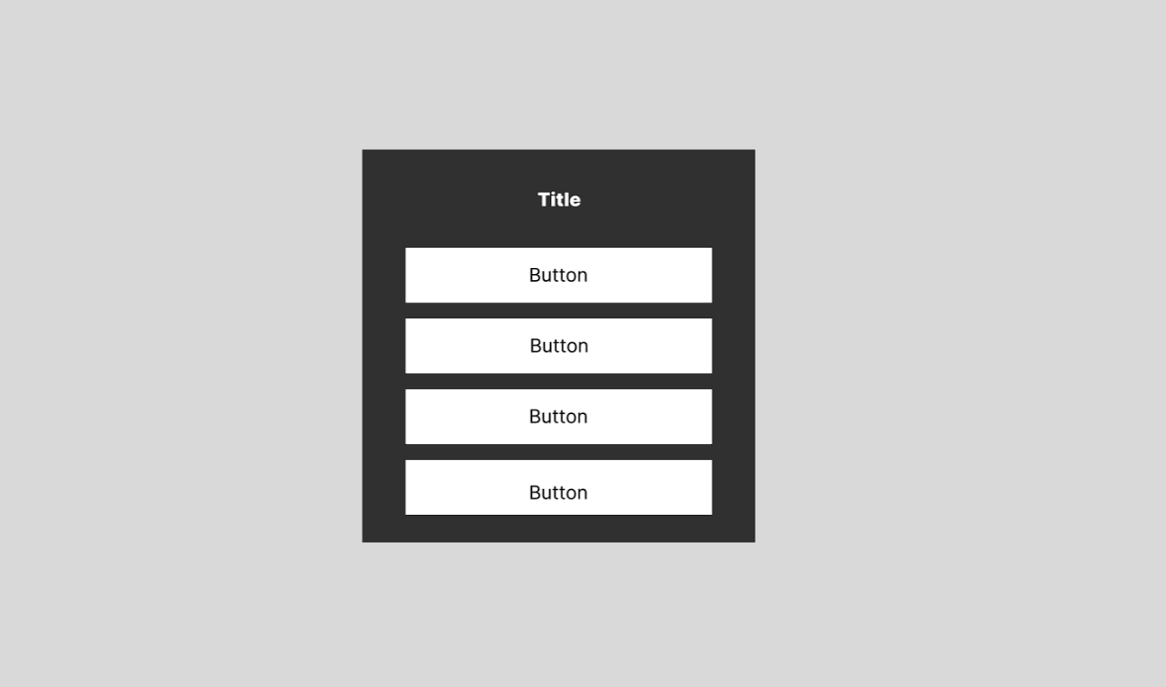

Figure 2: UI - Pause Screen

Title Screen

Figure 3: UI - Title Screen

## Timeline/Schedule

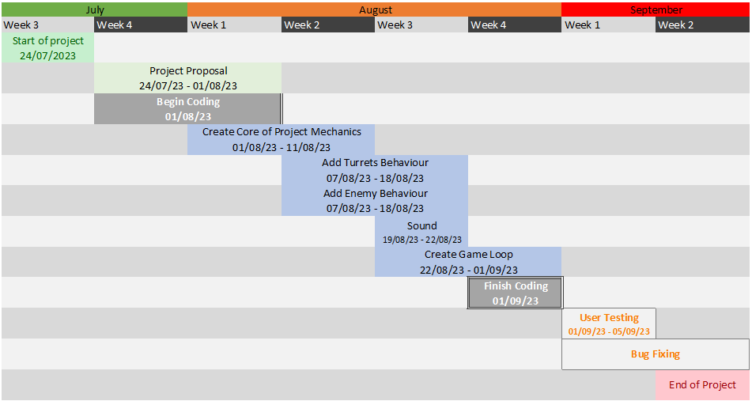

Figure 4: Timeline Gantt Chart

I have also included references to assets used in creating the prototype of this game.

**References**

*Abstract black texture background hexagon Free Vector*. (2021, September 23). Freepik. https://www.freepik.com/free-vector/abstract-black-texture-background-hexagon_18702139.htm#query=dark%20pattern&position=0

*Audiowide - Google Fonts*. (n.d.). Google Fonts. https://fonts.google.com/specimen/Audiowide

*Boldhead Font | Dafont.com*. (n.d.). https://www.dafont.com/boldhead.font

*Cartoon FX Remaster Free | VFX Particles | Unity Asset Store*. (2019, April 13). Unity Asset Store. https://assetstore.unity.com/packages/vfx/particles/cartoon-fx-remaster-free-109565

*Clean Vector Icons | 2D Icons | Unity Asset Store*. (2021, January 1). Unity Asset Store. https://assetstore.unity.com/packages/2d/gui/icons/clean-vector-icons-132084

*Customizable skybox | 2D Sky | Unity Asset Store*. (2020, August 31). Unity Asset Store. https://assetstore.unity.com/packages/2d/textures-materials/sky/customizable-skybox-174576

*Elemental Animations FREE | 3D Creatures | Unity Asset Store*. (2022, December 2). Unity Asset Store. https://assetstore.unity.com/packages/3d/characters/creatures/elemental-animations-free-227604

*Fatty Poly Turret Part2 | 3D Weapons | Unity Asset Store*. (2021, March 17). Unity Asset Store. https://assetstore.unity.com/packages/3d/props/weapons/fatty-poly-turret-part2-159985

*Gridbox Prototype Materials | 2D Textures & Materials | Unity Asset Store*. (2021, February 22). Unity Asset Store. https://assetstore.unity.com/packages/2d/textures-materials/gridbox-prototype-materials-129127

*Low Poly Brick Houses | 3D Exterior | Unity Asset Store*. (2020, December 7). Unity Asset Store. https://assetstore.unity.com/packages/3d/props/exterior/low-poly-brick-houses-131899

*Low Poly Cliff Pack | 3D Landscapes | Unity Asset Store*. (2016, November 29). Unity Asset Store. https://assetstore.unity.com/packages/3d/environments/landscapes/low-poly-cliff-pack-67289

*Low Poly Fence Pack | 3D Exterior | Unity Asset Store*. (2016, October 25). Unity Asset Store. https://assetstore.unity.com/packages/3d/props/exterior/low-poly-fence-pack-61661

*Low Poly Fire | Fire & Explosions | Unity Asset Store*. (2023, May 4). Unity Asset Store. https://assetstore.unity.com/packages/vfx/particles/fire-explosions/low-poly-fire-244190

*Low Poly Pack | 3D Environments | Unity Asset Store*. (2017, August 10). Unity Asset Store. https://assetstore.unity.com/packages/3d/environments/low-poly-pack-94605

*Low Poly Props | 3D Environments | Unity Asset Store*. (2016, December 26). Unity Asset Store. https://assetstore.unity.com/packages/3d/environments/low-poly-props-64233

*Low Poly Rock Pack | 3D Environments | Unity Asset Store*. (2016, November 29). Unity Asset Store. https://assetstore.unity.com/packages/3d/environments/low-poly-rock-pack-57874

*Low Poly Ultimate Home Pack | 3D Environments | Unity Asset Store*. (2020, August 31). Unity Asset Store. https://assetstore.unity.com/packages/3d/environments/low-poly-ultimate-home-pack-164671

*LowPoly Environment Pack | 3D Landscapes | Unity Asset Store*. (2017, October 10). Unity Asset Store. https://assetstore.unity.com/packages/3d/environments/landscapes/lowpoly-environment-pack-99479

*Low-Poly Simple Nature Pack | 3D Landscapes | Unity Asset Store*. (2020, May 16). Unity Asset Store. https://assetstore.unity.com/packages/3d/environments/landscapes/low-poly-simple-nature-pack-162153

*LowPoly Water | Particles/Effects | Unity Asset Store*. (2019, July 18). Unity Asset Store. https://assetstore.unity.com/packages/tools/particles-effects/lowpoly-water-107563

*Part 1.1: Who is playing games? | Pew Research Center*. (2019, December 31). Pew Research Center: Internet, Science & Tech. https://www.pewresearch.org/internet/2008/09/16/part-1-1-who-is-playing-games/#:~:text=Teens%20who%20game%20daily%20are,gamers%20are%20ages%2015%2D17.

*Simple Low Poly Nature Pack | 3D Landscapes | Unity Asset Store*. (2020, October 25). Unity Asset Store. https://assetstore.unity.com/packages/3d/environments/landscapes/simple-low-poly-nature-pack-157552

*Skeleton Animations FREE | 3D | Unity Asset Store*. (n.d.). Unity Asset Store. https://assetstore.unity.com/packages/3d/skeleton-animations-free-217504

*Skeleton Outlaw | Characters | Unity Asset Store*. (2019, August 6). Unity Asset Store. https://assetstore.unity.com/packages/3d/characters/humanoids/fantasy/skeleton-outlaw-130946

*Stylize Water Texture | 2D Water | Unity Asset Store*. (2022, June 12). Unity Asset Store. https://assetstore.unity.com/packages/2d/textures-materials/water/stylize-water-texture-153577

*Zombie Monster Animations FREE | Characters | Unity Asset Store*. (2023, July 16). Unity Asset Store. https://assetstore.unity.com/packages/3d/characters/humanoids/fantasy/zombie-monster-animations-free-259680