2307-BSE

Game Development - Project

CS205.2

Alexander Legner

# Document Outline

## Table of Contents

Document Outline 2

Table of Contents 2

Table of Figures 2

Table of Tables 3

Weekly Log 5

Week 1 5

Week 2 6

Week 3 6

Week 4 7

Week 5 7

Week 6 7

Week 7 8

Week 8 8

GitHub Tracking 9

Findings 14

Aim 14

Challenges Faced 14

User Testing 14

Conclusion 15

**References** 16

## Table of Figures

Figure 1: GitHub Repo 5

Figure 2: Dynamic Maze Generation 5

Figure 3: Levels 1-6 as a Cube 5

Figure 4: Main Menu UI 5

Figure 5: Glowing Cubes 5

Figure 6: Settings UI 5

Figure 7: Enemy with Health Bar 6

Figure 8: Health and Sprint HUD 6

Figure 9: Weapon Selection HUD 6

Figure 10: Ammo Example 6

Figure 11: Objectives HUD 6

Figure 12: Audio Files 6

Figure 13: Moving Cubes Level 7

Figure 14: Ammo Pickup 7

Figure 15: Minigun 7

Figure 16: Rising Lava Level 7

Figure 17: Level 1 Walls 7

Figure 18: Game Over HUD 7

Figure 19: Win Screen 8

Figure 20: Boss Level 8

Figure 21: GitHub Tracking 1 9

Figure 22: GitHub Tracking 2 10

Figure 23: GitHub Tracking 3 10

Figure 24: GitHub Tracking 4 11

Figure 25: GitHub Tracking 5 12

Figure 26: GitHub Tracking 6 13

## Table of Tables

Table 1: User Testing 14

Intentionally Blank

# Weekly Log

## A screenshot of a computer Description automatically generatedWeek 1

Figure 1: GitHub Repo

On week 1 I first created the GitHub Repo <https://github.com/ilexl/CS205> with two separate Unreal Projects to avoid merge conflicts at the beginning so both Alex Craig and I could work on the project quickly. I used a ‘.gitignore’ file specific to Unreal Engine products so no temporary files were unnecessarily added.

Alex Craig had created a maze generator for level 1/6 which dynamically created a maze at run time.

Figure 2: Dynamic Maze Generation

I created a level manager which spawned all the levels in dynamically at run time and added the ability for the levels to move around like a rotating cube depending on which level was going to be played.

Figure 3: Levels 1-6 as a Cube

I had an issue with the environment being too dark, so I created a light in the centre with random glowing cubes. This solved the issue and looked decent.

I added code which raised the player into the light when the level changed to prevent any unwanted physics which dropped the player into the void.

Figure 4: Main Menu UI

Figure 5: Glowing Cubes

I created a Main Menu and Settings UI from our Research and made them work in the project.

I made the graphics settings work and tested to make sure they were still working correctly even in deployment of the built version of the game.

Figure 6: Settings UI

Lastly, I created a temporary and blank HUD so I could work on it in the following week. This was a solid start to the project but, Alex Craig and I knew we had lot more to do in the following weeks.

## A colorful squares and rectangles Description automatically generatedWeek 2

Alex Craig created an item spawner to the maze level which randomly spawned items for now.

I created a health and spring system along with the UI to add to the HUD. The sprint

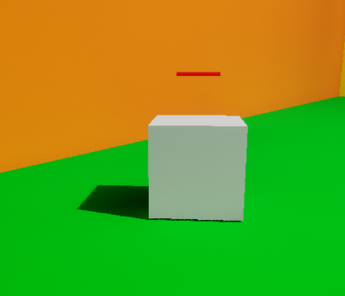Alex Craig added an item pickup blueprint which would allow for any item to be created with this and be picked up easily by a player.

Figure 7: Enemy with Health Bar

Figure 8: Health and Sprint HUD

I created a temporary enemy for development with. I added health systems to enemies along with a health bar for them so players could see how much health they had left.

I also created the second level where the player has to defeat a wave of enemies to proceed. The default gun you get in unreal was used to deal damage to the enemies as most of the code was already there for us to use so we didn’t remake a weapon.

I also decided to merge the project into one Unreal project instead of two. This created a merge conflict but was easy to resolve. This allowed us to work on the same game now and work more closer together.

## Week 3

I added weapon selection for the player so they can have more than one weapon. I added slots for 3 possible weapons including the default Unreal Engine gun, a minigun and a gravity altering gun. At this stage I only had the default gun working and had temporary place holders for the others

I also added ammo for the weapons so that the player was forced to go and collect ammo instead of just killing everything. I also added a reload sound for some audio feedback to the player when the gun reloads and misfires.

Figure 9: Weapon Selection HUD

Alex Craig created a moving cube level for level 3/6.

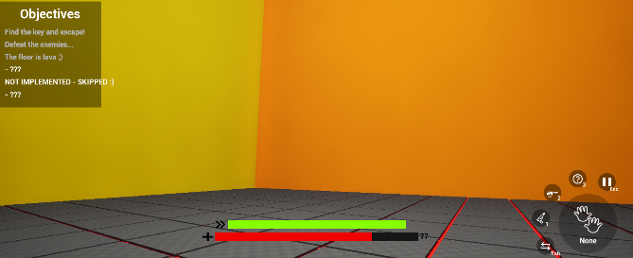I lastly added objectives to the game on the HUD which work with the levels as they are started and completed so the player has some idea on what to do.

Figure 10: Ammo Example

Figure 11: Objectives HUD

Figure 12: Audio Files

## Week 4

Alex Craig created a grid system for the moving cubes level 4/6 and made the cube move/hit each other in a grid like direction.

I created the AI for enemies so they can move around and shoot back at the player. I had an issue where I couldn’t dynamically create a van mesh for the AI so I eventually changed the levels to be already spawned in so the Nav Mesh could work.

Figure 13: Moving Cubes Level

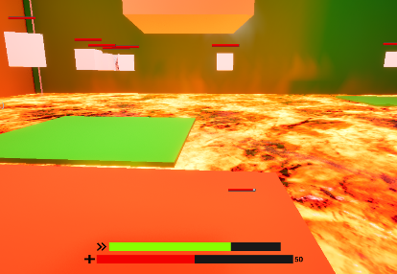I created a health and ammo pickup from the pickup blueprint made previously. The ammo adds a full mag of the weapon, I used the bullets as the visuals for the ammo pickup as I plan on having different bullets for the minigun.

I made enemies randomly drop a pickup when they die. It is a chance-based drop and not guaranteed.

Figure 14: Ammo Pickup

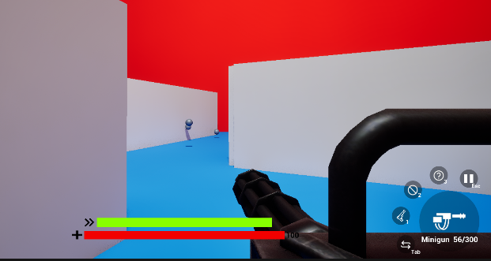I created a level where lava rises for level 3/6 and platforms that break if you stand on the too long with other platforms moving randomly around to hopefully jump on.

Figure 15: Minigun

Figure 16: Rising Lava Level

## Week 5

Alex Craig made cubes logic for them to move properly and added platform you can jump to keys.

I updated level 2 to make platforms breakable and move randomly and fixed some bugs related to it.

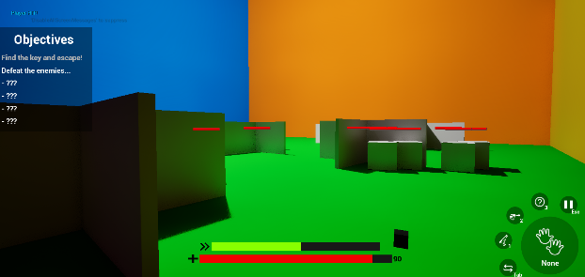I added a minigun as the second weapon the player can use instead of just having the standard gun.

I updated enemies AI so they can fire back at the player properly.

## Week 6

I fixed z fighting for the breakable platforms on level 3/6 by adding a small z offset between the platforms. Now they overlap with no issues.

Figure 17: Level 1 Walls

I implemented ammo for minigun with a new pickup based on its bullets.

I removed melee enemies due to the complexity and having no animations for them. Ranged enemies both worked well and didn’t need an animation.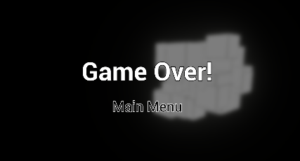

I added walls to hide behind on level 2 so the enemies can’t all shoot you at once and I changed level 2 enemies spawn from all at once to spawn over time.

Figure 18: Game Over HUD

Lastly, I added a game over HUD and logic.

## A screenshot of a video game Description automatically generatedWeek 7

Figure 19: Win Screen

I created a ‘You Win’ screen and added the logic for it when the game is won. Now the player could get back to the main menu.

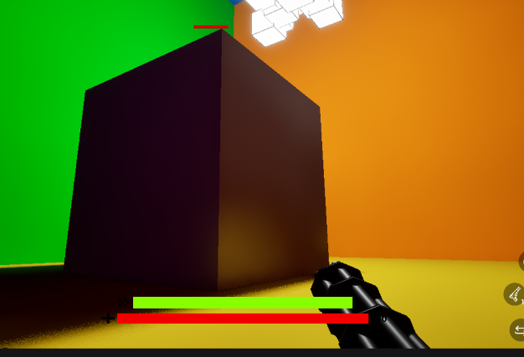I created a boss for level 6/6 with one large boss. Killing the boss wins the games.

Alex Craig added damage to moving cubes and added key pickups and logic for end of level 4/6.

Alex Craig created level 5/6 which means all the levels in the game were complete.

I did some finishing tweaks such as commenting code/blueprints and balanced the player’s/enemy’s damage.

Figure 20: Boss Level

## Week 8

We had a completed game by this point and spend most of this week finalising the report and presentation. We also did some user testing for the report and did some small bug fixes that were found from the user testing.

## GitHub Tracking

<https://github.com/ilexl/CS205>

Figure 21: GitHub Tracking 1

Figure 22: GitHub Tracking 2

Figure 23: GitHub Tracking 3

Figure 24: GitHub Tracking 4

Figure 25: GitHub Tracking 5

Figure 26: GitHub Tracking 6

# Findings

## Aim

The aim of this project was to answer the following question:

How can we increase engagement for a player in a shooter video game by refining or enhancing a core mechanic.

In further detail a shooter video game genre has various core mechanics. These include fast-paced movement – finding and using weapons – eliminating enemies – finding and using items – health system and compressive level design with progression. Could we increase engagement with a player by refining or enhancing one of these core mechanics in an FPS game without having to create a new core mechanic.

The core mechanic we chose to focus on was the puzzle element within a shooter game. We believed by making puzzles more complex and harder that we would make the game more enjoyable by pushing a player limit and making the player think about what they are doing instead of just spamming bullets.

## Challenges Faced

Time limitation – Due to only having 8 weeks to make the MVP we did not have enough time to get everything we wanted to implement put into the game. We created a MVP which can be considered a full game, but there is a lot missing that we would add/change if we had more time.

Limited graphics – We used simple graphics and assets to keep the game simple and easy to code. If we were to come back to this project or continue it in the future, then we would add more complex models and textures to make the game more polished.

GitHub – We had an issue with merging files on GitHub as the files are in Unreal Engine’s Binary Format and can’t be easily merged. This resulted in a lot of code being deleted when we merged and having to redo it before we could continue.

## User Testing

We got 5 random people to play test the game and give us the feedback they had for the game.

Table 1: User Testing

|  |  |  |
| --- | --- | --- |
| Person # | Comments | Rating #/10 |
| Person 1 | “The graphics are quite poor, and the gameplay is okay. The puzzles in the game make it quite difficult but was fun to play.” | 5/10 |
| Person 2 | “This was a fun and simple game! I especially liked the rising lava level, there were multiple aspects that I was forced to focus on to stay alive” | 7/10 |
| Person 3 | “The game is quite a simple concept and yet not easy at all. Some of the levels were fun and had interesting puzzles but some others were lacking in its originality.” | 5/10 |
| Person 4 | “Even though the graphics are quite simple, this game proves that games don’t need to look good to be fun. I practically enjoyed the puzzles of the game while being shot at by the enemies.” | 6/10 |
| Person 5 | “The game is quite enjoyable; from the time you said you had this is an enjoyable game with some unique puzzles and enemies.” | 8/10 |

## Conclusion

From the user testing we got some helpful feedback about the game with a mean rating of 6.2/10. The aim of this project was to create a shooter game and focus on improving the puzzles mechanics to improve player enjoyment. Given the limitations we faced, I believe the project was a success. We have a completed MVP which players tended to enjoy the puzzles within. Although with more time we could have polished up the game and added more features into the game, we still completed our objective by creating the MVP.

**References**

Ilexl. (n.d.). *GitHub - ilexl/CS205*. GitHub. https://github.com/ilexl/CS205