**Somali International University**

Faculty: Computer Science and Information Technology   
Department: Computer Science   
Subject: Oracle database   
Exam: Final Exam  
Shift: Part Time

Full Name: _________________________________________________

ID Number: ________________________________________________

**Part I: Write True or False**

1. Provides a design structure for executable units of code. Maintenance of code is made easier with such a well-defined structure[_________]
2. Integration of procedural constructs with SQL**:** Without PL/SQL, you would not be able to logically combine SQL statements as one unit[_________]
3. Declarative (optional): The declarative section begins with the keyword DECLARE and ends when the executable section starts[_________]
4. Begin (required): The executable section begins with the keyword BEGIN. This section needs to have at least one statement[_________]
5. Exception handling (optional): The exception section is nested within the executable section. This section begins with the keyword EXCEPTION[_________]
6. End (required): All PL/SQL blocks must conclude with an END statement. Observe that END is terminated with a semicolon[_________]
7. **Functions:** Functions are named objects that contain SQL and/or PL/SQL statements. Unlike a procedure, a function returns a value of a specified data type[_________]
8. **Procedures**: Procedures are named objects that contain SQL and/or PL/SQL statements e[_________].
9. **Anonymous** blocks Anonymous blocks are unnamed blocks. They are declared inline at the point in an application where they are to be executed and are compiled each time the application is executed [_________].
10. Executable (required): The required executable section begins with the keyword BEGIN and ends with END. This section essentially needs to have at least one statement[_________].

**Part II: Answer of the following Questions**

1. What is benefits of PL/SQL in oracle ?
2. Explain the below graphic?

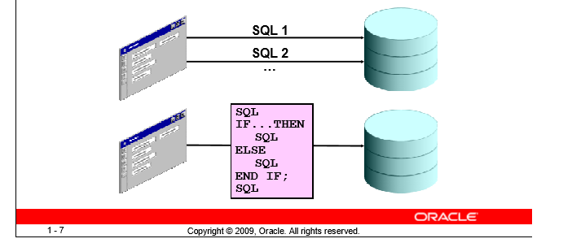

1. What is %TYPE Attribute and write code of type attribute?
2. Write Syntax of Anchored Data type.
3. How To Create, Declare, Initialize and Display Bind Variables in PL/SQL?
4. How to Declare a Bind Variable (Variable command)?
5. Tell Types of Variables in Procedural language ?
6. LIST ALL EMPLOYEES AND ADD 20 dollar IN EACH SALARY.?
7. LIST ALL 'ANALYST' AND ADD 250 RUPEES IN EACH SALARY?
8. CHANGE THE COLUMN HEADING ENAME INTO YOUR NAME AND DISPLAY IT.