New one doesn’t need to run something new to run your app

Diff Doc vs VM
VM can run diff app. But slow to start; each need OS license; CPU, memory need
Containers run multiple app; lightweight; use OS; start quickly; need less hw

Development
Docerfile – package app to image
Image – app files, environment and so on
Run app inside container
Docker registery – like github

Docker action
Run others app in your laptop: Start wth os; install nodel copy app file; run node app.js. however docker package everything

Dockerfile:
FROM node:alpine - Where to start. Which image. Go to dockerhub
COPY . /app – all the files into that image
WORKDIR /app – where is work directory, so you just write node app.js not node app/app.js
CMD node app.js – its inside app

Docker build -t hello-docker . - .means current directory
Now image stored.
Docker image ls – list all images

Docker run hello-docker – runn app

Publish it to dockerhub that everyone use
Go to Play with docker
Docker version
Docker pull codekdn/hello-docker – download image
Docker image ls -all img
Docker run codewith/hello-docker –

Ubuntu
Docker run ubuntu – pull from dockerhub
Docker ps – list of running containers
Docker ps -a – stop containers
Docker run -it ubuntu – interative mode
Echo hello
Echo $0 – loc of docker

Docker basic commands
docker pull docker/getting-started - Download image. Image name
docker images – show all imgs
docker run -d -p 80:80 docker/getting-started - deatach mode run container. Assigning port. Host environment and contrainer env is different. Host post80 – container port 80
docker ps – container that running
docker stop 220ekfek (container id) – stop container
docker image rm cbdfbjdf – remove image
docker image rm -f cbfjbekj – remove forcefully
docker run hello-world

Push Docker Image to Docker Hub

Docker login – type username and password
Docker images – show all
Docker image rm -f welcome-app – remove it
Docker build -t username/welcome-app . – build
Docker tag username/welcome-app username/welcome-app1 - rename image
Docker push username/welcome-app:latest – push img
Docker pull username/welcome-app:latest
Docker run -d -p 5000:5000 usrname/welcome-app:latest

Docker compose
Docker-compose.yml
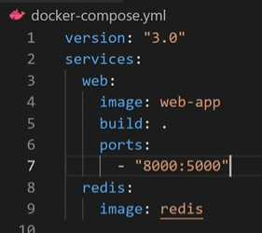
Docker compose up – run it
Docker compose stop – stop it
Docker images – see servies
Docker image rm -f fjja
Docker ps – see running container

