*Project Team Info Sheet*

Muhammet Ali Ilgaz (171805017)

Merve Cavlı (181805083)

Samet Solak (191805106)

***Phoenix Team***

About Phoenix Team:

We are a three person team that came together for desining and implementing software systems .We believe each other as the team because we have some knowladges about some different things in computers. We thougth these knowledges helps us when we are developing this projects. We are determined people. This is most important for project and project deadline. We think we will have a successful result. Our biggest common feature is that we are always open to learning and development. That is why we are strong together as a team.

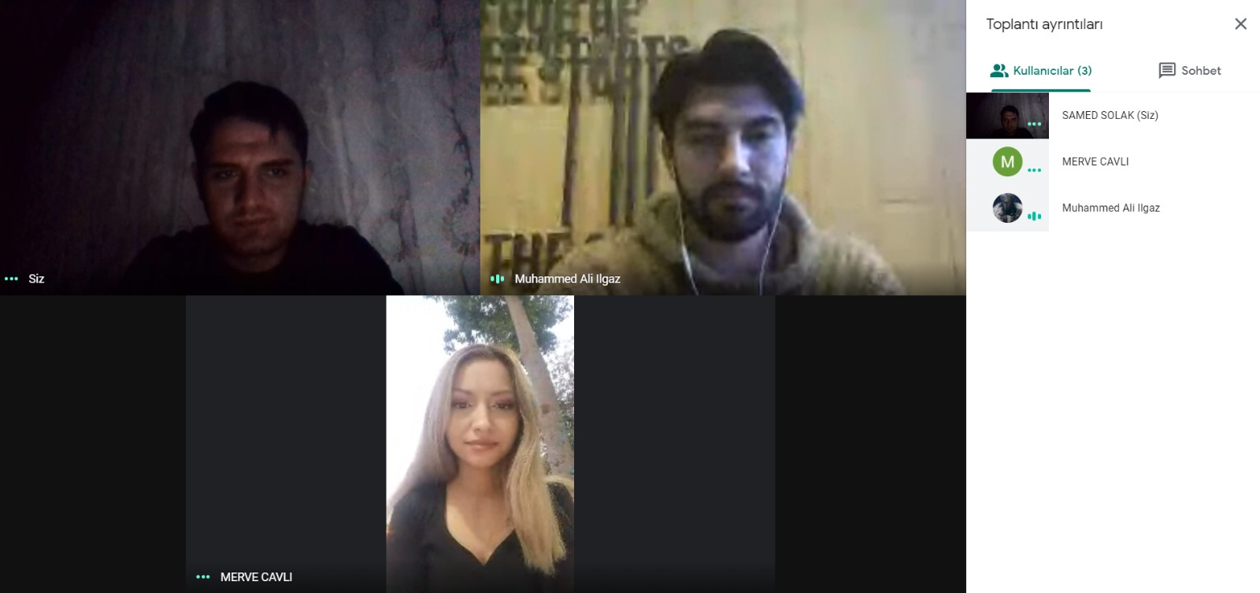

As it is seen in the picture, our meetings are 100% online.

Phoenix Team Members:

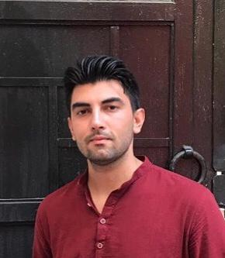

Muhammet Ali ILGAZ

(Main Contact for the Instructor)

I love pushing the limits all the time. Being successful is very important to me. For me, determination, struggle and work are always at the forefront. I like to be the best at what I do. There is no limit to knowledge, and in this context, I attach importance to improving myself at any time.

**Education and Qualitys**

**Spt 2017-June 2022:**

Computer Engineering / Adnan Menderes University, Aydın

-Working as a game developer in Happy Game Jam, Mobile Game Development event.

- Being a pioneer in the team with creative thinking and adapting to teamwork.

-To increase experiences on mobile game development

-Join to BİLMÖK, Bilgisayar Mühendisliği Öğrenci Kongresi (Yeditepe University-2017)

-Being innovative

**Spt 2011-June 2015:**

Hatice Sezer Anadolu Öğretmen Lisesi, Antalya

**Skills:**

-Java,

-C#

-Python

-Game Developer

-Unity

-Android Programming

**Languages:** English,Turkish

**GitHub account name:** ilgazali



**Skills:**

C#,

Java,

SQL,

PHP,

Selenium,

LeanFt

**Languages:** English, Turkish

**GitHub account name:** ss0lak

Samet Solak

My main goal was to be at the top of software branch, but it is not possible because I realized later that there is no person the best in this major. No matter how knowledgeable you are, you can always see and learn new things. I understood that I need to believe myself and work hard to be at the somewhere close the top even if I cannot be at the top. That's why I'm trying to do more than I can.

Education and Qualitys

**-Computer Engineering / Adnan Menderes University, Aydın**

**-Department of computer programming / Istanbul University, Istanbul**

**-Working with some test automations such as LeanFT, Selenium**

**-Working as a developer with different software languages especially C# for some projects**

**-Open for improvement and innovation**

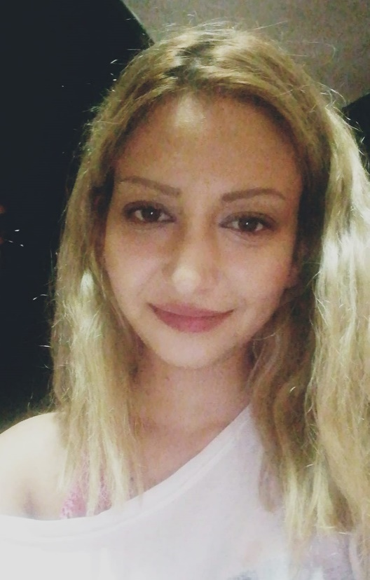

Merve CAVLI

Since i was a child I have always been a curious person. I can say that learning something new is my passion. I have never been a person who improves herself in only one certain field. I am a student of Computer Engineering department for now but I know that i will never be only an engineer. I will be a dancer, an actress, an archer and i can be anything at the same time. Believing myself makes me a successful person all the time. I trust myself, and i can be good at anything.

Education and Qualitys

**Spt 2017-June 2022:**

-Computer Engineering / Adnan Menderes University, Aydın

-Korean Language training from iienstitu.com / received a certificate.

-Championship award from Toros Collage Chess Tournament

-Join to BİLMÖK, Bilgisayar Mühendisliği Öğrenci Kongresi (Yeditepe University-2017)

-Being versatility

**Spt 2013-June 2017:**

İçel Anadolu Lisesi, Mersin

**Skills:**

-Java,

-C

-Python

-HTML5

-CSS3

**Languages:**

English,Turkish,Korean Language

**GitHub account name:** mervecavli

Team Agreement

* All group members will attend main meetings via Google Meet but in case of a need, any other means of communication can be used.
* Each team member should return to messages or calls sent to them in a timely manner.
* There will be a main meeting every two days and attendance is mandatory.
* Meetings will be held remotely due to covid-19.
* Each team member will present a status report at the meetings.
* Each team member will take jobs according to their interests and skills, and one person will be elected team leader by voting, and the selected person will be responsible for the distribution of tasks.
* Team members will submit their assigments at each meeting and the team leader will review them.
* If any team member is ineffective, the team member will be warned by the team leader and the other team members will take care of the disrupted work among themselves.