project proposal

**Merve Cavlı (181805083) Muhammet Ali Ilgaz (171805017) Samet Solak (191805106)**

Phoenix

Team

PHOENIX TEAM PROJECT: ART HOUSE ONLINE

“Online Education System”

In this essay, you will have an information about the project of Phoenix Team which is named as “Art House Online”.

Project Purpose

It is a well-known fact that; in the recent times, most people are afraid of going out of their house due to pandemic. Even if they take some risks for their vital needs, they cannot do the same things for their social life. To give an example; there are people who want to attend painting courses, dance courses and so on. Unfortunately, these are not easy like before. However, these things were not easy for some people who behave shy or who have no time for any activity because of their hours of labour or something different, before the pandemic. At this point, our purpose is to make something possible for these people. We believe that everyone should develop a hobby and that is the reason why “Art House Online Project” exists.

Project Goals

- Giving people a hobby.

- Generalizing art because it helps people.

- Enabling people to improve themselves during the pandemic.

- Enabling teachers to reach more students.

Overall Functionalities of the Project

“ArtHouseOnline” is a website that can be used by everyone, easily. There are so many course options on the website such as dance, painting, music; and there are subbranches for them too. For example; for a user who choses dance course, there will be nine kinds of dance he or she can chose. To be able to do this, user has to sign up our website first. Then, the user can search courses or instructors and find what he/she wants. User can watch a preview for free. The course can be free or paid-for. It is up to the instructor. If the course is paid-for, user can pay by credit card safely, and get the whole course videos forever. Also, if user wants to take the course later, he/she can add the course to “favorites” not to forget it.

On the other hand, there are two “sign up” types on our website: sign up as a trainee and sign up as an instructor. If an instructor wants to teach courses on ArtHouseOnline, the instructor needs to sign up and add a CV (preferably with a video) to prove that he/she can teach someting on our platform. After the instructor gets a mail that shows he or she is accepted, the instructor can start to add course videos and put a price for the courses. It is important to have a good profile photo, preview and biography for instructors to be preferred.

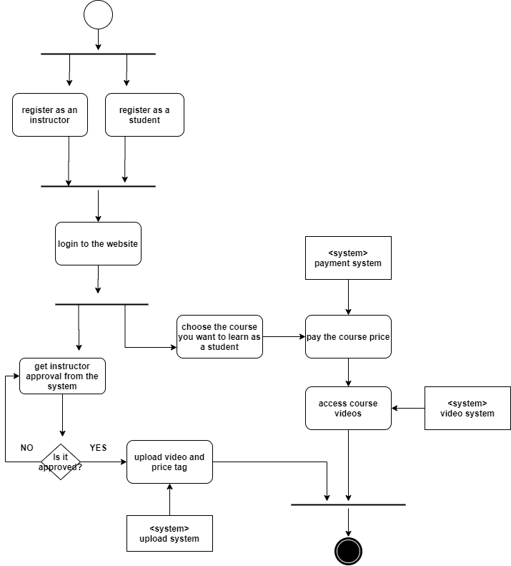Main Components of the System

As shown in the figure on the left, we divided the system into logical components and tried to explain the main processes simply.

As a summary, we believe that art is for everyone and everyone needs art. That is why, we do not want any reason to separate art and people, so we started to this project. We hope that our website will be helpful for people but it is good to remember that “it is better to travel hopefully than to arrive.”