


پروژه پایانی سیالات 1
برسی پمپ های گریز از مرکز

تهیه کننده : ایلقار مرادی 40326023

استاد گرامی:دکتر مشایخ
تدریس یار: مهندس محمدی

خرداد 1405

Symbol | Description | symbol | Description
D or $ϕ$ | Impeller diameter | $$ρ$$ | density
$$g$$ | Gravitational acceleration | $$γ$$ | Specific weight
H or $H_{pump}$ | Pump head | $$V$$ | Velocity
CV | Control volume | A | Area
CS | Control surface | $$ν$$ | volume
Q | Flow rate | $$τ$$ | Shaft torque
$$ω$$ | Shaft angular velocity | $$η$$ | Efficiency
$$P_{hyd}$$ | Hydraulic power | $$P_{mech}$$ | Mechanical power
$$N_{s}$$ | Specific speed | $$\dot{m}$$ | Mass flow rate
List of Symbols:

Introduction: this project provides calculations for specific speed, head gain, hydraulic power and total pump efficiency for datasets 1 and 2 given by the project file.
Also, the project is extended to select a suitable pump from the catalog provided with flow rate and head as input, also the MATLAB program gives pump diameter, efficiency and electric motor power for the selected pump.
1. Case study:
a) conservation equations for the control volume:
conservation of mass:
$$\frac{d}{dt}\int_{CV}{ρdV}+\int_{CS}{ρ\left(\vec{V}.\vec{n}\right)dA} =0 \underset{→}{steady flow} ρA_{1}V_{1}= ρA_{2}V_{2} (eq 1)$$
Conservation of linear momentum:
$$\sum{F}= \frac{d}{dt}\int_{CV}{ρVdν}+\int_{CS}{ρ\left(\vec{V}.\vec{n}\right)dA}=\dot{m}\left(V_{2}-V_{1}\right) \left(eq 2\right)$$
Conservation of angular momentum:
$$\sum{M}= \frac{d}{dt}\int_{CV}{(r× V)ρdν}+\int_{CS}{(r× V)ρ\left(\vec{V}.\vec{n}\right)dA}=\dot{m}\left({r× V}_{2}-{r× V}_{1}\right) \left(eq 3\right)$$

conservation of energy (Bernoulli Equation):
$$H_{pump}+ \frac{P_{1}}{ρg}+\frac{V_{1}^{2}}{2g}+z_{1}=\frac{P_{2}}{ρg}+\frac{V_{2}^{2}}{2g}+z_{2} (eq 4)$$
$$P_{hyd}=γQH_{pump} (eq 5)$$
b- in this section a brief Description of the parameters listed in the project file is given:
- Hydraulic power: The rate at which the pump delivers energy to the fluid. Only This power has direct relation with the $H_{pump}$ (refer to eq 4 and eq 3)
- Mechanical power: The rate at which the motor of the pump delivers energy to the pump impeller. (N: rotational speed RPM)
$P_{mech}= τ.ω →τ.\frac{2πN}{60} (eq 6)$
- Pump head: This is the total energy added to the fluid expressed as column of water.
From angular momentum conservation inside the impeller, the theoretical head an ideal impeller can produce is:
$$H_{Euler}=\frac{ω}{g}\left(r_{2}V_{t2}-r_{1}V_{t1}\right) (eq 7)$$
- Specific speed: a parameter that classifies the type of pump — not its size. It tells you the shape of the impeller that is best suited for a given combination of head and flow rate. This parameter is used to compare pumps and find the best suited pump for a specific application

$$N_{s}=\frac{N\sqrt{Q}}{H^{3/4}} (eq 8)$$
- Hydraulic efficiency of the pump: the ratio of mechanical power and the desired Hydraulic power.
$$η_{hyd}=\frac{P_{hyd}}{P_{mech}}=\frac{γQH_{pump}}{τ.\frac{2πN}{60}} (eq 9)$$

- Overall (total) efficiency of the pump: the ration of power supplied to pump and the desired Hydraulic power.
$$η_{t}=η_{motor}×η_{mech}×η_{hyd}$$

2. calculations for Dataset1: hydraulic parameters listed in introduction section of this report have been calculated for a flow rate of 800 gpm and calculations are extended to cover the full dataset. calculated results have been plotted and poly fitted to better analyze the behavior of each parameter with respect to flow rate.
Flow rate (gpm) | Suction pressure (psig) | Discharge pressure (psig) | Motor Current (amp)
0 | 0.65 | 53.3 | 18
500 | 0.25 | 48.3 | 26.2
800 | -0.35 | 42.3 | 31
1000 | -0.92 | 36.9 | 33.9
1100 | -1.24 | 33 | 35.2
1200 | -1.62 | 27.8 | 36.3
1400 | -2.42 | 15.3 | 38
1500 | -2.89 | 7.3 | 39

Assumptions:
- Constant specific weight for water with changes in altitude and pressure
- Constant nominal speed N = 1750 rpm
Parameters calculated for Flow rate = 800:
Flow rate (gpm) | $$N_{s}$$ | $$H_{pump}$$ | $$P_{hyd}$$ | $$η_{pump}$$
800 | 1545.44 | 101.713 | 15.2932 | 78.62%

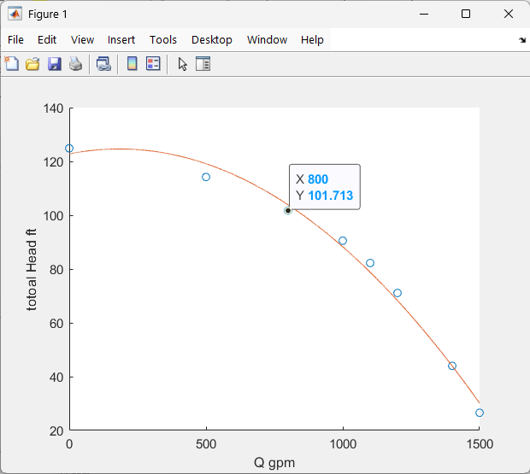
Plotted data:
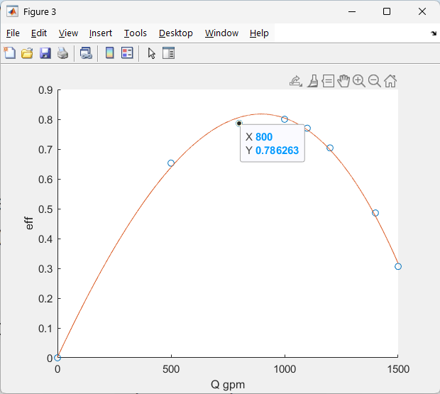
Figure 2- $η$ vs flow rate

Figure 1- total head vs flow rate
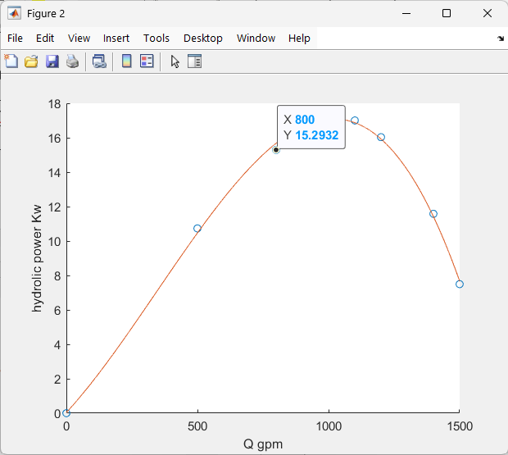
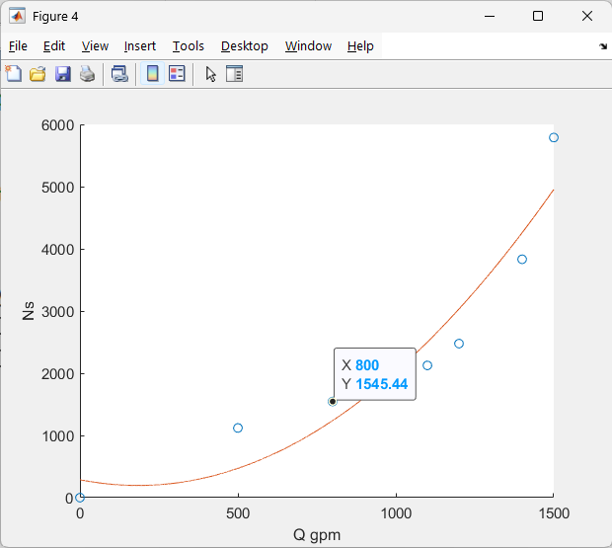
Figure 3 hydraulic power vs flow rate
Figure 4- specific speed vs flow rate

analyzing the behavior: as shown in Figure 1 increase in flow rate of the pump causes lower head gain in higher flow rate values and maximum head of the pump occurs at Q = 0 (shutoff condition) and with the maximum flow rate the head gain of the system drops to 26.584ft. Figure 2 has characteristics of a bell shaped curve with maximum efficiency (BEP ) of 81.74% accruing at around 892 gpm after this point the efficiency of the system drops duo to several reasons including higher friction in higher flow rates, turbulence and cavitation.
By increase in flow rate The head gain decreases slowly at first ($0≤Q≤≈850$) (shown as the tangent line to the graph). By referring to eq 5 we can see $P_{hyd}∝H_{Pump}×Q$ so small decrease in $H_{pump}$ and large increase in flow rate makes the Hydraulic power increase. After point $Q≈850$ the decrease in $H_{pump}$ increases so that after this point the Hydraulic power starts to decrease.
The rate of specific speed increase is relatively low at first due to large head, but by increase in flow rate and the decrease in head gain causes the increase in rate of specific speed increase.

Calculations for dataset 2: calculations done for dataset 1 are repeated for this dataset in addition to first dataset, mechanical power is also calculated for this dataset.
Torque (N.m) | Flow rate (L/min) | Suction pressure (bar) | Discharge pressure (bar) | Motor Power (kW)
2.1 | 254 | -0.08 | 0.06 | 0.52
2 | 228 | -0.07 | 0.11 | 0.5
1.9 | 197 | -0.05 | 0.18 | 0.48
1.7 | 163 | -0.04 | 0.25 | 0.46
1.8 | 177 | -0.05 | 0.21 | 0.47
1.7 | 155 | -0.04 | 0.25 | 0.45
1.5 | 127 | -0.03 | 0.29 | 0.42
1.5 | 129 | -0.03 | 0.29 | 0.42
1.4 | 99 | -0.02 | 0.32 | 0.4
1.2 | 75 | -0.02 | 0.34 | 0.38
1.1 | 50 | -0.02 | 0.35 | 0.36
1 | 27 | -0.01 | 0.36 | 0.33
0.9 | 2 | -0.01 | 0.36 | 0.31
Assumptions:
- Constant specific weight for water with changes in altitude and pressure
- Constant nominal speed N = 1100 rpm
Parameters calculated for flow rate = 197(L/min):
Flow rate (l/min) | $$N_{s}$$ | $H_{pump}$(m) | $P_{hyd}$(W) | $P_{mech}$(W) | $$η_{pump}$$
197 | 33.1926 | 2.3515 | 75.5167 | 218.864 | 15.73%
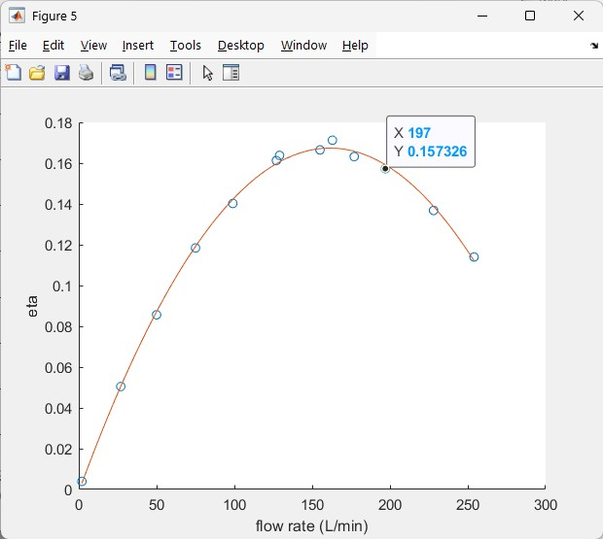
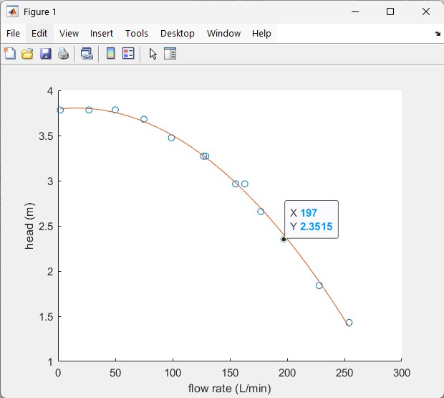
Plotted data:

Figure 6- $η$ vs flow rate
Figure 5- total head vs flow rate
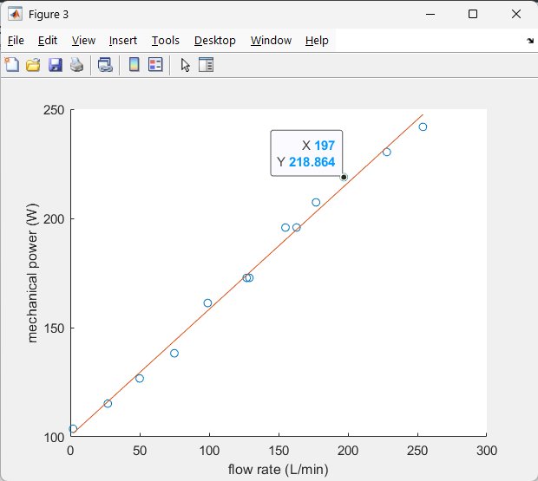
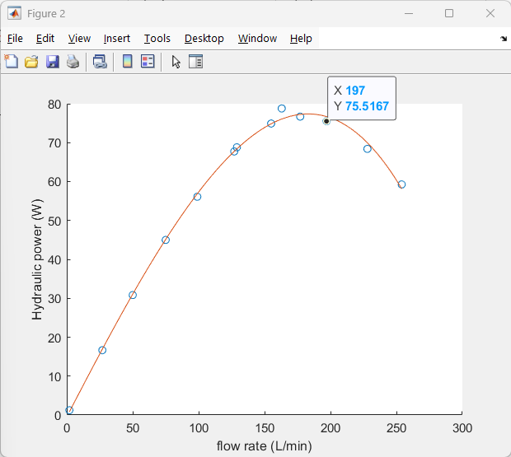

Figure 9- mechanical power vs flow rate
Figure 8 hydraulic power vs flow rate
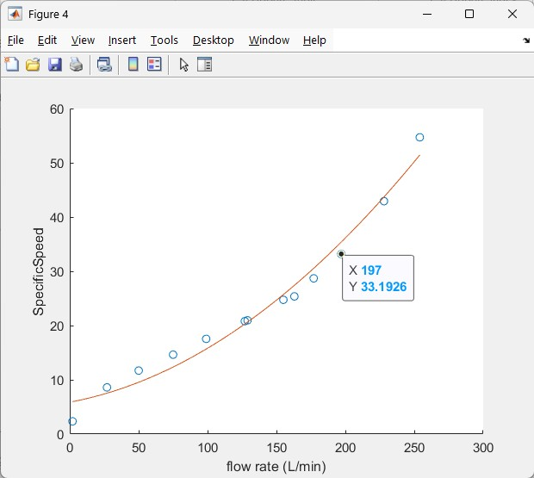

Figure 7- specific speed vs flow rate

analyzing the behavior: behaviors of graphs shown in Figures 5, 6, 7, and 8 are the same as dataset 1 (refer to behavior analysis of dataset 1).
Mechanical power as graphed in Figure 9 seems to have a linear relation with flow rate. This is also observed from the data table and the semi-linear relation between Torque and flow rate. And from equation 6 we have $P_{mech}=τ.\frac{2πN}{60}$ so by increase in flowrate the $P_{mech}$ grows linearly.

Pump selection: the project is extended to automate pump selection for given flow rate and required head.
First the graph on page 5 of provided catalog is digitalized using Plot Digitizer software and the extracted data is stored in MATLAB as matrices. by searching in these matrices, the program can select right pump. After pump selection the program identifies Impeller diameter, pump efficiency at the operating point and required electric motor power which their data are digitalized using the same software.
Few examples of the program are given below note that $P_{motor}$ is the minimum electric power and the actual power must be chosen higher value than what program reports (refer to page 3-section 4 of the pump catalog).
Q ($\frac{m^{3}}{h})$ | Head (m) | selected pump | $$ϕ$$ | $$η (\%)$$ | $P_{motor}$(kW)
28 | 34 | Pump 40-160 | 169 | 66 | 4.6
10 | 20 | Pump 32-125 | 130 | 59.42 | 1.35
25 | 15 | Pump 40-125 | 125 | 67.61 | 1.14

Conclusions: This project reflects the relations between the hydraulic parameters and flow rate of the pump. As shown in Figures 2 & 6, pump efficiency has a peak point which corresponds to the BEP. Also, observing that, keeping N constant, head gain drops as flow rate increases.
By analyzing the trends and plots shown in this report an engineer can select and optimize pumps based on head and flow rate of the project and find the BEP for pumps and helps who desire to study behavior of each pump.
This project required extracting and importing experimental data from catalog and converting that raw data into usable plots and maps so finally an engineering decision could be made based on that data.

Used resources:
- Pump Iran: centrifugal pump catalog
- White, F. M. (2016). Fluid mechanics (8th ed.). McGraw-Hill Education - chapter 3
- Wikipedia.org – specific speed

Revolutions Per Minute
Best Possible Efficiency
Beware that digitized data is human generated and could be inaccurate.
Note that this project has used LLMs like claude.ai and Deepseek.com as helping hand

