Mapster

Project Checkpoint



Irma Lam, Lauren Dunn, Clarissa Soon

**Accomplishments:**

1. Ranking score of 10 predefined countries based on news from three APIs: New York Times, USA Today, and Bing. The basic scoring algorithm uses term frequency and different weights for the keywords depending on their severity. We defined 6 different categories:

1) Politics and religious

2) Natural Disasters

3) Epidemics

4) Crime and terrorism

5) Nuclear

6) Other

1. Intensity Map showing different color shades for countries with different scores

Light Green (safer) → Dark Green (less safe)

1. Basic User Interface for Website

Screenshots:

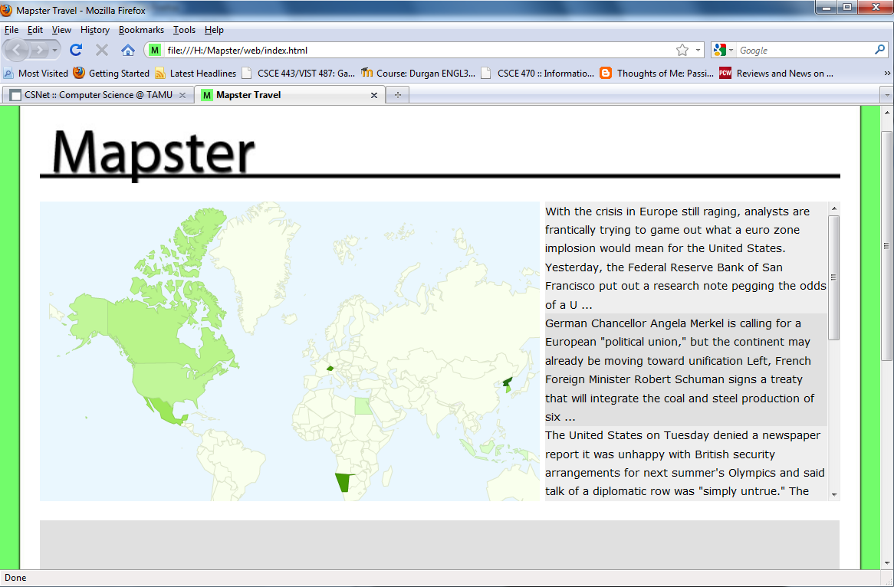

Basic User Interface for our website and Intensity Map based on score

Light Green (safer) → Dark Green (less safe)

Shows World Map (with intensity based on “safety” scores). Countries that are not in shades of green are not considered currently. Clicking on a country brings up the country name and the score. The text on the right will be news snippets from the news API that contributed the most to the “safety” score. (Since we have not fully integrated the back end, current text is just random news snippets)  
  
We are using Google’s Fusion Table to display our Intensity/Heat Map based on “safety” scores.  
  
**Conclusion**  
Overall, we accomplished our goals stated in our checkpoint, although we still need to improve on our scoring algorithm to get more accurate scores.