**Quiz 2 Basis Data**

**Nama anggota kelompok:**

1. **Ilham Akbar (** [**ilhamakbarkajen12345@gmail.com**](mailto:ilhamakbarkajen12345@gmail.com) **)**
2. **Arief Tri Hendrayanto (** [**andiarif122@gmail.com**](mailto:andiarif122@gmail.com) **)**
3. **Linati Khairina Syarofah (**[**Alinlinati@gmail.com**](mailto:Alinlinati@gmail.com) **)**
4. **Alvaro Rayhan R. (**[**Alvarorayhan99@gmail.com**](mailto:Alvarorayhan99@gmail.com) **)**
5. **Brando Mikardoni R. (**[**mrbrandomr7@gmail.com**](mailto:mrbrandomr7@gmail.com) **)**
6. **Gigas Jouhan A. (**[**Gigasjouhan@gmail.com**](mailto:Gigasjouhan@gmail.com) **)**
7. **Boy Diva Sena (**[**odka781@gmail.com**](mailto:odka781@gmail.com) **)**

**Soal Quiz**

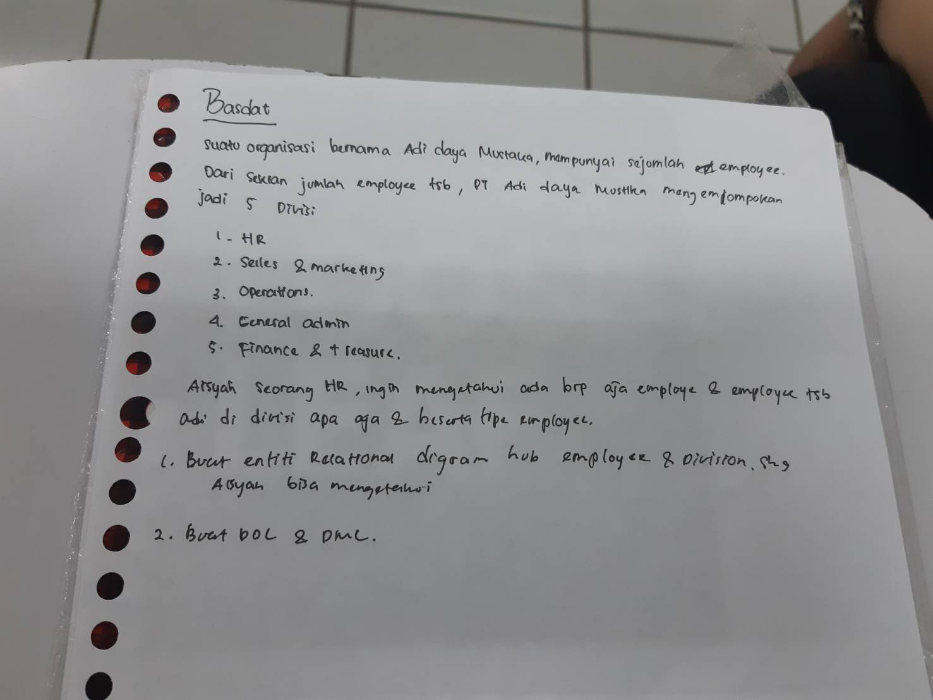

**Jawaban :**

1. ER-Diagram

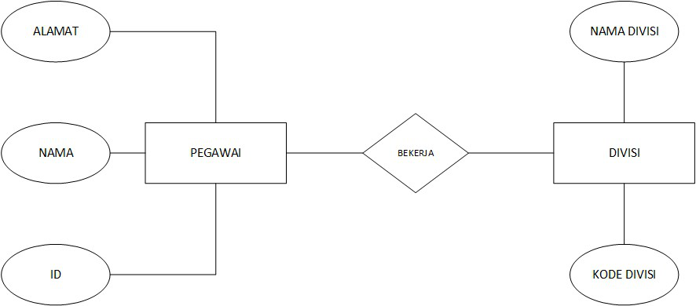

1. DDL dan DML

DDL:

* create table employee (ID char(10) primary key, nama_employee varchar(20), alamat varchar(25))
* create table divisi (nama_divisi varchar(20), kode_divisi char(4))

DML:

* insert table employee (ID char(10) primary key, nama_employee varchar(20), alamat varchar(25))
* insert table divisi (nama_divisi varchar(20), kode_divisi char(4))
* select nama_employee

from employee

where kode_divisi

select count nama_employee