TP_MOD_2_2311104068_ILHAMLIIASSIDAQ

1. 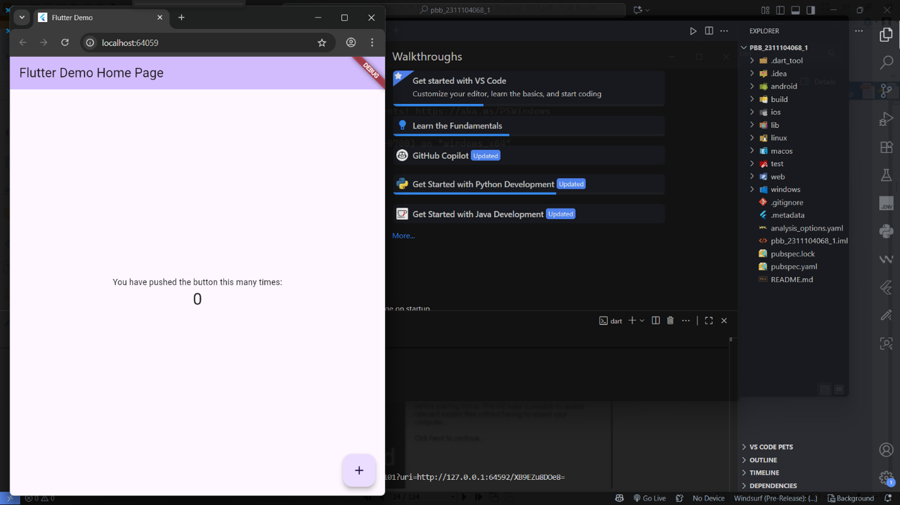A black cell phone with a blue box and a blue box with text

   AI-generated content may be incorrect.