**Optimization of Resource Allocation and Task Allocation with Project Management Information Systems in Information Technology Companies**

Ilham Nur Pratama1 , Muhammad Dachyar2*, Novandra Rhezza Pratama3

Department of Industrial Engineering, University of Indonesia, Kukusan, Kecamatan Beji, Kota Depok, Jawa Barat 16424

[Ilham.nurpratama@gmail.com1](mailto:Ilham.nurpratama@gmail.com1), [mdachyar@yahoo.com](mailto:mdachyar@yahoo.com) 2, [novandra@ui.ac.id](mailto:novandra@ui.ac.id)3

*Abstract –* This study explores how to design an integrated Resource Allocation and Task Allocation Optimization System (RATAOS) using Enterprise Architecture (EA) to improve project management efficiency. By integrating PMIS with the optimization system designed using a random forest model and NLP, the system optimizes resource and task allocation, reducing operational costs by 14% and planning phases by 88.7%. Project completion time increased by 50.80%, demonstrating the effectiveness of the integrated system. Overall, this study highlights the potential of utilizing EA to design an integrated optimization system, improve project management efficiency, and reduce operational costs.

*Keywords –* Project Management Information System; Enterprise Architecture; Decision making; Project Human Resource Management

DOI: 10.18421/TEMxx-xx

<https://doi.org/10.18421/TEMxx-xx>

**Corresponding author:** Muhammad Dachyar,

*Department of Industrial Engineering University of Indonesia*

**Email:** mdachyar@yahoo.com

*Received: -----.*

*Revised: -----.*

*Accepted: -----.*

*Published: -----.*

Description: Description: Description: Description: Description: Description: Description: by-nc-nd-.png© 2023. ----; published by UIKTEN. This work is licensed under the Creative Commons Attribution-NonCommercial-NoDerivs 4.0 License.

1. The article is published with Open Access at <https://www.temjournal.com/>

# Introduction

In today's highly competitive business environment, organizations are constantly seeking ways to improve their operations and increase their efficiency. Project management is an essential part of this process, as it enables organizations to plan, execute, and control their projects effectively. Figure 1 shows the data of information technology company related to why project being late [1]. The reason projects are late is most often due to an incompetent project manager, an organization doing more than one project, and a limited project budget. Also, another thing that impacts the project completion time is unsupported project software, poor human resource management, limited governance implementation, limited risk management, and changing scope frequently. This kind of condition is usually called the resource-constrained multi-project scheduling problem.

The resource-constrained multi-project scheduling problem (RCMPSP) is a well-known challenge faced by organizations in project management. RCMPSP is the problem of allocating limited resources to a set of projects with the objective of minimizing project duration or cost while considering resource constraints and project interdependencies. [2], [3]. The RCMPSP is an NP-hard problem, which means that it is computationally difficult to solve optimally for large-scale instances [3]. Therefore, there is a need for a more efficient way of allocating resources to multiple projects.

Figure 1 Reasons why project late

PMIS is a critical tool for project management, which helps organizations to manage and monitor their projects' progress in real-time [4], [5].

PMIS has proven to be a useful tool for managing projects, especially when it comes to managing resources, scheduling, and workload allocation [5], [6]. However, there are still some challenges that organizations face when using PMIS, particularly when it comes to managing multiple projects with limited resources[7].

To address this challenge, this research proposes to integrate other systems with PMIS to optimize resource allocation and workload distribution. One such system is Natural Language Processing (NLP), which is a branch of artificial intelligence that helps computers understand, interpret, and generate human language.[8]. NLP can be used to analyze and extract information from project documents, such as project charters, scope statements, and the words of the project manager, to assist project managers in making better decisions regarding resource allocation.[9].

Another system that can be integrated with PMIS is Random Forest, which is a machine learning algorithm that can be used to predict project outcomes based on historical data [10], [11]. Random Forest can be used to predict the resource requirements for future projects based on historical data, such as the size, complexity, and duration of past projects. This can help project managers allocate resources more effectively, reducing project duration and costs.

The integration of NLP and Random Forest with PMIS can provide project managers with valuable insights into resource allocation and workload distribution [5], [12]. NLP can assist project managers in determining which tasks need assistance in resource and task allocation, while Random Forest can help them predict resource requirements and project outcomes based on historical data. Together, these systems can help project managers make more informed decisions regarding resource allocation, reducing project duration and costs.

This paper in detail will discuss in the first section overview and literature review of RCMPSP problems that occurred in Information Technology, how PMIS already help the existing problem, and why PMIS still not fulfill the need of work and resource allocation. The second section will discuss more about the overview and literature review of related knowledge that is used in this research. The third section will discuss how this research carries out until it can conclude that the proposed solution will give the desired result. The fourth section will discuss the design process of a system NLP and Random Forest system design to help work and resource allocation [11]. This research uses enterprise architecture to capture the enterprise condition and then model the proposed solution to fill the gap inside the organization [13]. The existing process of the project management process group will also be described using Business Process Modeling Notation (BPMN) to help clarify the existing conditions. The fifth section will discuss the testing phase of the designed system and how it can fulfill the needs of the project manager to allocate work and resources, speed up the process, and reduce the operational cost.

# Overview and Literature Study

## Project Management Information Systems

During project implementation, project managers use a tool to facilitate the project management process across all project management process groups called the Project Management Information System (PMIS). PMIS is a tool that an organization uses to generate, store, and manage project data in pursuit of optimal project performance [5] PMIS generally has several main functions that can assist project managers [4], [5] which are scheduling software, a project cost control tool, a project resource control tool, and a project documentation information system.

Another function of PMIS is performance management and project portfolio management. Performance management is a human resource management practice to evaluate resources based on criteria entered into the system [14]. Manual project performance management uses methods such as key performance indicators (KPIs), a balance scorecard (BSC), and the European Foundation for Quality Excellence Model. However, these performance management methods have limitations, as the measured performance is not real-time [15].

When performance management is integrated with artificial intelligence in PMIS, it allows for data-driven performance management. PMIS is used as a performance management system, which is a complex system used to measure both qualitative and quantitative human resource performance and assist in decision-making related to resource utilization [16].

## Enterprise Architecture

The information system in a corporate environment has a different complexity compared to the general information system. In a corporate or enterprise information system, there are integrated systems, many interconnected processes, and hierarchies. To solve problems and design enterprise information systems, there is a method known as enterprise architecture (EA). EA is a method and principle that links the functional objectives of a business with the use of information technology and information system strategies to achieve business value [17]–[19]. EA shows the structure of a company and its systems, which consist of corporate goals; organizational structure; Information structure and hierarchy; business processes that are running.

The Open Group Architecture Framework (TOGAF) is a standard enterprise information system framework that has almost all the components of other architecture development methods [17]. The architecture development method of TOGAF consists of several phases [17], which are Preliminary phase; Determining architecture vision; Business planning; Information system planning; Planning for the technology to be used; Study of opportunities and solutions that can be resolved, Planning for service migration mechanisms; Implementation of established policies; Mechanisms for change management; Requirement management

TOGAF has an Enterprise Architecture modeling language called ArchiMate [13], [17]. By using ArchiMate, a design can be described generally and can depict the conditions of [13], [17]:Business; Applications; Technology; Strategy; Motivation.

## Business Process Management

Business process is a sequence of activities that a company performs to achieve a particular goal [20], [21]. It is important to manage these processes to ensure the efficient achievement of the desired objectives and customer satisfaction. The management of business processes is called Business Process Management (BPM), which includes analyzing, designing, implementing, and continuously developing these processes [21]. BPM involves policies, strategies, methods, technology, and people to support the management of business processes. There are two main phases in BPM's development process, namely process development and process reengineering. Process development aims to improve or innovate current business processes for sustainable development, while process reengineering challenges and tests the current processes to meet desired needs.

BPMN is a tool that is utilized to depict a business process that exists inside a process [22]. It is a business process modeling tool that is commonly used in industries that practice agile software development [22]. A business process is marked with a start and end sign and contains process components and decisions that illustrate how a business can function.

When it comes to business process management, there are several best practices that can be implemented to achieve a management process that aligns with existing standards [23], [24]. Some of the commonly used business process management practices include task elimination, task composition, integral technology, empowerment, order assignment, resequencing, specialist generalist, integration, parallelism, and numerical involvement [23], [24]. These best practices should be considered when designing processes to determine the necessary improvements.

## Machine Learning in Decision Making

Artificial Intelligence (AI) has become one of the tools used to help solve modern problems that cannot be solved by previous solutions. AI can be defined as the ability of an artificial system to mimic the intelligent functions possessed by humans [9]. Artificial intelligence (AI) is the scientific umbrella that underpins machine learning and deep learning. AI assists project managers in assigning tasks based on the abilities of the individuals working on them [25].

Machine learning (ML) is a type of artificial intelligence that enables a system to learn from training data rather than programming a predetermined model from scratch [9]. There is several machine learning available at this time, but one will be discussed in this research are Natural Language Programming (NLP) and Random Forest. The rationale for selecting these two machine learning techniques for this research lies in the expectation that the proposed system will possess human-like language abilities while simultaneously interpreting data in a machine-like manner. Specifically, natural language processing (NLP) offers the capability to recognize regular expressions within a sentence and convert them into a desired set of words. In contrast, Random Forest employs a combination of multiple decision tree models to generate highly precise predictions based on the training data, thereby ensuring the validity of the results across a variety of scenarios.

# Research Methodology

This research starts with a literature study and data gathering related to existing PMIS to see how PMIS already helps project managers optimize workload and resource allocation and if there are any holes to fill with this research.

Based on the literature from Table 1**,** It has been explained how PMIS is used to assist project managers in project management. It is known that among the PMIS available in the market, they still cannot accommodate the needs of project managers related to dynamic work and resource management. Therefore, project managers combine several PMIS to solve dynamic project management problems. However, there is no research yet on the development of PMIS to solve specific problems related to work management and resource allocation management.

Table 1 Literature review of PMIS and how PMIS use for task and resource allocation.

|  |  |  |  |
| --- | --- | --- | --- |
| **Title** | **Year** | **Goal** | **Findings** |
| Smart Project Management Information Systems (SPMIS)  for Engineering Projects – Project Performance Monitoring  & Reporting | 2021 | The purpose of this research is to see how organizations implement PMIS in various industries. And look at the best practices for using SIMP in each industry [5] | It is known that almost all existing PMIS’ have advantages and disadvantages, especially to fill the needs of task management and resource management. Practitioners generally integrate several PMIS’, to meet the needs of the project [5] |
| Early-warning performance monitoring system (EPMS) using  the business information of a project | 2018 | Development of a project monitoring system to see work obstacles, so that it can be predicted if there is a project risk, immediate mitigation can be carried out, so that it remains in accordance with the predetermined project scope [15]. | A system is obtained that can monitor the Performance Index of construction projects by creating a dynamic graphic that is integrated with the company database [15].  This monitoring data can be used as a reference for making decisions in project management. However, there is no decision option that can be chosen by the project manager to take further action. |
| Project portfolio management information systems’ positive influence on performance –the importance of process maturity | 2020 | Conduct research on the implementation of the Project and Portfolio Management Information System (PPMIS) in organizations, to see the effectiveness of PPMIS in organizations. | It is known that PPMIS plays a positive role in improving the quality of project & portfolio management. However, this positive effect only appears in PPMIS which has been formalized properly and when it has been used holistically [26]. PPMIS can also have a positive impact on all types of portfolios regardless of the type of complexity. |
| Using AI to develop a framework to prevent employees from missing.  project deadlines in software projects – case study of a global human capital  management (HCM) software company | 2022 | Studying about artificial intelligence frameworks can be used by companies in minimizing delays in project delivery [25]. | It is known that to develop a SIMP that can reduce project delays, it needs to be able to:   1. Predict the total required time. 2. Inform them of the availability of resources within an organization. 3. Facilitate more harmonious communication between project members.   Currently, the available SIMP only predicts the total time based on the availability of resources, without taking into account the actual capabilities of those resources [25]. |

The data gathering process will collect data from information technology practitioners who have more than 10 years of work experience related to their preferences about [25], [27]–[30]:

* Resource allocation to certain task
* Number of tasks given to a resource
* Resource allocation for special task
* Consideration for selecting replacement resource.

All the data gathered from the expert then becomes the foundation for the system's design, especially the identification system to mimic the expert's behavior. Experts are also given questions related to the allocation of work based on varying degrees of difficulty and priority to see what level of resources will be allocated. The scenarios of allocation based on degree of difficulty and priority used in this research are [25], [27]:

* Low Difficulty with Less Priority
* Low Difficulty with High Priority
* High Difficulty with Less Priority
* High Difficulty with High Priority

This study defines the level of resources into 4 types of levels namely:

* Outsource Level
* Officer Level
* Senior Officer Level
* Functional Manager Level

This resource level has different costs and competencies for each level, as well as the ability of the resource to do a job. Outsourced officers have relatively lower costs when compared to functional managers. However, the functional manager can do more work in less time, but the costs incurred are greater. The data of the steps that were mentioned before is shown in Figure 3and Figure 4**.**

It shows that the expert will look at the person’s workload first before selecting other aspects related to resource allocations. The experts also prefer to give the maximum number of jobs allocated at the same time, which is two, so resources won’t have much backlog on their side. There are times when experts do special work allocation to a certain resource because of project characteristics and project demand. The expert considers that when a resource has skills above average, a person is selected for that special task. It can be concluded that when there are considerations for selecting backup resources, experts prefer to select resources that are available and could perform the task that is being transferred.

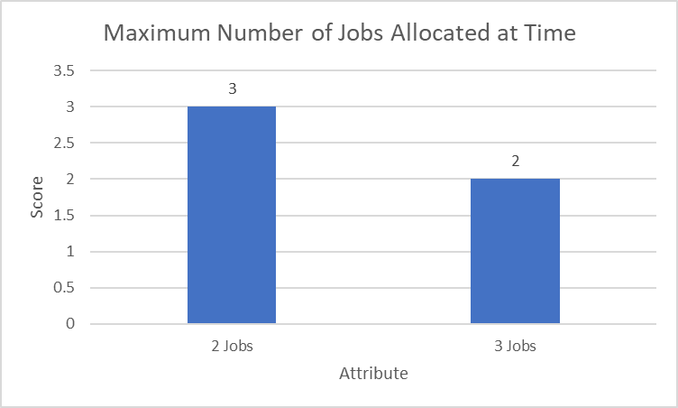

Figure 2 Resource allocation preferences and Maximum number of Jobs allocated at a time.

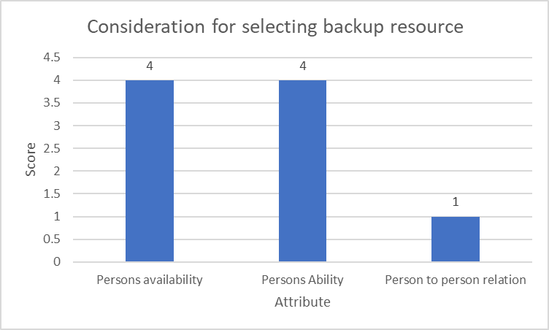

Figure 3 Special resource allocation and consideration for selecting backup resource.

# Resource Allocation and Task Allocation Optimization System (RATAOS)

This system architecture is represented using enterprise architecture (Figure 5), to show the relationship between humans, technology, application, and the business itself. In the system architecture shown, there are three layers: business, application, and technology, which form the core of the system that will be built. At a high level, the business layer comprises eight business actors, two business roles, three business processes, and two business events. The purpose of this layer is to interact with the application layer to input projects into the Project Management Information System (PMIS) and receive recommended resources from the Resource Allocation and Task Assignment Optimization System (RATAOS). The application layer consists of 5 application interfaces, 8 application events, 1 application service, and 2 application components. The PMIS and RATAOS are the two application components that provide the necessary interface, events, and services for input processing. The business layer utilizes the application layer, which, in turn, requires support from the technological layer to operate effectively. The technological layer comprises two devices, two pieces of system software, and one technology service, all of which are critical to supporting the application layer and making it operational and accessible.

Figure 4 Enterprise architecture for resource and task allocation optimization system

The database for storing the data from the application layer has also been designed so it will be easy to store and get the appropriate data for the process. Before beginning the building process, the first step is to know the existing condition of the process that already occurs in an enterprise. Figure 5 shows the example of project management process flow in Information Technology Company. All the processes nodes will be simulated with parameter from Table 2 and Table 3 to get the simulation result.

Figure 5 Flow process as is for project management process.

Table 2 Cost per hour on activity execution

|  |  |
| --- | --- |
| **Actor** | **Cost per Hour (USD)** |
| Functional Manager | 5.58 |
| Officer | 2.80 |
| Senior Officer | 4.18 |
| Outsource | 2.09 |

Table 3 Detail working time per process.

| **No.** | **Process** | **Worker** | **Hours** |
| --- | --- | --- | --- |
| 1 | Input AM order from requisition system | Senior Officer (Account Manager) | ± 1 |
| 2 | Input project from AM to PMIS | Senior Officer (Project Manager) | ± 0.5 |
| 3 | Define the task for a project | PM, Functional Manager | ± 1 |
| 4 | Create timeline for project | Senior Officer (Project Manager) | ± 0.5 |
| 5 | Decides resource who will do the task for a project | Functional Manager | ± 1 |
| 6 | Confirmation to the related resource for doing a task | Functional Manager | ± 24 |
| 7 | Resource allocation for a task | Functional Manager, Project Manager | ± 0.167 |
| 8 | Execution by officer | Officer | ± 240 |
| 9 | Execution by senior officer | Senior Officer | ± 192 |
| 10 | Execution by outsource | Outsource | ± 360 |
| 11 | Input new requirement due to change request | AM, PM | ± 0.5 |
| 12 | Closing project | PM | ± 2 |
| 13 | Update data in PMIS | PM | ± 1 |

Activity numbers 4-6, as specified in Table 3, will undergo optimization by the Resource Allocation and Task Assignment Optimization System (RATAOS). Following the RATAOS simulation, a further simulation will be conducted to assess the optimized or "to-be" process. The simulation results for the existing or "as-is" process are presented in Table 4 and Figure 6.

The findings reveal that completing a project takes 12.4 weeks, or approximately 2.85 months, which is longer than the average sprint duration of only one month [4], [31]. The planning durations require 35.83 hours, which is longer than the actual planning duration or any sprint planning durations as identified by PMI [4]. Additionally, Figure 6 depicts a right-skewed resource usage distribution, with officer allocation remaining high. This outcome was due to work allocation based on intuition rather than data-based decision-making.

Table 4 As is process simulation results.

|  |  |
| --- | --- |
| **Parameter** | **Value** |
| Cycle time of a process | 12.4 Weeks |
| Overall process cost | 2,410.77 USD |
| Planning Duration | 35.83 Hours |

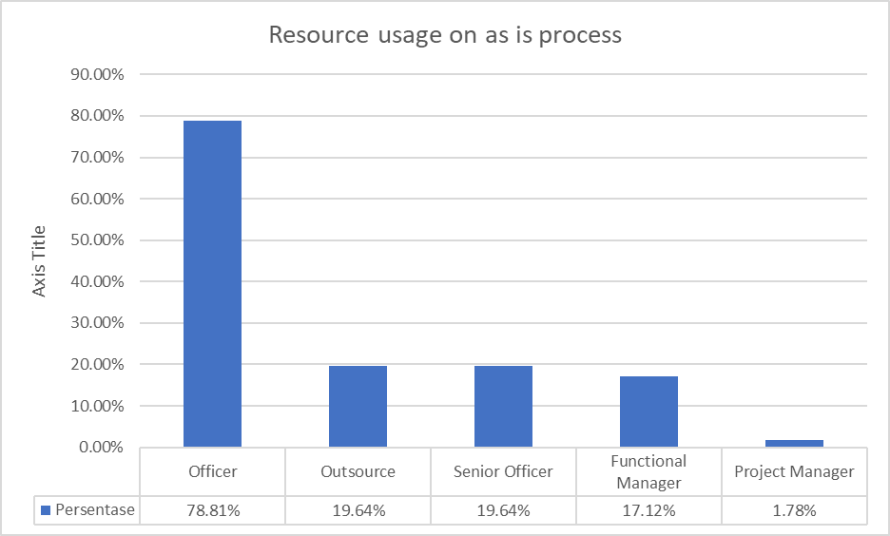

Figure 6 Resource usage on as is process.

The simulation data then will be the foundation and characteristics for NLP and a random forest identification system, so it can be used for eliminating the bottleneck as a result. NLP and random forest are trained using 29000 records to get a precision identification of what project managers and functional managers input. The input of RATAOS is task name, difficulty level, and deliverables load. For difficulty level and deliverables load, there will be values of high and low. The interface view of the RATAOS is shown on Figure 7.

Figure 7 RATAOS interface when inputting task.

The system was then tested 10 times using the 4 different scenarios mentioned before. The simulation of the system can be found in Table 5. The presented result has already been optimized, but at high deliverables and low difficulty scenarios, it still seems to have a low percentage of identification, at only 50%. This is caused by the experts and the training data used in this study; they are still not used to outsourcing work when there are no resources to do it. Of course, in the future, this will need to be considered for the system to function optimally. It also needs to be straightened out with operational activities and the way of thinking of people who use it.

Table 5 Simulation result for RATAOS identify which resource is suit to task.

|  |  |  |
| --- | --- | --- |
| **Scenario** | **Accuracy Percentage** | **Average Processing Time** |
| Low Deliverables, Low Difficulty | 90% | 0.0131 second |
| High Deliverables, Low Difficulty | 50% | 0.0071 second |
| Low Deliverables, High Difficulty | 80% | 0.0103 second |
| High Deliverables, High Difficulty | 70% | 0.0089 second |
| **Average** | **72.50%** | **0.0098 second** |

The simulated RATAOS are then used for the inputs to the new process, which will be called the “to be” process. The new process will be modelled in BPMN and can be found on Figure 8.

Figure 8 Flow process to be for project management process.

To be process then will be simulated using parameter shown in Table 2 and Table 3. The result of to be which compared with as is process can be found in Table 6 and Figure 9. The activities 4-6 will be replaced by the RATAOS system to cut the time and cost of a process. It is proved that by the simulation, the cycle time of a project to be completed is reduced to 6.3 weeks, or a 50.8% reduction, which is now closer to the regular sprint window of only 1 month. The overall process cost was also reduced by 14%, to 2,073.53 USD. This is caused by a previous process that was handled by humans but will now be handled by the system, and no more time will be wasted on awaiting confirmation of the availability of a resource because the data on its availability is already referenced by the system. By allocating the appropriate resources, it also helps to reduce the bottleneck, which will cause waiting costs. The planning duration also decreased by 88.7% from the as-is process. This causes no more waiting time for the planning process, so the time can be used for another process.

Table 6 As is vs to be simulation results.

|  |  |  |  |
| --- | --- | --- | --- |
| **Parameter** | **As Is** | **To Be** | **Delta** |
| Cycle time of a process | 12.4 Weeks | 6.1 Weeks | -6.3 Weeks |
| Overall process cost | 2,410.77 USD | 2,073.53 USD | -337.26 USD |
| Planning Duration | 35.83 Hours | 4.05 Hours | -31.78 Hours |

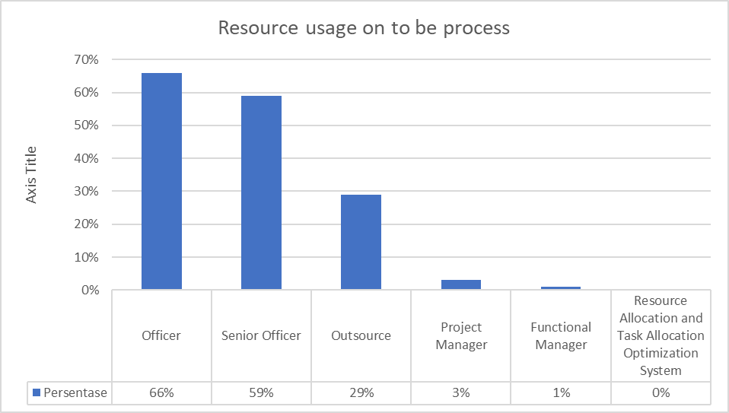

Figure 9 Resource usage on to be process.

The simulation results from 40 times of testing will then be tested using a t-test to see if there is a significant difference between two different treatment groups [32], [33]. The treatment to be tested is the time and cost of the current process compared to the time and cost of the process after RATAOS is integrated with PMIS. The first step of this analysis is creating a hypothesis for the test, which:

* Null hypothesis (H0): There is no significant difference in terms of time and cost for the project using RATAOS integrated with PMIS.
* Alternative hypothesis (H1): There is a significant difference in terms of time and cost for the project using RATAOS integrated with PMIS.

The data from the time and cost parameters will then be tested on statistical descriptive to ensure there are no outliers. Table 7 shows the descriptive statistics result.

Table 7 Statistic descriptive result of time and cost

|  |  |  |  |  |  |
| --- | --- | --- | --- | --- | --- |
| **Condition** | **Number of Data(n)** | **Mean** | **Standard Deviation** | **Median** | **Maximum** |
| As is Time | 40 | 1512.84 | 476.03 | 1436.4 | 2469.6 |
| To be Time | 40 | 815.64 | 227.73 | 747.6 | 1411.2 |
| As is Cost | 40 | 31954350.0 | 6602127 | 31993500 | 48616500 |
| To be Cost | 40 | 18622312.5 | 3855809 | 18092250 | 31014000 |

The mean and the median values of cost and time for the as-is and to-be processes do not differ significantly, so the t-test analysis can be carried out. The Welch t-test will be carried out in this research due to the variance difference between time and cost in the as-is and to-be-processed scenarios. The t-test will use an alpha value of 0.05, which has a confidence level of 0.95. The result is shown on Table 8.

Table 8 welch t-test result on as is and to be process.

|  |  |
| --- | --- |
| **Alpha value(ɑ)** | 0.05 |
| **T-Critical** | ±2.024 |
| **T-Statistics on time** | 8.356 |
| **Significance on time** | 1.919 • 10-12 |
| **T-Statistics on cost** | 11.028 |
| **Significance on cost** | 1.386 • 10-17 |

The T-Statistics values for the time and cost parameters in the as-is and to-be processes are greater than the T-Critical value obtained from the t-distribution [33]. This means that there is a significant difference in the time and cost parameters between the before and after conditions of using SOAPSD optimization in PMIS. The significance values for the time and cost parameters in the as-is and to-be conditions are below the predetermined alpha value of 0.05, which means that we reject the null hypothesis (H0) and accept the alternative hypothesis (H1) that there is a significant difference in time and cost for the project using RATAOS integrated with PMIS.

# Conclusion

To optimize job and resource allocation in information technology companies, a Project Management Information System (PMIS) can be integrated with the Resource Allocation and Task Allocation Optimization System (RATAOS). This can improve efficiency and accuracy. The optimization results are detailed below, based on research and analysis conducted in previous chapters. Integrating PMIS with RATAOS can reduce planning time by 31.78 hours due to changes in processes that were previously done manually and required confirmation by humans but are now done by the system. RATAOS integrated with PMIS has an accuracy rate of 72.50% in determining resources with a processing time of 0.029 seconds. This helps speed up the resource allocation process with high accuracy, but the output from the system needs to be socialized to ensure that experts and users are aware of the importance of procuring resources when internal resources can no longer handle the workload. With the improvement in planning process time, operational costs for project activities can be reduced by USD 352.1, and by accelerating the planning process and allocating tasks to appropriate resources, it is possible to speed up the work done by a resource and accelerate project completion by 1.5 months, which is almost 50% faster than the current completion time. According to the paired t-test, there is a significant variation in time and cost between the current condition and the desired condition after incorporating the job and resource allocation optimization system into the project management information system. Based on the conclusions drawn, two recommendations are made for future research. The first recommendation is to continue the system design based on the simulation into the installation phase for real-world observations. The second recommendation is to model the project completion process in information technology companies into an operations research equation and compare the parameters of the before and after conditions to observe any significant differences.

# References

1. Arslan, H. M. (2018). CURRENT CLASSIFICATION OF MULTI CRITERIA DECISION ANALYSIS METHODS AND PUBLIC SECTOR IMPLEMENTATIONS. Current Debates in Public Finance, Public Administration & Environmental Studies, October, 241–261.
2. Ashkezari, A. B., Zokaee, M., Aghsami, A., Jolai, F., & Yazdani, M. (2022). Selecting an Appropriate Configuration in a Construction Project Using a Hybrid Multiple Attribute Decision Making and Failure Analysis Methods. Buildings, 12(5). https://doi.org/10.3390/buildings12050643
3. Badiru, A. B. (2014). Handbook of Industrial and Systems Engineering (A. B. Badiru (ed.); Second). CRC Press.
4. Bondarenko, S., Halachenko, O., Shmorgun, L., Volokhova, I., Khomutenko, A., & Krainov, V. (2021). The Effectiveness of Network Systems in Providing Project Maturityof Public Management. TEM Journal, 10(1), 272–282. https://doi.org/10.18421/TEM101-34
5. Chilton, M. A. (2014). Resource allocation in IT projects: Using schedule optimization. International Journal of Information Systems and Project Management, 2(3), 47–59. https://doi.org/10.12821/ijispm020303
6. Dachyar, M., Zagloel, T. Y. M., & Saragih, L. R. (2020). Enterprise architecture breakthrough for telecommunications transformation: A reconciliation model to solve bankruptcy. Heliyon, 6(10), e05273. https://doi.org/10.1016/j.heliyon.2020.e05273
7. Gao. (2001). A Practical Guide to Federal Enterprise Architecture. In Public Law (Vol. 1, Issue February 2001). http://www.citeulike.org/group/15536/article/9666776
8. Garg, S., Sinha, S., Kar, A. K., & Mani, M. (2022). A review of machine learning applications in human resource management. International Journal of Productivity and Performance Management, 71(5), 1590–1610. https://doi.org/10.1108/IJPPM-08-2020-0427
9. González Moyano, C., Pufahl, L., Weber, I., & Mendling, J. (2022). Uses of business process modeling in agile software development projects. Information and Software Technology, 152(March), 107028. https://doi.org/10.1016/j.infsof.2022.107028
10. Hannemann, I., Rodrigues, S., Loures, E., Deschamps, F., & Cestari, J. (2022). Applying a decision model based on multiple criteria decision making methods to evaluate the influence of digital transformation technologies on enterprise architecture principles. IET Collaborative Intelligent Manufacturing, 4(2), 101–111. https://doi.org/10.1049/cim2.12046
11. Harinaldi. (2005). Prinsip-Prinsip Statistik Untuk Teknik dan Sains (Erlangga (ed.); 1st ed.). Erlangga.
12. Hosseinian, A. H., & Baradaran, V. (2021). A two-phase approach for solving the multi-skill resource-constrained multi-project scheduling problem: a case study in construction industry. Engineering, Construction and Architectural Management. https://doi.org/10.1108/ECAM-07-2019-0384
13. Hurwitz, J., & Kirsch, D. (2018). Machine Learning for Dummies. In Journal of the American Society for Information Science (Vol. 35, Issue 5). John Wiley & Sons. https://doi.org/10.1002/asi.4630350509
14. K.Pratt, M., & Roy, M. (2017). What is business process reengineering (BPR) - Definition from WhatIs. TechTarget. https://www.techtarget.com/searchcio/definition/business-process
15. Kerzner, H. (2017). Project Management 12th Edition. In Syria Studies (12th ed., Vol. 7, Issue 1). John Wiley & Sons. https://www.researchgate.net/publication/269107473_What_is_governance/link/548173090cf22525dcb61443/download%0Ahttp://www.econ.upf.edu/~reynal/Civil wars_12December2010.pdf%0Ahttps://think-asia.org/handle/11540/8282%0Ahttps://www.jstor.org/stable/41857625
16. Kim, C. W., Yoo, W. S., Lim, H., Yu, I., Cho, H., & Kang, K. I. (2018). Early-warning performance monitoring system (EPMS) using the business information of a project. International Journal of Project Management, 36(5), 730–743. https://doi.org/10.1016/j.ijproman.2018.03.010
17. Kock, A., Schulz, B., Kopmann, J., & Gemünden, H. G. (2020). Project portfolio management information systems’ positive influence on performance – the importance of process maturity. International Journal of Project Management, 38(4), 229–241. https://doi.org/10.1016/j.ijproman.2020.05.001
18. Mansar, S. L., & Reijers, H. A. (2005). Best practices in business process redesign: Validation of a redesign framework. Computers in Industry, 56(5), 457–471. https://doi.org/10.1016/j.compind.2005.01.001
19. Navidi, W. (2013). Statistics for Engineers and Scientists 3rd Edition. In B. D. Hash (Ed.), Paper Knowledge . Toward a Media History of Documents (3rd ed.). McGrawHill Higher Education.
20. Onesmus, M. (2020). Introduction to Random Forest in Machine Learning. Section.Io; Section. https://www.section.io/engineering-education/introduction-to-random-forest-in-machine-learning/
21. Pappas, L. (2021a). The State of Project Management Training. In Wellingtone.
22. Pappas, L. (2021b). The State of Project Management Training. In Wellingtone. http://search.proquest.com.ezproxy.library.wisc.edu/abicomplete/docview/198717427/13BF4534484E6D0878/5?accountid=465
23. Patil, A., Madaan, J., Chan, F. T. S., & Charan, P. (2022). Advancement of performance measurement system in the humanitarian supply chain. Expert Systems with Applications, 206(June), 117844. https://doi.org/10.1016/j.eswa.2022.117844
24. PMI. (2021a). A Guide to the Project Management Body of Knowledge PMBOK GUIDE Seventh Edition and The Standard for Project Management. In Angewandte Chemie International Edition, 6(11), 951–952. (7th ed.). Project Management Institute.
25. PMI. (2021b). Pulse of Profession 2021: Beyond Agility. https://www.pmi.org/-/media/pmi/documents/public/pdf/learning/thought-leadership/pulse/pmi_pulse_2021.pdf?v=b5c9abc1-e9ff-4ac5-bb0d-010ea8f664da&sc_lang_temp=en
26. Reijers, H. A. (2021). Business Process Management: The evolution of a discipline. Computers in Industry, 126, 103404. https://doi.org/10.1016/j.compind.2021.103404
27. Saragih, L. R., Dachyar, M., & Zagloel, T. Y. M. (2021). Implementation of telecommunications cross-industry collaboration through agile project management. Heliyon, 7(5), e07013. https://doi.org/10.1016/j.heliyon.2021.e07013
28. Satic, U., Jacko, P., & Kirkbride, C. (2022). Performance evaluation of scheduling policies for the dynamic and stochastic resource-constrained multi-project scheduling problem. International Journal of Production Research, 60(4), 1411–1423. https://doi.org/10.1080/00207543.2020.1857450
29. Sheoraj, Y., & Sungkur, R. K. (2022). Using AI to develop a framework to prevent employees from missing project deadlines in software projects - case study of a global human capital management (HCM) software company. Advances in Engineering Software, 170, 103143. https://doi.org/10.1016/j.advengsoft.2022.103143
30. Shetty, B. (2019). Supervised Machine Learning Classification: An In-Depth Guide. Builtin. https://builtin.com/data-science/supervised-machine-learning-classification
31. Tewari, I., & Pant, M. (2020). Artificial Intelligence Reshaping Human Resource Management : A Review. Proceedings of IEEE International Conference on Advent Trends in Multidisciplinary Research and Innovation, ICATMRI 2020, 2020–2023. https://doi.org/10.1109/ICATMRI51801.2020.9398420
32. van Besouw, J., & Bond-Barnard, T. (2021). Smart project management information systems (Spmis) for engineering projects – project performance monitoring & reporting. International Journal of Information Systems and Project Management, 9(1), 78–97. https://doi.org/10.12821/ijispm090104
33. vom Brocke, J. (2018). Business Process Management Cases :Digital Innovation and Business Transformation in Practice (J. Mendling (ed.); 1th ed.). Springer Berlin Heidelberg. https://doi.org/10.1007/978-3-319-58307-5_9