**Introduction**  
  
This blog will be about the small modifications I have made and plan to make on my recently purchased, *used*, [Tennis Tutor ball machine](http://sportstutor.com/tennis-tutor/).

[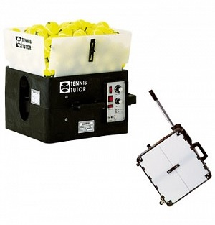](http://4.bp.blogspot.com/-IxnIrKVsi4Y/Vie6gJQMM0I/AAAAAAAAA4c/1eYROeNZKyk/s1600/TT%2Bbm.jpg)

Figure 1 - Tennis Tutor ball machine

To this end I have done a lot of research and reverse engineering. This is a hobby project, and as such, I cannot give any warranties. It has worked for me, so far.  
  
Almost all parts I have acquired were bought from eBay, and have travelled all the way from China to Brazil. It amazes me how cheap those parts come from all around the world every time I receive those little packages.  
  
I tried to keep everything simple, at least in the beginning.  
  
Please feel free to comment on my posts. I will gladly answer to questions related to this project.  
  
**Initial motivations**  
At first, my goals were simple:  
  
(i) to fix the oscillator of my used Tennis Tutor, which was behaving quite oddly, without spending much, and;  
(ii) to find some way of converting it to a battery powered machine, without spending much either.  
  
Since I am in Latin America, and I really did not know how old was my ball machine, I thought to myself: hey, let's open it and take a look. After all, I have an Electronic's Engineering degree! Putting it to good use would be fun.  
  
**Brief ball machine description**  
  
The version of the Tennis Tutor I have purchased is quite simple. You can take a look inside it in Figure 2.

[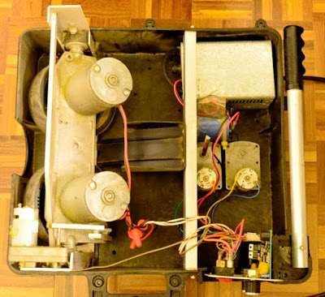](http://1.bp.blogspot.com/-UbYHvtqR4qM/VifvKPiclQI/AAAAAAAAA4s/NtSWJWC2lqQ/s1600/_DSC2686.JPG)

Figure 2 - A first look inside the Tennis Tutor ball machine.

It has two horizontal throwing wheels driven by two somewhat large balanced DC motors, which, according to the [Sports Tutor website](http://www.sportstutor.com/) (the makers of the Tennis Tutor), are able to throw balls at a speed of 85 mph. The speed is adjusted by a potentiometer (Figure 3).

[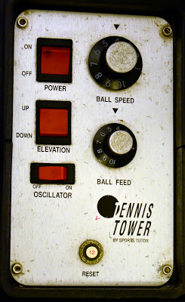](http://3.bp.blogspot.com/-eGdr7IpSs2I/VigQlZ8uEJI/AAAAAAAAA48/15ZpAclFz5o/s1600/_DSC2680_.jpg)

Figure 3 - My Tennis Tutor control panel (I really don't know why it has Tennis Tower written in it)

Then there is a ball feeder that takes care of feeding tennis balls to the two wheels, one at a time. Feeding interval according to specifications ranges from 1.5 to 12 seconds. This is adjusted by a second potentiometer (Figure 3), which drives a small DC motor and a gear system to rotate a shaft connected to the feeding apparatus.  
  
You are also able to adjust the tennis ball throwing angle with an up and down button (Figure 3) that is driven by a small DC motor located next to the two big throwing DC motors.  
  
And finally, you can turn-on a simple "oscillator" function, which makes the ball machine swing from left to right and vice-versa, at a predetermined speed which cannot be adjusted. This is not really much useful since the ball feeding mechanism is not in sync with the oscillator speed. The result is a "random" ball throwing direction (this is the name Sports Tutor has assigned to this function). A little boring to my taste.  
  
My version of the ball machine is A/C powered, which means it must be plugged to an electric outlet to be used. They do sell the same machine with battery power, which are charged by an external adaptor. The batteries are of the same kind as those used in Uninterrupted Power Supply (UPS) systems, easily available even in Brazil where I am located. The battery powered version does not work when the batteries are depleted, even when connected to the charger and plugged to an electrical outlet.  
  
**Tennis Tutor internal diagrams and control board schematics**  
At first I tried to contact Sports Tutor directly. I sent them an e-mail hoping to get some useful guidance on converting the ball machine to battery operation and on fixing the oscilator function. Peter Martinez was the one who replied to my e-mail. I explained to him my problem and he advised me on how much it would cost to convert the machine from A/C to battery operation. It was not that expensive (not in the USA), but when adding taxes and import duties, it was not that worth also.  
  
So I started retrieving whatever information I could from the Internet. There were two useful things I found on-line:  
  
(i) [a good video on Youtube explaining how to replace old batteries](https://www.youtube.com/watch?v=I-4to3n5Xek) (and also how to open the ball machine) and;  
(ii) [a very old (1987) and useful patent by Tennis Tutor Inc. (US4834060)](http://www.google.ca/patents/US4834060).  
  
The video on (i) helped me understand where inside my Tennis Tutor the batteries should be installed, and what type o battery I would have to purchase.  
  
The patent on (ii) explained a lot about how the control circuit inside the Tennis Tutor were conceived in their first version. It was very surprising to see almost everything inside the ball machine - including control circuits, battery recharging circuit and mechanics - explained by the patent. As my ball machine is not that different, this patent was really useful.  
  
Bellow (Annex I) you will find a selection of what I found most useful inside the patent.  
  
In the next post I will start to cover the design of an amendment circuit and sensors to replace the random oscillation feature of my Tennis Tutor ball machine.  
  
  
  
  
**Annex I - Most useful pictures and descriptions from Patent US 4834060**

[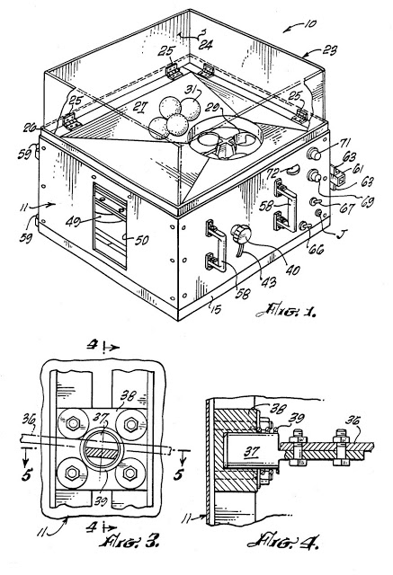](http://2.bp.blogspot.com/-igxdmxSSAVw/VigXF4G2PsI/AAAAAAAAA5c/NUVPgrLSmWg/s1600/Fig2.jpg)

[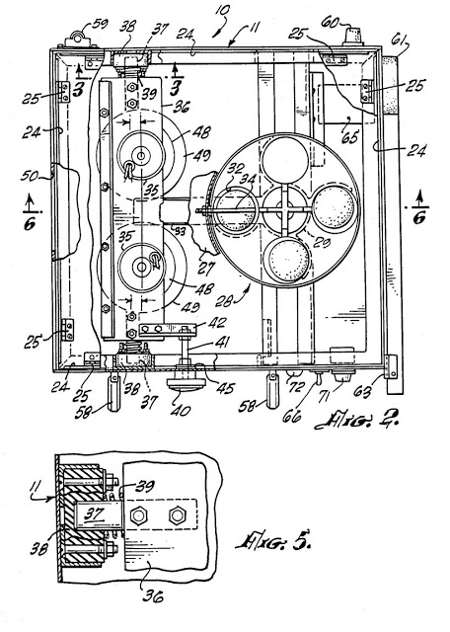](http://4.bp.blogspot.com/-HBfSzBRrzb4/VigXF1aEDoI/AAAAAAAAA5g/wPEkBIUb0Uc/s1600/Fig3.jpg)

[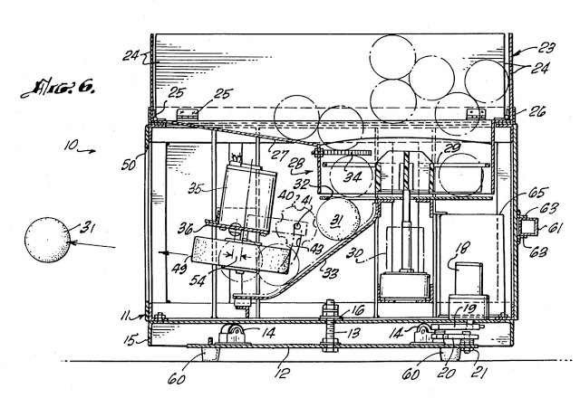](http://3.bp.blogspot.com/-rjfFVTaRuC4/VigXFz2YXvI/AAAAAAAAA5k/fSqHqX7QGaU/s1600/Fig4.jpg)

[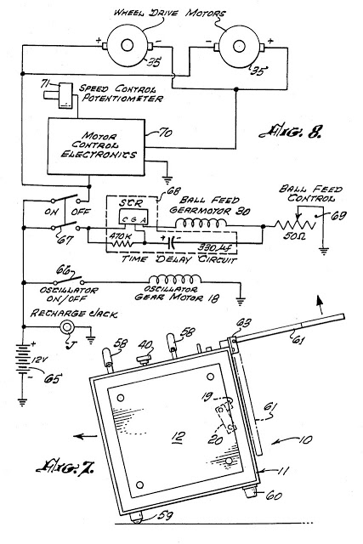](http://2.bp.blogspot.com/--nNGKgzwPVk/VigXGo3ZTeI/AAAAAAAAA5o/VGGVyF1AzDg/s1600/Fig5.jpg)

[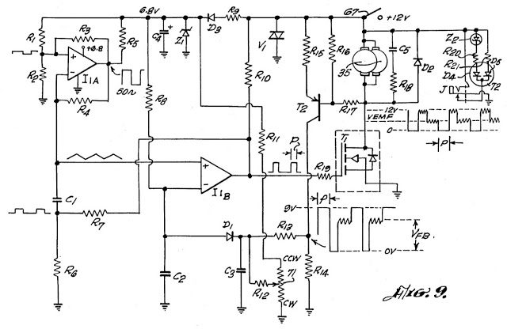](http://3.bp.blogspot.com/-GgWnhSSdlec/VigX2tXKv-I/AAAAAAAAA6M/PAMyXWyY36w/s1600/FigX.jpg)

[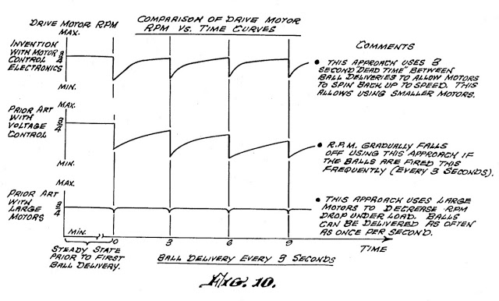](http://4.bp.blogspot.com/-syEnmTr1kQI/VigXG1NpwDI/AAAAAAAAA5w/MedXVEGe-uY/s1600/Fig6.jpg)

Here is a transcription of the "The Electrical Schematic and Motor Control Electronics", as well as a description of the machine "Operation":  
  
*"****THE ELECTRICAL SCHEMATIC AND MOTOR CONTROL ELECTRONICS***  
 *Before proceeding to describe the improved control circuitry for the present invention it is advantageous to comment briefly about the state of the prior art ball throwers and typical operating characteristics thereof contrasted with those of this invention. Typical prior art ball throwing machines have power requirements very substantially in excess of that feasible with storage batteries. These machines are of two general types, one being the counter-rotating wheel type utilizing approximately 300 watts and the other being a compressed air type to throw balls and typically consuming approximately 1000 watts of power. In striking contrast, the invention apparatus utilizes 15 to 60 watts readily and economically provided by a sealed on-board re-chargeable 12-volt storage battery weighing approximately 6 pounds which provides for approximately 2 to 3 hours of normal use.*

*The machine of this invention is oscillated in a horizontal orientation by a gear motor 18 and the balls are fed to chute 33 by gear motor 30 which indexes the feeder mechanism, each motor 18, 30 consuming about 3 watts. The ball throwing motors 35 have permanent magnet stators, are rated at 1/8 horsepower each, and together consume power between 10 and 55 watts depending upon the ball throwing velocity.*

*FIG. 10 contrasts the RPM vs. Time characteristics of this invention with two typical types of prior art machines, one of which utilizes voltage control and the other large high torque motors, each using these design expedients to avoid decrease in operating speed in successive ball throwing cycles. Each graph is based on a 3-second ball delivery cycle.*

*The top graph shows the operating characteristics of this invention which functions in a highly stable and satisfactory manner to full restore the operating speed of motors 35 between 3-second ball throwing cycles.*

*The prior art design utilizing voltage control is incapable of fully restoring operating speed between 3-second cycles and in consequence, the operating speed gradually fades.*

*The prior art large motor type depicted in the lowest graph avoids speed drop between cycles and is capable of operating in shorter intervals of time but at the expense of heavy bulky non-handportable equipment consuming very substantial quantities of power.*

*The simplified schematic shown in FIG. 8 shows the sealed 12-volt storage battery 65 supplying power via control switch 66 to the drive motor 18 for oscillating the ball thrower in a horizontal arc. The ball feeding motor 30 is supplied with power through the double throw switch 67 via the time delay circuit 68 and a speed control rheostat 69. The power supply to the ball throwing motors 35 is controlled by the second blade of switch 67 and the solid state circuitry represented at 70 and the associated speed control potentiometer 71, the details of this important circuitry being shown in detail in FIG. 9.*

*The solid state control circuitry 70 illustrated in FIG. 9 operates at approximately 98% efficiency, so important to a ball thrower having hand portability and powered by an on-board battery. Moreover, the entire circuitry is very small; weighs only a few ounces; permits ball speed over a range greater than 2 to 1; provides for full motor speed as loads vary; and provides full motor speed up from a standing start in less than 6 seconds as contrasted with the up to 15-second spin-up time if using voltage control. Another important feature is a constant motor drive speed for a given setting of the ball speed control knob as the battery voltage decays during use. This is accomplished as will be explained by a voltage clamping circuit set at a level substantially below normal battery charge level and functioning in concert with motor voltage feedback.*

*The electronic control circuit for ball throwing motors 35 operates to switch the power on and off in pulses of variable width at a frequency generated by an oscillator to restore quickly the speed lost as a ball is thrown. The width of the power pulse is determined by comparing the back electromotive force generated by the motors with a reference voltage signal to provide for constant speed control as the battery voltage decays during discharge. The reference voltage signal is provided by a circuit clamping the voltage at a stable reference value, such as 6.8 volts. This clamping circuit comprises resistor R9, diode D3, zener diode Z1 and capacitor C4. Diode D3 serves as a disconnect diode to prevent negative transients from discharging filtering capacitor C4. Zener diode Z1 clamps the voltage on the line at a suitable reference voltage such as that mentioned above.*

*This reference voltage activates an oscillator circuit comprising an integrated circuit comparator I1A and its associated components R1 to R6 and C1, this comparator having a square wave output of a suitable frequency, such as 50 cycles, and an amplitude which varies between 6.8 volts and 0 volts. This output signal alternately charges and discharges capacitor C1 via resistor R4, creating a triangular reference voltage signal which is applied to the positive input of the integrated circuit comparator I1b.*

*At the instant a ball is thrown, the speed of motors 35 drops as does the back EMF, the latter being represented by the signal VEMF below motors 35 in FIG. 9. This signal appearing at the junction of T1, R17 and motors 35, is applied to the base of transistor T2 which is a common emitter amplifier stage having a gain output determined by the values of resistors R14, R15, R16 and R17. The motor back EMF signal inverted by transistor T2 appears at the junction of R13 and R14 and is represented graphically to the right of that junction. The signal passes through resistor R13 and is offset by a DC voltage determined by resistors R11, R12 and the motor speed control potentiometer 71, the latter serving to vary the DC offset voltage added to the feedback signal.*

*Diode D1 clips the positive portion of this feedback signal and passes only the pure feedback portion Vfb to the negative input of the integrated circuit comparator I1b which offsets the positive bias supplied through R8. Capacitor C3 filters out the higher frequency components of the feedback signal. Capacitor C2 filters the feedback signal so that the comparator sees an average value of Vfb. As the signal decreases or increases on the comparator I1b negative input, the comparison of that signal with the triangular wave form present at the comparator positive input provides an output signal which is proportionally wider or narrower respectively and this output is delivered to the gate of transistor T1 through current limiting resistor R19. Transistor T1 comprises four metal oxide semi-conductor field effect transistors in parallel. When T1 is driven by comparator I1b it conducts thereby placing the negative terminals of motors 35 at ground potential. Since the positive terminals of the motors are at positive 12 volts, the full supply voltage of the battery is placed across the motors for the time interval controlled by the output signal of comparator I1b. If the oscillator provides a 50 hertz signal, then this full power pulse is applied to the motors 50 times per second.*

*As now will be apparent, this feedback action provides the speed regulation for these motors. It also provides constant throwing motor speed for a specific setting of the speed control potentiometer 71 even though the battery voltage is falling during battery discharge. This constant motor speed is achieved because the reference voltage signal applied to the positive input of comparator I1b is clamped at 6.8 volts. The comparator compensates for decreasing back EMF by widening its output pulse width in an amount to supply constant power to the motors until the battery voltage has fallen so far the comparator remains fully on. The output of comparator I1b, which is stabilized by current flowing through resistor R10 when it is not in an output state, not only drives the gate of transistor T1 but also completes a hysteresis loop to ground through resistors R6 and R7. The hysteresis loop prevents oscillation when the comparator is in an output state.*

*The solid state control circuitry also includes important circuit protection features. For example, when transistor T1 is shut off an inductive spike is produced. This spike is clamped by diode D2 which is in parallel with motors 35. This prevents a large potentially dangerous positive voltage from reaching transistor T1. This voltage spike is shown clamped at the plus 12-volt level in the graph below the motors in FIG. 9.*

*There is also a rate suppression network consisting of capacitor C5 and resistor R18 connected across the terminals of motors 35. This network reduces radio frequency noise and controls the rise and decay times of the voltage to motors 35 when power is applied and removed. In addition, varistor V1 acts as a transient suppression device to clamp any extraneous inductive pulses which might appear on the positive voltage supply line to less than 22 volts.*

*Another adjunct comprises a battery charge monitor which includes a jack J having its plug receiving end mounted in the sidewall of the apparatus housing shown in FIG. 1 into which a plug connected to a source of charging power can be inserted. This jack is connected in circuit with dual light emitting diodes 72 mounted on the control panel of the apparatus housing (FIG. 1), a zener diode Z2, and resistors R20, R21.*

*The battery monitoring circuit is only in operation when a plug is present in Jack J. The light emitting diode D4 in circuit with resistor R20 is green whereas the other diode D5 is red, both being enclosed in the same physical package so that their light output is combined. When the battery voltage is below 12 volts, the red diode glows whereas the other diode does not begin to glow green until the battery voltage approaches 13 volts. The green diode does not glow until the battery voltage exceeds the zener voltage of zener diode Z2. Resistors R20 and R21 provide current limiting for diodes D4 and D5 respectively.*

*When the battery is discharged and the charging power plug is inserted into jack J only the red diode will glow. As the battery charges, the green diode will begin to glow and as the charge increases it will glow more brightly than the red diode, the green color dominating as the full battery charge is reached. The increasing green light as the battery charges will cause the light output of the two diodes to change from red, to orange, to yellow, and finally to green as the battery becomes fully charged, thereby providing a changing visual indication of the state of battery charge.*

***OPERATION***

*Ball throwing apparatus 10 is placed in operation by transporting and/or hand carrying it to a playing area and placing the feet 60 on stationary base 12 on a supporting surface. The hopper sidewall panels 24 are then placed in use by releasing them from a catch (not shown) holding them collapsed and opening them to their extended position and filling the hopper with a supply of balls. Shelf 36 supporting the motors 35 and the ball throwing wheels 49 is adjusted to eject the balls 31 grasped in between their spacing from any point along the immovable length of chute 33 for any pivoted position of shelf and wheels in a desired vertical trajectory. The clamping knob 40 adjusts the tilt position of the shelf and then clamps it firmly in this position by tightening knob 40. The oscillator motor, if desired, is then turned on by closing switch 66 to drive motor 18 to oscillate the apparatus housing 11 to-and-fro horizontally about pivot bolt 13. The ball feed control potentiometer 69 is adjusted to index balls for gravity flow down chute 33 and into the ball-throwing-wheels position at desired intervals after the ball feed motor 30 has been activated. Switch 67 controlling current flow to this motor and to the motor control electronics complex 70 is typically made or thrown after all other adjustments have been made. However, the time delay component 68 delays energization of the ball feed motor 30 for an appropriate length of time, such as 8 seconds, after energization of the solid state circuitry 70 to permit motors 35 to reach full operating speed. This gives time for the player to reach his playing position and prevents the premature ejection of balls before the motors are up to their proper operating speed.*

*The solid state circuitry then functions as outlined above by generating a steady state oscillating signal converted to a triangular configuration and supplied to the positive terminal of comparator I1b. As each ball is thrown there is a precipitous and almost instantaneous decrease in motor speed accompanied by a decrease in their back EMF. This signal is converted into pulses and supplied to the base of the amplifier transistor T2 where it is inverted in amplified form at the junction of R13, R14. This back EMF signal proportional to motor speed is delivered to the negative input of comparator I1b to provide output signal pulses in step with the frequency of the oscillator circuit and of variable width. This variable signal is utilized to turn on the field effect transistor T1 to supply full power to motors 35 for variable pulse periods and at the rate of the oscillator output signal. In this manner the resumption of full speed of motors 35 is restored in a most efficient and expedited manner. If the operator wishes to vary the speed of motors 35 he adjusts the potentiometer 71 to vary the DC offset voltage added to the feedback signal enroute to comparator I1b.*

*Suitable values and identification of the solid state components found to provide excellent results in the high efficiency control circuit shown in FIG. 9 are as follows:*

*Component / Description  
R1 24K ohm  
R2 33K ohm  
R3 470K ohm  
R4 510K ohm  
R5 10K ohm  
R6 270 ohm  
R7 100K ohm  
R8 1 M ohm  
R9 330 ohm  
R10 1.8K ohm  
R11 390 ohm  
R12 39K ohm  
R13 100K ohm  
R14 8.2K ohm  
R15 1K ohm  
R16 1.2K ohm  
R17 6.8K ohm  
R18 160K ohm  
R19 82 ohm  
R20 1K ohm  
R21 22K ohm  
P1 5K linear taper (potentiometer)  
C1, C2 .33 microfarads  
C3 .022 microfarads  
C4 470 microfarads  
C5 .47 microfarads  
D1, D3 IN4148  
D2 IN 5400  
D4, D5 Dual diode, red/green, RS276-025  
Z1 6.8 V, IN754  
Z2 12 V, IN4742  
V1 Varistor, S14K14  
T1 MOSFET BUZ 71  
T2 2N39061  
C1A, 1C1B Integrated Circuit, LM393N*  
 *The resistors are rated at one-half watt and the capacitors are rated at 50 volts.*

*While the particular hand-carried selectively operable by on-board battery or an AC to DC power converter ball throwing apparatus herein shown and disclosed in detail is fully capable of attaining the objects and providing the advantages hereinbefore stated, it is to be understood that it is merely illustrative of the presently preferred embodiment of the invention or design herein shown and the scope and spirit of the invention is not limited or restricted other than as defined in the appended claims."*