**Azure Virtual Machine (VM) Assignment – Ilhan Agpak**

**1. Student Information**

* **Name:** Ilhan Kagan Agpak

**2. Assignment Steps and Explanations**

**2.1 Creating an Azure Account**

I created an **Azure for Students** account. I received **$100 free credits** for testing Azure services.

**2.2 Creating a Resource Group**

* I opened **"Resource Groups"** in the Azure portal.
* I created a new **Resource Group** named **IlhanAgpak_RG**.
* I selected **West Europe** as the location.

📸 **Screenshot:** metin, yazılım, web sayfası, bilgisayar simgesi içeren bir resim

Yapay zeka tarafından oluşturulan içerik yanlış olabilir.

**2.3 Creating a Virtual Machine (VM)**

* I opened **"Virtual Machines"** in the Azure portal.
* I created a new **Windows Server 2019 Datacenter** VM.
* **VM Name:** IlhanAgpak-VM
* **Region:** West Europe
* **Size:** Standard D2ls v6 (2 vcpus, 4 GiB memory)
* **Security:** **RDP (port 3389) was opened.**

📸 **Screenshot:** *metin, yazılım, sayı, numara, bilgisayar simgesi içeren bir resim

Yapay zeka tarafından oluşturulan içerik yanlış olabilir.*

**2.4 Connecting to VM via RDP**

* I went to **Azure portal > My VM > Connect > RDP**.
* I downloaded the RDP file and connected to the VM.
* The Windows Server desktop appeared.

📸 **Screenshot:** 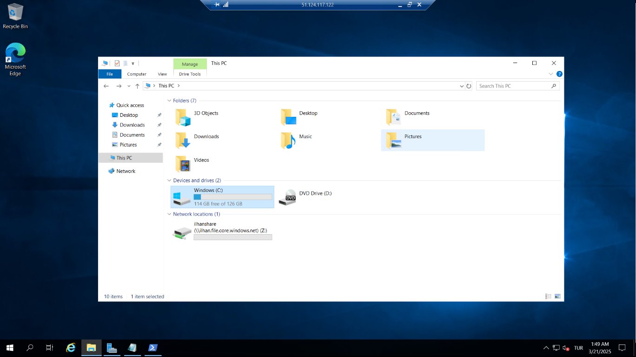

**2.5 Setting Up Azure File Share**

* I created a **Storage Account** in Azure.
* Inside it, I created a **File Share** named ilhanshare.
* I used **PowerShell commands** from Azure to mount the **File Share as "Z:" drive** in the VM.
* The Z: drive appeared in **File Explorer**, and I successfully created a test file.

📸 **Screenshot:** *metin, yazılım, web sayfası, bilgisayar simgesi içeren bir resim

Yapay zeka tarafından oluşturulan içerik yanlış olabilir.*

**Installing IIS and Publishing a Website**

* I installed the IIS web server using PowerShell:
  + Install-WindowsFeature -name Web-Server -IncludeManagementTools
* I added an **index.html** file to C:\inetpub\wwwroot.
* I tested the website by entering http://[VM IP address] in my browser.

📸 **Screenshot:** *ekran görüntüsü, metin, yazılım içeren bir resim

Yapay zeka tarafından oluşturulan içerik yanlış olabilir.*

**3. Problems and Solutions**

**3.1 Problem: index.html File Did Not Work**

**Reason:** The file was saved as index.html.txt, so it was not recognized as an HTML file.  
**Solution:** I saved the file correctly as index.html using "Save As" and selecting **"All Files"** instead of .txt.

**3.2 Problem: HTTP (Port 80) Was Blocked**

**Reason:** I forgot to enter **port 80** when adding an inbound security rule.  
**Solution:** I went to **Azure portal > Networking > Inbound Rules**, and I added a new rule to allow traffic on **port 80 (HTTP)**.

**4. Cleaning Up Resources**

* After completing the assignment, I deleted all resources (VM, Resource Group, File Share) in the **Azure portal**.
* This prevents extra charges on my Azure credits.