PDF Generation using iText JAR

import java.io.File;
import java.io.FileOutputStream;
import java.io.OutputStream;
import java.util.Date;

import com.lowagie.text.Document;
import com.lowagie.text.Paragraph;
import com.lowagie.text.pdf.PdfWriter;

public class GeneratePDF {

public static void main(String[] args) {
try {
OutputStream file = new FileOutputStream(new File("C:\\Test.pdf"));

Document document = new Document();
PdfWriter.getInstance(document, file);
document.open();
document.add(new Paragraph("Hello Ilian"));
document.add(new Paragraph(new Date().toString()));

document.close();
file.close();

} catch (Exception e) {

e.printStackTrace();
}
}
}

Convert String to Date

java.util.Date = java.text.DateFormat.getDateInstance().parse(date String);
or
SimpleDateFormat format = new SimpleDateFormat( "dd.MM.yyyy" );
Date date = format.parse( myString );

03. Converting Strings to int and int to String

String a = String.valueOf(2); //integer to numeric string
int i = Integer.parseInt(a); //numeric string to an int

Resize and Sort an Array.

private static Object resizeArray (Object oldArray, int newSize) {
int oldSize = java.lang.reflect.Array.getLength(oldArray);
Class elementType = oldArray.getClass().getComponentType();
Object newArray = java.lang.reflect.Array.newInstance(
elementType,newSize);
int preserveLength = Math.min(oldSize,newSize);
if (preserveLength > 0)
System.arraycopy (oldArray,0,newArray,0,preserveLength);
return newArray;
}

// Test routine for resizeArray().
public static void main (String[] args) {
int[] a = {3,2,1};
for (int i = 0; i < a.length; i++) {
System.out.println(a[i]);
}

a = (int[])resizeArray(a,5);
a[3] = 4;
a[4] = 5;
Arrays.sort(a);
for (int i = 0; i < a.length; i++) {
System.out.println(a[i]);
}
}

Collections
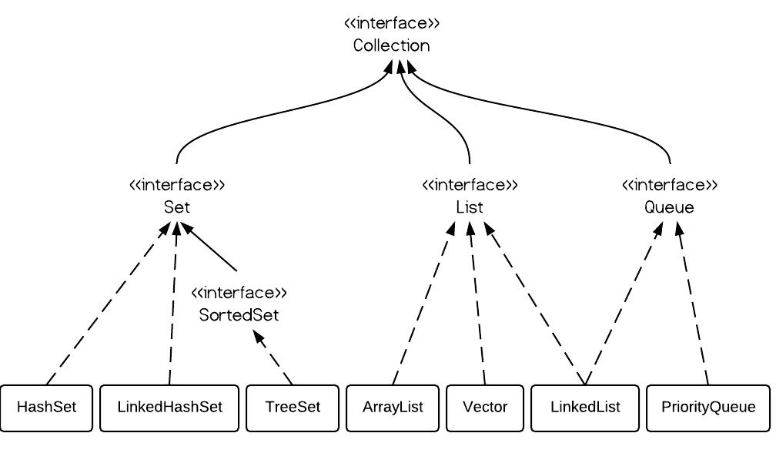
Sort an ArrayList.
import java.util.ArrayList;
import java.util.Collections;
import java.util.List;

public class SortArrayList {

public static void main(String[] args) {

ArrayList<Integer> al=new ArrayList<>();
al.add(3);
al.add(2);
al.add(1);

Collections.sort(al);

for (Integer i : al) {
System.out.println(al.get(i));
}

// Why throw out of bounce ???

}
}

Convert Array to Map

import java.util.Map;
import org.apache.commons.lang.ArrayUtils;

public class Main {

public static void main(String[] args) {
String[][] countries = { { "United States", "New York" }, { "United Kingdom", "London" },
{ "Netherland", "Amsterdam" }, { "Japan", "Tokyo" }, { "France", "Paris" } };

Map countryCapitals = ArrayUtils.toMap(countries);

System.out.println("Capital of Japan is " + countryCapitals.get("Japan"));
System.out.println("Capital of France is " + countryCapitals.get("France"));
}
}

