Configuration routeur :
Configuration LAN (Gig0/0):
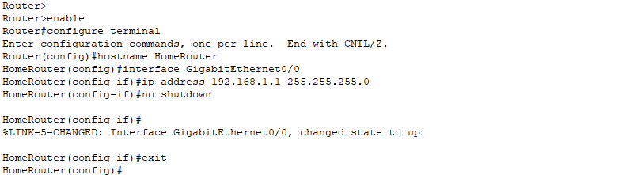
Configuration de l’interface WAN (Gig0/1) qui connecte le routeur avec L’internet (ISP) :
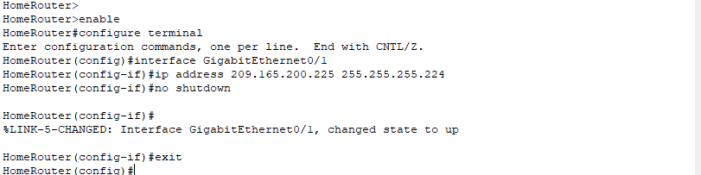
Config du routage dynamique en utilisant le protocol OSPF :
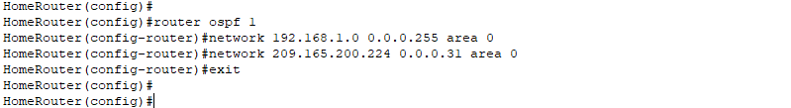
Configuration des access:
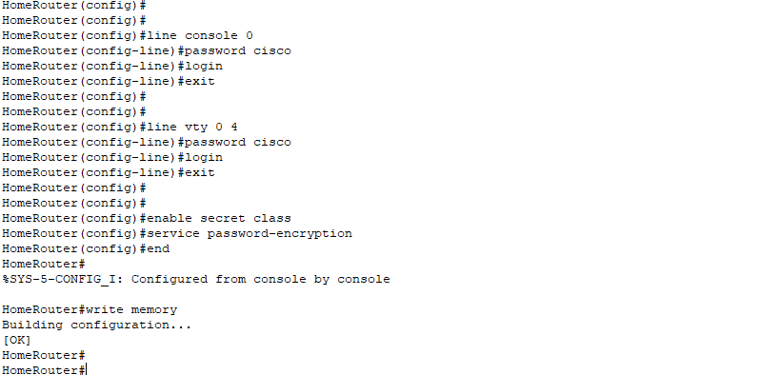
Configuration du switch:
Set Switch Hostname and Configure VLAN 1 Interface IP Address :
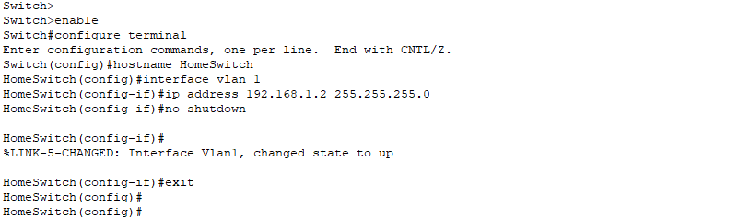
(Note: This assigns IP 192.168.1.2 to VLAN 1’s SVI (Switch Virtual Interface) which enables remote management of the switch on subnet 192.168.1.0/24, otherwise you’ll have to have a physical connection with the switch to configure it. This configuration allows it to be remotely configured using protocols such as Telnet, SSH, SNMP, or HTTP/HTTPS.
`no shutdown` activates the interface.)

Set Default Gateway and Configure Switch Ports for PCs and the other devices :
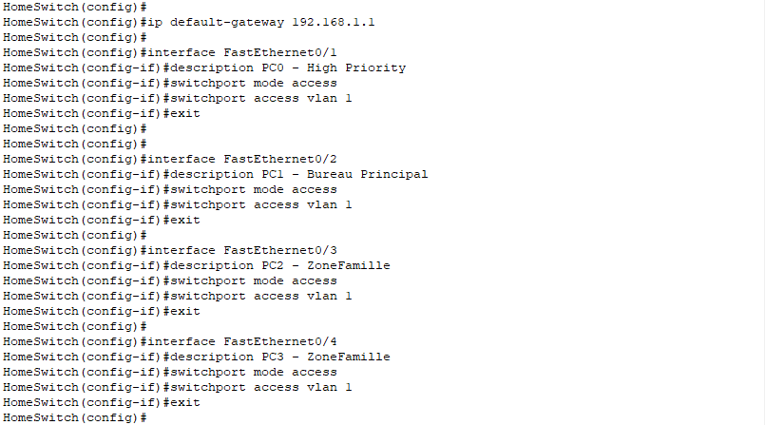
(Notes:
-interface FastEthernet0/1 — selects port Fa0/1.
-description PC0 – Priorite’ Haute — adds a note saying this port connects to PC0 with high priority.
-switchport mode access — configures port as an access port (connects to end devices, not other switches).
-switchport access vlan 1 — assigns port to VLAN 1.
-exit — exits interface config.
We repeated this for all the devices in the network:
Fa0/1 (PC0 - High Priority)
Fa0/2 (PC1 Bureau Principal)
Fa0/3 (PC2 - Family Zone)
Fa0/4 (PC3 - Family Zone)
)

Configure Router Connection Port :
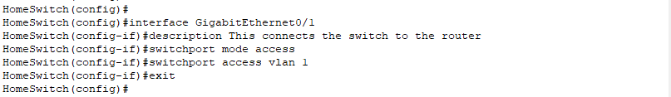
(Notes:
Sets GigabitEthernet0/1 as an access port on VLAN 1, connecting the switch to the router.
)
Access Configurations:
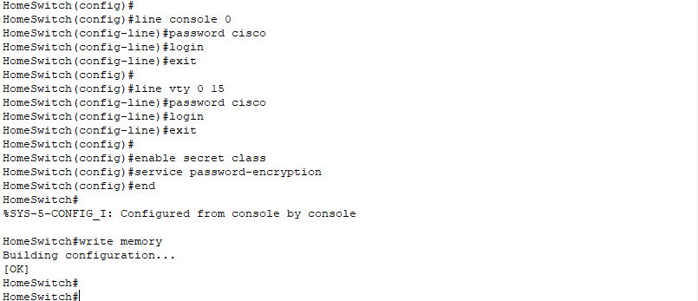
Notes :
• Configures password cisco for console access (physical or terminal connection).
• Enables login prompt on console.
• Sets password cisco for remote logins via Telnet or SSH (VTY lines 0-15 cover up to 16 simultaneous sessions).
• Enables login prompt on VTY.

enable secret class
• Sets the enable secret password to class.
• This password protects privileged EXEC mode (enable mode).
• Enable secret is encrypted, more secure than just enable password.
service password-encryption
• Encrypts all plaintext passwords in the config to prevent casual reading.
write memory
• Saves the running config to startup config — makes it persistent across reboots.

Configuration de la QoS (on the router) :
Define Traffic Classes
• This creates a class map named PC0-TRAFFIC.
• It matches traffic defined in Access Control List (ACL) 101 — in this case, traffic from PC0.

Define Traffic Classes, Access Control Lists (ACLs), QoS Policy:
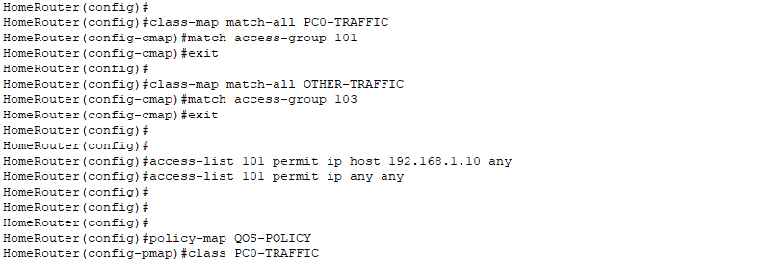
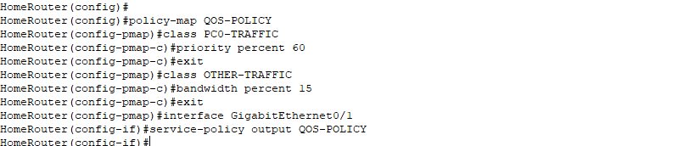
Notes: This assigns a priority of 60% percent to the PC0 (60% of the bandwidth). The other traffic (PC1 – PC2 – PC3 get the remaining 45%).

Configuration de QoS (on the switch) :
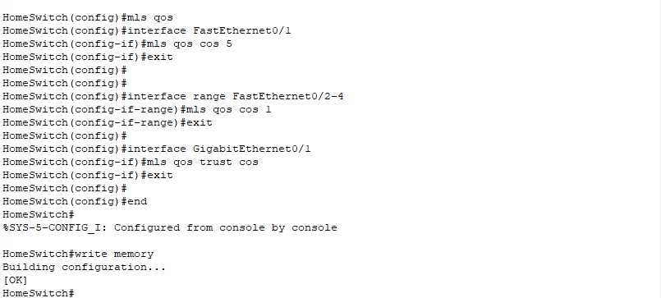
Notes:
`mls qos`
Enables Modular Layer Switch QoS features on the switch.
`interface FastEthernet0/1`
` mls qos cos 5`
Marks packets from PC0 (connected to Fa0/1) with CoS value 5 (high priority).
`interface range FastEthernet0/2-4`
`mls qos cos 1`
Marks PCs 1–3 (connected to Fa0/2-4) with low priority (CoS 1).
`interface GigabitEthernet0/1`
`mls qos trust cos`
Tells the switch to trust CoS values coming from the router.
Ensures packets retain their QoS marking when forwarded between router and switch.
`write memory`
Saves the switch configuration permanently.

Verification du QoS sur le routeur :
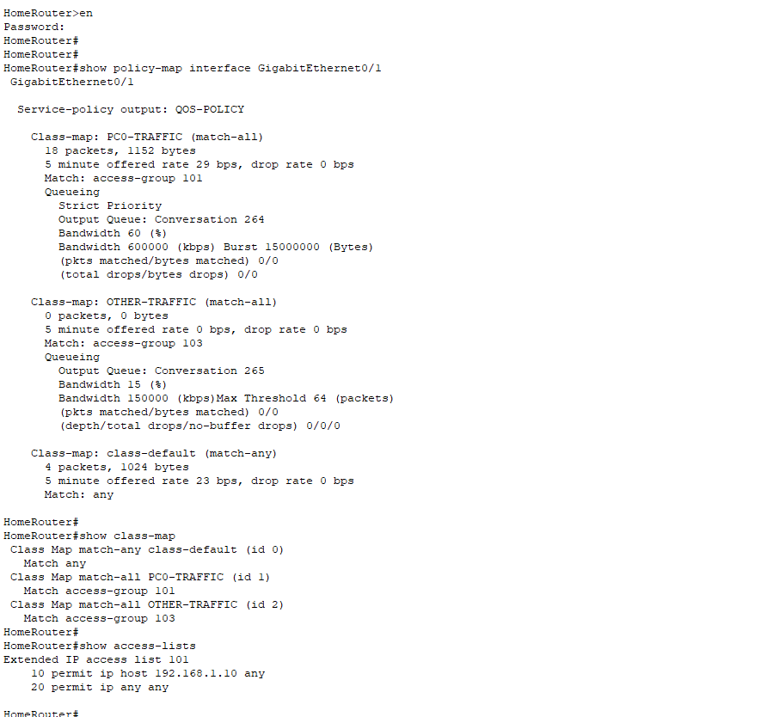

Verif du QoS sur le switch :
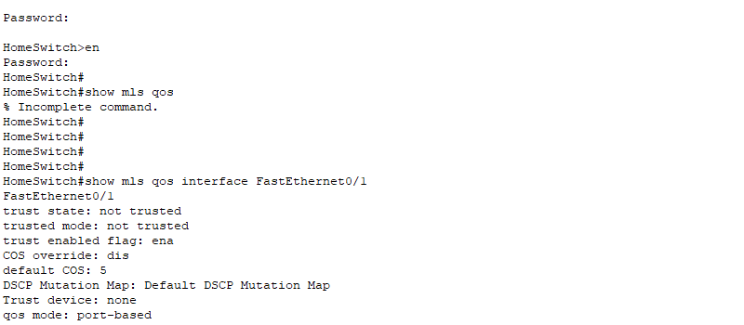
END

