For the Task Categories I created the endpoints:

* POST: localhost:8080/categories/
* PUT: localhost:8080/categories/
* GET: localhost:8080/categories/
* GET: localhost:8080/categories/{id}
* DELETE: localhost:8080/categories /{id}

For the Task I create the endpoints:

* POST: localhost:8080/tasks/
* PUT: localhost:8080/tasks/
* GET: localhost:8080/tasks/
* GET: localhost:8080/tasks/{id}
* DELETE: localhost:8080/tasks/{id}

Some examples:

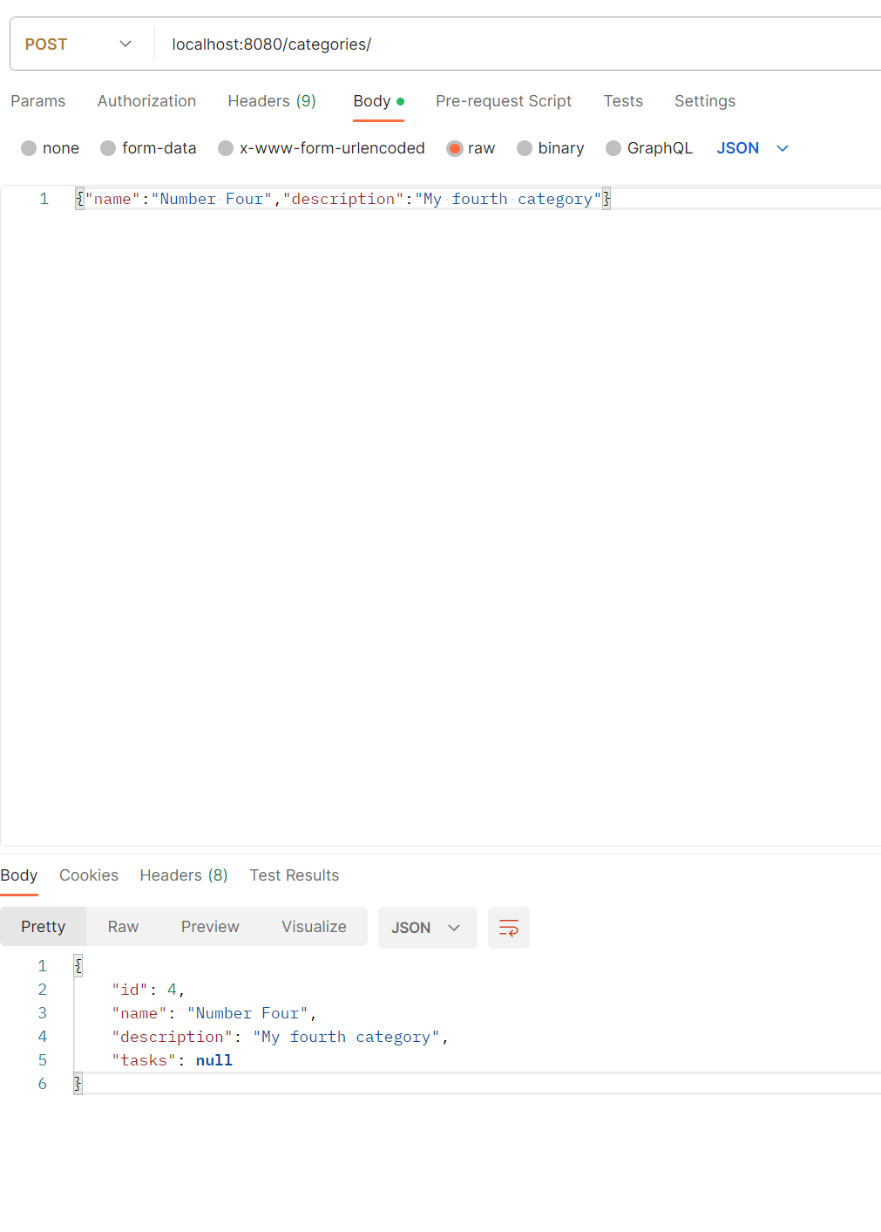

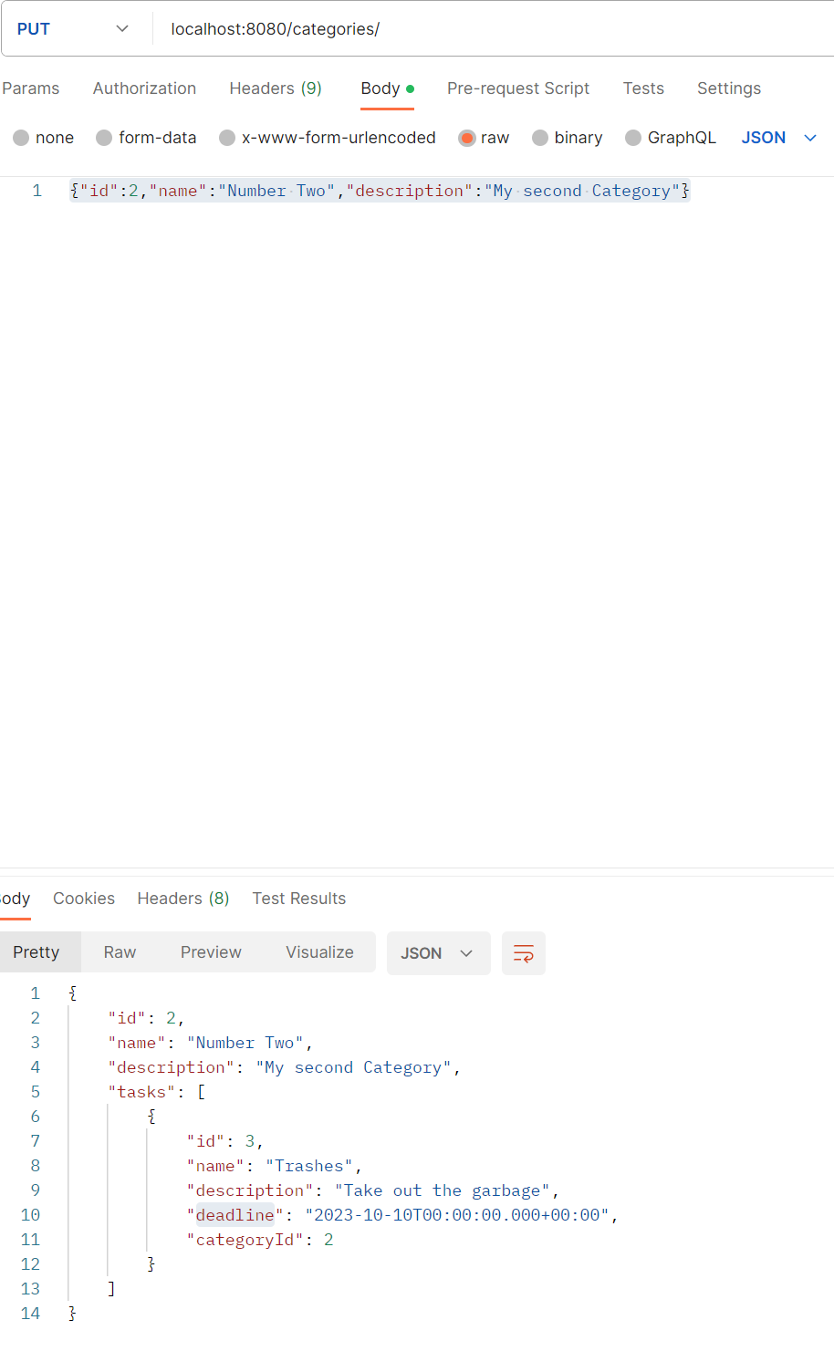

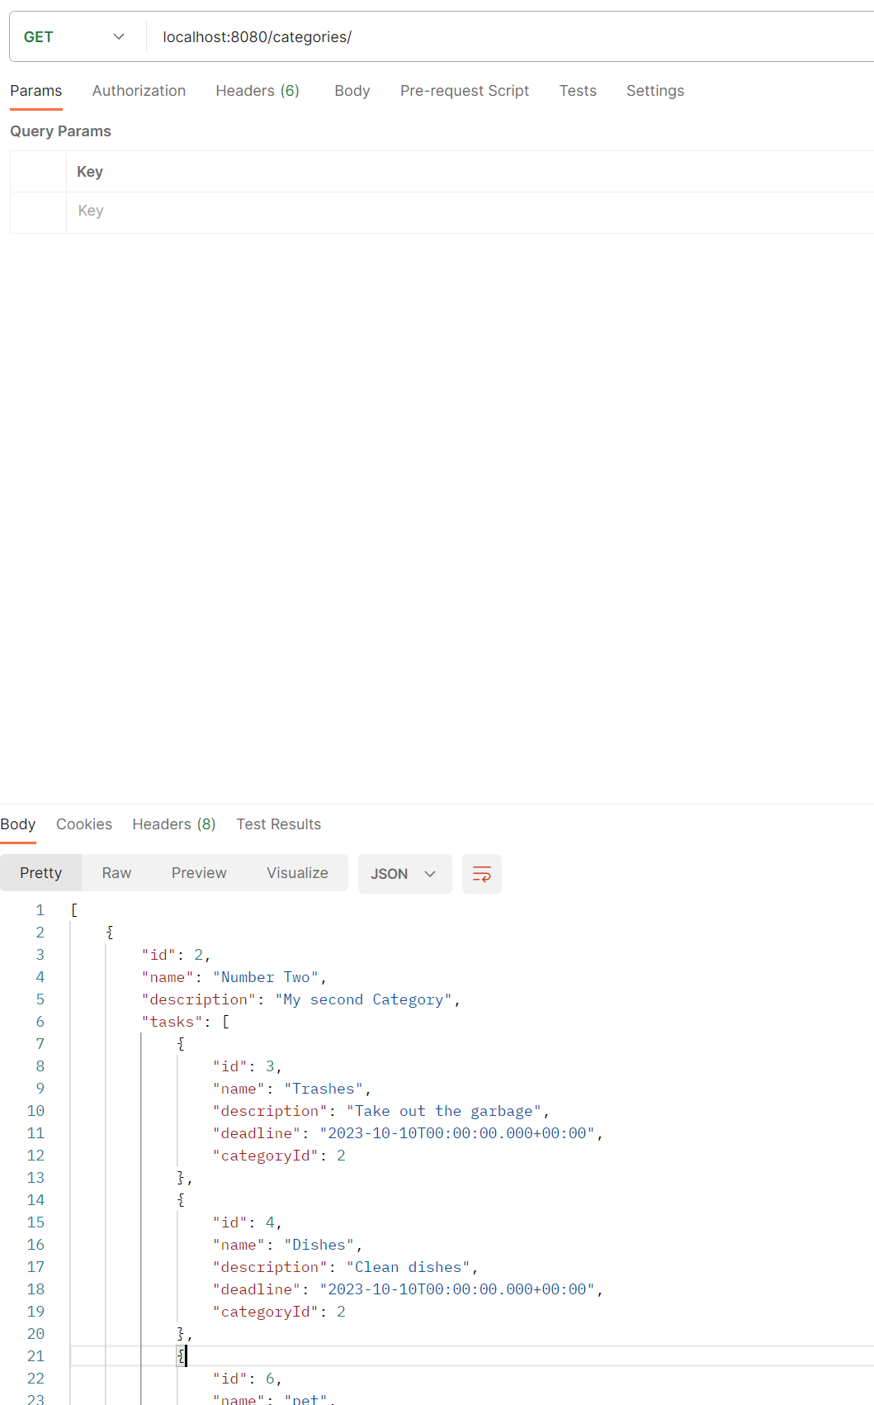

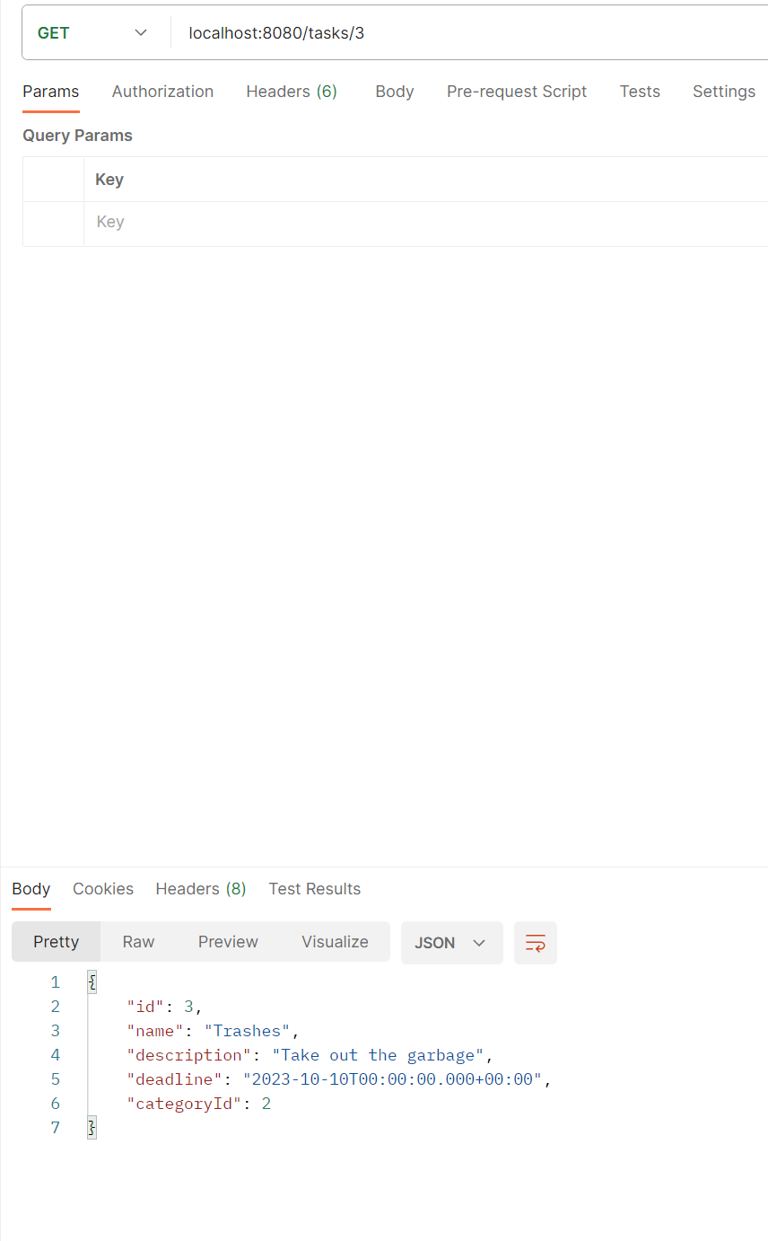

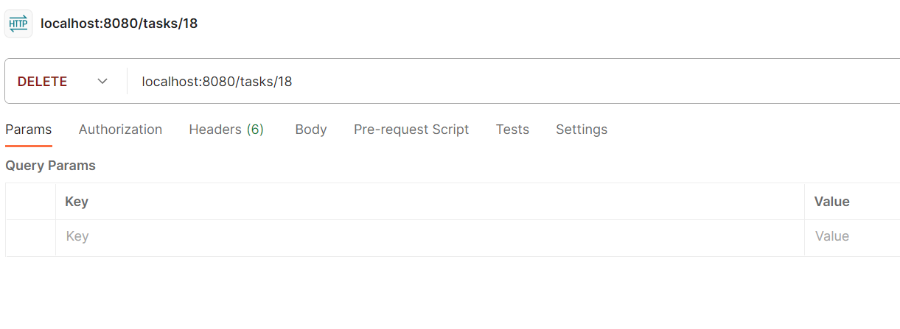

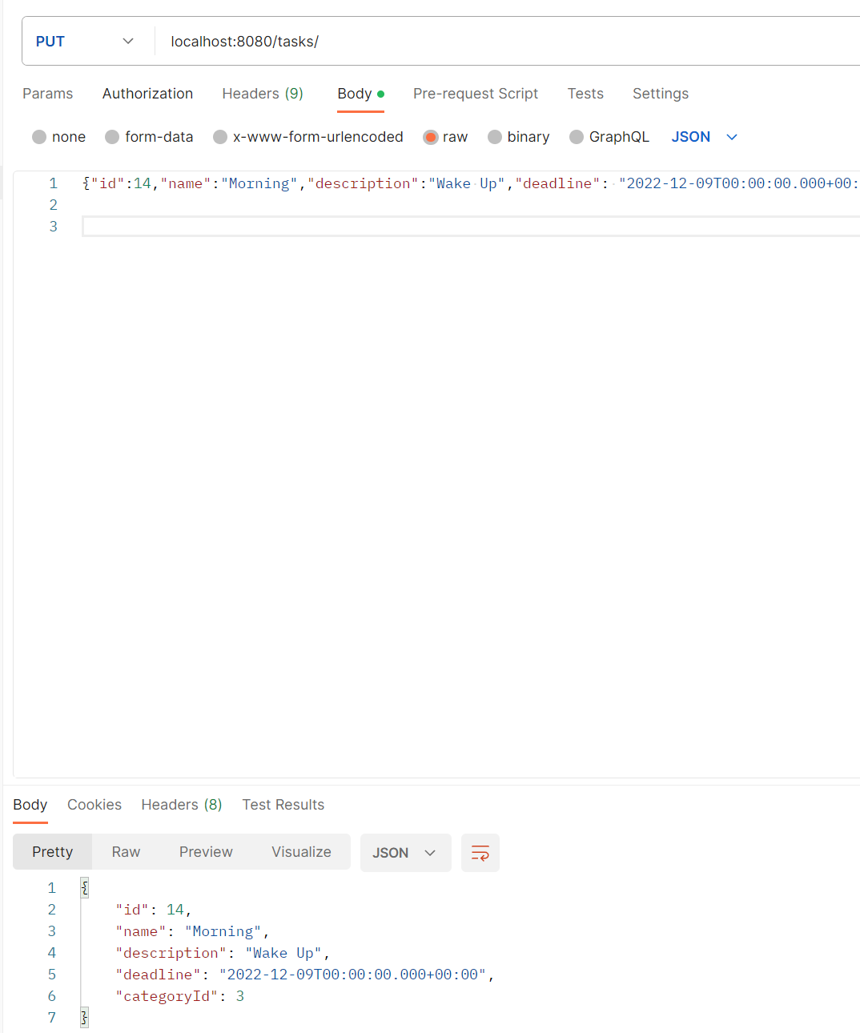

Besides the API, I created a Single Page Application to see my results

Using Angular 16

Some examples:

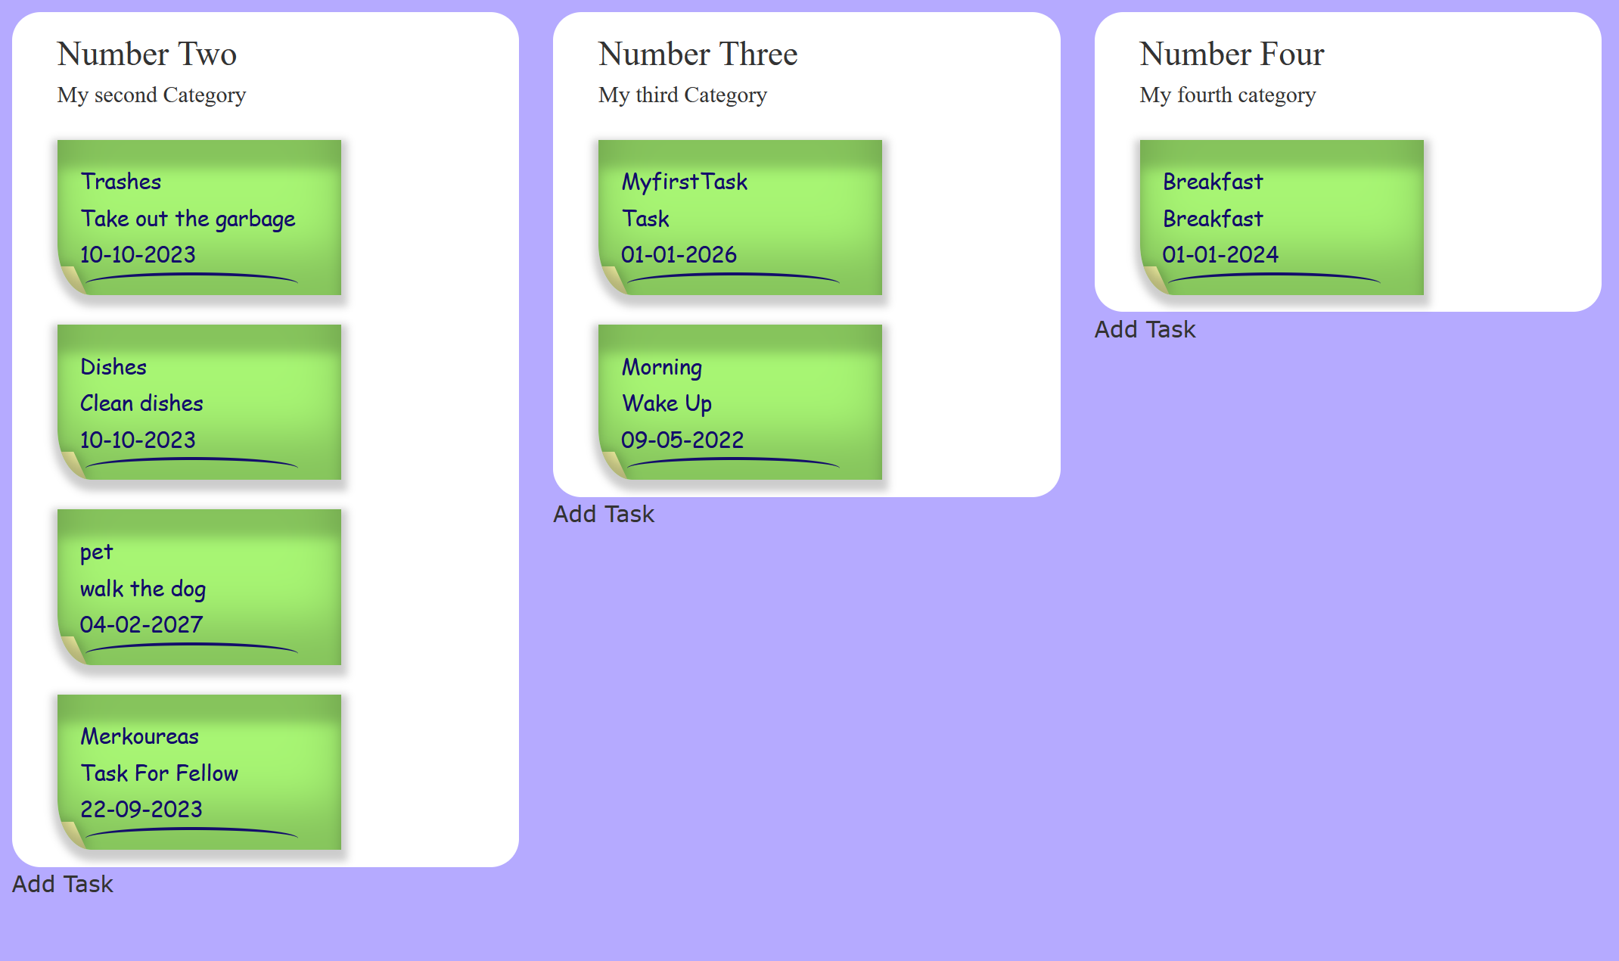

I also created adding a Task

