A CASE-STUDY BASED REPORT
ON
Player Statistics Visualization Using PCA and UMAP for Football Player Data Analysis
submitted in partial fulfilment of the requirements for the Course
MACHINE LEARNING
BACHELOR OF TECHNOLOGY
in
A.Y.: 2026-27
by
I. Harshika Roll No: 2520030607
Mundru Siri Chandana Roll No: 2520030603
Under the Esteemed guidance of
Mr. Shaik Asif
Asst.Professor, Dept. of CSE




INDEX
Abstract 3
Introduction 4
Background 4
Motivation for the Project 5
Overview of the Work Carried Out 5
Scope and Responsible-Use Statement 6
Problem Statement 7
Case-Study Scenario 7
Central Case-Study Question 8
Formal Problem Definition 8
Objectives that Guide the Study 8
Assumptions and Limitations 9
Dataset and Exploratory Data Analysis 10
About the Dataset 10
Purpose of EDA 10
Preparation Steps Actually Performed 11
EDA Exploration - Implementation 12
Summary of EDA Findings 16
Algorithm Selection and Implementation 18
Why PCA? 18
Why UMAP? 20
PCA vs UMAP Comparison 22
Conclusion 24
References 24

Signature of the Team members

1. Abstract
Football databases describe thousands of players through many numerical attributes at the same time. Because such data are high-dimensional, similarities between players, groups of players and relationships among attributes are difficult to see in tables or through one-to-one comparisons. This case study, Player Statistics Visualization Using PCA and UMAP, addresses this difficulty using the FIFA23 Official Player Dataset, which contains 17,660 player records and 29 columns. Seven numerical attributes were selected for the analysis: Age, Overall, Potential, Special, International Reputation, Weak Foot and Skill Moves. These attributes were checked for missing values and standardized using StandardScaler so that all of them contribute on a comparable scale.
The standardized seven-dimensional data were reduced to two dimensions using two unsupervised dimensionality-reduction techniques: Principal Component Analysis (PCA), which is a linear projection, and Uniform Manifold Approximation and Projection (UMAP), which is a nonlinear embedding method (two output dimensions, 15 neighbours, minimum distance 0.1 and random seed 42). In the implementation, the first two principal components explain 48.03% and 16.50% of the total variance respectively, giving 64.53% in total. The resulting two-dimensional scatter plots show the PCA representation as a single continuous, dense distribution of players, whereas the UMAP representation shows the same players as several visually separated dense groups. The two representations are compared qualitatively.
The work is exploratory. It is an unsupervised learning and dimensionality-reduction task with no target variable; it does not predict player performance, does not apply a clustering algorithm and does not report supervised evaluation metrics. Closeness of two players in a plot is interpreted only as similarity in the reduced representation of the seven selected attributes. PCA has been widely used as a data-reduction technique in sports research, as shown by a systematic review of soccer, basketball and rugby studies [1], which is used in this report as supporting literature; the dataset and the UMAP component of this project are independent of that review.
Keywords: FIFA23 player dataset; dimensionality reduction; Principal Component Analysis; UMAP; standardization; data visualization; sports analytics; unsupervised learning.

2. Introduction

2.1 Background
Sports analytics applies data analysis to the evaluation of players, teams and tactics, and football is one of the sports in which large volumes of data are routinely recorded. Football player data can describe a player through many numerical attributes simultaneously. In general sports-analytics settings, match-event statistics such as goals, assists, passes, shots and tackles are common examples of such measurements. These are mentioned here only as general examples; none of them is a column of the FIFA23 dataset used in this project, and none is used in the analysis.
When every record has several attributes, the data are called high-dimensional: each attribute is one dimension, and a player is a point in a space with as many dimensions as there are attributes. Humans can inspect at most two or three dimensions directly, so structure in the data, such as players with similar profiles, cannot be seen by simply looking at the table. Dimensionality reduction addresses this by mapping the data to a space with fewer dimensions (here, two) while retaining as much useful structure as possible.
This project uses two such techniques. Principal Component Analysis (PCA) is a linear technique that finds new axes, called principal components, along which the variance of the data is greatest [3]. Uniform Manifold Approximation and Projection (UMAP) is a nonlinear technique that builds a graph of local neighbourhood relationships among the data points and then finds a low-dimensional layout that preserves that structure as far as possible [2].

Supporting literature
Pino-Ortega et al. [1] published a systematic review titled Training Design, Performance Analysis, and Talent Identification: A Systematic Review about the Most Relevant Variables through the Principal Component Analysis in Soccer, Basketball, and Rugby in the International Journal of Environmental Research and Public Health (2021). Following the PRISMA guidelines, the authors searched four electronic databases and included 34 studies in their synthesis: 17 on soccer, 11 on basketball and 6 on rugby. The review reports that PCA was used in these studies to reduce large sets of technical, tactical, physical, biomechanical and anthropometric variables to a small number of components; according to its abstract, the data sets were reduced by about 75% and an average of roughly four factors was retained, explaining about 80% of the total variance. The authors also recommend that future studies apply PCA to data sets that combine variables from different dimensions.
This review supports the idea that PCA is an established data-reduction technique in sports research. It should be distinguished clearly from the present project: the review is a literature study of soccer, basketball and rugby research based on tracking, match and physical-test variables, and it focuses on PCA only. The present project does not use any data set from that paper; it uses the separate FIFA23 Official Player Dataset, and it additionally applies and compares UMAP. The methodology followed here is the one implemented in the project notebooks, not a methodology taken from the review.

2.2 Motivation for the Project
The FIFA23 dataset contains 17,660 player records. Using only the seven selected attributes, this amounts to 123,620 individual values (17,660 × 7). Reading this many values in a table is impractical, and comparing players attribute by attribute does not show how the whole population is organized. Plotting the attributes against each other does not solve the problem either: seven attributes give 21 different pairs of axes, and each plot shows only two attributes at a time.
A two-dimensional representation allows the entire set of players to be shown in a single plot, so that the analyst can see at a glance how the players are spread, where dense regions occur, and where individual players lie relative to the rest. PCA and UMAP provide this representation in two different ways, and comparing them shows how the choice of method influences what can be seen. This visual exploration is the motivation for the project.

2.3 Overview of the Work Carried Out
The work follows the pipeline implemented in the project notebooks. The FIFA23 Official Player Dataset is loaded and inspected; seven numerical attributes are selected and checked for missing values; the selected features are standardized with StandardScaler; the same standardized matrix is then reduced to two dimensions separately by PCA and by UMAP; each result is plotted as a 2D scatter plot; and finally the two representations are compared in order to explore player similarities and patterns. The workflow is shown in Figure 1 and summarized in Table 1.
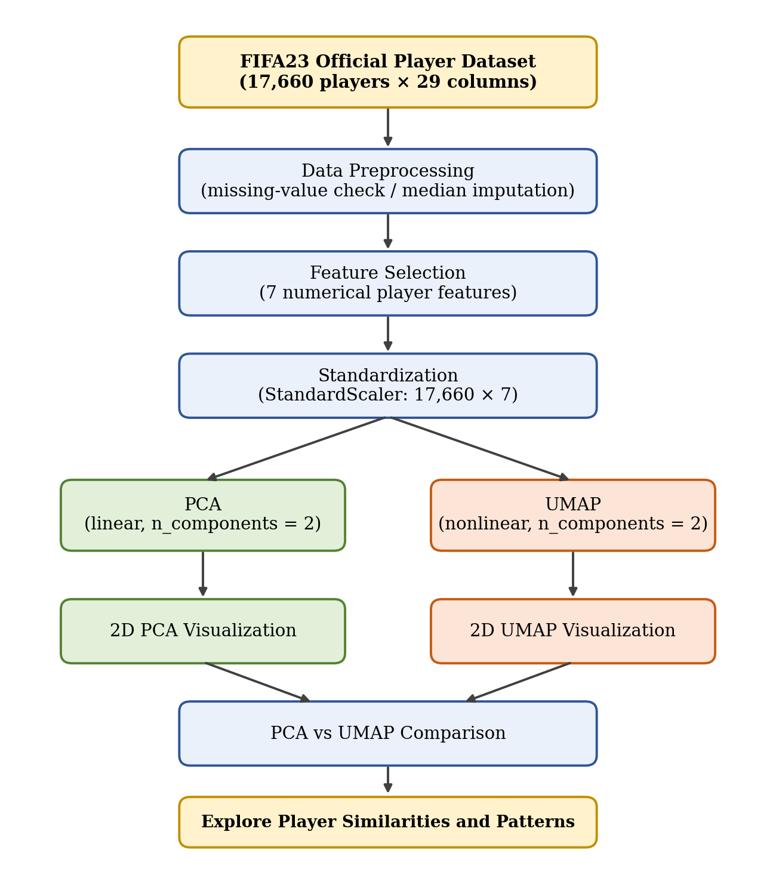
Figure 1: Workflow of the Player Statistics Visualization project (FIFA23 dataset to PCA/UMAP comparison)
Table 1: Stages of the implemented pipeline
Stage | What is done | Tool used
Data loading | FIFA23 CSV (zip) loaded; shape (17,660, 29) confirmed | pandas.read_csv
Preprocessing | Missing values checked in the selected features; median imputation coded | isnull, fillna
Feature selection | Seven numerical attributes selected, giving a 17,660 × 7 matrix | pandas
Standardization | Each feature rescaled to zero mean and unit variance | StandardScaler
PCA | Linear reduction of 7 features to 2 principal components | sklearn.decomposition.PCA
UMAP | Nonlinear reduction of the same 7 features to 2 dimensions | umap.UMAP
Visualization | 2D scatter plots for PCA and UMAP, and a side-by-side comparison | Matplotlib

2.4 Scope and Responsible-Use Statement
This project is an exploratory visualization and analysis of player attributes in the FIFA23 Official Player Dataset. It is intended to help a reader see how players with different attribute values are arranged when seven attributes are projected to two dimensions. The following boundaries apply to the whole report:
- The project is unsupervised. No target or label variable exists, and nothing is being predicted.
- The project does not make or support real-world recruitment, transfer or selection decisions, and it does not predict actual match performance or the future development of any player.
- The attributes belong to a football video-game dataset. Conclusions therefore concern the attribute profiles recorded in this dataset and should not be read as direct measurements of real-world performance.
- No clustering algorithm is applied and no accuracy, precision, recall, F1-score, RMSE or similar metric is reported, because these do not apply to a dimensionality-reduction visualization task.
- Players named in figures and tables are shown only as illustrative examples of where individual records fall in the two-dimensional plots.

3. Problem Statement
Football datasets describe thousands of players, and each player is described by many attributes at once. In this project the FIFA23 Official Player Dataset provides 17,660 players, and seven numerical attributes are selected for each player: Age, Overall, Potential, Special, International Reputation, Weak Foot and Skill Moves. These seven attributes form a multidimensional dataset that is hard to inspect as a whole.
Tables and individual comparisons of players do not easily reveal:
- similar player profiles;
- groups of players;
- relationships between multiple attributes; and
- hidden patterns in the dataset.
Therefore a Machine Learning-based approach is required that reduces the dimensionality of the player data and provides an effective visual representation. This project uses PCA and UMAP to transform the seven player attributes into two-dimensional representations that can be plotted and compared.
Table 2: Existing approach compared with the proposed approach
 | Existing approach | Proposed approach
Method | Tables, basic charts and individual comparisons of player statistics | Standardization followed by PCA and UMAP dimensionality reduction
Attributes handled together | Difficult beyond a few attributes at a time | All seven selected attributes are handled together and shown in 2D
Similar profiles and patterns | Hard to see, and time-consuming to find | Explored visually through scatter plots
Output | Lists of values | Separate 2D PCA and UMAP visualizations and their comparison

3.1 Case-Study Scenario
A football analyst is working with the FIFA23 Official Player Dataset and wants to identify players with similar attribute profiles. The analyst is interested in players who have a similar combination of Overall, Potential, Special and Skill Moves, along with the remaining selected numerical features: Age, International Reputation and Weak Foot.
The analyst faces two difficulties. First, manually comparing these attributes across thousands of players is difficult and time-consuming. Second, a simple table-based comparison gives no easy way to visualize the relationships among players. The analyst therefore needs to answer the question: Which players have similar attribute profiles, and what patterns exist among the players?
Case outcome. With PCA and UMAP applied to the standardized attributes, the analyst can use two-dimensional visual representations instead of comparing thousands of player records manually. The analyst can explore similar player profiles, groups of players, patterns in the attributes and relationships between players, and can compare how the two techniques represent the same player dataset. The case remains an exploration of football player statistics; it is not a recommendation system and it does not rank or select players.

3.2 Central Case-Study Question
The case study is guided by the following central question:
How can PCA and UMAP be used to reduce and visualize FIFA23 player attributes so that similar player profiles and patterns can be explored more easily?

3.3 Formal Problem Definition
Let the selected data be a matrix of n = 17,660 players and d = 7 numerical features, where the row x_{i} ∈ R⁷ holds the Age, Overall, Potential, Special, International Reputation, Weak Foot and Skill Moves values of player i. Each feature j is standardized as z_{ij} = (x_{ij} − μ_{j}) / σ_{j}, where μ_{j} and σ_{j} are the mean and standard deviation of feature j. The problem is to learn a mapping f: R⁷ → R² that gives every player a two-dimensional point y_{i} = f(z_{i}) such that the data can be explored visually. Two mappings are studied: a linear mapping obtained by PCA, and a nonlinear embedding obtained by UMAP.
Table 3: Formal definition of the machine learning task
Element | Definition
Input | Standardized values of the 7 selected numerical player features (Age, Overall, Potential, Special, International Reputation, Weak Foot, Skill Moves) for 17,660 players, i.e. a 17,660 × 7 matrix
Process | Dimensionality reduction using PCA (linear) and UMAP (nonlinear), each applied separately to the same standardized matrix
Output | Two-dimensional representations: PC1 and PC2 from PCA, and UMAP-1 and UMAP-2 from UMAP (each 17,660 × 2)
Goal | Make multidimensional player data easier to explore and compare visually
Learning type | Unsupervised learning / dimensionality reduction

Nature of the learning task. This project is an unsupervised learning and dimensionality-reduction project. There is no target or label variable to be predicted; PCA and UMAP are used to transform and visualize the feature space itself. For this reason, supervised measures such as accuracy, precision, recall, F1-score or RMSE do not apply, and none is reported.

3.4 Objectives that Guide the Study
- Analyze the FIFA23 Official Player Dataset.
- Select relevant numerical player attributes (Age, Overall, Potential, Special, International Reputation, Weak Foot and Skill Moves).
- Preprocess and standardize the selected features.
- Apply PCA for linear dimensionality reduction.
- Apply UMAP for nonlinear dimensionality reduction.
- Generate two-dimensional visualizations of both results.
- Explore player similarities and patterns in the visualizations.
- Compare the PCA and UMAP representations.

3.5 Assumptions and Limitations

Assumptions
- The seven selected numerical features are suitable descriptors of player profiles for exploratory visualization.
- Standardization makes the selected features comparable, so that attributes with large numerical ranges (such as Special) do not dominate those with small ranges (such as Weak Foot).
- PCA and UMAP each provide a useful two-dimensional representation of the standardized data.
- The values in the supplied FIFA23 dataset are taken as given and are treated as the attribute values of each player.

Limitations
- A two-dimensional representation cannot preserve every detail of the original seven-dimensional data. For PCA, 64.53% of the variance is retained in two components, so the remaining 35.47% is not shown in the plot.
- Visual proximity should be interpreted as similarity in the reduced representation, not as proof that players are identical.
- The project is exploratory and does not directly predict real-world football performance.
- The UMAP visualization can depend on parameter settings. Only one setting (n_neighbors=15, min_dist=0.1, random_state=42) was used, and no parameter-sensitivity study was carried out.
- No clustering algorithm and no quantitative measure of embedding quality was computed, so the comparison of PCA and UMAP is qualitative and based on the plots.
- The current EDA does not perform explicit statistical outlier detection; no outlier count is therefore reported.
- The attributes are the numerical columns available in the FIFA23 dataset; other columns, including Value, Wage, Height and Weight, are stored as text in the source file and are not part of the selected feature set.

4. Dataset and Exploratory Data Analysis

4.1 About the Dataset
The dataset used in this project is the FIFA23 Official Player Dataset, supplied as FIFA23_official_data.csv (compressed as a zip file). Loading it in the notebooks gives a table with 17,660 rows (players) and 29 columns. The columns are: ID, Name, Age, Photo, Nationality, Flag, Overall, Potential, Club, Club Logo, Value, Wage, Special, Preferred Foot, International Reputation, Weak Foot, Skill Moves, Work Rate, Body Type, Real Face, Position, Joined, Loaned From, Contract Valid Until, Height, Weight, Release Clause, Kit Number and Best Overall Rating. No other dataset is used [5].
Seven numerical columns were selected for PCA and UMAP. They are listed in Table 4 with the data types reported by the notebook and the minimum and maximum values observed in the dataset file.
Table 4: The seven selected numerical features
# | Feature | Data type | Observed range | Remark
1 | Age | int64 | 15 – 54 | Age of the player
2 | Overall | int64 | 43 – 91 | Overall rating of the player
3 | Potential | int64 | 42 – 95 | Potential rating of the player
4 | Special | int64 | 749 – 2312 | Aggregate rating value; much larger scale than the other features
5 | International Reputation | float64 | 1 – 5 | Small whole-number rating
6 | Weak Foot | float64 | 1 – 5 | Small whole-number rating
7 | Skill Moves | float64 | 1 – 5 | Small whole-number rating

All seven features are numerical, which is a requirement for PCA (which works on variances and linear combinations) and for UMAP (which works on distances between points). The notebook reports no missing values in any of the seven features, so all 17,660 players can be used. Their numerical ranges differ greatly: Special extends from 749 to 2312, whereas International Reputation, Weak Foot and Skill Moves lie between 1 and 5. Standardization is therefore needed before either technique is applied. The remaining columns are text-based, identifier or date columns (for example Name, Nationality, Club and Position) and were not selected.

4.2 Purpose of EDA
Exploratory Data Analysis (EDA) is carried out before modelling in order to understand the data and to check that the selected features are suitable for the techniques that follow. In this project EDA is used to understand:
- the structure of the dataset (number of rows and columns, column names and first records);
- the data types of the columns;
- missing values;
- duplicate records;
- the distribution and relationships of the data; and
- the suitability of the selected features for PCA and UMAP.
Table 5 shows which of these aspects were examined in the current EDA notebook and how.
Table 5: EDA aspects and how they were addressed in the notebook
EDA aspect | Addressed in the notebook? | How
Dataset structure | Yes | df.shape, df.head(), list of column names
Data types | Yes | df.dtypes
Missing values | Yes | isnull().sum() on the full dataset and on the selected features
Duplicates | Yes | X.duplicated().sum() on the selected features
Relationships between features | Indirectly | PCA component contributions (loadings) and the 2D PCA and UMAP plots
Distributions | Indirectly | Density of players in the 2D PCA and UMAP plots; separate histograms were not produced
Suitability of selected features | Yes | Numerical types, absence of missing values, and different numerical ranges (hence standardization)
Statistical outlier detection | No | Not performed in the current EDA

4.3 Preparation Steps Actually Performed
Only the preparation steps present in the EDA notebook are described here. They are listed in order in Table 6.
Table 6: Preparation steps performed in the EDA notebook
Step | Action | Result reported by the notebook
1. Dataset loading | pd.read_csv(file_path, compression="zip") | Shape (17660, 29)
2. Inspection | First rows, column names and data types displayed | 29 columns; mix of int64, float64 and object types
3. Missing-value check | df.isnull().sum() on the full dataset | 10 columns contain missing values (Table 7); none of them is a selected feature
4. Feature selection | X = df[features].copy() with the 7 features | Selected data shape (17660, 7)
5. Missing-value handling | X = X.fillna(X.median()) (median imputation) | 0 missing values before and 0 after; no value was changed
6. Duplicate check | X.duplicated().sum() | 65 duplicate rows (identical values on the 7 selected features); reported, not removed
7. Standardization | StandardScaler().fit_transform(X) | Standardized data shape (17660, 7)

Missing values in the full dataset. The notebook reports missing values in ten of the 29 columns, none of which belongs to the seven selected features (Table 7).
Table 7: Columns of the full dataset that contain missing values
Column | Missing values | Column | Missing values
Club | 211 | Loaned From | 16,966
Body Type | 38 | Contract Valid Until | 361
Real Face | 38 | Release Clause | 1,151
Position | 35 | Kit Number | 35
Joined | 1,098 | Best Overall Rating | 17,639

Missing-value handling. The notebook fills missing numerical values in the selected features with the column median. Because none of the selected features has a missing value, this step leaves the data unchanged. The columns listed in Table 7 are not used in PCA or UMAP.
Duplicates. The notebook counts 65 rows whose values on the seven selected features are identical to those of another row. This check is made on the selected features only, so these rows are not necessarily duplicate player records; the notebook reports the count and does not remove any rows.
Standardization. The features have different numerical ranges, so StandardScaler is applied. It transforms each feature to zero mean and unit variance, ensuring that every feature contributes comparably to PCA and UMAP.
Outliers. Explicit statistical outlier detection (for example, an interquartile-range or z-score rule) was not performed in the current EDA. No outlier count is therefore reported and no records were removed. Observed ranges, such as Age from 15 to 54, are given in Table 4 only to describe the data.
The key preparation code from the EDA notebook is shown below.
features = ["Age", "Overall", "Potential", "Special",
"International Reputation", "Weak Foot", "Skill Moves"]
X = df[features].copy()

X = X.fillna(X.median()) # fill missing numerical values with median
duplicate_count = X.duplicated().sum()

scaler = StandardScaler()
X_scaled = scaler.fit_transform(X)

4.4 EDA Exploration - Implementation
The EDA notebook (PCA & UMAP (EDA REPORT)) is a single end-to-end script. Its exploration is presented below in the order in which it runs: structure and data types, the selected-feature preview, the PCA summary, and the visualizations.

Dataset structure and selected data
The notebook prints the first rows of the dataset, the 29 column names and their data types, and then the first five rows of the selected data, shown in Table 8. The feature values illustrate the scale difference discussed above: Special is about 2,300 for these players, whereas International Reputation, Weak Foot and Skill Moves are single-digit ratings.
Table 8: First five rows of the selected feature matrix (as printed in the notebook)
Row | Age | Overall | Potential | Special | Int. Reputation | Weak Foot | Skill Moves
0 | 27 | 87 | 88 | 2312 | 4.0 | 4.0 | 3.0
1 | 27 | 86 | 87 | 2305 | 3.0 | 3.0 | 4.0
2 | 30 | 85 | 85 | 2303 | 2.0 | 3.0 | 3.0
3 | 31 | 91 | 91 | 2303 | 4.0 | 5.0 | 4.0
4 | 25 | 86 | 89 | 2296 | 3.0 | 3.0 | 3.0

PCA explained variance and component contributions
After standardization, PCA with two components is applied. The notebook prints the explained variance and the contribution (loading) of each feature to PC1 and PC2. PC1 explains 48.03% and PC2 explains 16.50% of the total variance, so the two components together explain 64.53%.
Table 9: PCA component contributions printed by the EDA notebook
Component | Age | Overall | Potential | Special | Int. Rep. | Weak Foot | Skill Moves
PC1 | 0.298 | 0.489 | 0.364 | 0.471 | 0.322 | 0.258 | 0.384
PC2 | 0.655 | 0.161 | −0.285 | −0.177 | 0.429 | −0.351 | −0.353

All seven loadings on PC1 are positive, with the largest contributions from Overall (0.489), Special (0.471) and Skill Moves (0.384); a higher PC1 value therefore corresponds to higher combined values of the attributes. PC2 has its largest positive loadings on Age (0.655) and International Reputation (0.429) and negative loadings on Potential, Special, Weak Foot and Skill Moves, so it contrasts these two groups of attributes.

PCA visualization
Figure 2 plots every player by the two principal components. The players form one continuous, elongated and dense distribution, concentrated at low to moderate PC1 values and thinning out toward high PC1 values. No separate groups can be seen in this projection.
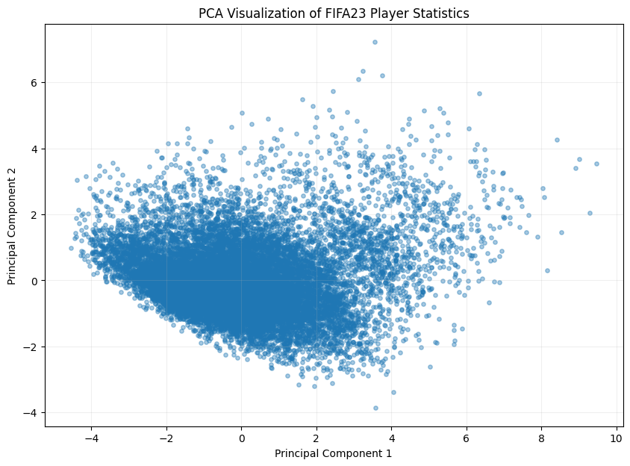
Figure 2: PCA Visualization of FIFA23 Player Statistics (EDA notebook)

UMAP visualization
Figure 3 plots the same players using the UMAP embedding. In contrast to the PCA plot, the players appear as several dense groups of different sizes that are visually separated by empty space; more than ten such groups can be seen, ranging from large dense regions to small fragments. These groups are visual structure in the embedding only: no clustering algorithm was applied, and the notebook does not assign or label groups.
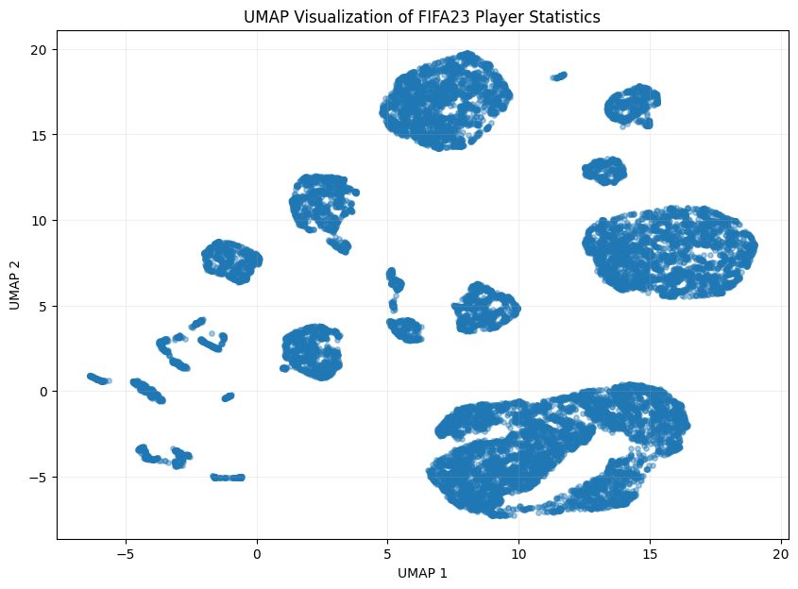
Figure 3: UMAP Visualization of FIFA23 Player Statistics (EDA notebook)

PCA and UMAP side by side
Figure 4 places the two representations next to each other for direct comparison. Both show the same 17,660 players; the difference in appearance arises from the different nature of the two methods.
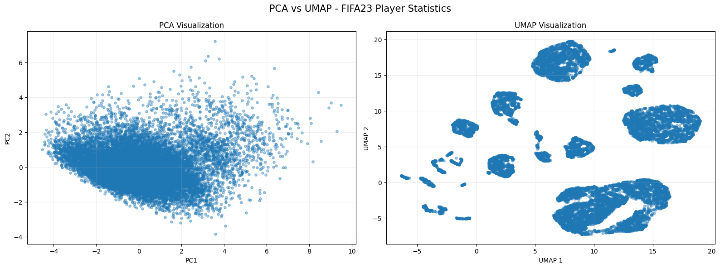
Figure 4: PCA vs UMAP - FIFA23 Player Statistics (EDA notebook)

Selected players in the PCA and UMAP plots
To show where individual records fall, the notebook labels six players: L. Goretzka, Bruno Fernandes, K. De Bruyne, L. Messi, Cristiano Ronaldo and Neymar Jr. Their coordinates are listed in Table 10. These players are used only as illustrative examples.
Table 10: Coordinates of the labelled players (from the notebook output)
Player | Age | Overall | Potential | PCA_1 | PCA_2 | UMAP_1 | UMAP_2
L. Goretzka | 27 | 87 | 88 | 6.985 | 1.942 | −0.607 | −5.036
Bruno Fernandes | 27 | 86 | 87 | 6.186 | 0.976 | −3.065 | −3.499
K. De Bruyne | 31 | 91 | 91 | 8.536 | 1.466 | −0.583 | −5.026
L. Messi | 35 | 91 | 91 | 9.009 | 3.685 | −0.574 | −5.020
Cristiano Ronaldo | 37 | 90 | 90 | 9.479 | 3.543 | −0.543 | −4.987
Neymar Jr | 30 | 89 | 89 | 9.298 | 2.050 | −0.568 | −5.013

In the PCA plot (Figure 5) all six players lie toward the right-hand, high-PC1 end of the distribution (PC1 between 6.19 and 9.48), where few players are located. In the UMAP plot (Figure 6), five of the six players (Goretzka, De Bruyne, Messi, Ronaldo and Neymar) are placed at almost the same position (UMAP-1 between −0.61 and −0.54, UMAP-2 between −5.04 and −4.99), so their labels overlap, while Bruno Fernandes lies close by but separately. This indicates that the five players have very close profiles in the reduced representation of the seven attributes.
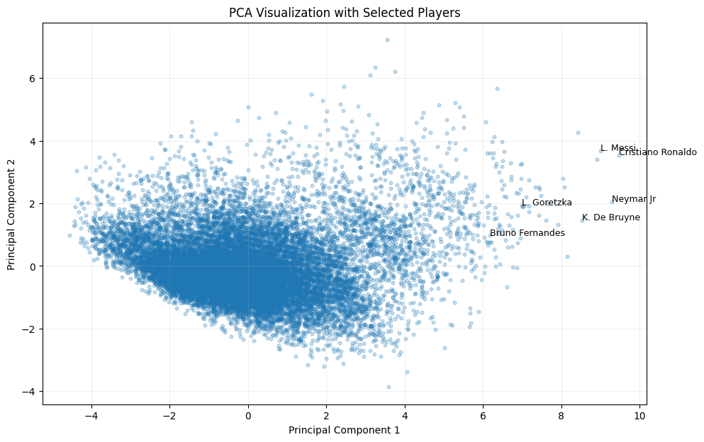
Figure 5: PCA Visualization with Selected Players (EDA notebook)
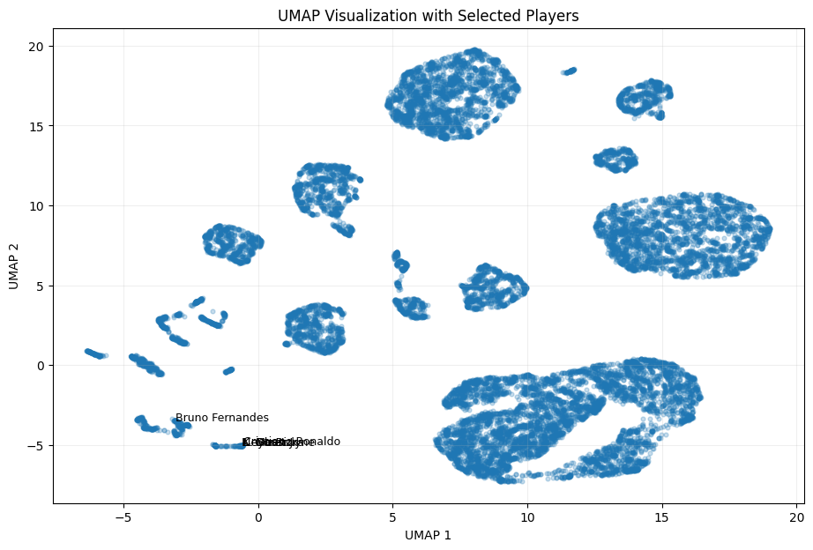
Figure 6: UMAP Visualization with Selected Players (EDA notebook)

4.5 Summary of EDA Findings
The findings below are those shown by the EDA notebook.
- The FIFA23 Official Player Dataset has 17,660 rows and 29 columns. Ten columns contain missing values, but none of them is among the seven selected features.
- The seven selected features (Age, Overall, Potential, Special, International Reputation, Weak Foot, Skill Moves) are numerical and contain no missing values, so median imputation did not change any value.
- The notebook finds 65 rows with identical values on the seven selected features; they were not removed.
- The features are on different numerical scales (for example, Special in the thousands and Weak Foot between 1 and 5), so standardization with StandardScaler was applied before PCA and UMAP.
- The first two principal components explain 48.03% (PC1) and 16.50% (PC2) of the variance, 64.53% in total. All seven loadings on PC1 are positive.
- In the PCA plot the players form one continuous distribution without visibly separated groups, whereas in the UMAP plot they form several visually separated groups.
- The labelled players (Goretzka, De Bruyne, Messi, Ronaldo, Neymar Jr and Bruno Fernandes) lie at the high-PC1 end of the PCA plot; five of them occupy nearly the same position in the UMAP plot.
- Explicit statistical outlier detection was not performed in the current EDA.

5. Algorithm Selection and Implementation
This section describes the two selected algorithms and their implementation, following the notebook Algorithm_Implementation.ipynb. The project is an unsupervised dimensionality-reduction task, so both algorithms are used to transform the feature space, not to predict a label.

Algorithm followed
- Load the FIFA23 Official Player Dataset.
- Select the seven numerical features and check them for missing values.
- Standardize the selected features using StandardScaler.
- Apply PCA to reduce the standardized data to two principal components.
- Apply UMAP to reduce the same standardized data to two dimensions.
- Generate 2D scatter plots for PCA and for UMAP.
- Compare the PCA and UMAP visualizations to explore similar player profiles, groups and patterns.

Implementation environment
Table 11: Software and libraries used
Item | Details
Programming language | Python 3
Environment | Jupyter-style notebook; the algorithm notebook was executed in Google Colab
Libraries | pandas, NumPy, Matplotlib, Seaborn, scikit-learn [4] (StandardScaler, PCA), umap-learn [2] (UMAP)
Dataset | FIFA23_official_data.csv (zipped CSV), 17,660 rows × 29 columns

Common preparation code
Both algorithms use the same standardized matrix produced by the following code from the notebook.
df = pd.read_csv(file_path, compression="zip") # Shape: (17660, 29)

features = ["Age", "Overall", "Potential", "Special",
"International Reputation", "Weak Foot", "Skill Moves"]
X = df[features].copy() # Shape: (17660, 7)
print(X.isnull().sum()) # 0 for every feature

scaler = StandardScaler()
X_scaled = scaler.fit_transform(X) # Scaled shape: (17660, 7)

5.1 Why PCA?
PCA is a linear dimensionality-reduction technique. It creates new variables, called principal components, which are linear combinations of the original standardized features. The components are orthogonal to each other and are ordered so that the first captures the greatest possible variance of the data, the second captures the greatest remaining variance, and so on. Keeping only the first two components reduces the seven-dimensional feature space to two dimensions.
PC1 is the direction of maximum variance in the standardized data, and PC2 is the direction of maximum variance that is orthogonal to PC1. Plotting PC1 against PC2 therefore gives the best two-dimensional linear view of the data in terms of variance. PCA is selected for this project because it is simple, deterministic, fast, and its axes can be interpreted through the loadings of the original features; it also provides a quantitative measure (explained variance) of how much information the 2D view retains. Its use for data reduction in sports research is documented in the literature [1].

PCA implementation (from the notebook)
pca = PCA(n_components=2)

X_pca = pca.fit_transform(X_scaled)

print("PCA completed successfully!")
print("PCA output shape:", X_pca.shape)

explained_variance = pca.explained_variance_ratio_
print("Explained variance by PC1:", explained_variance[0])
print("Explained variance by PC2:", explained_variance[1])
print("Total explained variance:", explained_variance.sum())

plt.figure(figsize=(10, 7))
plt.scatter(X_pca[:, 0], X_pca[:, 1], s=10, alpha=0.5)
plt.xlabel("Principal Component 1")
plt.ylabel("Principal Component 2")
plt.title("PCA Visualization of FIFA23 Player Data")
plt.show()
Table 12: Explanation of the PCA code
Code | Explanation
PCA(n_components=2) | Creates a PCA model that keeps two principal components, reducing 7 dimensions to 2.
pca.fit_transform(X_scaled) | Learns the principal components from the standardized data and projects every player onto them; the result X_pca has shape (17660, 2).
pca.explained_variance_ratio_ | Gives the fraction of the total variance explained by each retained component.
explained_variance.sum() | Adds the two fractions to give the variance retained by the 2D representation.
plt.scatter(X_pca[:, 0], X_pca[:, 1], ...) | Plots PC1 on the x-axis and PC2 on the y-axis; s=10 sets the point size and alpha=0.5 makes points semi-transparent so dense regions are visible.
plt.xlabel, plt.ylabel, plt.title | Label the axes and title the figure.

PCA output
The notebook reports an output shape of (17660, 2) and the following explained variance values:
Table 13: PCA explained variance (Algorithm_Implementation notebook)
Component | Explained variance ratio | Percentage
PC1 | 0.48032 | 48.03%
PC2 | 0.16503 | 16.50%
Total (PC1 + PC2) | 0.64535 | 64.53%

PC1 alone captures nearly half of the total variance, which shows that a large share of the variation across the seven attributes lies along one direction. The loadings (Table 9) show that this direction combines all seven attributes with positive weights, with Overall, Special and Skill Moves contributing most. PC2 adds a further 16.50% and mainly contrasts Age and International Reputation with Potential, Weak Foot, Skill Moves and Special. The remaining 35.47% of the variance is not represented in the two-dimensional plot.
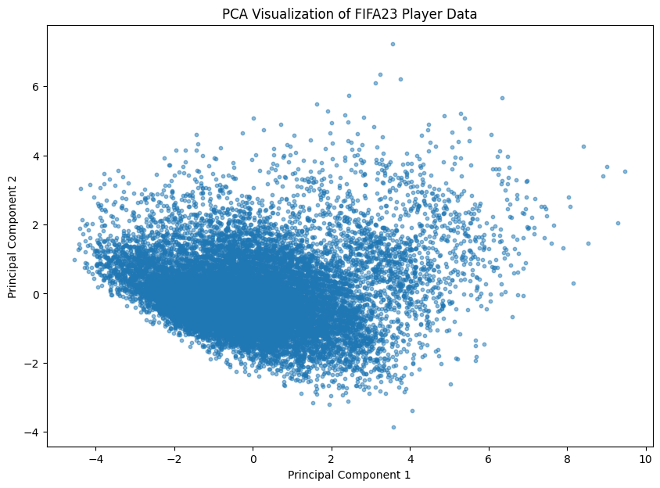
Figure 7: PCA Visualization of FIFA23 Player Statistics (Algorithm_Implementation notebook)
The PCA plot in Figure 7 shows one dense, continuous distribution of players with a long tail toward high PC1 values. Players are arranged along a gradual trend rather than in separated groups.

5.2 Why UMAP?
UMAP stands for Uniform Manifold Approximation and Projection [2]. It is a nonlinear dimensionality-reduction technique that creates a low-dimensional embedding of the data. It first builds a weighted graph of each point’s nearest neighbours in the original space and then optimizes a two-dimensional layout so that the neighbourhood structure of this graph is preserved as closely as possible. Because it does not restrict itself to linear projections, it can reveal local structure, such as groups of similar records, that a linear projection may merge.
UMAP is selected here to represent the same standardized seven-feature dataset in two dimensions and to contrast the nonlinear embedding with the linear PCA projection.

UMAP implementation (from the notebook)
umap_model = umap.UMAP(
n_components=2,
n_neighbors=15,
min_dist=0.1,
random_state=42
)

X_umap = umap_model.fit_transform(X_scaled)

print("UMAP completed successfully!")
print("UMAP output shape:", X_umap.shape)

plt.figure(figsize=(10, 7))
plt.scatter(X_umap[:, 0], X_umap[:, 1], s=10, alpha=0.5)
plt.xlabel("UMAP-1")
plt.ylabel("UMAP-2")
plt.title("UMAP Visualization of FIFA23 Player Data")
plt.show()
Table 14: UMAP parameters used in the notebook
Parameter | Value | Meaning
n_components | 2 | Number of dimensions of the output embedding; 2 allows a scatter plot.
n_neighbors | 15 | Size of the local neighbourhood used to build the graph. Smaller values emphasise fine local structure; larger values emphasise broader structure.
min_dist | 0.1 | Minimum distance allowed between points in the embedding. Smaller values pack similar points more tightly.
random_state | 42 | Seed for the random number generator, so that the embedding can be reproduced. The library warns that setting it makes the computation single-threaded.

No distance metric was specified, so the default of the umap-learn library applies. In the code, umap.UMAP(...) creates the model with the parameters above, fit_transform(X_scaled) builds the neighbourhood graph and returns the embedding X_umap of shape (17660, 2), and the remaining lines plot UMAP-1 against UMAP-2 in the same way as for PCA.

UMAP output
The notebook reports "UMAP completed successfully!" with an output shape of (17660, 2). The embedding is shown in Figure 8. Unlike PCA, the players do not form one continuous distribution: they appear as several dense groups of different sizes separated by empty space, with the largest groups at the top, right and lower right of the plot. As noted earlier, these groups are visual structure only; no clustering was performed. The UMAP axes have no direct interpretation, and the distances between separate groups and their relative positions should not be read quantitatively.
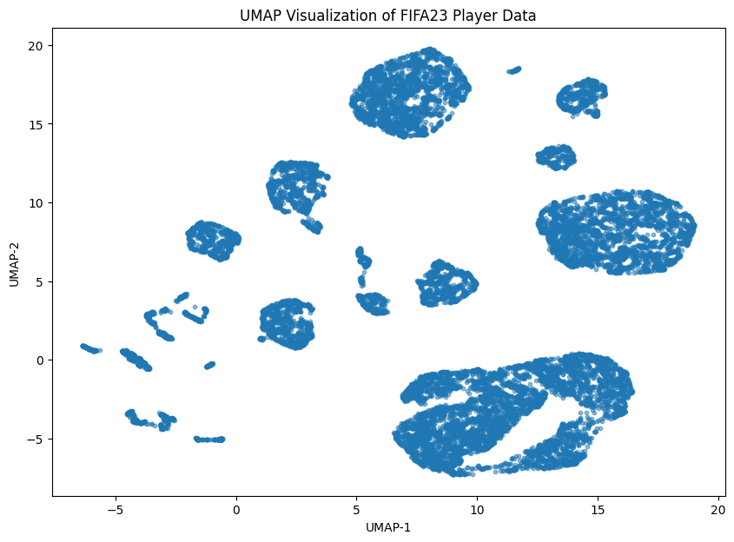
Figure 8: UMAP Visualization of FIFA23 Player Statistics (Algorithm_Implementation notebook)
The coordinates printed for the first five players by this notebook (for example, L. Goretzka: PCA_1 = 6.985, PCA_2 = 1.942, UMAP_1 = −0.607, UMAP_2 = −5.036) are identical to those printed by the EDA notebook, confirming that both notebooks produce the same result with the same parameters.

5.3 PCA vs UMAP Comparison
Table 15 compares the two techniques as used in this project. The comparison is descriptive: PCA provides a linear projection, while UMAP provides a nonlinear embedding that can preserve local neighbourhood structure.
Table 15: Comparison of PCA and UMAP in this project
Aspect | PCA | UMAP
Type | Linear dimensionality reduction | Nonlinear dimensionality reduction
Main idea | Finds orthogonal directions (principal components) of maximum variance | Builds a nearest-neighbour graph and finds a 2D layout that preserves local neighbourhood structure
Dimensionality reduction | 7 → 2 (PC1, PC2) | 7 → 2 (UMAP-1, UMAP-2)
Representation | Each axis is a linear combination of the 7 standardized features, with known loadings | Embedding coordinates with no direct feature meaning
Information measure | Explained variance: 48.03% + 16.50% = 64.53% | No variance measure; no quantitative metric was computed
Parameters in this project | n_components=2 | n_components=2, n_neighbors=15, min_dist=0.1, random_state=42
Dependence on settings | Deterministic for a given standardized input | Depends on parameter settings and on the random seed
Strength / use in this project | Interpretable global view; shows overall trend and the contribution of each attribute | Brings out local groupings among similar players that appear as separate dense regions
Visualization characteristics | One continuous, dense distribution with a tail toward high PC1; no separated groups | Several dense groups of different sizes separated by empty space; axes and between-group distances not directly interpretable

Figure 9 presents the two outputs side by side for the same 17,660 players. The two methods answer different questions: PCA shows how the players vary along the main linear directions of the seven attributes and how much variance this retains, whereas UMAP emphasises which players are close to one another in terms of local neighbourhoods. They are therefore complementary views of the same standardized data. Since no quantitative evaluation of the embeddings was performed, and since the UMAP result depends on its parameters, this report does not declare either technique to be better than the other.
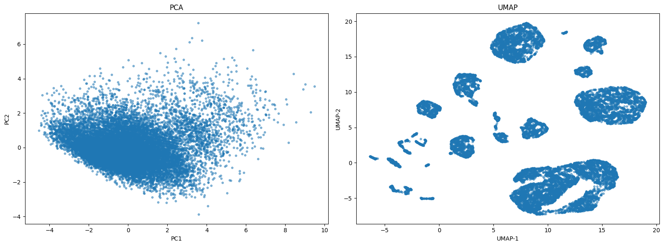
Figure 9: PCA vs UMAP Visualization of FIFA23 Player Statistics (Algorithm_Implementation notebook)

6. Conclusion
This case study applied dimensionality reduction to the FIFA23 Official Player Dataset in order to make multidimensional player data easier to explore. Seven numerical features (Age, Overall, Potential, Special, International Reputation, Weak Foot and Skill Moves) were selected for 17,660 players, checked for missing values (none were found in the selected features) and standardized using StandardScaler. The standardized seven-dimensional data were then reduced to two dimensions using PCA and UMAP, and each result was visualized as a two-dimensional scatter plot.
With PCA, the first two principal components explain 48.03% and 16.50% of the variance (64.53% in total), and the players appear as a single continuous distribution. With UMAP (two output dimensions, 15 neighbours, minimum distance 0.1 and random seed 42), the same players appear as several visually separated dense groups. The comparison shows that PCA offers an interpretable linear projection with a measurable share of retained variance, whereas UMAP offers a nonlinear embedding that preserves local neighbourhood structure; the two are complementary ways to explore player similarities and patterns, and neither is declared superior.
The project is exploratory and unsupervised. It does not predict player performance, does not guarantee the identification of the best players, and does not support real-world recruitment decisions. Closeness in a plot indicates similarity in the reduced representation of the seven attributes, not identity, and the UMAP result depends on its parameter settings.
Possible future extensions, which were not carried out in this work, include testing other UMAP parameter settings, applying a clustering algorithm to the embeddings, and evaluating the embeddings with a quantitative measure.

References
[1] Pino-Ortega, J.; Rojas-Valverde, D.; Gómez-Carmona, C.D.; Rico-González, M. Training Design, Performance Analysis, and Talent Identification—A Systematic Review about the Most Relevant Variables through the Principal Component Analysis in Soccer, Basketball, and Rugby. Int. J. Environ. Res. Public Health 2021, 18(5), 2642. https://doi.org/10.3390/ijerph18052642
[2] McInnes, L.; Healy, J.; Melville, J. UMAP: Uniform Manifold Approximation and Projection for Dimension Reduction. arXiv 2018, arXiv:1802.03426.
[3] Jolliffe, I.T.; Cadima, J. Principal component analysis: a review and recent developments. Philos. Trans. R. Soc. A 2016, 374, 20150202.
[4] Pedregosa, F.; et al. Scikit-learn: Machine Learning in Python. J. Mach. Learn. Res. 2011, 12, 2825–2830.
[5] FIFA23 Official Player Dataset (FIFA23_official_data.csv), 17,660 records × 29 columns, as supplied with the project.

