
OPERATING SYSTEMS AND SYSTEMS PROGRAMMING (25CS2104E)
2026–27, Term-I
Project Problem Statement Submission Form
Section / Team Details
Section No.: 1
Team No.: 7
Project Title: Linux Process Creation, Execution and Termination System
Team Members
Roll Number | Student Name | Signature
2520030607 | Ili.Harshika
2520030512 | Gurrapu Nikshitha
2520030365 | Angela Jose

1. Abstract
Process management is an important function of an Operating System, as it involves creating, executing, synchronizing, and terminating processes. This project proposes a Linux Process Creation, Execution and Termination System developed using the C programming language and Linux/POSIX system calls. The system demonstrates the basic life cycle of a process in a practical way.
The system creates a child process from a parent process using the fork() system call. The child process executes a selected program using the exec() family of system calls, while the parent process waits for the child to complete using wait(). After the child process terminates, the parent retrieves and displays the termination status. The project provides a clear practical understanding of parent-child relationships, process creation, program execution, process synchronization, and process termination in a Linux environment.
2. Problem Statement
This project aims to develop a Linux-based system that practically demonstrates the complete process life cycle. The system will create a child process from a parent process using fork(), execute a selected program in the child using the exec() family of system calls, and allow the parent process to wait for the child using wait(). After the child completes its execution and terminates, the system will retrieve and display its termination status. This provides a practical understanding of process creation, execution, synchronization, and termination in Linux.
3. Objectives
- To implement process creation in Linux using the fork() system call and understand the parent-child process relationship.
- To execute a selected program in the child process using the exec() family of system calls.
- To synchronize the parent and child processes using the wait() system call.
- To demonstrate process termination and retrieve and display the termination status of the child process.
4. Proposed Methodology
The system is implemented in C on a Linux platform using standard POSIX system calls. Execution begins when the user selects a program to run. The main process then invokes fork() to create a child process, splitting execution into two paths. The parent process calls wait() and blocks until the child finishes, while the child process calls an exec() function to replace its process image with the selected program and run it to completion. Once the program finishes, the child process terminates, and the parent, unblocked from wait(), retrieves the child's exit/termination status. Finally, the result is displayed to the user, showing whether the program executed successfully or failed. The overall project flow is illustrated below.
- Project Overflow :

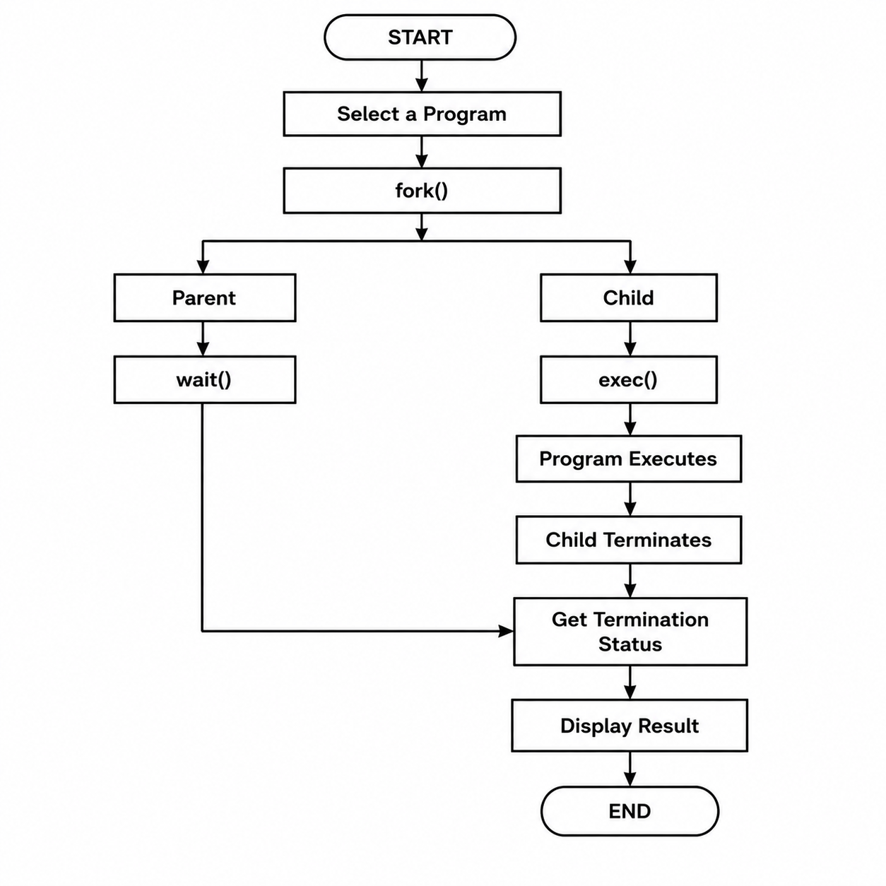
5. Operating Systems Concepts / Linux APIs Used
OS Concept / Linux API / System Call | Purpose in the Project
fork() | Creates a new child process (duplicate of the parent process)
exec() family (execvp/execl) | Replaces the child process image with the selected program
wait() / waitpid() | Suspends the parent until the child process terminates; synchronizes parent and child
Process ID (PID, PPID) | Uniquely identifies parent and child processes
Exit status / WIFEXITED, WEXITSTATUS | Used to retrieve and interpret the child's termination status
Process Control Block (PCB) concept | Underlying OS structure that maintains process state, used to explain process lifecycle

6. Individual Contribution
Roll Number | Student Name | Individual Responsibility
2520030607 | Ili.Harshika | Implement process creation using fork() and handle the parent-child process relationship.
2520030512 | Gurrapu Nikshitha | Implement program execution using exec() and process synchronization using wait().
2520030365 | Angela Jose | Implement process termination and exit-status handling, and perform testing of the system.

7. Tools / Platforms / Software Used
Tool / Platform / Software | Purpose
Linux / Ubuntu | Base operating system on which the program is developed and executed
C / C++ | Programming language used to implement fork(), exec(), and wait() calls
GCC Compiler | Used to compile the C source code into an executable
GDB / Terminal | Used for debugging and running/testing the program
VS Code | Code editor used for writing and organizing the project source code

8. Expected Outcome
The system is expected to successfully create a child process using fork(), execute a user-selected program in the child using the exec() family of calls, and have the parent process synchronize with the child using wait(). Upon completion, the system should correctly retrieve and display the child process's termination status, giving a clear, working demonstration of process creation, execution, synchronization, and termination on a Linux system.

9. GitHub Repository
GitHub Repository Link: https://github.com/iliharshika/SystemForge_OSSP
https://github.com/gurrapunikshitha/SystemForge_OSSP
https://github.com/angelapvjose92/SystemForge_OSSP

Repository Created: Yes

Faculty Name and Signature
Faculty Name: Dr.D.Bheekya
Signature: ______________________________________________________________
Remarks: ______________________________________________________________________

----------------------------------------------------------------------------------------------------------------------------

Faculty Use
Project Approved: ___________________________________
☐ Yes ☐ No
Date: _________________________________________________________________
Faculty Signature: _____________________________________________

