**COMPUTER GRAPHICS**

**CASE STUDY ON KRITA GRAPHICS DESIGNING SOFTWARE**

**wefwrefwrgrg**

**NAME – ILIHAS PATEL**

**ROLL NO-20CO033**

**BRANCH – COMPUTER ENGINEERING**

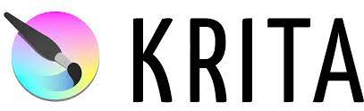

**CONTENTS**

* **Introduction to krita**
* **History**
* **Design and features**
* **Customization**
* **Display**
* **versions**

**INTRODUCTION TO krita**

**Krita**  is a [free and open-source](https://en.wikipedia.org/wiki/Free_and_open-source) [raster graphics editor](https://en.wikipedia.org/wiki/Raster_graphics_editor) designed primarily for [digital painting](https://en.wikipedia.org/wiki/Digital_painting) and [2D animation](https://en.wikipedia.org/wiki/Animation#2D_animation).

It runson [Windows](https://en.wikipedia.org/wiki/Windows), [macOS](https://en.wikipedia.org/wiki/MacOS), [Linux](https://en.wikipedia.org/wiki/Linux), [Android](https://en.wikipedia.org/wiki/Android_(operating_system)) and [Chrome OS](https://en.wikipedia.org/wiki/Chrome_OS). It features an [OpenGL](https://en.wikipedia.org/wiki/OpenGL)-accelerated canvas, [colour management](https://en.wikipedia.org/wiki/Color_management) support, an advanced brush engine, non-destructive [layers](https://en.wikipedia.org/wiki/Layers_(digital_image_editing)) and masks, group-based layer management, [vector artwork](https://en.wikipedia.org/wiki/Vector_artwork) support and switchable customisation profiles.

The project's name "Krita" is primarily inspired by the [Swedish](https://en.wikipedia.org/wiki/Swedish_language) words [*krita*](https://en.wiktionary.org/wiki/krita#Swedish), meaning "[crayon](https://en.wikipedia.org/wiki/Crayon)" (or [chalk](https://en.wikipedia.org/wiki/Chalk)), and [*rita*](https://en.wiktionary.org/wiki/rita#Swedish) which means "to draw".

A look to Krita-

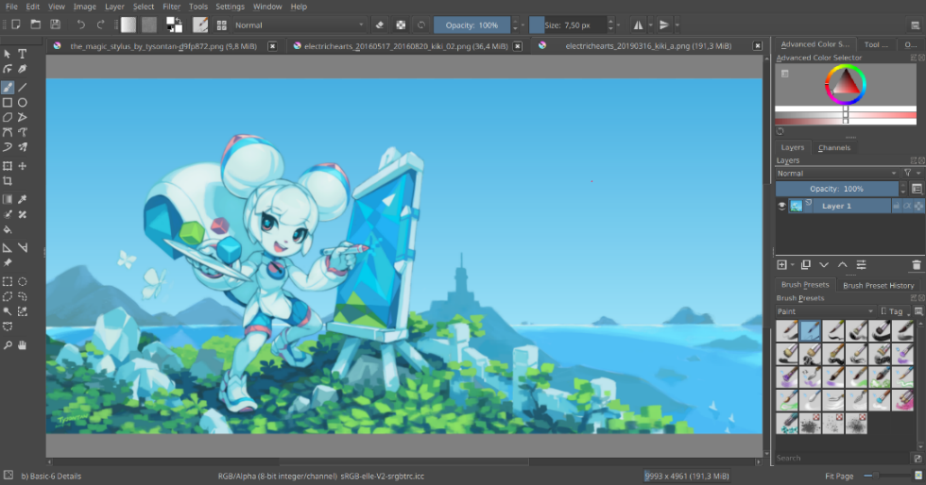

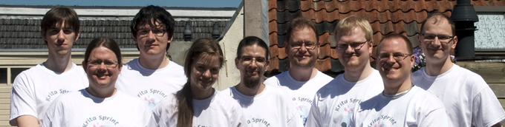

The team of developers of krita

**HISTORY**

Early development of the project can be tracked back to 1998 when [Matthias Ettrich](https://en.wikipedia.org/wiki/Matthias_Ettrich), founder of [KDE](https://en.wikipedia.org/wiki/KDE), showcased a [Qt](https://en.wikipedia.org/wiki/Qt_(software)) GUI [hack](https://en.wikipedia.org/wiki/Hack_(computer_science)) for [GIMP](https://en.wikipedia.org/wiki/GIMP) at [Linux Kongress](https://en.wikipedia.org/wiki/Linux_Kongress). The idea of building a Qt-based image editor was later passed to KImage, maintained by Michael Koch, as a part of [KOffice suite](https://en.wikipedia.org/wiki/KOffice). In 1999, Matthias Elter proposed the idea of building the software. Using [CORBA](https://en.wikipedia.org/wiki/Common_Object_Request_Broker_Architecture) around [ImageMagick](https://en.wikipedia.org/wiki/ImageMagick). To avoid existing trademarks on the market, the project underwent numerous name changes: KImageShop, Krayon, until it was finally settled with "Krita" in 2002. The first public version of Krita was released with KOffice 1.4 in 2004.[[8]](https://en.wikipedia.org/wiki/Krita#cite_note-8) In years between 2004 and 2009, Krita was developed as a generic image manipulation software like [Photoshop](https://en.wikipedia.org/wiki/Adobe_Photoshop) and GIMP.

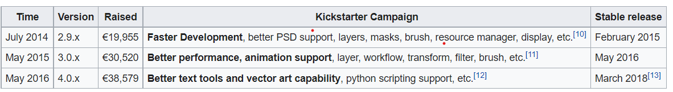A change of direction happened to the project in 2009, with a new goal of becoming digital painting software like [Corel Painter](https://en.wikipedia.org/wiki/Corel_Painter) and [SAI](https://en.wikipedia.org/wiki/Paint_Tool_SAI). Also from that point, the project began to experiment with various ways of funding its development, including [Google Summer of Code](https://en.wikipedia.org/wiki/Google_Summer_of_Code) and funded jobs for students. As a result, the development gained speed and resulted in better performance and stability.

The **Krita Foundation** was created in 2013 to provide support for Krita's development. It collaborated with [Intel](https://en.wikipedia.org/wiki/Intel) to create Krita Sketch as a marketing campaign and Krita Studio with [KO GmbH](https://en.wikipedia.org/wiki/KO_GmbH) as a commercially supported version for movie and VFX studios. [Kickstarter](https://en.wikipedia.org/wiki/Kickstarter) campaigns have been used to crowdfund Krita's development since 2014.

**DESIGN AND FEATURES**

The current version of Krita is developed with [Qt 5](https://en.wikipedia.org/wiki/Qt_5) and [KDE Frameworks 5](https://en.wikipedia.org/wiki/KDE_Frameworks_5). It is designed primarily for [concept artists](https://en.wikipedia.org/wiki/Concept_art), illustrators, matte and texture artists, and the VFX industry. It has the following key features

The most prominent feature of Krita is arguably its [UX](https://en.wikipedia.org/wiki/User_experience) design with [graphics tablet](https://en.wikipedia.org/wiki/Graphics_tablet) users in mind. It uses a combination of pen buttons, keyboard modifiers and an icon-based [HUD](https://en.wikipedia.org/wiki/Head-up_display) to ensure frequently-used functions can be accessed by fewer clicks, without the need to search through text-based menus.

**Most-used drawing commands** can be accessed via touch by combining keyboard modifiers with pen/mouse buttons and gestures:

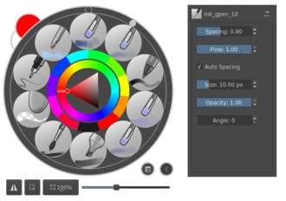

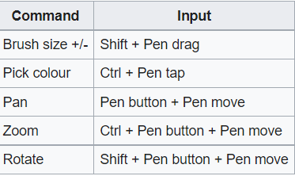

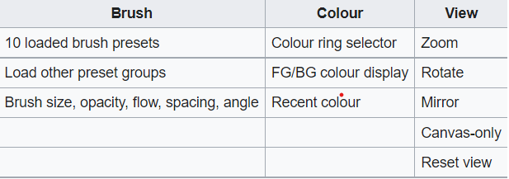

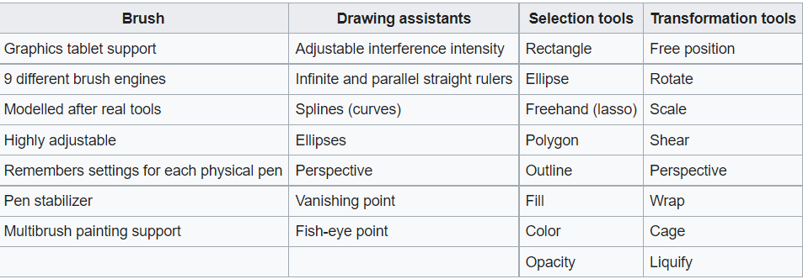

Customisation

**Krita's resource manager** allows each brush or texture preset to be tagged by a user and quickly searched, filtered and loaded as a group. A collection of user-made presets can be packaged as "**bundles**" and loaded as a whole. Krita provides many such brush set and texture bundles on its official website.

**Customisable tool panels** are known as **Dockers** in Krita. Actions include:

* 2 customisable toolbars
* Toggle display of each docker
* Attach any docker to any sides of main window, or detach to float free
* Buttons to collapse/expand each docker panel
* Group dockers by tabs

**Workspaces** allow UI customizations for different workflows to be saved and loaded on demand.

DISPLAY

**OpenGL accelerated canvas** is used to speed up Krita's performance. It provides the following benefits:

* Better framerate and response time: pen actions can be reflected without delay
* Better-quality, fast and continuous zooming, panning, rotation, wrap-around and mirroring
* Requires a GPU with OpenGL 3.0 support for optimal experience. In the case of Intel HD Graphics, that means [Ivy Bridge](https://en.wikipedia.org/wiki/Ivy_Bridge_(microarchitecture)) and above.

[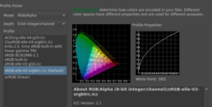](https://en.wikipedia.org/wiki/File:Krita_color_space_loader.png)

**Full colour management** is supported in Krita with the following capabilities:

* Assign and convert between colour spaces
* Realtime colour proofing, including colour-blind mode
* Colour model supported: RGBA, Grey, CMYKA, Law, YCbCr, XYZ
* Colour depth supported: 8-bit integer, 16-bit integer, 16-bit floating point, 32-bit floating point

### Filters

Krita's G'MIC filter controls

Krita has a collection of built-in filters and supports [G'MIC](https://en.wikipedia.org/wiki/G%27MIC) filters. It has real-time filter preview support.

Filters included in a default installation: levels, colour adjustment curves, brightness/contrast curve, desaturate, invert, auto contrast, HSV adjustment, pixelise, raindrops, oil paint, gaussian blur, motion blur, blur, lens blur, colour to alpha, color transfer, minimise channel, maximise channel, top/left/bottom/right edge detection, sobel, sharpen, mean removal, unsharp mask, gaussian noise removal, wavelet noise reducer, emboss horizontal only/in all directions/(laplacian)/vertical only/with variable depth/horizontal and vertical, small tiles, round corners, phong bumpmap.

