**PostgreSQL** (pronounced "post-gress-Q-L") is an open source relational database management system ( DBMS ) developed by a worldwide team of volunteers.**PostgreSQL** is not controlled by any corporation or other private entity and the source code is available free of charge.

**pgAdmin** open source administration development platform for PostGreSQL

**In simple terms** Postgres is how and where your data is stored, PgAdmin is a Viewer into Postgres to maintain the database or retrieve data.

**DOWNLOADING POSTGRES**

<https://www.postgresql.org/>

You will be asked to Create a password. Write this password down, you will need it to connect to your database.

When asked what applications you would like installed, check all except Registration required add-ons. Also you may have some already installed, ie Postgres will already be installed.

We won’t need these add-ons for class but you may want them as you further your understanding of data and databases.

*this snippet may look different from yours

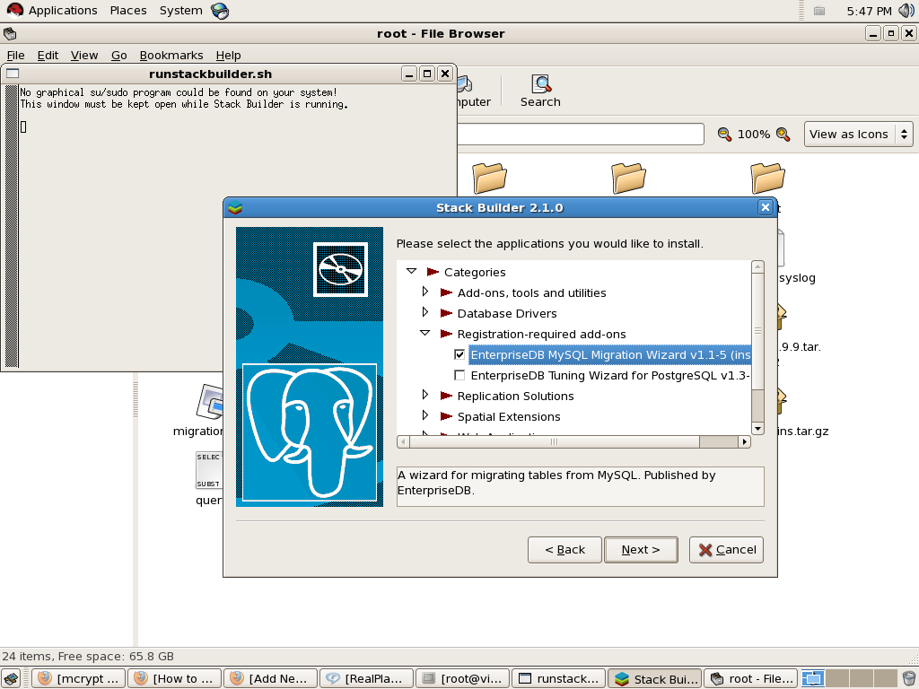

DOWNLOADING PGADMIN4

<https://www.pgadmin.org/download/>

Pgadmin4 is a viewer into the databases. The product can be buggy at times. You may need to reboot the program or even your device. Having a lot of programs running on your device will decrease performance.

After Pgadmin4 is loaded we will connect to AWS and then to our own servers.

Connecting to AWS

Right click

Choose Create click on Server

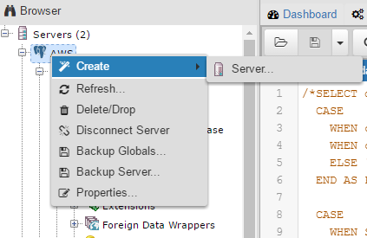

Give your connection to AWS a name, recommendation….AWS

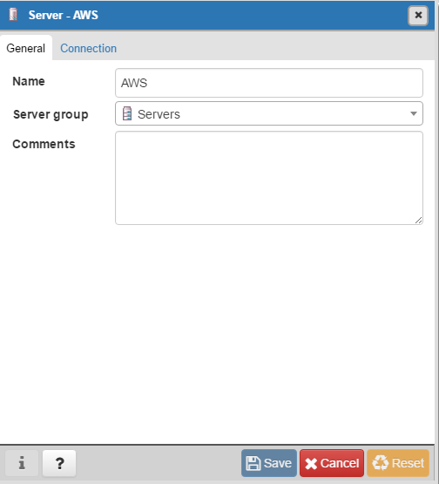

Then click on the Connections tab.

In the connection tab fill in the following.

Your password for AWS is analyticsga

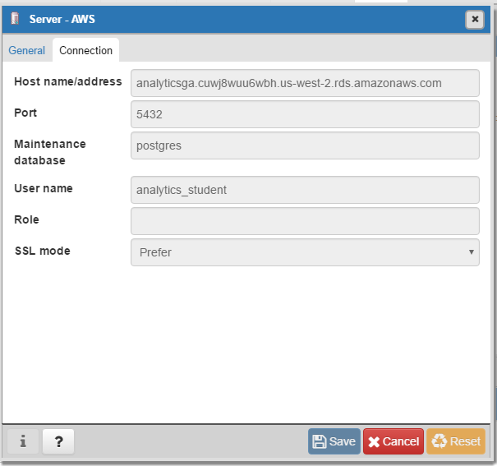

Save your connection and explore AWS. See if you can find tables for Iowa liquor sales.

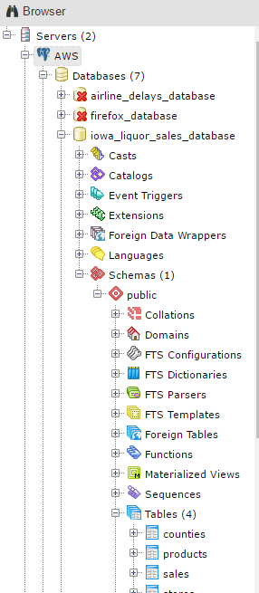

Connecting to localhost

Create a new server connection

Name your connection whatever you like.

Here are the properties for your connection.

Remember the Password you created? You will need that now.

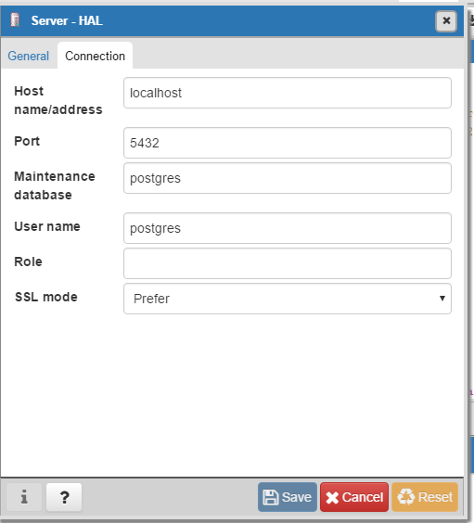

CREATING AND LOADING DATA INTO A TABLE

CREATE TABLE public.titanic

(

passengerid integer,

survived integer,

pclass integer,

name character(225) ,

sex character(30),

age numeric,

sibsp integer,

parch integer,

ticket character(30),

fare money,

cabin character(15),

embarked character(1)

);

COPY titanic FROM 'C:\Users\Matthew\Desktop\DataScience\titanic.csv' DELIMITER ',' CSV HEADER;

If you get permissions errors first check to make sure you have the file selected and not just the folder. Then try this method.

· Right click the folder containing the data file(s) that permission was denied to and then click **Properties**.

· In the Folder's Properties window, select the **Security** tab.

· Click the **Edit** button.

· In the "Permissions for the folder" window that opened, click the **Add...** button.

· Type Everyone into the "Enter the object names to select" text area box.

· Click **OK** and the window will close.

· Verify that the default **Read & Execute** permissions were set to **Allow** via the check checkbox in the previous window.

· Click **OK** and the window will close.

· Click the **Apply** button in the Folder Properties window.

Now you can run the SQL COPY statement that needs to access those files.

· Once done, return to the Folder's Properties window.

· Click the **Edit** button.

· Select the Everyone entry in the "Group or user names:" field.

· Click the **Remove** button.

· Click **OK** on the remaining open windows.

The permissions have now been returned to what they were.

MAC USERS

