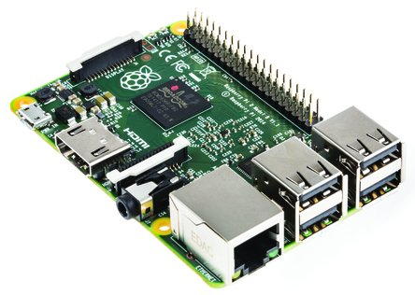

# Raspberry Pi 2 - MODB - 1GB - Quad core

Rs 2,923

1. Original Element14 version with 1 year warranty <br>
2. Broadcom 900 MHz BCM2836 ARMv7 Quad Core Processor SoC, Broadcom VideoCore IV GPU <br>
3. 1 GB RAM <br>
4. Expanded 40-pin GPIO Header <br>
5. 4 x USB2.0 Ports with up to 1.2A output

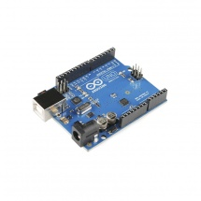

# Robohaat Arduino UnoR3 SMD

Rs. 504

1. ATmega328 microcontroller<br>
2. Input voltage - 7-12V<br>
3. 14 Digital I/O Pins (6 PWM outputs) <br>
4. 6 Analog Inputs<br>
5. 32k Flash Memory<br>
6. 16Mhz Clock Speed

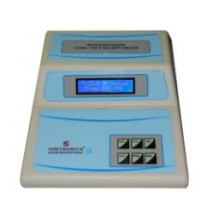

# Simtronics Microprocessor Conductivity / TDS Meter, SE – 980

Rs. 9026

1. For conductometric titrations of acids, bases and specific organic compounds in aqueous.<br>
2. Non-aqueous and biological media<br>
3. Extendable to measure total dissolved solids<br>
4. Temperature compensation from 0 to 50°C (Manual), Capacitive

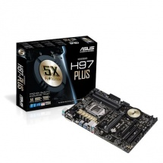

# Asus Motherboard, H97-PLUS

Rs. 8714

1. Supports LGA1150 socket Processor<br>
2. Proven quality - 5X Protection. 1000+ compatible devices. 7000+ validation hours. <br>
3. Crystal Sound 2 - Flawless audio that makes you part of the game<br>
4. Media-acclaimed UEFI BIOS with new EZ Tuning Wizard<br>
5. Fan Xpert 2+ - Ultimate cooling and quietness

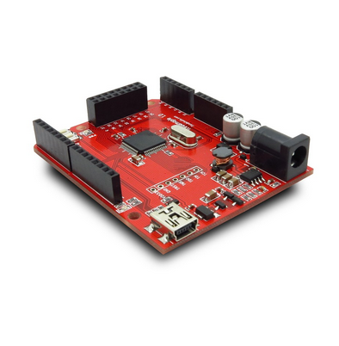

Iteadmaple Microcontroller Leaf Maple Board with Cortex M3 STM32 For Arduino

Rs 380

1. 72MHz ARM Cortex M3 core<br>
2. 20KB SRAM and 128KB Flash<br>
3. 64 channel nested vector interrupt handle<br>
4. 7 channels of Direct Memory Access(DMA) <br>
5. Wide range external input from and USB supply adaptive<br>
6. X-link/X-linkEx full compatible<br>
7. Pins map full compatible for Arduino shield

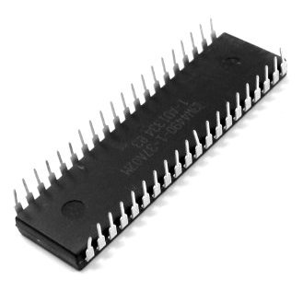

# AT89S52 8051 IC DIP Mount 8 Bit Microcontroller 8K ISP Flash 24MHz

Rs 327

1. Compatible with MCS-51Products | Mounting Style : Through Hole | Package: 40 Pin DIP<br>
2. 4.0V to 5.5V Operating Range | Low-power Idle and Power-down Modes<br>
3. Eight Interrupt Sources | Interrupt Recovery from Power-down Mode<br>
4. 32 Programmable I/O Lines | Three 16-bit Timer/Counters | Watchdog Timer | Flexible ISP Programming (Byte and Page Mode) | Full Duplex UART Serial Channel