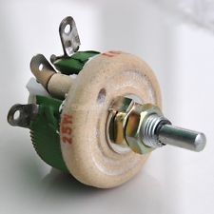

25 W 50 OHM HIGH POWER WIREWOUND RHEOSTAT

Rs 200

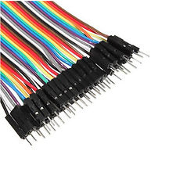

**40pcs Dupont 10CM Male To Female Jumper Wire Ribbon Cable For Arduino Best**

Rs 150

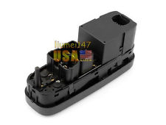

**New Electric Power Window Master Control Switch For 1998-2000 Volvo V70 XC70 S70**

**Rs 2000**

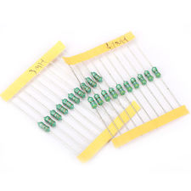

**Utility 200pcs 20 Value Assorted Color Wheel Inductor Kit 1/2W 10% Tolerance Set**

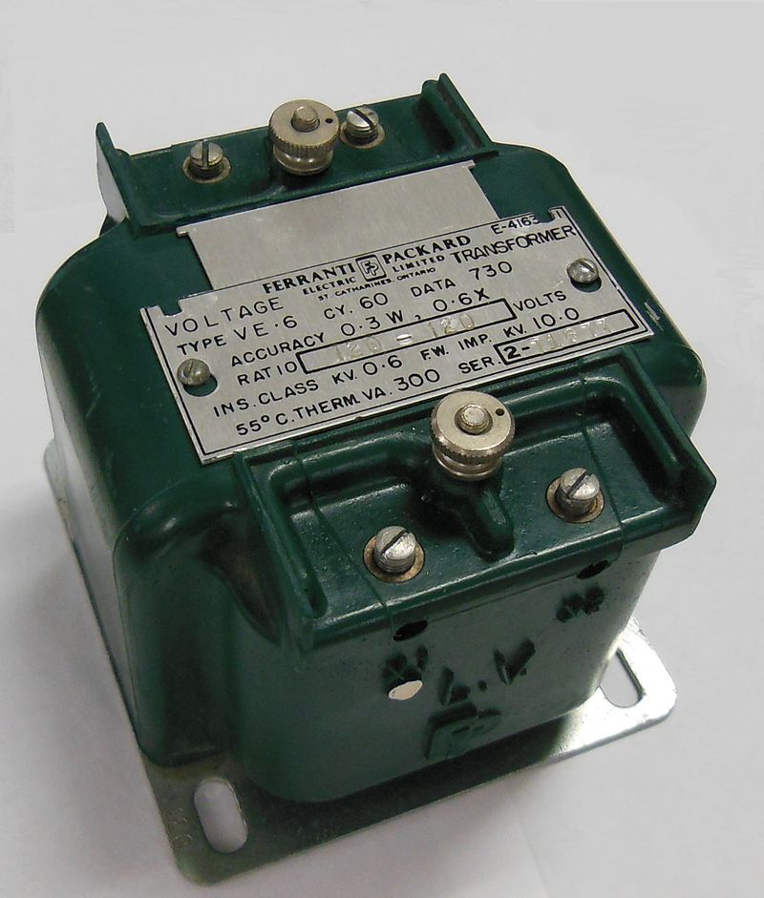

Instrument transformer, with polarity dot and X1 markings on LV side terminal

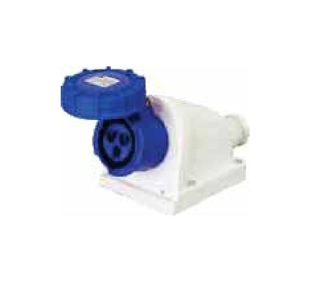

C&S CS 62437 Surface Mounting Socket (2 Poles + Earthing, 32A)

Rs. 866