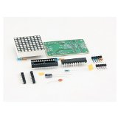

MAX7219 Dot Led Matrix Module MCU Control LED Display Module For Arduino ARM Raspberry AND Other MCU

Rs123.00

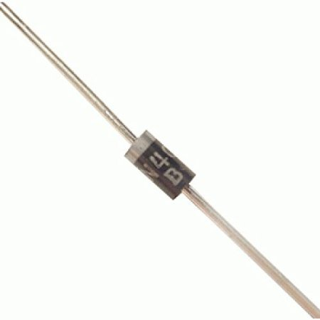

# Robomart IN4007 Diode (Pack of 50)

# Rs 150

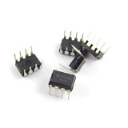

# 555 Timer IC (5Pcs)

Rs 93.00

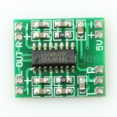

# PAM8403 digital power amplifier board 2 * 3 w class D power amplifier board high 2.5 ~ 5 v can be USB power supply

# Rs 162.00

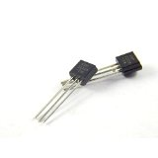

# 2N222 - NPN - Transistor (10 Pcs)

# Rs 70.00

# 

# 20MHZ CRYSTAL OSCILLATORS(PACK OF 10)

115.00