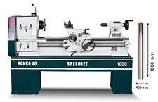

### [BANKA 40 SPEEDJET [1000mm] - All Gear Lathe Machine - Lathe Machine](http://www.ebay.in/itm/BANKA-40-SPEEDJET-1000mm-All-Gear-Lathe-Machine-Lathe-Machine-/321846601706?hash=item4aef8d67ea)

Rs.1,64,700/-

## Straight edge meter<br>

## Spirit level precision<br>

## Thermometer temperature<br>

## Sound level decibel DB<br>

## Screw Thread special tester<br>

## Test Mandrel Long bar MT<br>

## Thread , slip , plug,Ring, Gauge<br>

## Surface plate , Height Gauge , V block<br>

## Lead & profile test- stellenberg

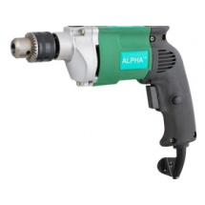

# Alpha 13 mm Electric Drill, 400W

**Rs. 799**

1. 400 watt motor<br>
2. 2000 rpm<br>
3. 13 mm chuck capacity<br>
4. 220v, 50/60 Hz

# http://img.tolexokit.com/media/catalog/product/A/c/Ac-Motor-Drive-Vfd-M-Series_10.jpg?resize=1&q=95&w=215&h=215&zc=2

Top of Form

# Delta AC Motor Drive, VFD-M Series, VFD004M21B-D

Bottom of Form

# Rs. 10901

1. Output frequency 0.1 ~ 400 Hz<br>
2. Adjustable V/f curve and vector control<br>
3. Carrier frequency up to 15 kHz<br>
4. Auto torque boost & slip compensation<br>
5. Built-in PID feedback control<br>
6. Built-in MODBUS communication, baud rate up to 38400 bps<br>
7. 0 speed holding function<br>
8. Built-in sleep / revival function<br>
9. Support communication module (DN-02, LN-01, PD-01)