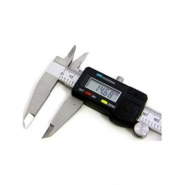

**Aerospace Digimatic Vernier Caliper, Size: 0-150 mm**

**Rs. 649**

1. Digital Vernier Caliper - 6 inch - 150 mm<br>
2. Range :0 - 150 mm<br>
3. Large LCD Display with mm and inch Display options<br>
4. Auto Power On - Function for Quick Measurement<br>
5. Made of Hardened Stainless Steel

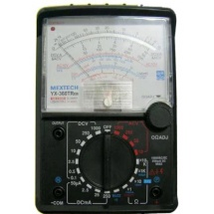

# MEXTECH YX360TR Analogue Multimeter

**Rs. 694**

1. Product Type: Multimeter<br>
2. Weight: 650g<br>
3. Features: Capacitance, temperature, data hold, frequency(20 khz), dode test, hfe test, continuity test<br>
4. SUPC: SDL026851005

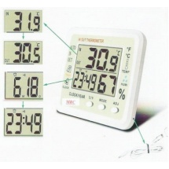

# Metro Q Temperature Humidity Meter MT-701

**Rs. 660**

1. **Brand Name:**Metro Q<br>
2. **Model:**MT-701<br>
3. **Volumetric Weight:**1<br>
4. **Dimension:**121 x 141 x 20 mm<br>
5. **Temperature Range:**-50C~+70C(-58F~158F) <br>
6. **Humidity:**Indoor 10% RH~99%RH<br>
7. **Operating Temperature :**-50C to +70C (-58F to +158F) <br>
8. **Operating Humidity :**indoor 10% RH ~ 99% RH<br>
9. **Battery Type :**1.5 V (AA size) x 1