# http://img.tolexokit.com/media/catalog/product/B/a/Bajaj-3-W-Clutch-Plate-OLY-7078_3.jpg?resize=1&q=95&w=215&h=215&zc=2

# Olympic Clutch Plate For Bajaj 3 W

# Rs. 532 / pack

1. **Brand Name :**Olympic<br>
2. **Pkg Qty :**1<br>
3. **Number Of Items :**10 Set<br>
4. **Product Type :**Three Wheelers<br>
5. **Model Text :**OLY 7078<br>
6. **Cod Available :**295019<br>
7. **Sku Shipping Info :**295025

# 

# PD9068-THUNDER-TIGER-FLYWHEEL-TA

# Thunder Tiger Flywheel TA SC PD9068 NIB

# Rs. 450.00

1. Use: Vehicles & Remote Control Toys<br>
2. Technical parameters: Value 2<br>
3. For Vehicle Type: Airplanes<br>
4. Remote Control Peripherals/Devices: Starter<br>
5. RC Parts & Accs: Motor Components<br>
6. Upgrade Parts/Accessories: Wheel Hub<br>
7. Four-wheel Drive Attributes: Assemblage<br>
8. Model Number: PD9068

# Blue Round and Rack GEAR Combo. Small*medium*Big round gear + Rack gear.

**Blue Round and Rack GEAR Combo.**

**Rs.** 175.00

1. Small Round Gear<br>

-Inner shaft diameter: 6mm<br>

-Total gear diameter: 4 cm<br>

1. Medium ROund Gear<br>

-Inner shaft diameter: 6mm<br>

-Over all size: 5.5 cm<br>

1. Big Round Gear<br>

-Inner shaft diameter: 6mm<br>

-Overall Size: 6.5 cm

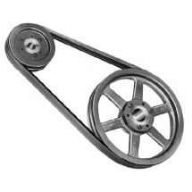

# Fenner Multi Rib Ploy V Pulley , 12(PJ)

Rs. 433

1. Type: Multi Rib Poly V Pulleys<br>
2. Model: 12 Grooves<br>
3. TLB Size: 2517<br>
4. Section: PJ<br>
5. Outer dia mm: 224

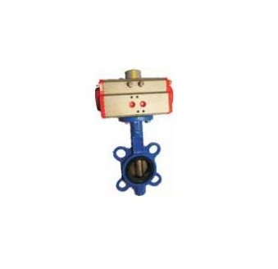

# Actuator With Butterfly Valve Ci Disc Pneumatic

Rs. 3,660

1. Model: SB370-250<br>
2. Type: Actuator With Butterfly Valve With CI Disc<br>
3. Thread Size: 10''

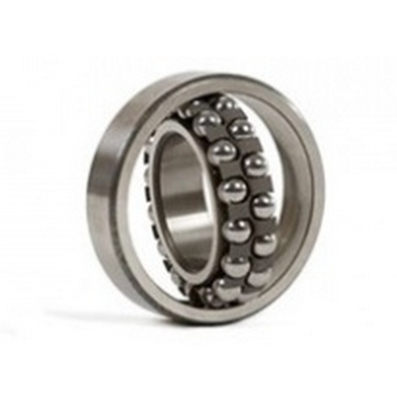

# BBN Ball Bearings

**Rs. 252**/ pack

1. **Material Type :**SAE 52100 Steel<br>
2. **Pkg Qty :**1<br>
3. **Cod Available :**Yes,295019<br>
4. **Sku Shipping Info :**Normal,295025