Linux内核死锁(deadlock)检测
JUN11
20112 COMMENTSWRITTEN BY CHEN
业务运行过程中，Linux系统僵死，屏幕无任何有效打印信息，网络中断、键盘鼠标没有任何响应。这种故障现象，可能是因为Linux内核死锁导致。由于无任何有效打印信息，内核日志中也没有记录，就无法定位故障根因。

如何让Linux内核在僵死前打印相关信息，对问题定位尤为关键。其中一个有效手段是打开“Kernel Hacking”选项，然后重新编译内核。
对于Linux内核死锁有帮助的几个配置选项有：
[*] Detect Soft Lockups
[ ] Panic (Reboot) On Soft Lockups
[*] Detect Hung Tasks
(120) Default timeout for hung task detection (in seconds)
[*] Panic (Reboot) On Hung Tasks
[ ] Lock usage statistics
[ ] Spinlock debugging: sleep-inside-spinlock checking

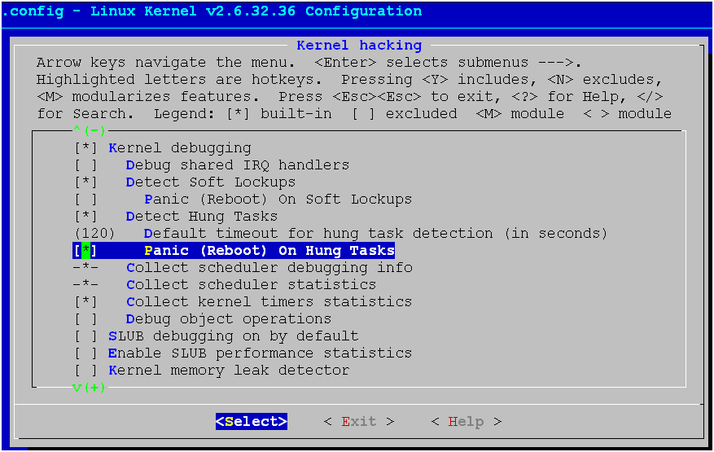

下面一个实例是在SLES11.1 2.6.32.12-0.7内核中系统僵死前，检测到内核死锁并panic，打印出了死锁进程和信息。
ftp D ffff88010d7c5978 4472 22481 4259 0×00000000
ffff880031d1dd08 0000000000000016 ffff8801025cf6f8 0000000000000005
ffff880031d1dc08 ffff880031d1dfd8 000000000000ca98 00000000001d1580
0000000000004000 00000000001d1580 ffff880031d1dca8 ffffffff8108970c
Call Trace:
[<ffffffff8108970c>] ? __lock_acquire+0xf7f/0×1038
[<ffffffff81076ca2>] ? sched_clock_cpu+0x9a/0×183
[<ffffffff810859e9>] ? mark_held_locks+0x6e/0xa3
[<ffffffff8184df73>] ? mutex_lock_nested+0x2cf/0x4ff
[<ffffffff8184df89>] mutex_lock_nested+0x2e5/0x4ff
[<ffffffff810b1d6c>] ? generic_file_aio_write+0×62/0xea
[<ffffffff810b1d6c>] ? generic_file_aio_write+0×62/0xea
[<ffffffff810b1d6c>] generic_file_aio_write+0×62/0xea
[<ffffffff810f93b2>] do_sync_write+0xee/0×157
[<ffffffff810704ca>] ? autoremove_wake_function+0×0/0x4d
[<ffffffff810fa23d>] vfs_write+0xed/0x1d1
[<ffffffff810fa43e>] sys_write+0x5c/0x9f
[<ffffffff8100376b>] system_call_fastpath+0×16/0x1b
1 lock held by ftp/22481:
#0: (&sb->s_type->i_mutex_key#5){+.+.+.}, at: [<ffffffff810b1d6c>] generic_file_aio_write+0×62/0xea
Kernel panic – not syncing: hung_task: blocked tasks
Pid: 536, comm: khungtaskd Not tainted 2.6.32.120609_new #14
Call Trace:
[<ffffffff8184a9b4>] panic+0x9f/0×228
[<ffffffff810a2b59>] watchdog+0x33c/0x3a2
[<ffffffff810a293d>] ? watchdog+0×120/0x3a2
[<ffffffff810a281d>] ? watchdog+0×0/0x3a2
[<ffffffff81070177>] kthread+0xa0/0xaf
[<ffffffff8100477a>] child_rip+0xa/0×20
[<ffffffff81048bbd>] ? finish_task_switch+0×0/0xfe
[<ffffffff8100413c>] ? restore_args+0×0/0×30
[<ffffffff8107001c>] ? kthreadd+0xc0/0x17b
[<ffffffff810700d7>] ? kthread+0×0/0xaf
[<ffffffff81004770>] ? child_rip+0×0/0×20
Posted in 内核基础

