組別： (不記名，滿分40分、無故缺席者得20分；每人最後得分=該組平均)
日期：2020/03/18
得分 | a. | b. | c. | d. | e. | f. | g. | 總分

- The following table lists a number of tasks that must be completed in order for a crew of workers to finish a project.
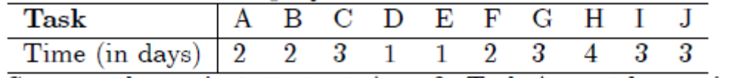
Suppose the project starts at Apr. 9. Task A must be carried out before any other tasks can start. Task B must precede tasks E and F, and both E and F must be completed before H can begin. Tasks C and D must precede task G, which in turn must precede I. Task J must be carried out last. It is assumed that there are enough workers to carry out any number of tasks simultaneously.
- [10%] Draw a PERT diagram showing the relations of these tasks.(b) [5%] Draw the critical path.

(c) [5%] We say a "conflict of tasks" occurs when two tasks violate their precedent relations. Give a suitable sequence for conducting all the tasks so that no conflict of tasks occurs in the entire process.

(d) [5%] What is the fewest number of days needed to make this product?

(e) [5%] What is the earliest date for this project to be done?

(f) [5%] If we start to do task D in Apr.14, will it affect your answer in (e)? If yes, affect how much? If no, explain why not.

(g) [5%] What is the latest date for task H to begin, in order not to affect your answer in (e)?

Comments:
- 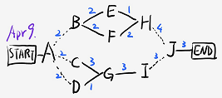
- Critical path: ACGIJ
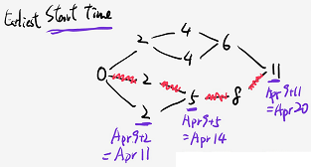
- ABCDEFGHIJ or any permutation that follows topological ordering
- 14 days
- Apr. 22, since Apr.9+14-1=Apr.22
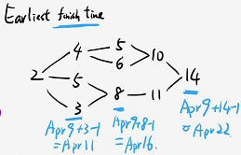
- Yes, 1 day later
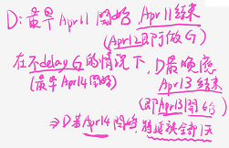
- Apr.16, since the earliest time to start J is Apr.20, and H can start 4 days earlier which is Apr.20-4=Apr.16.

