組別： (不記名，滿分100分、無故缺席者得20分；每人最後得分=該組平均)
日期：2015/06/11
得分 | 1 | 2 | 3 | 4 | 總分

- (a)[10%] Construct an expression tree based on the Polish notation expression, then evaluate it:
+*+34-12-3/42
(b)[10%] Construct an expression tree based on the reverse Polish notation expression, then evaluate it:
34+12-*42/3-+

- [30%] Give the (a)preorder, (b)postorder and (c)inorder listing of vertices for the following graph
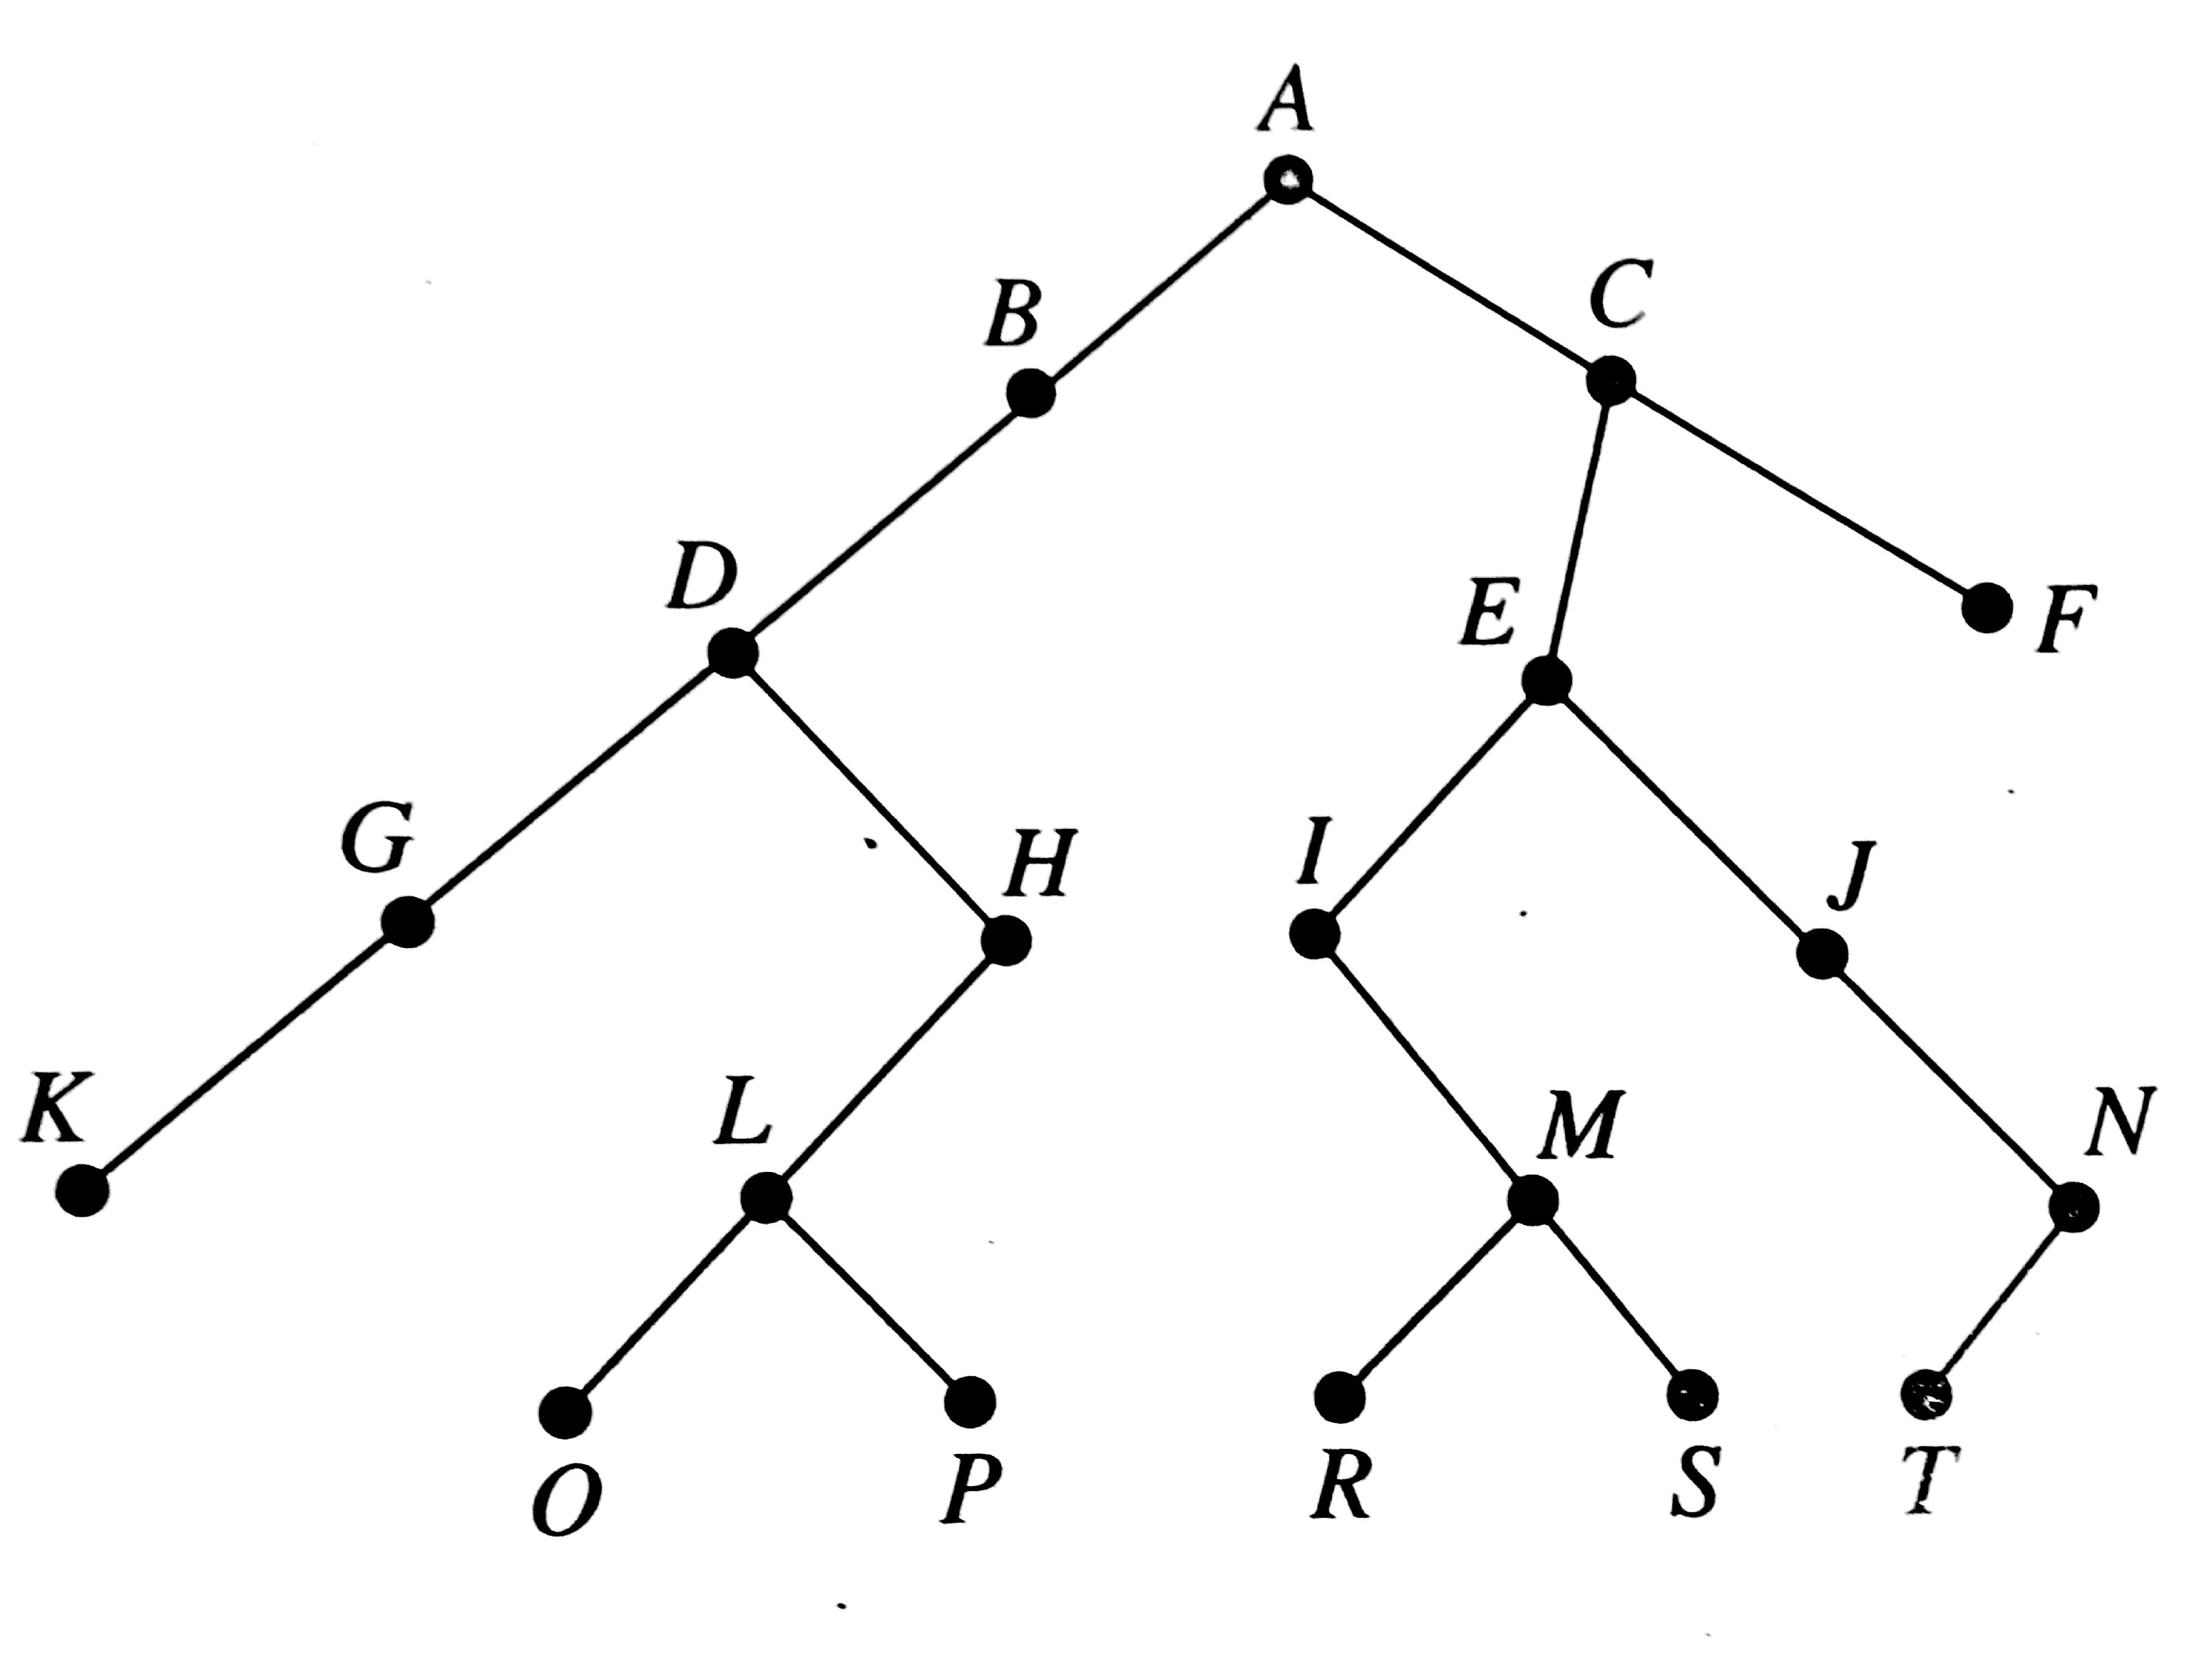
- [15%] (a) Given an undirected graph, how to know it contains a bridge? Explain your method and estimate its complexity.
[15%] (b) Answer the same questions as (a) for a directed graph.

- [10%](a)Decode the message 11101010000010110 with the assignment A:010, B:111, M:000, N:110, and T:10.
[10%](b)
