Mining changes of patterns from multi-period datasets

I-Lin Wang and Chun-Ta Dai
National Cheng Kung University, Taiwan

ABSTRACT
Given datasets of multi periods, we are concerned with detecting any pattern of interested consistent changes from some period to the last period. Such a problem seems unsolvable for conventional data mining techniques that seek frequent patterns since such techniques require conducting the FP-growth algorithm for each period as well as many pairwise comparisons between datasets of consecutive periods. Here we propose an efficient algorithm based on a novel data structure that seeks the target patterns in a very efficient way. Computational tests show our algorithm has very good performance, especially for datasets of more periods, or of larger similarity between consecutive periods.

Introduction
Data mining is concerned with analyzing large volumes of data to discover patterns hidden in the dataset. Previous pattern discovery research usually focuses on identifying frequent patterns, which only processes single dataset without considering the effect of time. Considering the time factor, previous temporal data mining research focuses on mining for the following topics: the sequential pattern (Agrawal and Srikant 1995), the cyclic association rules (Ozden et al., 1998), the temporal association rules (Ale and Rossi, 2000), the calendar-based temporal association rules (Li et al., 2003), the episodes in event sequences (Mannila et al., 1997), the temporal patterns (Li et al., 2006), and the intertransaction association rules (Tung et al. 2003). However, all of these research topics do not investigate the patterns of data changes over time, although such changes are important and often occur in practice. Change mining that seeks the changes or differences in datasets may give better understanding in the tendency of the underlying processes. For example, learning the tendency of changes on customer demands via mining the changes in the items sold over time would help the manager of a logistics company to arrange the inventory in a better way.

To detect the variations of different datasets, Dong and Li (2004) propose a mining algorithm to identify the emerging patterns (EPs) that have significant changes in supports between different datasets. Bay and Pazzani (2001) detect the differences of groups by mining the contrast sets. Liu et al. (2000) identify the variations of decision rules by mining the difference of the decision trees for two datasets. Kim et al. (2005) investigate changes in decision rules based on the decision tree analysis. Although these studies can be applied to search for the trend of data changes over time, they can only deal with the datasets of two periods. In this paper, we develop techniques that seek the changes of patterns for datasets collected from multi periods to detect the tendency of data changes.

Conventional techniques in mining for frequent patterns are not suitable for mining the changes of patterns over time, since their application focuses on frequent patterns only and thus those infrequent patterns with support less than the minimum threshold of times (say, ) defined by the user may be skipped and ignored. To grab the changes for those infrequent patterns, has to be zero, which usually incurs computational difficulty in detecting all the possible patterns over the entire datasets. In other words, to identify the patterns that grow times from one period to its following period and continue the trend of change for every two consecutive periods until period , one requires to set the minimum support threshold to be zero in the first period of interest (say, period ), seeks the patterns whose supports are at least 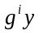 in period 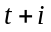, for any support 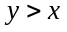 and for each 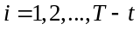. Thus we will totally have 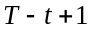 datasets. Suppose each dataset contains 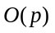 patterns and each pattern has 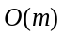 items. Then one has to conduct 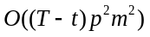 pairwise comparisons for mining the changes of patterns starting from period to period . Since there exist plenty of patterns with supports greater than zero, using frequent patterns for mining the changes of patterns will consume too much time, and thus become very inefficient.

In this paper, we are particularly interested in mining the changes of patterns between the datasets of two consecutive periods that occur continuously from a previous period to the current period . As a result, both the time and variation factors will be considered at the same time to get the trend of events. The more periods of the datasets to be analyzed, the more significant and reliable the pattern changes represent. To the best of our knowledge, no research has been reported in literature for mining the changes of patterns on multi-period datasets. Here we develop techniques that not only seek the changes of patterns over multi periods to detect the tendency of data changes, but also take the changes of infrequent patterns into account so that any change on any pattern would be identified by our algorithm in an efficient way, as long as the change fits the range of growth rates specified by the user.

The rest of this paper is organized as follows: Section 2 explains more details about the problem we are dealing with. Detailed procedures of our proposed mining algorithm are illustrated in Section 3. Section 4 includes the results and analyses of our computational experiments where we have implemented our proposed algorithm and an extension of FP-growth algorithm called MFPG for the purpose of performance comparison. Finally, Section 5 summarizes and concludes the paper.
Preliminaries
Consider a pattern as a set of items, where each item represents an entity or element in a time stamped transaction dataset in temporal data mining (Roddick and Spiliopoulou, 2002). The support for each pattern may vary with respect to time. While the frequent pattern mining focuses on the frequencies of patterns, we are more interested in identifying the trend of growth or decline of patterns with respect to time in this paper.

Any change for a pattern appearing in two consecutive periods can be calculated by the ratio of its support, from the earlier period to the latter one. In other words,
(1) 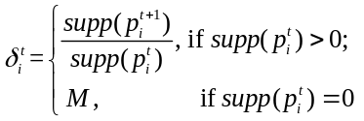
where 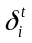 represents the growth rate for the support of pattern 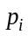 from period to period 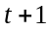, and is a very large number. There may exist many types of pattern changes. For example, one may be interested in a pattern change that follows a growth rate, whether increasing (i.e.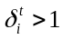) or decreasing (i.e.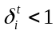), between any two consecutive periods and. In this paper, we are particularly interested in the patterns that change continuously with the same tendency from some previous period 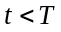 to the current period . In particular, we define the range of interested growth rate, denoted by 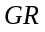, and seek those valid candidate patterns that continuously satisfy 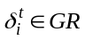 from some period to period . Such changes of patterns indicate a trend of growing or declining, and are usually worthy of attention. Although not of our interests, any irregular changes of patterns can also be detected using our proposed algorithm in Section 3.
proposed solution method
To have a more efficient mining for the pattern changes, we propose an algorithm called MCP that starts from the dataset of the last period, since those changes ceased in any intermediate period are not of our interests. MCP contains three major steps: (1) constructing a modified FP-tree to store items and their frequencies based on the FP-tree structure (see Han et al., 2004), (2) traversing on the modified FP-tree to detect candidate patterns and storing those candidate patterns in a candidate-pattern forest (CP-forest), and (3) detecting those valid changed patterns satisfying the range of the specified growth rates.

In the beginning, we construct a modified FP-tree based on the FP-tree proposed by Han et al. (2004) to store each item in the datasets of the last two periods as a node in the modified FP-tree. An FP-tree is a prefix tree designed to store information from the dataset with less space, so that the information retrieval and extraction become more efficient. First, we construct an FP-tree for the data of period to store any pattern with support more than zero, then store the data of period in the same FP-tree by adding another vector of support associated with each node, or creating a new branch for a pattern that appears in period but not in period . Take Figure 1 for example. The pattern {ce} and {adb} is a new branch since they appears in period but not in period. An FPlist (e.g. [bedac] in Figure 1) can be generated by the nondecreasing order of the support of items in period.

Figure 1: Constructing the original modified FP-tree for period and
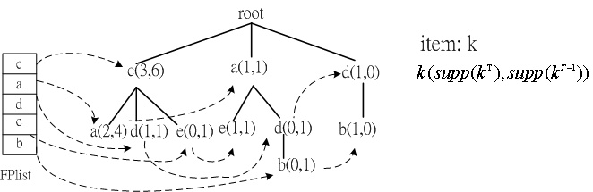

Based on the modified FP-tree that stores the patterns of data from period and, we propose a tree-traversal technique to generate possible candidate patterns from all the branches in the modified FP-tree. In particular, mining from a bottom node to the root in a modified FP-tree gives a unique branch which represents a candidate pattern. Take Figure 1 for example, {ac, dc, ec, bd, ea, bda} represents such branches called original candidate pattern (OCP). For each item by the order in FPlist (e.g. [bedac] in Figure 1), we can construct its associated candidate pattern tree (CP-tree()) rooted at item by adding the OCPs starting with item . Take Figure 1 for example, we first construct a CP-tree rooted at b, which contains only one branch (i.e. bda) since the pattern bd is part of the pattern bda. The support vector associated with each item can be calculated by adding up all the support vectors for that item in the modified FP-tree, thus we will have the support vector (1,1)=(0,1)+(1,0) associated with both b, d, and a. Note that besides those OCPs, there may exist other candidate patterns. It can be shown that any intersection of any two OCPs may produce a generated candidate pattern (GCP), which is also a valid CP to be added. Furthermore, all the CPs can be found by the union of the OCPs and GCPs. Whenever a GCP or an OCP is added to a CP-tree, one requires updating the associated support vectors.

After all the CPs and their associated support vectors are updated in a CP-tree, we start a verification process to update the CP-tree. In particular, for each item in a CP-tree, we calculate 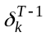 and then assign a skip flag associated with that item, if 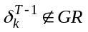. Note that the support vector associated with each item in a CP-tree is 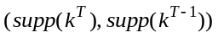. Each branch in a CP-tree represents a candidate changed pattern. Thus by tracing from a leaf up to the root in a CP-tree and skipping those items with skip flag, we can identify a valid changed pattern. All the patterns with continuous valid changes from some period to period can be identified by conducting such tracing procedures for all branches in all CP-trees.

For each period 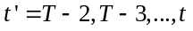, we first reset the support vector associated with each item in each CP-tree from 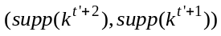 to be 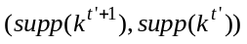 where 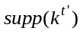 is initially set to be zero. We reorder each transaction data (i.e. itemset) by the order of FPlist, and then check whether that itemset corresponds to a pattern in the CP-tree rooted at the first item of . If has appeared in the CP-tree, we will update , the right part the support vector associated with each item in . Otherwise, that will be ignored and skipped. Once all the itemsets have been processed, we conduct the same verification process as described in previous paragraph to update each CP-tree in the CP-forest, and then repeat the steps described in this paragraph for the next iteration (i.e. 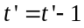 ) until 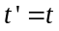.
computational experiments and analyses
We implement a random data generator based on the synthetic transaction data generator used in Agrawal and Srikant (1994). Besides the parameters used in the original generator such as the number of transactions (D), number of items (I), average length of each transaction (L), and number of patterns (P), we add two more parameters: the number of periods (T), and similarity (S) between the data of two consecutive periods so that T periods of temporal data can be generated and the data of any two consecutive periods share some similarity. Such a similarity between the transactions of different periods usually exists and is commonly seen in practice (see Li et al., 2006). In particular, let D_{t} denote the number of transactions in period t, then we will randomly choose SD_{t} transactions out of D_{t} to be part of D_{t+1}.

In order to test the efficiency of MCP, we also implement an algorithm called MFPG based on the FP-growth algorithm proposed by Han et al. (2004). MFPG has to detect all the patterns with support more than zero for each period, and then compare all the patterns obtained from two consecutive periods for mining the changes of patterns. MFPG is expected to be inefficient, since there are potentially 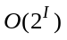 possible patterns in a dataset which makes the FP-growth algorithm and pairwise comparisons between patterns of two consecutive periods become very time-consuming. Due to the storage limitation, we test five families of datasets (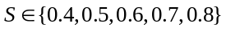) and each dataset contains data of nine periods (T=9). Thus totally forty-five cases are generated with the following settings: D=10000, I=1000, L=5, and P=20. Each family of datasets requires about 1.8MB space. All the algorithms and generators are implemented in C++ on an Intel PC with 3GHZ CPU and 2 GHZ main memory.

Figure 2(a) illustrates the cumulative running time of algorithms MCP and MFPG on the family of dataset with S=0.6. For period 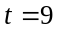 and 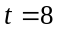, MCP first takes about 58 seconds in constructing a modified FP-tree and the CP-forest, and then mining for the patterns with changes in the target range. For period 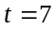 through 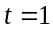, MCP only needs to update the CP-forest for mining the patterns and thus it takes very little time (within 10 seconds in total) as can be observed in Figure 2(a). On the other hand, MFPG takes about 158 seconds in comparing patterns of period and pairwisely. Although MFPG takes less and less time for latter periods (from about 70 seconds down to 45 seconds), it takes totally about 550 seconds for the entire family of dataset, which is still about 8 times longer than MCP. This shows the design of CP-trees in MCP does successfully serve its purpose in shortening the time for mining so many possible patterns. For different similarity setting, as shown in Figure 2(b), MCP still beats MFPG a lot, and has even better efficiency for datasets of larger similarity. Again, such a better performance for datasets of larger similarity are due to the structure of CP-trees, since the datasets of larger similarity should decrease the size of CP-trees, which in turn reduce the time in mining for possible patterns. On the other hand, similarity seems to have no much consistent effect on the performance of MFPG.

Figure 2: Performance comparison on MCP and MFPG
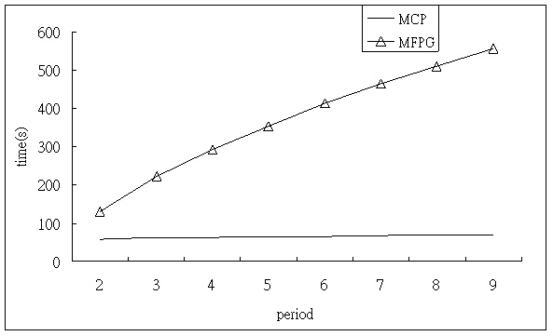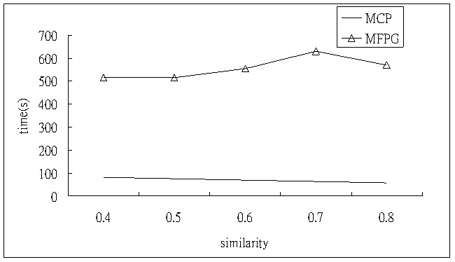
- (b)

To test the capability of MCP in handling large-scale datasets that MFPG can not deal with, we further test five families of datasets with similar settings as before except L=10 and P=10000, where each family consumes about 4 MB space. As illustrated in Figure 3, MCP takes about 500 seconds for the family of S=0.4. It requires less and less running time for datasets of larger similarity.

Figure 3: Running time of MCP for large-scale datasets with L=10 and P=10000
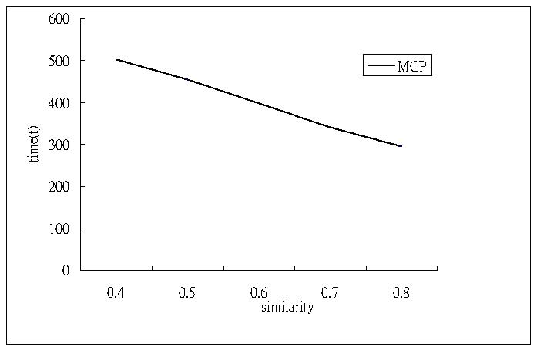
conclutions
The problem to detect the patterns of target changes from some period to the last period is investigated in this paper, since such a phenomena does exist in many real-world applications. Conventional data mining techniques for detecting frequent patterns are not suitable for solving this problem since it requires conducting the FP-growth algorithm for each period and pairwise comparisons for all the patterns between datasets of two consecutive periods, which will consume a lot of time. To speed up the mining process, we propose a novel algorithm called MCP based on a novel data structure called CP-tree. MCP first constructs a modified FP-tree for datasets of the last two periods, and then builds up each CP-tree for each item which records candidate patterns of interests. By some tree-traversing techniques, all the candidate patterns will be produced and stored in the CP-forest composed by all the CP-trees. Traversing along CP-trees for mining the target patterns requires very little time, which makes MCP very suitable for mining the datasets of multi-periods that are not solvable by conventional data mining techniques. For datasets of larger similarity, MCP can take more advantages since the CP-forest will become smaller. The results of computational experiments also certify that MCP does serve for its purpose.

REFERENCES
Agrawal, R. and Srikant, R. “Fast algorithm for mining association rules in large data bases.” In Proceedings of 20th International Conference on Very Large Data Bases, (1991): 487-499

Agrawal, R. and Srikant, R. “Mining sequential patterns.” In Proc. 1995 Int. Conf. Data Engineering (ICDE’95), Taipei, Taiwan, (1995):3-14

Ale, J.M. and Rossi, G.H. “An approach to discovering temporal association rules.” in Proceedings of SAC’00, Como, Italy, 19- 21, (March 2000): 294-300

Bay, S. D. and Pazzani, M. J. “Detecting group differences: Mining contrast sets.” Data Mining and Knowledge Discovery, Vol. 5, (2001): 213-246

Dong, G. and Li, J. “Mining border descriptions of emerging patterns from dataset pairs.” Knowledge and Information Systems, Vol. 8, (2004): 178-202

Han, J., Pei, Y., Yin, Y. and Mao, R. “Mining frequent patterns without candidate generation: a frequent-pattern tree approach.” Data Mining and Knowledge Discovery, Vol. 8, (2004): 53–87

Kim, J. K., Song, H. S., Kim, T. S. and Kim, H. K. “Detecting the change of customer behavior based on decision tree analysis.” Expert Systems, Vol. 22, No. 4, (2005): 193-205

Li, Y., Ning, P., Wang, X. S. and Jajodia. S. “Discovering calendar-based temporal association rules.” Data & Knowledge Engineering, Vol. 44, (2003): 193–218.

Li, Y., Zhu, S., Wang, X. S., and Jajodia, S. “Looking into the seeds of time: Discovering temporal patterns in large transaction sets.” Information Sciences Vol. 176, (2006):1003-1031

Liu, B., Hsu, W., Han, H. S. & Xia, Y. “Mining changes for real-life applications.” Second International Conference on Data Warehousing and Knowledge Discovery,(2000): 337-346

Mannila, H., Toivonen, H. and Verkamo, A. I. “Discovery of frequent episodes in event sequences.” Data Mining and Knowledge Discovery, Vol. 1, No.3, (1997):259–289

Ozden., B., Ramaswamy, S. and Silberschatz, A. “Cyclic association rules.” Proceedings of the Fourteenth International Conference on Data Engineering, (February 1998): 412-421

Roddick, J. F. and Spiliopoulou, M. “A survey of temporal knowledge discovery paradigms and methods.“ IEEE Transactions on Knowledge and Data Engineering, Vol. 14, No. 4, (2002): 750-767

Tung, A. K. H., Lu, H., Han, J. and Feng, L. “Efficient mining of intertransaction association rules.” IEEE Transactions on Knowledge and Data Engineering, Vol. 15, No. 1, (2003): 43-56

