Reliability and Network Compaction for Multi-state Capacitated Manufacturing Networks

I-Lin Wang ^{1*} and Cheng-Nan Chen ¹

¹Department of Industrial and Information Management
National Cheng Kung University
No.1 University Rd.
Tainan, 704, Taiwan
Corresponding author’s e-mail: ilinwang@mail.ncku.edu.tw

Abstract: In a manufacturing network, there often exist operations that produce the same products or semi-products of different qualities. Such a phenomenon can be described by a distillation process using a specialized D-node introduced by Fang and Qi (2003), where the flow enters a D-node has to be distributed according to a pre-specified vector of ratios associated with its outgoing arcs. The existence of D-node complicates the manufacturing process since it creates the relation of flow dependency. In particular, to send flow successfully from a source node to a sink node, an augmenting subgraph containing many paths instead of a single augmenting simple path has to be constructed, since the flow passing through a D-node has to be distributed to all of its outgoing arcs. As a result, when the capacity associated with each arc obeys a multi-state probability distribution, calculating the system reliability for a capacitated manufacturing network containing D-nodes becomes a difficult task. This paper focuses on techniques to derive the system reliability for such a capacitated manufacturing network containing D-nodes. We will first introduce preprocessing techniques that simplify the problem structure, and then propose algorithms for calculating the system reliability. An illustrative example will be given to provide more insights for the problem and the proposed algorithm.

Keywords: Network reliability, Multi-state arc capacity, Manufacturing network, Distillation process, Network Compaction.
- INTRODUCTION
Network flow optimization problems arise very often in many real-world applications such as transportation, logistics, and telecommunication. Conventional network optimization problems usually consider to minimize the total transportation cost or seeks the maximum throughput between source nodes and terminal nodes while satisfying the constraints of node flow balance (i.e. flows entering a node equals flows leaving a node) and arc capacity (i.e. flows in an arc can not exceed its designed capacity), assuming all the components (i.e. nodes and arcs) are perfect so that flows can always pass them through without any connection failure. Such an assumption of perfect connection among the network components is too good to be true. Besides taking the connection failures into consideration, many real-world network components have multi-state parameters in their natures. Take a manufacturing network for an example, the transportation between the same warehouses and retailers may have different capacities depending on the available transportation modes, or the vehicles types, and the availability for these modes or vehicles may be itself a random number. In order to understand the performance of a real-world manufacturing network, this paper studies the reliability issues for a specialized manufacturing network called the distribution network.
Network reliability involves issues related to the analysis of networks whose components are subject to random failures. A lot of literatures (see Ball et al., 1995; Colbourn, 1987; Shier, 1991) have summarized its applications and underlying mathematical properties. Most studies concern two measures: the connectivity measure that deals with the probability to connect a set of nodes, and the performability measure that considers the acceptable performance level in parameters such as the amount of throughput or path-length when the network is connected. For example, Douilliez and Jamoulle (1972) and Frank and Hakimi (1965) firstly discuss the stochastic flow problems where the probability for the maximum flow exceeding an acceptable level is to be calculated for networks with arcs of multi-state capacities, given the probability for each capacity state associated with each arc.
Recently, some researchers have proposed new solution methods for calculating the probability to ship units of flow from an source node to a terminal node in a network with multi-state arc capacities. Such a reliability problem are usually solved by means of the minimal paths (MP) or minimal cuts (MC), which are sets of arcs whose subsets are no longer an path (for MP) or cut (for MC). It can be observed that the size of MPs and MCs is exponentially grown with respect to the size of the network. How to efficiently enumerating all the useful MPs or MCs is itself an NP-hard problem. Therefore, the Monte-Carlo simulation approach can be applied (see Ramirez-Marquez and Coit, 2005) to calculate an approximate network reliability in a shorter time.
Instead of enumerating all the MPs connecting and , Yeh (2005) considers all the combinations of arc capacity states, eliminates those combinations infeasible to ship units of flow, and then seeks useful MPs from the remaining solution space. Yeh (2006) proposes another novel algorithm that clusters nodes in a way to efficiently seek the useful MCs. Taking the total flow cost, multiple origin-destination (OD) pairs, and node failures into consideration, Lin (2007a) gives an algorithm based on enumerating MPs to calculate the reliability of shipping multiple commodities between multiple OD pairs with total cost under a given amount of budget for a network with multi-state arc capacities. The same author (Lin, 2007b) further proposes another solution method based on useful MCs.
All of the reliability problems stated above assume the networks satisfy nothing more the constraints of node flow balance and arc flow capacities. However, the real-world networks usually involve more side constraints. For example, Koene (1982) firstly models the refining processes often arisen in manufacturing networks where the flow in some specialized nodes is split proportionally into a number of components. He calls the problem as a processing network problem (PNP) and shows many applications including scheduling, assembly and energy problems can be modeled by PNPs. Chen and Engquist (1986) propose a modified simplex algorithm based on a basis-partitioning technique and show its efficiency to be several times faster than MINOS, a general purpose LP solver. Chang et al. (1989) further improves the algorithm of Chen and Engquist (1986) by tightly integrating the data structures of the network and sparse matrix.
The PNP related research seems to be ceased for about a decade and half, until recently Fang and Qi (2003) investigate the properties and solution methods for optimization problems over a specialized network used for describing the processes of distillation (i.e. refining) and combination often seen in the real-world manufacturing processes. In fact, the manufacturing networks proposed by Fang and Qi (2003) are equivalent to PNPs. Nevertheless, the work by Fang and Qi (2003) intrigued several new research topics, including the maximum distribution flow problem (MDFP; see Sheu et al., 2006, and Wang and Lin, 2005) and the minimum distribution cost problem (MDCP; see Lin and Wang, 2006). All these related studies focus on techniques to optimize networks with a special class of nodes called D-nodes, where D stands for distillation or distribution. Each D-node is associated with a distillation constraint, in which the flow entering a D-node has to be distributed to each distillation arc (i.e. an arc leaving from a D-node) according to its associated pre-specified percentage. In other words, the related literature studying the manufacturing networks all assume the network parameters such as the capacity or length associated with each arc is fixed, and thus totally reliable.
In order to understand the affect of unreliable network components, this paper thus takes the first step to investigate the situations when the capacity associated with each arc in a distribution network is no more perfect. In particular, assuming the nodes are perfect but the capacity associated with each arc has multiple states and follows a given probability distribution, we are interested in techniques to simplify the problem and methods to efficiently calculate the network reliability. To this end, we first propose a network compaction scheme which can be served as a preprocessing operation that simplifies the structure of the original network and reduces its size such that many complicated operations for calculating the reliability can be avoided. Second, we briefly introduce how the network reliability can be calculated in a distribution network. The problem we are dealing with is harder than previous research since the appearance of distillation constraints destroys the total unimodularity property of conventional network flow problems, so that the assumption of flow integrality will no longer hold. To the best of our knowledge, we are the first to deal with the reliability issues over such a specialized network class.
The structure of this paper is organized as follows: Section 2 introduces basic notations, properties, and an illustrative example of our problem. Section 3 give detailed description of our network compaction scheme, where five cases will be discussed and examples will be illustrated. Techniques to calculate the reliability over a distribution network with multi-state arc capacities has been proposed in Section 4. Section 5 concludes the paper and gives suggestions for future research.
- PRELIMINARIES
Here we first formulate the constraints for distribution networks, and then give a small example to illustrate the difficulty of our problem.
Given a simple digraph 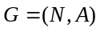 of 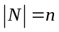 nodes and 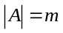 arcs, excluding the source node and terminal node , the remaining nodes in 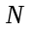 can be divided into two groups of nodes: 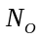 and 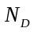, where represents the set of ordinary transshipment nodes that satisfy the flow balance constraints only, and represents the collection of the distillation nodes (D-nodes). A D-node i has only one incoming arc (l,i) called mother arc and at least two outgoing arcs called distillation arcs. Each distillation arc (i,j) is associated with a positive real number called distillation factor, to specify the percentage of the flow in (l,i) to be distributed into the distillation arc (i,j). We also assume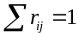 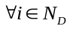 for each distribution arc (i,j). In other words, for each D-node i with incoming flow 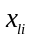, the flow on each arc (i,j) leaving i can be calculated by its distillation constraint 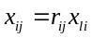. A D-group is defined as a set of maximally adjacent D-nodes. The top D-node of a D-group is called the mother node. For each distillation arc (i,j), we define its normalized capacity vector as 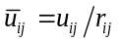.
Each arc 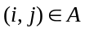 is associated with an ordered capacity vector 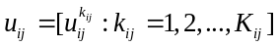 of 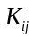 states, where each capacity state 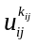 may represent the capacity for arc 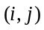 with probability 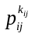. All the capacities inside a capacity vector are arranged in strictly ascending order, that is, 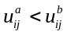 as long as 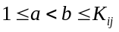. Let 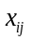 represent the current flow along arc (i,j), then the reliability associated with arc (i,j) equals to 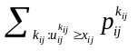, the probability to successfully shipping units of flow along arc (i,j). Let 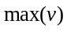 denote the maximum value inside a capacity vector . For our convenience, for e ach arc , we define a new capacity vector 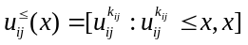 to represent a capacity vector that includes the newly added capacity state with value , as well as those states of capacity in 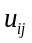 with values smaller or equal to the given value . When two arcs (i,j) and (j,k) are merged to be a new arc (i,k), the resultant capacity state vector over arc (i,k), denoted by 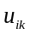, can be calculated by the specialized product of the capacity state vectors 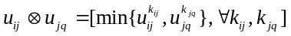. Note that the number of states may decrease in the merged capacity state vector (i.e. 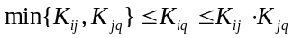), and 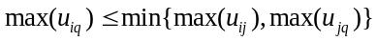 by our definition. On the other hand, when two parallel arcs (i,j) and (i,j)’ are merged, the resultant capacity state vector 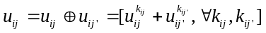. More details about the merged arcs will be discussed in Section 3.
Although the flow vectors are always assumed to be integral in previous research (see Yeh, 2005, 2006; Lin, 2002, 2007a, 2007b), such an assumption will no longer hold in our case due to the distillation constraints, which also makes our problem more complicated and difficult to solve.

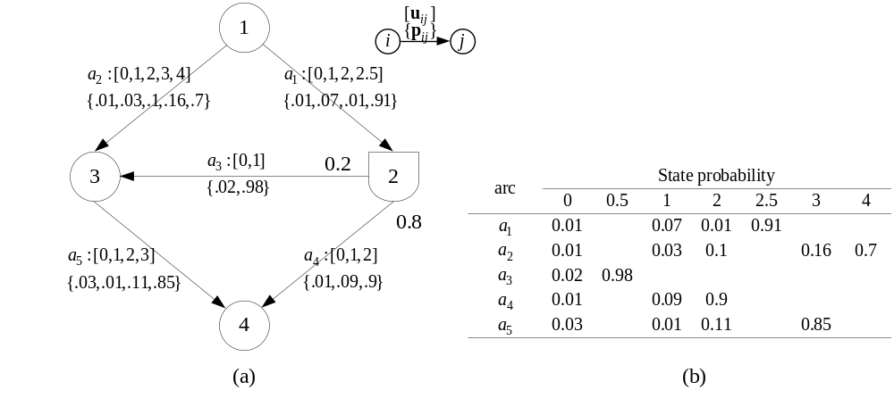
Figure 1. A small distribution network with multi-state arc capacities
Figure 1 illustrates a small example of our problem. In particular, the problem has a unique source node (i.e. node 1), terminal node (node 4), one O-node (node 3), one D-node (node 2), as well as 3 ordinary arcs (i.e. arcs a₁, a₂, and a₅) and 2 distillation arcs (arcs a₃ and a₄), where arcs a₁ to a₅ have 4, 5, 2, 3, and 4 states of capacities, respectively. The state probability vectors and the distillation factors are listed in the right part of Figure 1. The flows entering node 2 must be split into two parts, that is, 20% going to node 3 and 80% going to node 5. Our objective is to calculate the probability of successfully sending d units of flows from node 1 to node 4.
Our problem comes with three major challenges: First, the minimal path usually used in previous research may be a subgraph rather than a simple path; Second, the flow vectors become real numbers which results in infinite ways of flow decompositions, so that methods of enumerating MPs usually used in previous research become inapplicable in our case; Third, our problem become more difficult, especially for cases with complicated connecting relations between D-nodes or O-nodes. The first challenge relies on techniques to efficiently enumerate the basic components for shipping flows. The number of basic components obviously grows exponentially with the size of the network, and is not the target of this paper to improve. The second challenge can be resolved by considering the finite number of the capacity states, and will be discussed in Section 4. Next Section will focus on resolving the third challenge, where we will propose a network compaction scheme to simplify the network structure of our problem, so that an equivalent problem of much smaller size will be used for further investigation.
3. A NETWORK COMPACTION SCHEME
In this section, we exploit the techniques proposed by Lin (2005) for compacting the distribution networks with multi-state arc capacities. In particular, five cases, (C1) through (C5), which are often encountered in distribution networks will be discussed, and procedures to reduce the size or unify their parameters so that the resultant network become easier to solve. Since the compaction involves capacity reset operations, thus some probability vector may be modified. For our convenience, we use to represent the resultant probability vector modified by our network compaction scheme.
(C1) Compacting D-groups
Since all the flows in each distillation arcs can be easily computed by the production of flow distillation factors from the top D-node, a D-group can be reduced to a single D-node. Similarly, each path from the mother node to each leaf D-node inside a D-group can also be reduced to a single distillation arc, and its associated distillation factor equals to the product of the distillation factors on its corresponding path in the original graph. Take Figure 2 for example, arcs (2,4) and (4,6) in Figure 2(a) can be integrated into the new distillation arc (2,6) in Figure 2(b) with distillation factor 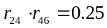.

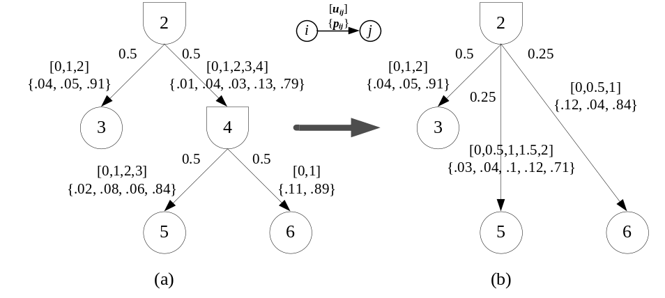
Figure 2. An example to compact a D-group
Although the computation on flows and distillation factors for compacting D-groups is rather intuitive, the compaction for the capacity vectors is not trivial. Consider the path 2-4-6 in Figure 2(a), the resultant distillation arc (2,6) will have a merged capacity vector 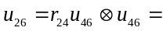, 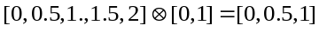, since the distillated capacity vector of arc (2,4) into (4,6) becomes 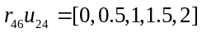. The probability associated with the merged distillation arc (2,6) requires careful calculations:
; ; and
.
Note that every compaction in this case will reduce at least one D-node and one mother arc. The compaction can be iteratively processed from the leaf distillation arcs upwards to the top mother node. For a D-group of D-nodes, one only requires 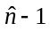 compactions of this case to convert the original D-group to a single D-node.
(C2) Compacting single transshipment O-nodes
When a transshipment O-node only connects with an incoming arc and an outgoing arc, such an O-node can be eliminated and both its adjacent arcs can be integrated as one single arc. Take Figure 3 for example, arcs (2,4) and (4,5) in Figure 3(a) can be integrated into the new arc (2,5) in Figure 3(b). The capacity state vector can be calculated by . The probability associated with the merged distillation arc (2,5) requires careful calculations:
; ; and
.

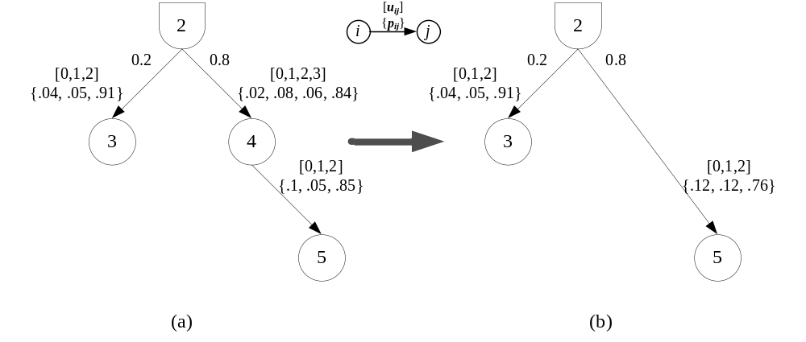
Figure 3. An example to compact a single transshipment O-node
Note that every compaction in this case will reduce at least one O-node and one arc.
(C3) Compacting self-loop arcs
Although the given digraph is assumed to be simple in the beginning, it is possible that self-loops may be formed in some intermediate compaction steps of our network compaction scheme. In that case, the self-loop can be directly eliminated since the flows inside loops will not affect the flows from the source node to the terminal node by the flow decomposition theorem. Every compaction of self-loop will reduce one arc.

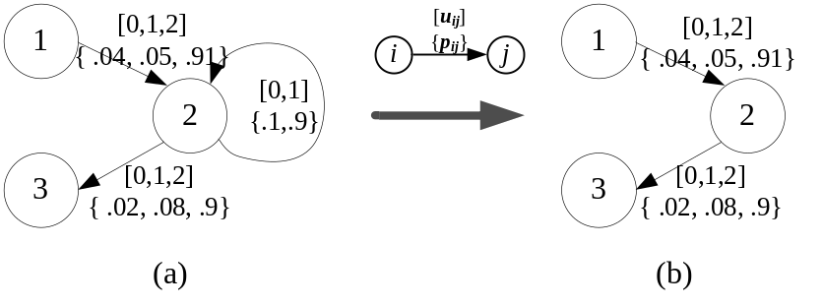
Figure 4. An example to compact a self-loop
(C4) Compacting parallel arcs
Similar to the case of compacting self-loops, although the given digraph is assumed to be simple in the beginning, it is possible that parallel arcs may be formed in some intermediate compaction steps of our network compaction scheme. It is trivial that parallel arcs can be integrated, but their capacity states require further attention to be integrated. We give detailed discussion in two subcases:
Case 4.1: parallel arcs connecting O-nodes
In the case when both end nodes of the parallel arcs are O-nodes, the merged arc may have more states of capacity. Take Figure 5 for example, there are two parallel arcs (1,2) and (1,2)’, where 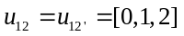. Thus the merged capacity vector 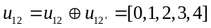 has five states of capacity. The probability associated with the merged arc (1,2) requires careful calculations:
; ;;
; and
.

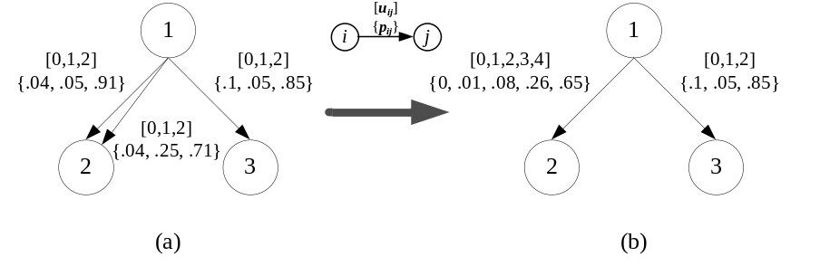
Figure 5. An example to compact parallel arcs between O-nodes
Case 4.2: parallel arcs connecting a D-node
In the case when one end node of the parallel arcs connecting to a D-node, those arcs must be distillation arcs and thus the new distillation factor associated with the merged arc can be calculated by the sum of the distillation factors of the original arcs. However, calculating the merged capacity vector as well as its probability vector is not trivial, since it involves capacity normalized operations so that the capacity vectors of those parallel arcs can be compared under the same standard. Among those parallel distillation arcs, one having the least normalized capacity is a bottleneck arc and its normalized capacity can be used to calculate the capacity for the merged arc.

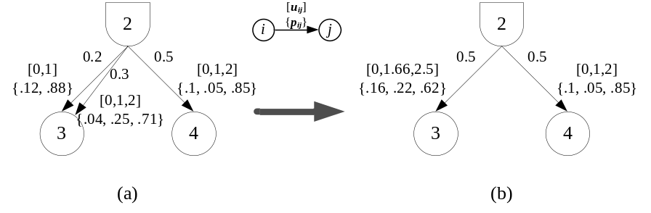
Figure 6. An example to compact parallel arcs connecting a D-node
Take Figure 6 for example, there are two parallel distillation arcs (2,3) and (2,3)’, where 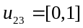and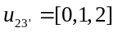. For each of the six possible capacity state combinations, we have to determine the bottleneck arc of each combination using their normalized capacity vectors, respectively. In particular, 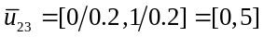 and 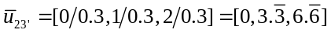. Among the six combinations, there are only three normalized capacity states: 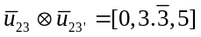. Thus the merged capacity vector can be calculated by 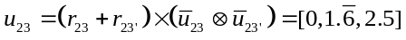, and the probability associated with each capacity state can be calculated as follows:
;; and
.
Note that each compaction of parallel arcs will reduce at least one arc from the original network.
(C5) Compacting mismatched capacities
Any D-node connected with arcs of mismatched capacities can be compacted. According to the flow distillation constraints, the flow on each outgoing arc from a D-node is proportional to the flow on the incoming arc. Therefore we may easily identify the first saturated arc for a D-node by calculating the normalized capacity for each distillation arc relative to the incoming arc. Intuitively speaking, all the capacities associated with arcs connecting to a D-node can be unified so that when one of those arcs is saturated, so will be the other arcs. However, to deal with the multi-state capacity vectors, we require further careful calculation. Depending on the type of bottleneck arcs (i.e. either a mother arc or a distillation arc), we use two subcases to discuss the compaction steps:
Case 5.1: the bottleneck arc is a distillation arc
In the case when the normalized capacity of a distillation arc is smaller than the capacity of the mother arc, we use the normalized capacity of that bottleneck arc to reset the capacity of other arcs. Take Figure 7 for example, since , we know arc (2,4) is the bottleneck arc. In other words, we can use the capacity state vector of arc (2,4) to reset the capacity state vector of arc (2,3) and arc (1,4). In particular,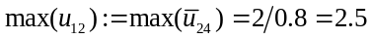, thus 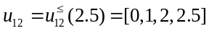, where the elements of its probability vector remains unchanged for those unchanged capacity states (i.e. 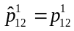 and 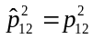) and the probability for the state of the largest capacity equals the sum of the probabilities associated with those original states of larger capacities (i.e. 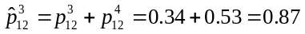). Similarly, so that 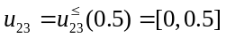, and their associated probabilities can be calculated by 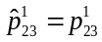 and 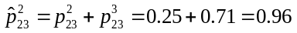.

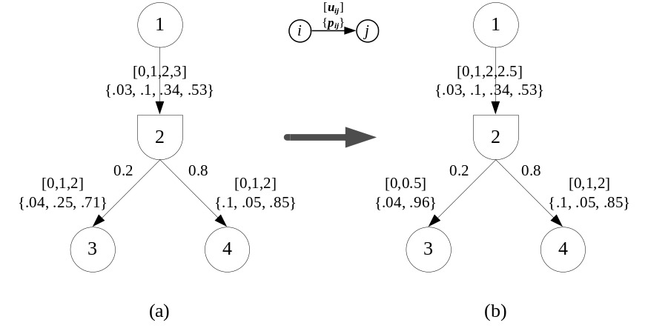
Figure 7. First example to compact mismatched arcs
Case 5.2: the bottleneck arc is a mother arc
In the case when the normalized capacity of a distillation arc is larger than the capacity of the mother arc, we use the capacity of the mother arc to reset the capacities of other arcs connecting to the D-node. Take Figure 8 for example, since , we know arc (1,2) is the bottleneck arc. In other words, we can use the capacity state vector of arc (1,2) to reset the capacity state vector of arc (2,3) and arc (2,4). In particular,, thus 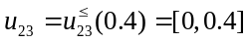, where the elements of its probability vector remains unchanged for those unchanged capacity states (i.e. ) and the probability for the state of the largest capacity equals the sum of the probabilities associated with those original states of larger capacities (i.e. 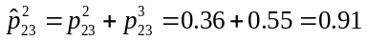). Similarly, so that 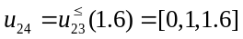, and their associated probabilities can be calculated by 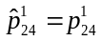, 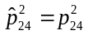 and 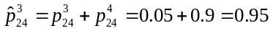.

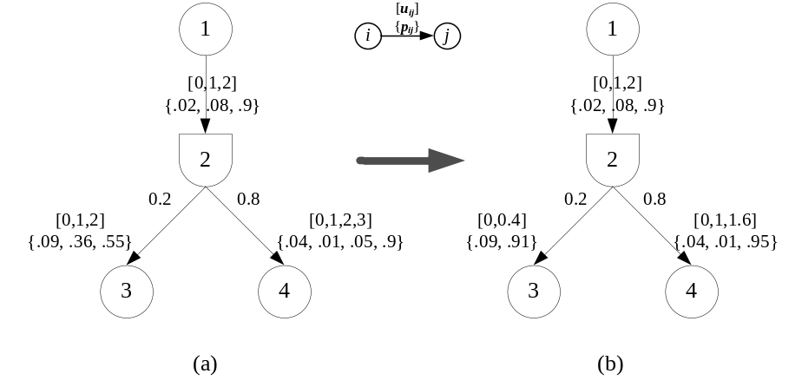
Figure 8. Second example to compact mismatched arcs
Although each compaction of mismatched arcs will not affect the topology of the original networks, all the other compaction cases will reduce at least one node or one arc. Based on the inducing relation of the compaction cases as analyzed in Lin (2005), one can easily show that the network compaction scheme proposed in this Section only require polynomial number of iterations to terminate. Unfortunately, each compaction may require many operations to reset capacity states and their associate probabilities, which in the worst case may take exponential time with respect to the site of the network. Nevertheless, we believe the proposed network compaction scheme will empirically save much effort in calculating the network reliability over distribution networks with D-nodes.
4. CALCULATING THE NETWORK RELIABILITY
Due to the distillation constraints, the arc flows may no longer be integral. Therefore, all the solution methods in literature designed for integral flow or capacity vectors (e.g. Yeh, 2005, 2006; Lin, 2002, 2007a, 2007b) can not be directly applied in calculating the network reliability in our problem. To resolve such difficulties, we exploit the combination of arc capacity states to calculate the network reliability for distribution networks with multi-state arc capacities.
First, we enumerate all the combinations of the arc capacity vectors, and then we eliminate those combinations infeasible for shipping units of flows from to based on the idea proposed by Yeh (2005). Four constraints will be checked for each capacity combination: (1) the sum of the capacities for arcs outgoing from should be larger than or equal to the requested demand . In other words, 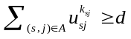; (2) the sum of the capacities for arcs entering should be larger than or equal to the requested demand . In other words, 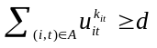; (3) for each D-node , the sum of the capacities of its distillation arcs should be larger than or equal to the capacity of its mother arc. In other words, 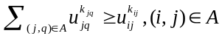; On the other hand, if 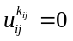, then 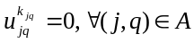; and (4) for each arc, its capacity should not exceed the requested units of demands. In other words, 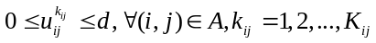. Some new constraints may be generated, depending on the special topology of the problem, so that the number of candidate capacity combinations can be further reduced. In the last step, we have to check all the remaining candidate capacity combinations one by one to see whether it can ship units of flow from to . Moreover, we only keep the dominating qualified capacity combinations. For example, suppose [1,3,0,0,3] and [0,3,0,0,3] are both qualified capacity combinations, then only [0,3,0,0,3] will be retained since it can dominate the vector [1,3,0,0,3].
Let 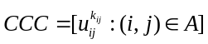and 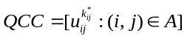 respectively represent an dimensional candidate capacity combination vector and the qualified capacity combination vector, where each element represents a selected arc capacity state. The probability corresponding to a candidate (or qualified) capacity combination, denoted by 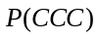 (or 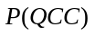), can be directly calculated by 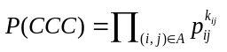 (or 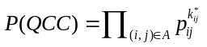).
Take the small distribution network in Figure 1 for example, let 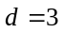. We can first enumerate all the possible combination for the arc capacity vector as shown in Table 1.
Table 1. A list of all the possible arc capacity combinations for the distribution network in Figure 1.
a₁ | a₂ | a₃ | a₄ | a₅
0 | 0 | 0 | 0 | 0
0 | 0 | 0 | 0 | 1
0 | 0 | 0 | 0 | 2
0 | 0 | 0 | 0 | 3
0 | 0 | 0 | 1 | 0
0 | 0 | 0 | 1 | 1
2.5 | 4 | 0.5 | 2 | 3

Overall, there will be 480 possible arc capacity combinations. Using the following constraints to eliminate infeasible arc capacity combinations, finally only 29 candidate capacity combinations remain.
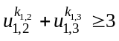
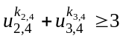
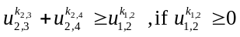
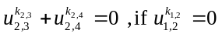
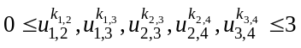
Then we can further eliminate 25 combinations so that only two basic augmenting components (i.e. {a₂,a₅} and {a₁,a₂,a₃,a₄,a₅}) with 4 qualified capacity combinations remain: (1) 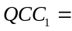[0,3,0,0,3], (2) 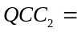[1,2,0.5,1,3], (3) 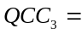[2,1,0.5,2,2], and (4) 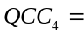[2.5,1,0.5,2,1]. Therefore, the network reliability can be calculated by .
5. CONCLUSIONS AND FUTURE RESERACH
Although the network reliability has been investigated for more than four decades, most of the research only deals with the networks satisfying the node flow balance and arc capacity constraints. Considering the refining process in manufacturing that often arisen in real-world applications, this paper aims at reliability issues over a specialized distribution network composed of D-nodes which are associated with distillation factors that specify the percentage of flow entering a D-node to be distributed to each of its distillation arcs.
Our paper has two major contributions: First, we propose a network compaction scheme with five cases for compacting the original distribution network into an equivalent one of smaller size. Such a compaction scheme is guaranteed to terminate within number of iterations polynomial to the size of the network, and is expected to reduce the complexity of the original network to some extent empirically. Second, we give a brief introduction in dealing with the fractional flow using the state enumeration techniques. To help speed up the process, we further eliminate many unqualified capacity combination using several intuitive flow constraints. For the illustrative example given in this paper, our technique successfully eliminate most of the unqualified candidate capacity combinations which helps the calculation for the network reliability, that is, probability that one or more qualified capacity combination may have.
For future research topics, we suggest further investigations in analyzing the complexity of our network compaction scheme, as well as more techniques to speed up the calculation of network reliability.

ACKNOWLEDGMENT

I-Lin Wang was partially supported by the National Science Council of Taiwan under Grant NSC96-2221-E-006-015.
REFERENCES
- Chang, M. D., Chen, C.-H. J. and Engquist, M. (1989). An improved primal simplex variant for pure processing networks. ACM Transactions on Mathematical Software, 15(1): 64-78.
- Chen, C.-H. J. and Engquist, M. (1986). A primal simplex approach to pure processing networks. Management Science, 32(12): 1582-1589.
- Douilliez, P. and Jamoulle, E. (1972). Transportation networks with random arc capacities. R.A.I.R.O., 3: 45-49.
- Fang, S.C., and Qi, L. (2003). Manufacturing network flows: A generalized network flow model for manufacturing process modeling. Optimization Methods and Software, 18: 143–165.
- Frank, H. and Hakimi, S.L. (1965). Probabilistic flow through a communications network. IEEE Trans. Circuit Theor, CT-12: 413-414.
- Glover, F. and Klingman, D. (1988). Layering strategies for creating exploitable structure in linear and integer programs. Mathematical Programming, 40: 165-181.
- Koene, J. (1982). Minimal Cost Flow in Processing Networks. a Primal Approach, Ph.D. Thesis, Eindhoven University of Technology, Eindhoven, The Netherlands,
- Lin, Y.K. (2002). Using minimal cuts to evaluate the system reliability of a stochastic-flow network with failure nodes and arcs. Reliability Engineering and System Safety, 75: 41-46.
- Lin, Y.K. (2007). Reliability evaluation for an information network with node failure under cost constraint. IEEE Transactions on Systems, Man, and Cybernetics—Part A: Systems and Humans, 37(2): 180-188.
- Lin, Y.K. (2007). Generate upper boundary vectors meeting the demand and budget for a p-commodity network with unreliable nodes. European Journal of Operational Research, 183: 253–262.
- Lin, J.C. (2005). Maximum flows in distribution networks: problem generator and algorithms. Master’s thesis, National Cheng Kung University
- Moore, E.F. and Shannon, C.E. (1956). Reliable circuit using less reliable relays. J. Franklin Inst., 262, 191-208; 263, 281-297.
- Ramirez-Marquez, J.E. and Coit, D.W. (2005). A Monte-Carlo simulation approach for approximating multi-state two terminal reliability. Reliability Engineering and System Safety, 87: 253-264.
- Yeh, W.C. (2005). A novel method for the network reliability in terms of capacitated-minimum-paths without knowing minimum-paths in advance. Journal of the Operation Research Society, 56: 1235-1240
- Yeh, W.C. (2006). A simple algorithm to search for all MCs in networks. European Journal of Operational Research, 174: 1694-1705.

