[Dental Clinic] Requirements Specification

Version 1.0

April 19, 2021

**Table of Contents**

**[YOURPROJECT] REQUIREMENTS SPECIFICATION 1**

**VERSION 1.0 1**

**APRIL 19, 2021 1**

**1.** **EXECUTIVE SUMMARY 3**

1.1 Project Overview 3

1.2 Purpose and Scope of this Specification 3

**2.** **PRODUCT/SERVICE DESCRIPTION 3**

2.1 Product Context 3

2.2 User Characteristics 3

2.3 Assumptions 3

2.4 Constraints 3

2.5 Dependencies 4

**3.** **REQUIREMENTS 4**

3.1 Functional Requirements 5

3.2 Non-Functional Requirements 5

*3.2.1* *Product Requirements 5*

**3.2.1.1** **User Interface Requirements** 6

**3.2.1.2** **Usability** 6

**3.2.1.3** **Efficiency** 6

3.2.1.3.1 Performance Requirements 6

3.2.1.3.2 Space Requirements 6

**3.2.1.4** **Dependability** 6

**3.2.1.5** **Security** 7

*3.2.2* *Organizational Requirements 7*

**3.2.2.1** **Environmental Requirements** 7

**3.2.2.2** **Operational Requirements** 7

**3.2.2.3** **Development Requirements** 7

*3.2.3* *External Requirements 7*

**3.2.3.1** **Regulatory Requirements** 7

**3.2.3.2** **Ethical Requirements** 7

**3.2.3.3** **Legislative Requirements** 7

3.2.3.3.1 Accounting Requirements 7

3.2.3.3.2 Security Requirements 7

3.3 Domain Requirements 7

**4.** **USER SCENARIOS/USE CASES 7**

# Executive Summary

## Project Overview

The project entails the creation and ongoing management of a website for Dr. Blerina Mustaqe Kokoneshi's dental clinic, situated in Tirana, Albania. The website is envisioned to be a comprehensive digital platform that not only showcases the clinic's range of dental services but also serves as an informative resource for individuals seeking guidance on dental health and hygiene. The primary aim is to create a user-friendly and informative online presence that reflects the professionalism and expertise of the clinic, thereby attracting new patients and retaining existing ones.

In addition to serving as a digital brochure for the clinic, the website is designed to enhance patient engagement and streamline administrative tasks. Features such as online appointment booking, interactive maps for easy clinic location, and contact forms for inquiries are intended to provide convenience for patients and improve operational efficiency for the clinic staff. The website will also include detailed profiles of the dental team, showcasing their qualifications and areas of expertise, thus fostering trust and confidence among potential and current patients.

Furthermore, the website will host a blog or news section where the clinic can share updates, dental care tips, and educational articles on various oral health topics. This not only positions the clinic as a thought leader in the field of dentistry but also helps in improving the website's search engine visibility, attracting more visitors. Overall, the project aims to create a digital presence that effectively communicates the clinic's values, services, and commitment to patient care, while also providing a platform for engagement and education.

## Purpose and Scope of this Specification

The purpose of this specification is to outline the requirements for a dental clinic website that will serve as an online platform for Dr. Blerina Mustaqe Kokoneshi's dental practice in Tirana, Albania. The website aims to provide patients with a user-friendly interface to access information about the clinic, its services, staff, and location. Additionally, the website will enable patients to schedule appointments, contact the clinic, and access educational resources about dental health.

The scope of this specification includes the development of a responsive website that is accessible on various devices, including desktops, tablets, and smartphones. The website will feature a clean and professional design that reflects the clinic's branding and reputation. Key functionalities will include an appointment booking system, a contact form, a section for patient testimonials, and a blog for dental health tips and news.

In scope:

* Development of a responsive website with a user-friendly interface.
* Integration of an appointment booking system.
* Creation of a contact form for patient inquiries.
* Design of a section for patient testimonials.

Out of scope:

* E-commerce functionality for selling dental products online.
* Integration with third-party insurance systems for direct billing.
* Development of a mobile application for the clinic.

The website will be designed with a focus on ease of use, ensuring that patients can easily navigate and find the information they need. The appointment booking system will be streamlined to allow patients to quickly select available time slots and schedule their visits. The contact form will provide a direct communication channel between patients and the clinic, enhancing patient engagement and satisfaction.

# Product/Service Description

## Product Context

Dr. Blerina Mustaqe-Kokoneshi's dental clinic website is designed to be an informational and interactive platform for patients seeking dental services in Tirana, Albania. It serves as a digital extension of the clinic, providing a comprehensive overview of the services offered, the qualifications of the dental team, and practical information such as location and contact details. The website aims to enhance the patient experience by offering convenient access to information, appointment booking, and communication with the clinic staff. It operates independently but is connected to the clinic's internal management systems for appointment scheduling and patient record management.

## User Characteristics

The Dental Clinic system caters to a diverse set of users, each with unique characteristics and requirements:

* Patients:
* + Demographics: Patients of all ages, from children to the elderly, seeking dental care.
  + Technical Expertise: Varying levels of comfort and proficiency with technology, from tech-savvy individuals to those who may require assistance.
  + Access Needs: Some patients may have special accessibility requirements, such as language translation services or accommodations for physical disabilities.
  + Interactions: Patients can view general information about the clinic, including staff profiles, services offered, and location details. They can log in to their accounts to view personal information, schedule appointments, access medical records, and communicate with healthcare providers.
* Staff:
* + Roles: Includes dentists, dental hygienists, dental assistants, receptionists, and administrative personnel.
  + Technical Expertise: Generally comfortable with technology, as they use the system for various administrative and clinical tasks.
  + Access Levels: Different staff members have varying levels of access to the system, depending on their roles and responsibilities. For example, dentists may have access to more detailed patient records than receptionists.
  + Interactions: Staff members use the system to manage patient information, schedule appointments, record treatment details, communicate with patients, and perform other administrative tasks.
* Administrators:
* + Technical Expertise: High level of proficiency with technology, as they are responsible for managing and configuring the system.
  + Access Levels: Full access to the system, including the ability to add or remove users, configure system settings, and generate reports.
  + Interactions: Administrators use the system to ensure its smooth operation, maintain data security, and provide support to other users.

## Assumptions

* *Technology Access*: It is assumed that all users, including patients and staff, have access to devices with internet connectivity, such as smartphones, tablets, or computers, to interact with the system.
* *User Familiarity*: While there may be varying levels of technical expertise, it is assumed that users have a basic understanding of how to navigate web-based applications.
* *Data Availability*: The system assumes that patient records, appointment schedules, and other relevant data are available and up-to-date to ensure accurate information is displayed and used.
* *Staff Training*: It is assumed that staff members, including receptionists, dental professionals, and administrators, will receive training on how to use the system effectively for their respective roles.
* *Privacy Compliance*: The system assumes that all users, especially staff members, are aware of and comply with privacy regulations and policies related to patient data.
* *Appointment Scheduling*: It is assumed that patients will schedule appointments within the available time slots, and the system will prevent double-booking or scheduling conflicts.
* *Internet Connectivity*: The system assumes reliable internet connectivity for uninterrupted access to the system's features and functions.
* *Maintenance and Updates*: It is assumed that the system will undergo regular maintenance and updates to ensure its security, performance, and relevance to the evolving needs of the dental clinic.

## Constraints

1. Parallel Operation with an Old System: The new system may need to operate in parallel with existing legacy systems until full migration is complete, which could limit the implementation of certain features or require additional compatibility measures.
2. Audit Functions: The system must include audit functions such as audit trails and log files to track user actions and changes to data, which may impact system performance and design.
3. Access, Management, and Security: The system must ensure secure access and management of patient data, requiring robust security measures that may constrain certain functionalities or user interface designs.
4. Criticality of the Application: Given the critical nature of healthcare applications, the system must prioritize reliability and accuracy, which may limit the complexity or novelty of certain features.
5. System Resource Constraints: The system's performance may be constrained by available hardware resources, such as limited disk space, memory, or processing power, affecting the scalability and efficiency of the system.
6. Other Design Constraints: The system's design may be constrained by other factors, such as adherence to specific design standards, programming language or framework limitations, and compatibility with third-party tools or systems.

## Dependencies

* *Integration with Existing Systems*: The new dental clinic management system may require integration with existing systems such as electronic medical records (EMR), billing software, or insurance databases. For example, patient data must be synchronized with the EMR system to ensure accurate and up-to-date records.
* *Hardware Requirements*: The system may depend on specific hardware components, such as servers, computers, or networking equipment, to function properly. For instance, the system might require a server with a minimum processing power and memory capacity to handle the clinic's data and user load.
* *Software Dependencies*: The system might rely on certain software platforms or libraries to operate. For example, it could require a specific operating system version, a database management system, or third-party APIs for sending appointment reminders via SMS or email.
* *Data Migration*: If the clinic is transitioning from an old system to the new one, there might be a dependency on successfully migrating existing patient records, appointment histories, and other relevant data to the new system without loss or corruption.
* *Regulatory Compliance*: The system's development and deployment may depend on meeting certain regulatory requirements, such as HIPAA compliance for patient data privacy and security in the United States. Compliance with local and international regulations is essential to ensure the system's legality and trustworthiness.
* *Staff Training*: The successful implementation of the system may depend on the staff's ability to use it effectively. This could involve training sessions, user manuals, and ongoing support to ensure that all users are comfortable with the system's features and functionalities.

By addressing these dependencies, the dental clinic can ensure that the system is developed and implemented with a comprehensive understanding of the factors that may impact its functionality and success.

# Requirements

## Functional Requirements

| **Req#** | **Requirement** | **Comments** | **Priority** | **Date**  **Reviewed** | **SME Reviewed / Approved** |
| --- | --- | --- | --- | --- | --- |
| FR01 | The system shall showcase the clinic's portfolio. | The website will display information about the clinic, its history, achievements, and core values. | 1 | 01/03/2024 | Ilir Gjylbegaj/Aron Subashi |
| FR02 | The system shall display detailed information about the clinic's staff. | Each staff member's profile will include their photo, qualifications, specialties, and contact information. | 1 | 04/03/2024 | Bled Ibrahimi/Ilir Gjylbegaj |
| FR03 | The system shall provide information about the clinic's location and contact details. | The website will include a map, address, phone numbers, and email addresses for the clinic. | 3 | 08/03/2024 | Aron Subashi/Amira Shehi |
| FR04 | The system shall list the services offered by the clinic. | Each service will have a description, including any preparation needed, what to expect during the procedure, and post-treatment care. | 2 | 12/03/2024 | Ilir Gjylbegaj/Aron Subashi |
| FR05 | The system shall allow patients to schedule appointments online. | Patients can choose a service, select an available time slot, and provide their contact information. The system sends a confirmation message. | 3 | 16/03/2024 | Bled Ibrahimi/Ilir Gjylbegaj |
| FR06 | The system shall send automated appointment reminders to patients. | The system sends reminder messages (email/SMS) to patients 24 hours before their scheduled appointment. | 2 | 20/03/2024 | Amira Shehi/Bled Ibrahimi |
| FR07 | The system shall allow staff to view and manage scheduled appointments. | Staff can view the appointment calendar, reschedule appointments, or cancel them. The system updates the schedule accordingly. | 1 | 24/03/2024 | Ilir Gjylbegaj/Aron Subashi |
| FR08 | The system shall provide a user-friendly interface for easy navigation. | The website will have a clear layout, easy-to-read fonts, and intuitive navigation to enhance the user experience. | 2 | 28/03/2024 | Bled Ibrahimi/Aron Subashi |
| FR09 | The system shall be optimized for mobile devices. | The website will be responsive and adapt to different screen sizes to ensure accessibility on smartphones and tablets. | 1 | 02/03/2024 | Amira Shehi/Ilir Gjylbegaj |
| FR10 | The system shall include a FAQ section to address common patient inquiries. | The FAQ section will provide answers to frequently asked questions about clinic services, appointment scheduling, and other relevant topics. | 3 | 06/03/2024 | Ilir Gjylbegaj/Aron Subashi |
| FR11 | The system shall ensure data privacy and security in accordance with relevant regulations. | The website will implement encryption, secure data storage, and other security measures to protect patient information. | 2 | 10/03/2024 | Bled Ibrahimi/Amira Shehi |
| FR12 | The system shall provide an online contact form for patient inquiries. | Patients can submit questions or requests through the website, which will be directed to the appropriate clinic staff. | 3 | 14/03/2024 | Amira Shehi/Aron Subashi |
| FR13 | The system shall include testimonials from satisfied patients. | The website will feature positive feedback and reviews from patients to build trust and credibility. | 1 | 18/03/2024 | Ilir Gjylbegaj/Aron Subashi |
| FR14 | The system shall offer multilingual support to accommodate a diverse patient base. | The website will be available in multiple languages to ensure accessibility for non-English speaking patients. | 2 | 22/03/2024 | Bled Ibrahimi/Ilir Gjylbegaj |
| FR15 | The system shall include a gallery of clinic facilities and equipment. | The website will showcase images of the clinic's state-of-the-art facilities and medical equipment. | 3 | 26/03/2024 | Aron Subashi/Bled Ibrahimi |
| FR16 | The system shall offer a virtual tour of the clinic. | Patients can take an online virtual tour of the clinic to familiarize themselves with the environment before their visit. | 1 | 30/03/2024 | Ilir Gjylbegaj/Aron Subashi |
| FR17 | The system shall provide information on insurance and payment options. | The website will outline the different insurance plans accepted by the clinic and available payment methods. | 2 | 03/03/2024 | Bled Ibrahimi/Ilir Gjylbegaj |
| FR18 | The system shall include a section for health tips and advice. | The website will offer articles, videos, and other resources on dental health and hygiene. | 3 | 07/03/2024 | Aron Subashi/Ilir Gjylbegaj |
| FR19 | The system shall allow patients to subscribe to a newsletter for clinic updates and promotions. | Patients can sign up to receive regular updates on clinic services, special offers, and dental health tips via email. | 1 | 11/03/2024 | Ilir Gjylbegaj/Amira Shehi |
| FR20 | The system shall include links to the clinic's social media profiles. | The website will provide direct links to the clinic's Facebook, Instagram, and other social media pages for patients to follow. | 2 | 15/03/2024 | Bled Ibrahimi/Ilir Gjylbegaj |
| FR21 | The system shall provide a detailed guide on how to prepare for dental procedures. | The website will offer step-by-step instructions for patients on preparing for various dental treatments, including pre-appointment care. | 3 | 19/03/2024 | Aron Subashi/Bled Ibrahimi |
| FR22 | The system shall include a blog section for the latest dental news and research. | The website will feature a blog with articles on the latest advancements in dental care, new research findings, and tips for oral health. | 1 | 23/03/2024 | Ilir Gjylbegaj/Amira Shehi |
| FR23 | The system shall allow patients to provide feedback on their experience with the clinic. | Patients can submit reviews and ratings of their experience with the clinic's services and staff, which will be displayed on the website. | 2 | 27/03/2024 | Bled Ibrahimi/Ilir Gjylbegaj |
| FR24 | The system shall offer an online store for dental care products. | The website will include an e-commerce section where patients can purchase recommended dental care products directly from the clinic. | 3 | 02/03/2024 | Amira Shehi/Bled Ibrahimi |
| FR25 | The system shall provide emergency contact information for urgent dental care. | The website will list emergency contact numbers and instructions for patients who require immediate dental attention outside regular hours. | 1 | 06/03/2024 | Ilir Gjylbegaj/Aron Subashi |
| FR26 | The system shall include a career section for job opportunities at the clinic. | The website will feature current job openings, requirements, and information on how to apply for positions at the clinic. | 2 | 10/03/2024 | Amira Shehi/Ilir Gjylbegaj |
| FR27 | The system shall provide a platform for online consultations with dental professionals. | Patients can schedule and conduct virtual consultations with dentists for preliminary assessments or follow-up discussions. | 3 | 14/03/2024 | Bled Ibrahimi/Amira Shehi |

## Non-Functional Requirements

### Product Requirements

#### **User Interface Requirements**

The website should be responsive and adaptable to various screen sizes, ensuring accessibility from desktops, tablets, and smartphones.

The user interface should be intuitive, with clear navigation menus, and consistent in terms of layout and design across different pages.

Error messages should be user-friendly and provide clear instructions on how to resolve issues.

The website should have a clean and professional design that reflects the branding of the dental clinic.

#### **Usability**

The website should be designed with a focus on learnability, ensuring that new users can quickly understand how to navigate and use the site.

User documentation and help sections should be comprehensive, providing clear instructions and guidance for all features of the website.

Help content should be context-sensitive, offering relevant information based on the user's current actions or page.

The overall design and layout of the website should be intuitive, allowing users to easily find information and complete tasks without extensive training.

#### **Efficiency**

##### Performance Requirements

The website should support a minimum of 100 simultaneous users without any degradation in performance.

The system should be capable of handling up to 500 transactions per day during normal operations and up to 1000 transactions per day during peak periods.

95% of page load times should be under 2 seconds, ensuring a fast and responsive user experience.

All appointment scheduling and form submissions should be processed within 3 seconds to maintain a smooth and efficient workflow for users.

##### Space Requirements

The website should be optimized for efficient use of server space, with a focus on minimizing the size of files and images.The database used for storing appointment and patient information should be structured to optimize space utilization and query performance.

#### **Dependability**

**Availability**

* The website should be available 24/7, with an uptime of at least 99.5%.
* The system should be accessible from all geographic areas where the clinic's patients reside.
* In the event of downtime, users should be notified via the website and email, with an estimated time of resolution.
* Scheduled maintenance should be performed during off-peak hours, with at least 48 hours' notice to users.
* The system should have a mean time between failures (MTBF) of at least 1,000 hours, ensuring high reliability for users.
* The system should not exceed one failure per 500 hours of operation, maintaining a high level of dependability for the clinic's operations.

**Reliability**

* The system should have a high level of reliability, with an acceptable mean time between failures (MTBF) that meets the needs of the clinic.
* The maximum permitted number of failures per hour should be defined and adhered to, ensuring consistent operation.

**Monitoring**

* The system should include monitoring tools to track its performance and health in real time, including server status, application performance, and user activity.
* Alerts should be configured to notify the technical team immediately in case of any system failures or significant performance issues.
* Error detection mechanisms should be in place to identify and log any system errors or anomalies as they occur.

**Maintenance**

* The system should be designed with modularity in mind, allowing for easy updates and maintenance without disrupting the overall functionality.
* The complexity of the system should be minimized to reduce the likelihood of errors and simplify maintenance procedures.
* The user interface and backend should be designed to facilitate easy access to system components for maintenance purposes.
* A regular maintenance schedule should be established to ensure that the system remains up-to-date and operates efficiently, with minimal downtime.

**Integrity**

#### **Security**

*Encryption*: The system should employ robust encryption methods to secure data transmission and storage.

*Activity logging, historical data sets*: Activity logging should be implemented to keep a record of all user actions within the system, and historical data sets should be maintained for security audits.

*Restrictions on intermodule communications*: Communication between different modules of the system should be restricted and controlled to prevent unauthorized access and data breaches.

*Data integrity checks*: Data integrity checks should be performed regularly to ensure the accuracy and integrity of the stored and processed information.

### Organizational Requirements

#### **Environmental Requirements**

* The system should be designed to operate in a standard office environment without any special requirements for temperature or humidity.
* The website should be accessible from any location with an internet connection, accommodating the geographical distribution of the clinic's patients and staff.

#### **Operational Requirements**

* The system should support concurrent access by multiple users without significant performance degradation.
* The appointment scheduling system should be able to handle peak loads, especially during the clinic's busiest hours.
* The system should provide a user-friendly interface for both patients and staff, facilitating easy navigation and interaction.

#### **Development Requirements**

* The system should be developed using standard web technologies such as HTML, CSS, and JavaScript to ensure compatibility with various browsers and devices.
* The development process should adhere to best practices in web security to protect patient and clinic data.
* The system should be modular, allowing for easy updates and maintenance.

### External Requirements

#### **Regulatory Requirements**

* The system must comply with all applicable healthcare regulations, including patient privacy laws and data protection standards.
* The website should provide clear information about the clinic's policies and procedures in accordance with regulatory requirements.

#### **Ethical Requirements**

* The system should ensure the confidentiality and integrity of patient data, upholding the ethical standards of medical practice.
* The website should present information in an honest and transparent manner, respecting the dignity and rights of patients.

#### **Legislative Requirements**

* The system must adhere to the Albanian Law on Data Protection for the handling of patient information, ensuring privacy and security.
* The website should comply with the Albanian Health Care Standards for digital health services, including the management of electronic health records and patient data.
* Appointment scheduling and patient management must align with the regulations set by the Ministry of Health in Albania for healthcare service providers.
* The system should be designed to accommodate updates to legal requirements, with the flexibility to adjust to new laws or regulations as they arise.
* An audit trail feature must be implemented to track all changes made to patient records, with detailed logs including timestamps, user identification, and before-and-after values for each modification.
* Data naming conventions and report formats should follow the guidelines established by the Albanian National Agency for Information Society (NAIS) to ensure standardization and interoperability with other healthcare systems.

##### Accounting Requirements

* The system does not involve financial transactions or billing services, as it is primarily focused on appointment scheduling and patient management.
* The platform should ensure that all scheduled appointments are accurately recorded and managed without any financial implications for the users.
* Any future integration of financial or billing features must comply with Albanian financial regulations and standards for healthcare services.
* The system should provide clear and transparent scheduling information to both patients and staff, without any hidden costs or fees.
* In the event of implementing financial features, the system must ensure the confidentiality and security of any financial data in accordance with relevant laws and regulations.

##### Security Requirements

* The system should implement robust security measures, including encryption and secure authentication, to protect sensitive information.
* The website should employ security best practices, such as regular security audits and updates, to guard against cyber threats.

## Domain Requirements

1. Field of Operation: The web application operates as a public-facing portfolio showcase for the dental clinic "Dr. Blerina Mustaqe Kokoneshi" in Tirana, Albania.

2. Purpose: The primary purpose of the application is to provide information about the clinic, its staff, services, and location. It also serves as a platform for patients to schedule appointments.

3. *User Interface*: The application should have a user-friendly interface that displays information about the clinic, its staff, services offered, and location. It should also provide an easy-to-use appointment scheduling feature.

1. Accessibility: The application should be accessible from various devices and browsers, ensuring that patients can access information and schedule appointments from desktops, tablets, or smartphones.
2. Data Privacy: While the application does not store sensitive patient data, it should still adhere to best practices for data privacy and security, especially in handling personal contact information submitted through the appointment scheduling feature.
3. Appointment Scheduling: The application should allow patients to view available appointment slots and book appointments. Confirmation of appointments should be sent to both the patient and the clinic.
4. Content Management: The clinic should have the ability to easily update information about staff, services, and other content on the website without requiring technical expertise.
5. Localization: The application should be available in both Albanian and English to cater to a diverse patient base.
6. SEO Optimization: The website should be optimized for search engines to increase visibility and attract more patients to the clinic.
7. Analytics: The application should integrate with analytics tools to track user engagement and gather insights on how patients interact with the website.

These domain requirements are tailored to the specific needs of the dental clinic's web application, focusing on providing information, facilitating appointment scheduling, and ensuring accessibility and user-friendliness.

***4. User Scenarios/Use Cases***

Major Functions Summary:

The Dental Clinic Web Application serves as an online portfolio showcasing the clinic's services, staff, location, and contact information. It also facilitates appointment scheduling for patients. The major functions of the product are:

* *Appointment Scheduling*: Allows patients to schedule appointments online, providing a convenient way for patients to book visits without the need for phone calls or in-person visits.
* *Information Display*: Displays comprehensive information about the clinic, including services offered, staff profiles, operating hours, and contact details.
* *Location Mapping*: Integrates a map showing the clinic's location, assisting patients in finding the clinic easily.
* *Browser Compatibility*: Ensures that the website is compatible with major web browsers for accessibility on various devices.
* *Performance Optimization*: Guarantees quick and efficient loading of the website, enhancing user experience.

Business Scenario:

* *Significant Business Need*: The dental clinic requires an online presence to showcase its services and staff, provide information to potential patients, and facilitate appointment scheduling.
* *Problem Driving the Scenario*: The clinic currently lacks an efficient way for patients to book appointments and access information about the clinic online.
* *Business and Technical Environment*: The solution is a web application hosted on a secure server, accessible via major web browsers. The application includes a user-friendly interface for appointment scheduling and information display.

Desired Objectives:

* Increase the clinic's visibility and accessibility to potential patients.
* Streamline the appointment scheduling process.
* Provide a platform for patients to access information about the clinic's services and staff.

**Actors and Business Model:**

**Actors**: Patients, Clinic Staff (Dentists, Receptionists)

**Business Model**: The web application serves as a digital front desk for the clinic, allowing patients to interact with the clinic's services online.

**Specific, Measurable Metrics for Success:**

* Number of appointments scheduled online.
* Increase in patient inquiries through the website.
* User satisfaction ratings for the website's ease of use and information accessibility.

By addressing these aspects, the Dental Clinic Web Application aims to enhance the clinic's operational efficiency and patient satisfaction.

1. **Definitions, Acronyms, and Abbreviations**

*Clinic*: Refers to the dental clinic "Dr. Blerina Mustaqe Kokoneshi" located in Tirana, Albania, which provides a range of dental services to patients.

*Patient*: An individual seeking dental services from the clinic. Patients can schedule appointments online through the clinic's website for various dental treatments.

*Appointment*: A scheduled meeting between a patient and the dentist at the clinic. Appointments can be made for various dental services, including check-ups, cleanings, fillings, and other treatments.

*Dentist*: A medical professional specializing in the diagnosis, prevention, and treatment of diseases and conditions of the oral cavity. The dentist provides dental care and treatment to patients at the clinic.

*Treatment*: A dental procedure or service provided by the dentist to address a patient's dental health needs. Treatments can include fillings, extractions, root canals, and other dental procedures.

*Website*: The official online platform of the clinic, accessible at https://dr-blerina-mustaqe-kokoneshi.com/, where patients can find information about the clinic's services, staff, and appointment scheduling.

*Service Page*: A section of the clinic's website that provides detailed information about the various dental services offered at the clinic.

*Staff Page*: A section of the clinic's website that showcases the professional profiles of the dental staff, including their qualifications, expertise, and areas of specialization.

*Location Page*: A section of the clinic's website that provides information about the clinic's location, including its address, contact details, and a map for easy navigation.

*Contact Page*: A section of the clinic's website that allows patients to get in touch with the clinic for inquiries, feedback, or additional information.

1. **References**

Clinic Website: The official website of Dr. Blerina Mustaqe Kokoneshi's dental clinic, which provides comprehensive information about the clinic's services, staff, and appointment scheduling. Accessible at https://dr-blerina-mustaqe-kokoneshi.com/.

User Interface Design Guidelines: A set of principles and standards that guide the design of the clinic's website and appointment scheduling system to ensure a user-friendly and accessible experience for patients.

Data Privacy Regulations: Legal and regulatory frameworks that govern the handling, storage, and protection of patient data by the clinic. These regulations ensure the confidentiality and security of personal and medical information provided by patients.

Dental Industry Standards: Guidelines and best practices established by dental associations and regulatory bodies that dictate the quality of care, treatment protocols, and ethical practices followed by the clinic.

Healthcare Legislation: National and local laws that regulate the operation of dental clinics, including licensing requirements, patient rights, and healthcare provider responsibilities.

Online Appointment Scheduling Systems: Literature and research on the implementation and effectiveness of online booking systems in healthcare settings, which inform the development of the clinic's appointment scheduling platform.

Web Accessibility Standards: Guidelines established by the World Wide Web Consortium (W3C) to ensure that websites are accessible to individuals with disabilities, which the clinic's website adheres to.

Patient Satisfaction Surveys: Studies and surveys conducted to assess the satisfaction of patients with the services provided by the clinic, which are used to continuously improve the quality of care and patient experience.

1. **Requirements Traceability Matrix**

(1):

| Business Requirement | Area | Deliverables | Status |
| --- | --- | --- | --- |
| DC_01  The system should allow patients to schedule appointments online | Appointment  Scheduling | Appointment Scheduling Module Design | In Progress |
| DC_02  The system should provide a map showing the clinic's location. | Information  Display | Clinic Location Map Integration | Ready for  Review |
| DC _03  The system should load quickly and efficiently. | Performance | Performance Optimization | Accepted |
| DC _04  The system should ensure data privacy and security for patient information. | Security | Data Privacy and Security  Policies | Ready for  Review |

(2):

| **BizReqID** | **Pri** | **Major Area** | **DevTstItems DelivID** | **Deliv Name** | **Status** |
| --- | --- | --- | --- | --- | --- |
| DC _01 | 1 | Clinic Website | Clinic-CD-01 | Clinic Conceptual Design | Accepted |
| DC _02 | 2 | Appointment  Scheduling | Appt-DS-02 | Appointment Data Structure | Accepted |
| DC _03 | 3 | Service  Information | Svc-PF-03 | Service Process Flow Diagram | ReadyForReview |
| DC _04 | 1 | Staff Profiles | Staff-UI-04 | Staff User Interface Mockups | Reviewed |
| DC _05 | 2 | Patient Feedback | Feedback-TC-05 | Patient Feedback Test Cases | Reviewed |
| DC _06 | 1 | Security | Sec-CD-06 | Security Conceptual Design | Accepted |
| DC _07 | 3 | Location  Map | Loc-UCD-07 | Location Use Case Diagram | Reviewed |
| DC _08 | 2 | Data Privacy | Privacy-DS-08 | Data Privacy Description | Accepted |
| DC_09 | 3 | User Interface | UI-PF-09 | User Interface Process Flow | Accepted |
| DC_10 | 1 | Mobile  Compatibility | Mobile-UCD-10 | Mobile Compatibility Use Case  Diagram | Reviewed |
| DC_11 | 3 | Performance | Perf-UI-11 | Performance User Interface  Mockups | ReadyForReview |
| DC_12 | 1 | Accessibility | Access-UCT-12 | Accessibility Use Case Test | Reviewed |
| DC_13 | 1 | Content  Management | CMS-CD-13 | Content Management System  Design | Accepted |
| DC_14 | 3 | SEO  Optimization | SEO-PF-14 | SEO Process Flow Diagram | Accepted |
| DC_15 | 2 | Social Media  Integration | SM-DS-15 | Social Media Integration  Description | Accepted |

For example (3):

| **BizReqID** | **CD01** | **CD02** | **CD03** | **CD04** | **UI01** | **UI02** | **UCT01** | **UCT02** | **UCT03** | **TC01** | **TC02** | **TC03** | **TC04** |
| --- | --- | --- | --- | --- | --- | --- | --- | --- | --- | --- | --- | --- | --- |
| DC_01 | X |  |  | X | X |  | X |  |  | X |  |  | X |
| DC_02 |  | X | X |  |  | X |  | X | X |  | X | X |  |
| DC_03 |  | X |  | X | X |  |  | X |  |  | X |  | X |
| DC_04 | X |  | X |  |  | X | X |  | X | X |  | X |  |

**Table KEY:**

*DC_01*: Related to the clinic's information and services display.

*DC_02*: Pertains to the appointment scheduling feature.

*DC_03*: Associated with the staff profiles section.

*DC_04*: Concerns the clinic's location and contact information.

*CD01, CD02, CD03, CD04*: Conceptual Design documents for different parts of the website.

*UI01, UI02*: User Interface design specifications for different parts of the website.

*UCT01, UCT02, UCT03*: Use Case Tests for different functionalities of the website.

*TC01, TC02, TC03, TC04*: Test Cases for different functionalities of the website.

1. **Organizing the Requirements**

**By System Mode**

While the web application for Dr. Blerina Mustaqe Kokoneshi's dental clinic primarily operates in a standard mode for routine operations, it is designed to adapt to different scenarios or modes that might arise. For instance:

* *Standard Mode*: This is the default mode where patients can browse services, schedule appointments, and access information about the clinic. The system functions normally, providing all the necessary features for users to interact with the clinic online.
* *Maintenance Mode*: There may be times when the website needs to undergo maintenance or updates. In this mode, certain functionalities might be temporarily unavailable or limited. However, essential information such as contact details and emergency service information will still be accessible.
* *Emergency Mode*: In the event of an emergency, such as a sudden clinic closure or a public health crisis, the system can switch to an emergency mode. In this mode, the website may display critical alerts, provide instructions for patients with upcoming appointments, and offer guidance on how to seek urgent dental care.

Each mode is designed to ensure that the website remains functional and informative, regardless of the circumstances, while prioritizing the safety and convenience of both patients and clinic staff.

**By User Class**

It's essential to recognize the varied groups of users that interact with our dental clinic's web application. Although the primary focus is on our patients, we should also consider the potential needs of different user classes in future expansions:

* *Patients*: As the main users, patients can explore the services we offer, get to know our dedicated staff, and find our clinic's location. They have the convenience of scheduling appointments online and staying updated with any news or announcements from our clinic.
* *Clinic Staff*: Although not currently implemented, a future enhancement could include a separate section for our staff. This would enable them to efficiently manage appointments, keep service information up-to-date, and engage with patients directly through the website.
* *Administrators*: In an upgraded version of the website, administrators might have access to more advanced features, such as site maintenance tools, analytics to monitor website performance and tools to manage user accounts. This level of access would ensure the smooth operation of the website and allow for adjustments to better serve the needs of patients and staff.

By taking into account these different user classes, we can design a website that not only meets the needs of our patients but also provides a solid foundation for future growth and enhancements, ensuring a seamless experience for all users.

**By Objects**

When considering objects in our web application, it's essential to identify the real-world entities that have a digital representation within the system. In our dental clinic's case, these objects might include:

* *Services*: Represent the various dental services offered by the clinic. Each service has attributes like a description, duration, and cost. Functions related to services might include scheduling appointments for a specific service or providing detailed information about what the service entails.
* *Staff*: Represents the clinic's dental professionals and support staff. Attributes could include their names, titles, qualifications, and areas of expertise. Functions might involve displaying staff profiles, contact information, and scheduling availability.
* *Appointments*: Serve as the bridge between patients and the clinic's services. Attributes include the appointment date, time, patient details, and the service being provided. Functions could include booking, rescheduling, or canceling appointments.
* *Patients*: While not directly interacted with on the website, patients are a crucial object in the system. They have attributes like name, contact information, and appointment history. In a more advanced system, functions might include logging in to view appointment history or receiving reminders for upcoming appointments.
* *News/Announcements*: Represents timely information that the clinic wants to share with its visitors. Attributes might include the date of the announcement, the title, and the content. Functions could involve displaying the latest news on the homepage or archiving past announcements.

By clearly defining these objects and their associated attributes and functions, we can ensure that our web application accurately reflects the operations of our dental clinic and provides a user-friendly experience for our patients and staff.

**By Feature**

Regarding the various features our dental clinic's web application offers, each one is designed to provide a specific service that enhances the user experience. These features are constructed with a focus on user needs, ensuring that each interaction with the system yields the desired outcome. Here are some examples:

* *Appointment Scheduling*: This feature allows patients to book appointments online. It involves a sequence of inputs such as selecting a service, choosing a preferred date and time, and providing contact information. The system then confirms the appointment, providing a clear response to the user's request. This feature may include checks to ensure the chosen time slot is available and that all required information is provided correctly.
* *Service Information*: This feature provides detailed information about the various dental services offered by the clinic. Users can browse through different services, each with its description, duration, and potential costs. The system ensures that the information presented is up-to-date and accurate, enhancing the user's understanding of what to expect during their visit.
* *Staff Profiles*: This feature showcases the qualifications and expertise of the dental professionals at the clinic. Users can view individual profiles, including the staff member's background, areas of specialization, and contact information. This helps build trust and confidence in the clinic's team.
* *Location and Contact Information*: This feature provides essential details about the clinic's location, including an interactive map, address, and contact details. It ensures that users can easily find the clinic and reach out for any inquiries or additional information.
* *News and Announcements*: This feature keeps users informed about the latest news, updates, and any special promotions offered by the clinic. It requires regular updates to ensure that the information is current and relevant to the users' needs.

Each of these features is designed with the user's experience in mind, ensuring that the interaction is smooth, the results are clear, and any potential errors are handled gracefully. By focusing on these features, we aim to provide a comprehensive and user-friendly online platform for our dental clinic's patients and staff.

**By Stimulus**

In our web application for the dental clinic, we can consider organizing some functions based on specific stimuli or triggers. This approach helps us address specific user needs or system responses more effectively. Here are some examples:

* *User Feedback Submission*: When a patient submits feedback through the website, this stimulus triggers a series of actions within the system. The feedback is recorded, an acknowledgment message is sent to the patient, and the feedback is routed to the appropriate staff member for review.
* *Appointment Reminder*: As the scheduled appointment date approaches, the system automatically generates a reminder stimulus. This triggers the sending of an email or SMS notification to the patient, reminding them of their upcoming appointment and providing any necessary instructions.
* *Service Inquiry*: When a user submits an inquiry about a specific dental service, this stimulus prompts the system to provide a detailed response. The response includes information about the service, its benefits, and how to schedule an appointment for it.
* *Emergency Contact*: If a user clicks on the emergency contact button on the website, this stimulus triggers an immediate response. The system provides the user with the clinic's emergency contact number and any relevant instructions for urgent dental situations.

By organizing functions around these stimuli, we ensure that the web application responds promptly and appropriately to user actions and system events, enhancing the overall user experience and efficiency of the clinic's operations.

**By Response**

In terms of generating responses, our system is structured to ensure that every function contributes effectively to producing the desired outcomes. For instance, the web application for our dental clinic is organized to facilitate various responses such as confirming appointments, providing information about services, and displaying staff profiles. Here are some detailed examples:

* *Appointment Confirmation*: When a patient schedules an appointment, the system generates a confirmation response. This response includes the appointment details, any necessary preparations, and a thank-you message, providing the patient with reassurance and clarity about their upcoming visit.
* *Service Information Request*: If a user requests information about a particular dental service, the system's response is to provide comprehensive details about the service. This includes an explanation of the procedure, its benefits, potential risks, and how to schedule an appointment for it.
* *Feedback Acknowledgment*: Upon receiving feedback from a patient, the system generates an acknowledgment response. This response thanks the patient for their input, assures them that their feedback will be reviewed, and, if necessary, informs them that they will be contacted for further discussion.

By organizing functions based on the responses they generate, we ensure that the web application is responsive and user-friendly, effectively addressing the needs and inquiries of patients and visitors.

**By Functional Hierarchy**

For the dental clinic's web application, we can organize the functionalities into a hierarchical structure that is logical and easy to navigate. This hierarchy will be supported by a data flow diagram and a data dictionary to illustrate the relationships between functions and data.

Primary Functions:

* *Appointment Scheduling*: Patients can book, view, and cancel appointments online.
* *Service Information*: Detailed descriptions of dental services offered by the clinic.

Secondary Functions:

* *Staff Profiles*: Information about the dental professionals, including qualifications and experience.
* *Location and Contact Details*: Clinic's address, contact information, and interactive map.

Supportive Functions:

* *Patient Feedback*: Collection of reviews and ratings from patients.
* *FAQs and Dental Health Tips*: Answers to common questions and advice on oral hygiene.

**User Scenario List**

|  |  |  |
| --- | --- | --- |
| **Nr** | **Name** | **Description** |
| US_01 | User logs in | The user (patient, receptionist, dentist, manager, or administrator) logs into the system to access the service by having a unique username and password. |
| US_02 | User views their profile | This is the procedure of each of the users viewing their profile. The user could be a manager/dentist/receptionist/patient or administrator. |
| US_03 | User edits their information | The Patient, Receptionist, Dentist, Manager, and Administrator need to update their information. |
| US_04 | Create a new user | To create a new user, we must have this status: receptionists can create patients; managers can create patients, receptionists, and dentists; admin can create any of them. |
| US_05 | Search for a user | To search for a special user, we must have the right status to do this. (EX: receptionists can search only for patients; managers can search for patients, receptionists, and dentists; admins can search for anybody, patients can search for dentists) |
| US_06 | Edit a searched user | To edit a searched user profile, we must have the respective status as we mentioned above. |
| US_07 | Fire an employee | The administrator can fire any employee. The Manager can fire only the receptionist and dentists. Both should log in from their specific user to fire an employee. |
| US_08 | Add a new appointment | The receptionist/Manager/Administrator can add a new appointment. |
| US_09 | Search for an appointment | Receptionist/Dentist/Administrator/Manager search for a specific appointment. |
| US_010 | Edit a searched appointment’s information | Administrator / Manager / Receptionist can make changes to various fields relating to appointments. |
| US_011 | Add services to a patient | Administrator / Manager / Receptionist adds clinic’s services to patient’s account. |
| US_012 | Generate a bill for a patient | The administrator / Manager / Receptionist generates a bill when patients receive a service. |
| US_013 | Add medical records to a patient | The dentist creates an examination report for the patients that are allowed to do so. |
| US_014 | Transfer an employee | As an administrator of a dental clinic, an employee needs to be transferred to another location due to a change in staffing needs. |
| US_015 | Patient leaves feedback | A patient wants to leave feedback about their recent experience with the dental clinic. |
| US_016 | Patient books an appointment | The patient can book an appointment. The “Dentists” button shows all the dentists who work for this business and their locations and contacts. A patient can search for a dentist by typing parts of their name or surname. For the searched and selected dentist, the patient can view when the dentist is available and can book an appointment. |
| US_017 | View feedback left by the patient | The manager can view the feedback left by patients for their own clinic/location. The administrator can view all the feedback left by the patients. Both should log in from their specific user to view respective feedback. |
| US_018 | User logs out | The user logs out of the software and cannot perform any more operations unless logged in again with valid credentials. |

**User Scenarios Extended**

**US_01 – User logs in**

1. The user must choose the user type: patient/receptionist/dentist/manager/administrator.
2. The user is redirected to the login page.
3. The user enters the username and password.
4. The user checks the reCAPTCHA ‘I am not a robot’.
5. The user clicks the sign-in button.
6. If the data is correct, the user is redirected to the user profile page.
7. If the data is not correct, an error message will be shown, and the user will repeat the process.

**US_02 – User views their profile**

1. The user goes to the website and logs in.
2. The user goes to the "My Profile" area.
3. The website loads the user’s profile page, which includes a picture, name, and position description.
4. The user has access to and can change contact details such as their address, phone number, and email address.
5. An overview of the administrator's ongoing activities and projects and information on their status and completion dates are available.
6. In addition to any feedback or assessments they have gotten, the administrator, manager, or dentist can check their performance indicators, which include attendance and productivity.
7. Additionally, the administrator, manager, or dentist has access to their educational background, prior employment history, and any certificates or honors they may have.

**US_03 – User edits their information**

1. The user goes to the "My Profile" area.
2. The user selects the "Edit Profile" option.
3. The user makes changes to their personal information such as name, address, phone number, or email address.
4. The user saves the changes.
5. The system confirms the changes and updates the user profile.

**US_04 – Create a new user**

1. The authorized user logs in.
2. The user goes to the "User Management" area.
3. The user selects "Create New User".
4. The user fills in the required details for the new user, such as name, role, email, and password.
5. The user saves the new user profile.
6. The system confirms the creation of the new user.

**US_05 – Search for a user**

1. The authorized user logs in.
2. The user goes to the "User Management" area.
3. The user enters the search criteria (e.g., name, role) in the search bar.
4. The system displays a list of users matching the criteria.
5. The user selects a user from the list to view or edit their profile.

**US_06 – Edit a searched user**

1. The authorized user logs in.
2. The user searches for a user as described in US_05.
3. The user selects the user to be edited.
4. The user makes the necessary changes to the user's profile.
5. The user saves the changes.
6. The system confirms the changes and updates the user profile.

**US_07 – Fire an employee**

1. The administrator logs in.
2. The administrator searches for the employee to be fired.
3. The administrator selects the employee profile.
4. The administrator selects the "Fire Employee" option.
5. The administrator confirms the action.
6. The system removes the employee from the active employee list and updates the records.

**US_08 – Add a new appointment**

1. The authorized user logs in.
2. The user goes to the "Appointment Management" area.
3. The user selects "Add New Appointment".
4. The user fills in the required details for the appointment, such as patient name, date, time, and dentist.
5. The user saves the new appointment.
6. The system confirms the creation of the new appointment.

**US_09 – Search for an appointment**

1. The authorized user logs in.
2. The user goes to the "Appointment Management" area.
3. The user enters the search criteria (e.g., patient name, date) in the search bar.
4. The system displays a list of appointments matching the criteria.
5. The user selects an appointment from the list to view or edit its details.

**US_10 – Edit a searched appointment’s information**

1. The authorized user logs in.
2. The user searches for an appointment as described in US_09.
3. The user selects the appointment to be edited.
4. The user makes the necessary changes to the appointment details.
5. The user saves the changes.
6. The system confirms the changes and updates the appointment.

**US_11 – Add services to a patient**

1. The authorized user logs in.
2. The user goes to the "Service Management" area.
3. The user selects "Add Service".
4. The user fills in the required details for the service, such as service name, description, and patient.
5. The user assigns the service to a specific patient.
6. The user saves the service assignment.
7. The system confirms the addition of the service to the patient’s account.

**US_12 – Generate a bill for a patient**

1. The authorized user logs in.
2. The user goes to the "Billing" area.
3. The user selects "Generate Bill".
4. The user fills in the required details for the bill, such as services provided.
5. The user generates the bill.
6. The system confirms the generation of the bill and provides a copy to the patient.

**US_13 – Add medical records to a patient**

1. The dentist logs in.
2. The dentist goes to the "Medical Records" area.
3. The dentist selects "Add Medical Record".
4. The dentist fills in the required details for the medical record, such as patient name, treatment details, and observations.
5. The dentist saves the medical record.
6. The system confirms the addition of the medical record to the patient's profile.

**US_14 – Transfer an employee**

1. The administrator logs in.
2. The administrator goes to the "Employee Management" area.
3. The administrator selects the employee to be transferred.
4. The administrator selects the "Transfer Employee" option.
5. The administrator fills in the required details for the transfer, such as the new location and reason for transfer.
6. The administrator confirms the transfer.
7. The system updates the employee's profile with the new location.

**US_15 – Patient leaves feedback**

1. The patient logs in.
2. The patient goes to the "Feedback" area.
3. The patient selects "Leave Feedback".
4. The patient fills in the required details for the feedback, such as rating and comments.
5. The patient submits the feedback.
6. The system confirms the submission and adds the feedback to the clinic’s records.

**US_16 – Patient books an appointment**

1. The patient logs in.
2. The patient goes to the "Book Appointment" area.
3. The patient searches for a dentist by typing parts of their name or surname.
4. The system displays a list of dentists matching the criteria.
5. The patient selects a dentist from the list to view their availability.
6. The patient selects a suitable date and time for the appointment.
7. The patient books the appointment.
8. The system confirms the booking and sends a confirmation to the patient.

**US_17 – View feedback left by the patient**

1. The manager logs in.
2. The manager goes to the "Feedback" area.
3. The manager selects the "View Feedback" option.
4. The system displays a list of feedback left by patients.
5. The manager selects feedback to view the details.
6. The manager reviews the feedback and takes necessary actions if required.

**US_18 – User logs out**

1. The user clicks the "Logout" button.
2. The system logs the user out and redirects them to the login page.
3. The user is no longer able to perform any operations unless they log in again with valid credentials

**User Cases:**

**UC_01 – US_01 – User logs in**

| **Name** | **User logs in** |
| --- | --- |
| **Summary** | To access his account, the user must provide personal information. This is the procedure of entering a unique username and password to get access to the online service. |
| **Actor** | Patient / Receptionist / Dentist / Manager / Administrator |
| **Description** | The user logs into his account after properly entering his username and password. This procedure is used to verify the user's identity, restrict access to confidential data, or stop unauthorized users from using the system. |
| **Precondition** | As a requirement, before signing in, the user must have an active account. The user must select one of the options: patient, receptionist, dentist, manager, or administrator. |
| **Alternatives** | A user can only have one role (patient, receptionist, dentist, manager, or administrator), and they can only access one account at a time. However, a dentist or a receptionist can have two accounts because they can also be patients. |
| **Post Condition** | In the case where authentication process is successful (username and password that are both legitimate) the user is given access to the system or service. User is redirected to "Home Page". Otherwise, the user is redirected to "Log In" Page. |

**UC_02 – US_02 – User views their profile**

| **Name** | **User views their profile** |
| --- | --- |
| **Summary** | The user can view their profile details such as name, contact information, role, and other relevant details. This allows users to keep their information up to date and verify the accuracy of their records. |
| **Actor** | Patient / Receptionist / Dentist / Manager / Administrator |
| **Description** | The user accesses the profile page after logging in to view and verify their information. This includes personal details and role-specific information. |
| **Precondition** | The user must be logged into the system and have the appropriate permissions to view the profile page. |
| **Alternatives** | None. |
| **Post Condition** | The user is able to view their profile information and verify its accuracy. |

**UC_03 – US_03 – User edits their information**

| **Name** | **User edits their information** |
| --- | --- |
| **Summary** | The user can update their profile details such as name, contact information, and other relevant details. This ensures that the information in the system is accurate and up to date. |
| **Actor** | Patient / Receptionist / Dentist / Manager / Administrator |
| **Description** | The user accesses the profile page after logging in and makes changes to their information. The changes are saved and updated in the system. |
| **Precondition** | The user must be logged into the system and have the appropriate permissions to edit their profile information. |
| **Alternatives** | None. |
| **Post Condition** | The user's profile information is updated and saved in the system. |

**UC_04 – US_04 – Create a new user**

| **Name** | **Create a new user** |
| --- | --- |
| **Summary** | Authorized users can create new user accounts for patients, receptionists, dentists, managers, or administrators. This ensures that new users can access the system and perform their roles. |
| **Actor** | Receptionist / Manager / Administrator |
| **Description** | The authorized user logs into the system and navigates to the user management section to create a new user account. The necessary information is entered and the account is created. |
| **Precondition** | The authorized user must be logged into the system and have the appropriate permissions to create new user accounts. |
| **Alternatives** | None. |
| **Post Condition** | A new user account is created and the new user can log into the system with their credentials. |

**UC_05 – US_05 – Search for a user**

| **Name** | **Search for a user** |
| --- | --- |
| **Summary** | Authorized users can search for existing user accounts based on specific criteria such as name, role, or other identifying information. This allows users to quickly find and manage user accounts. |
| **Actor** | Patient / Receptionist / Dentist / Manager / Administrator |
| **Description** | The user logs into the system and navigates to the user management section to search for an existing user account. The search criteria are entered and the results are displayed. |
| **Precondition** | The user must be logged into the system and have the appropriate permissions to search for user accounts. |
| **Alternatives** | None. |
| **Post Condition** | The search results are displayed and the user can select an account to view or edit. |

**UC_06 – US_06 – Edit a searched user**

| **Name** | **Edit a searched user** |
| --- | --- |
| **Summary** | Authorized users can edit the information of existing user accounts. This ensures that user information remains accurate and up to date. |
| **Actor** | Receptionist / Manager / Administrator |
| **Description** | The user searches for an existing user account and makes the necessary changes to the information. The changes are saved and updated in the system. |
| **Precondition** | The user must be logged into the system and have the appropriate permissions to edit user accounts. |
| **Alternatives** | None. |
| **Post Condition** | The user's information is updated and saved in the system. |

**UC_07 – US_07 – Fire an employee**

| **Name** | **Fire an employee** |
| --- | --- |
| **Summary** | The administrator or manager can terminate an employee's access to the system. This ensures that only active employees have access to the system. |
| **Actor** | Manager / Administrator |
| **Description** | The administrator or manager logs into the system, searches for the employee to be terminated, and selects the option to fire the employee. The employee's access is revoked. |
| **Precondition** | The administrator or manager must be logged into the system and have the appropriate permissions to terminate employees. |
| **Alternatives** | None. |
| **Post Condition** | The employee's access is revoked and they can no longer log into the system. |

**UC_08 – US_08 – Add a new appointment**

| **Name** | **Add a new appointment** |
| --- | --- |
| **Summary** | Authorized users can schedule new appointments for patients. This ensures that patients can receive the necessary dental services. |
| **Actor** | Receptionist / Manager / Administrator |
| **Description** | The authorized user logs into the system and navigates to the appointment management section to schedule a new appointment. The necessary information is entered and the appointment is created. |
| **Precondition** | The authorized user must be logged into the system and have the appropriate permissions to schedule appointments. |
| **Alternatives** | None. |
| **Post Condition** | A new appointment is scheduled and the patient is notified. |

**UC_09 – US_09 – Search for an appointment**

| **Name** | **Search for an appointment** |
| --- | --- |
| **Summary** | Authorized users can search for existing appointments based on specific criteria such as patient name, date, or other identifying information. This allows users to quickly find and manage appointments. |
| **Actor** | Receptionist / Dentist / Manager / Administrator |
| **Description** | The user logs into the system and navigates to the appointment management section to search for an existing appointment. The search criteria are entered and the results are displayed. |
| **Precondition** | The user must be logged into the system and have the appropriate permissions to search for appointments. |
| **Alternatives** | None. |
| **Post Condition** | The search results are displayed and the user can select an appointment to view or edit. |

**UC_10 – US_10 – Edit a searched appointment’s information**

| **Name** | **Edit a searched appointment’s information** |
| --- | --- |
| **Summary** | Authorized users can edit the information of existing appointments. This ensures that appointment information remains accurate and up to date. |
| **Actor** | Receptionist / Manager / Administrator |
| **Description** | The user searches for an existing appointment and makes the necessary changes to the information. The changes are saved and updated in the system. |
| **Precondition** | The user must be logged into the system and have the appropriate permissions to edit appointments. |
| **Alternatives** | None. |
| **Post Condition** | The appointment information is updated and saved in the system. |

**UC_11 – US_11 – Add services to a patient**

| **Name** | **Add services to a patient** |
| --- | --- |
| **Summary** | Authorized users can add services to a patient's account. This ensures that patients receive the necessary dental services. |
| **Actor** | Receptionist / Manager / Administrator |
| **Description** | The authorized user logs into the system and navigates to the service management section to add a new service to a patient's account. The necessary information is entered and the service is added. |
| **Precondition** | The authorized user must be logged into the system and have the appropriate permissions to add services to patient accounts. |
| **Alternatives** | None. |
| **Post Condition** | The service is added to the patient's account and the patient is notified. |

**UC_12 – US_12 – Generate a bill for a patient**

| **Name** | **Generate a bill for a patient** |
| --- | --- |
| **Summary** | Authorized users can generate a bill for services provided to a patient. This ensures that patients are billed accurately for the services they receive. |
| **Actor** | Receptionist / Manager / Administrator |
| **Description** | The authorized user logs into the system and navigates to the billing section to generate a bill for a patient. The necessary information is entered and the bill is generated. |
| **Precondition** | The authorized user must be logged into the system and have the appropriate permissions to generate bills. |
| **Alternatives** | None. |
| **Post Condition** | The bill is generated and provided to the patient. |

**UC_13 – US_13 – Add medical records to a patient**

| **Name** | **Add medical records to a patient** |
| --- | --- |
| **Summary** | The dentist can add medical records to a patient's profile. This ensures that patient records are accurate and up to date. |
| **Actor** | Dentist |
| **Description** | The dentist logs into the system and navigates to the medical records section to add a new medical record to a patient's profile. The necessary information is entered and the record is added. |
| **Precondition** | The dentist must be logged into the system and have the appropriate permissions to add medical records. |
| **Alternatives** | None. |
| **Post Condition** | The medical record is added to the patient's profile and saved in the system. |

**UC_14 – US_14 – Transfer an employee**

| **Name** | **Transfer an employee** |
| --- | --- |
| **Summary** | The administrator can transfer an employee to another location. This ensures that staffing needs are met across all locations. |
| **Actor** | Administrator |
| **Description** | The administrator logs into the system, searches for the employee to be transferred, and selects the option to transfer the employee. The necessary information is entered and the transfer is completed. |
| **Precondition** | The administrator must be logged into the system and have the appropriate permissions to transfer employees. |
| **Alternatives** | None. |
| **Post Condition** | The employee is transferred to the new location and their profile is updated in the system. |

**UC_15 – US_15 – Patient leaves feedback**

| **Name** | **Patient leaves feedback** |
| --- | --- |
| **Summary** | Patients can leave feedback about their recent experience with the dental clinic. This ensures that the clinic receives valuable feedback to improve services. |
| **Actor** | Patient |
| **Description** | The patient logs into the system and navigates to the feedback section to leave feedback about their experience. The necessary information is entered and the feedback is submitted. |
| **Precondition** | The patient must be logged into the system. |
| **Alternatives** | None. |
| **Post Condition** | The feedback is submitted and saved in the system. |

**UC_16 – US_16 – Patient books an appointment**

| **Name** | **Patient books an appointment** |
| --- | --- |
| **Summary** | Patients can book an appointment with a dentist. This ensures that patients can schedule their dental visits conveniently. |
| **Actor** | Patient |
| **Description** | The patient logs into the system and navigates to the appointment booking section to book an appointment with a dentist. The necessary information is entered and the appointment is booked. |
| **Precondition** | The patient must be logged into the system. |
| **Alternatives** | None. |
| **Post Condition** | The appointment is booked and the patient is notified. |

**UC_17 – US_17 – View feedback left by the patient**

| **Name** | **View feedback left by the patient** |
| --- | --- |
| **Summary** | The manager or administrator can view the feedback left by patients. This ensures that the clinic can address any concerns and improve services. |
| **Actor** | Manager / Administrator |
| **Description** | The manager or administrator logs into the system and navigates to the feedback section to view the feedback left by patients. The feedback is displayed and reviewed. |
| **Precondition** | The manager or administrator must be logged into the system. |
| **Alternatives** | None. |
| **Post Condition** | The feedback is reviewed and necessary actions are taken. |

**UC_18 – US_18 – User logs out**

| **Name** | **User logs out** |
| --- | --- |
| **Summary** | The user can log out of the system. This ensures that the user's session is securely ended. |
| **Actor** | Patient / Receptionist / Dentist / Manager / Administrator |
| **Description** | The user clicks the "Logout" button to end their session. The system logs the user out and redirects them to the login page. |
| **Precondition** | The user must be logged into the system. |
| **Alternatives** | None. |
| **Post Condition** | The user is logged out and redirected to the login page. |

**Activity Diagrams for every User Case:**

**UC_01 – User Logs In**

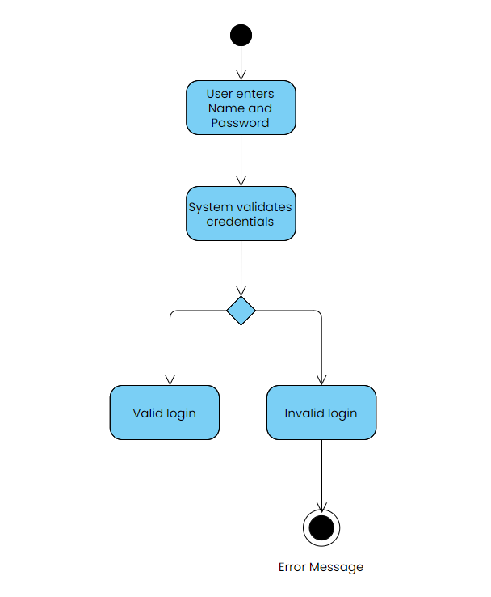

**UC_02 – User views their profile**

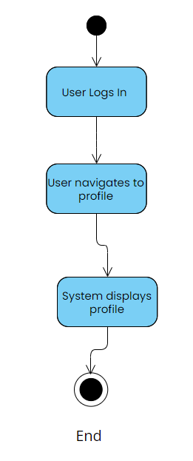

**US_03 – User edits their information**

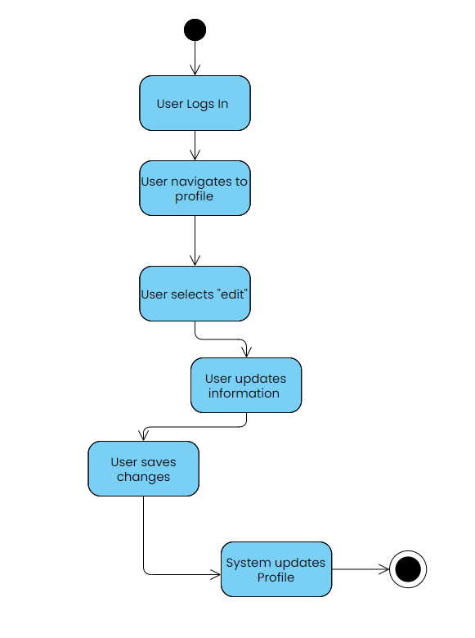

**US_04 – Create a new user**

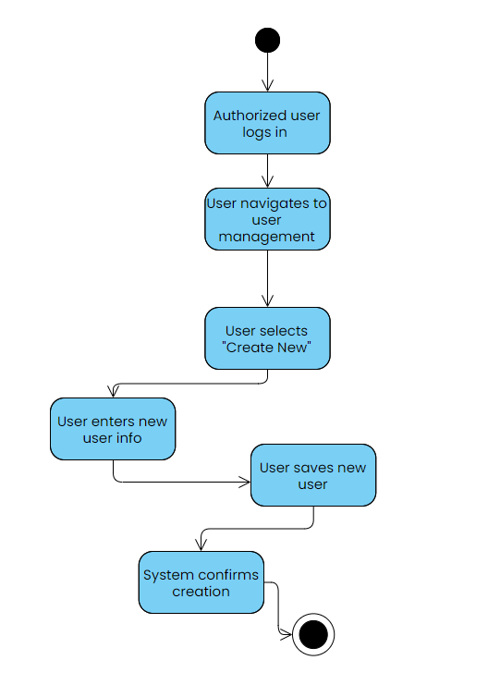

**US_05 – Search for a user**

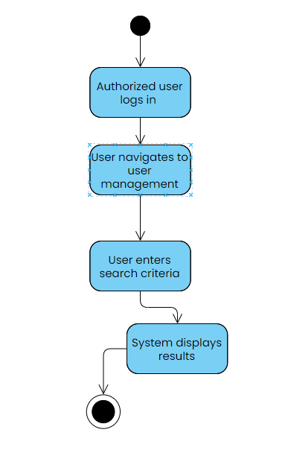

**US_06 – Edit a searched user**

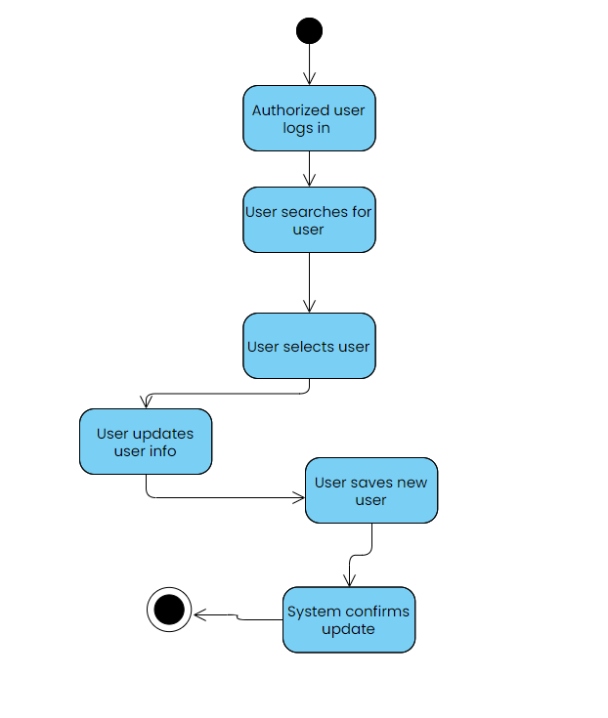

**US_07 – Fire an employee**

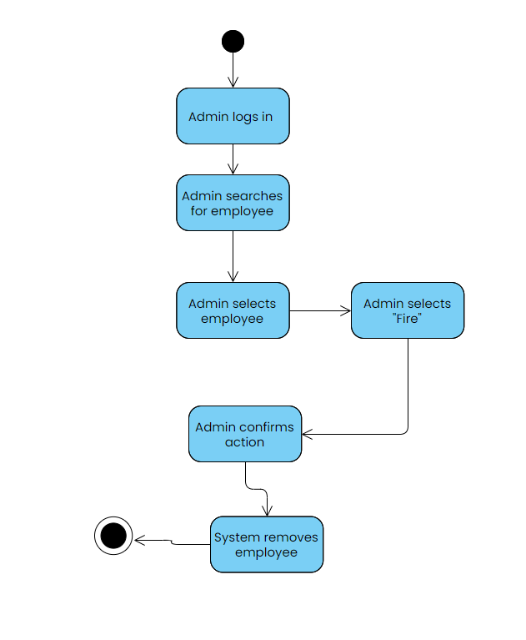

**US_08 – Add a new appointment**

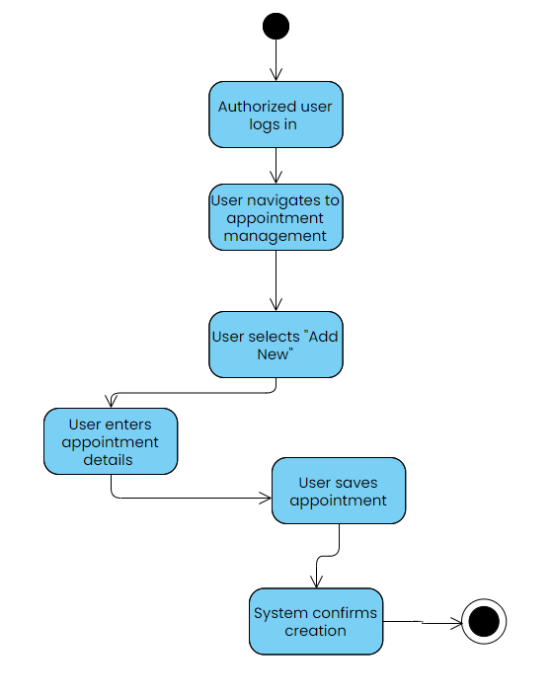

**US_09 – Search for an appointment**

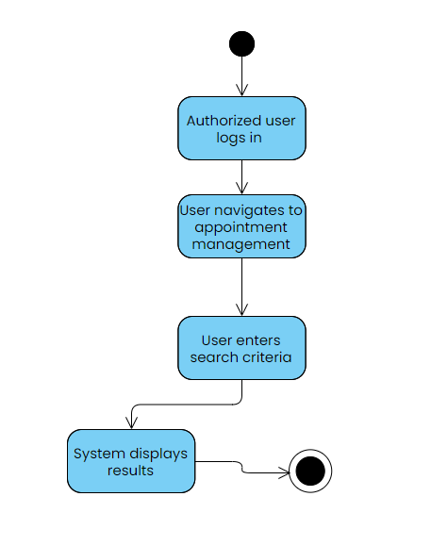

**US_10 – Edit a searched appointment’s information**

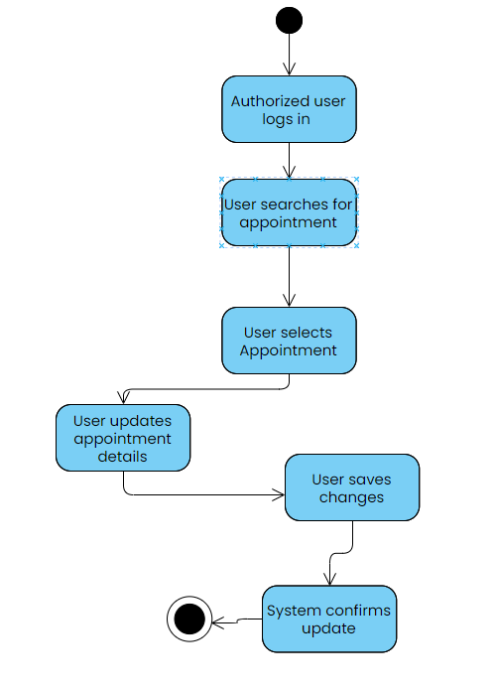

**US_11 – Add services to a patient**

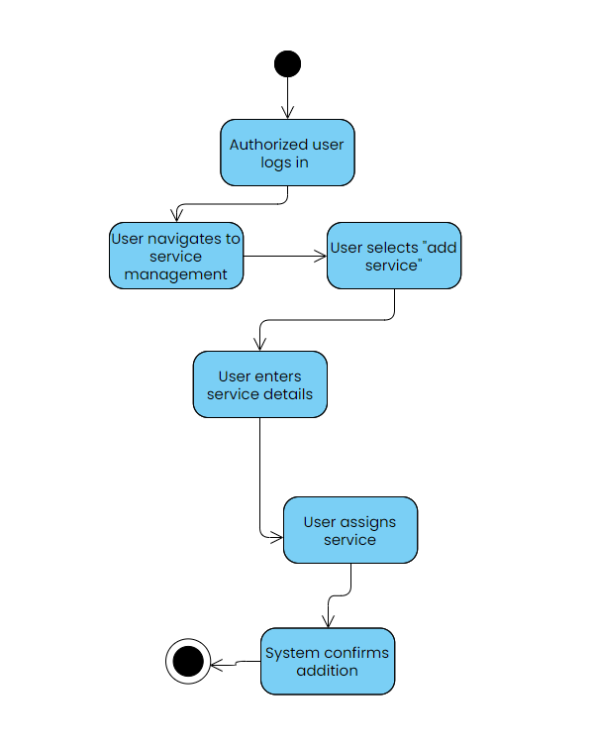

**US_12 – Generate a bill for a patient**

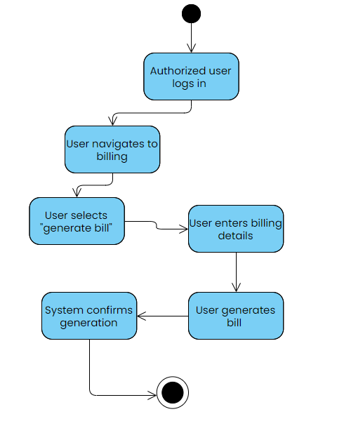

**US_13 – Add medical records to a patient**

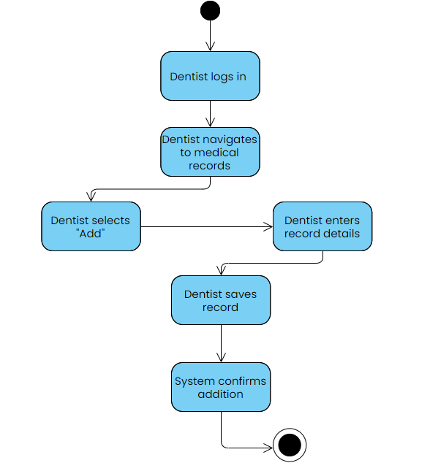

**US_14 – Transfer an employee**

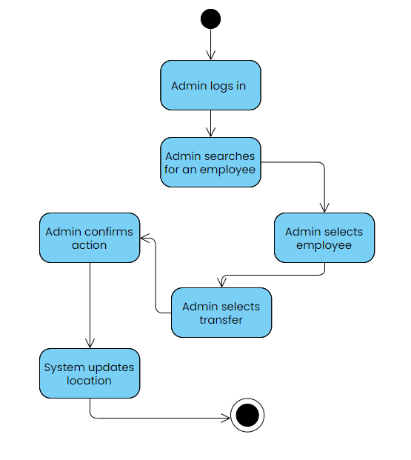

**US_15 – Patient leaves feedback**

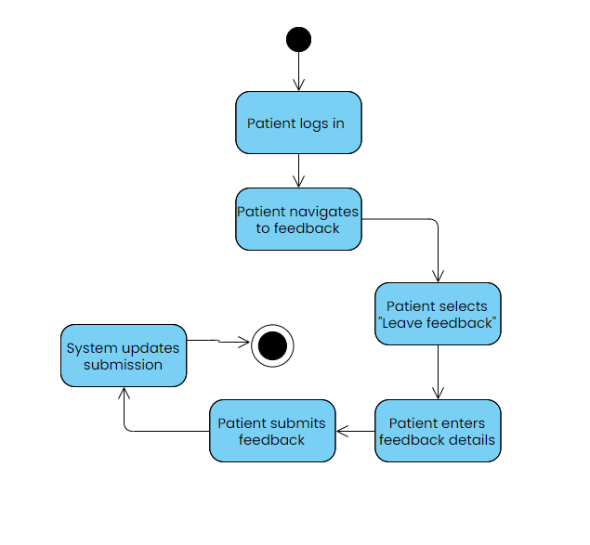

**US_16 – Patient books an appointment**

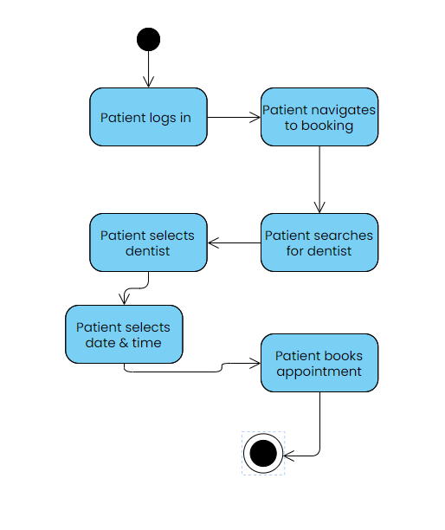

**US_17 – View feedback left by the patient**

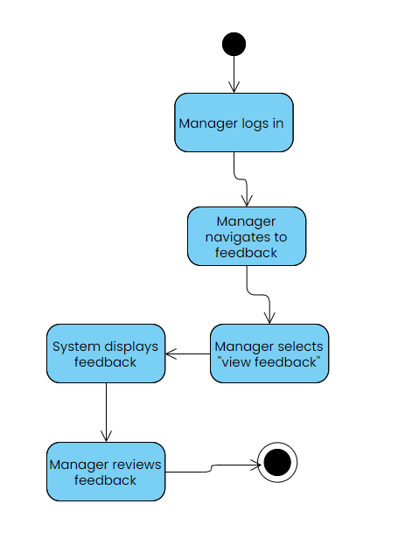

**US_18 – User logs out**

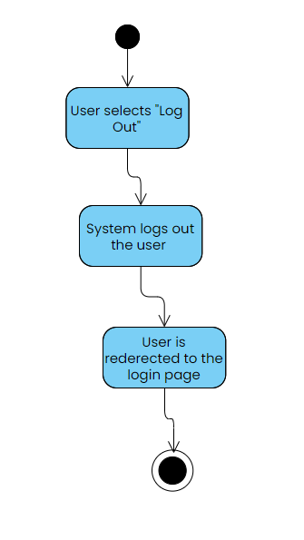

**User Case Diagrams:**

**UCD_01 – Basic Operations (US_01, US_02, US_03, US_18)**

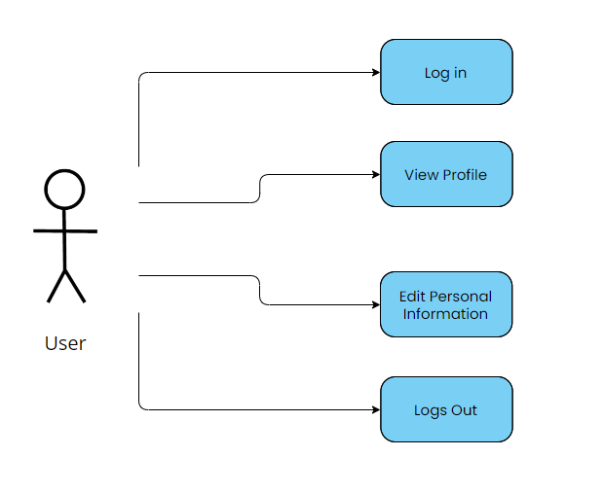

**Actors**: Patient, Receptionist, Dentist, Manager, Administrator

**Use Cases**: Login, View Profile, Edit Personal Information, Logout

**UCD_02 – Receptionist’s Functionalities (US_04, US_05, US_06, US_08, US_09, US_10, US_11, US_12)**

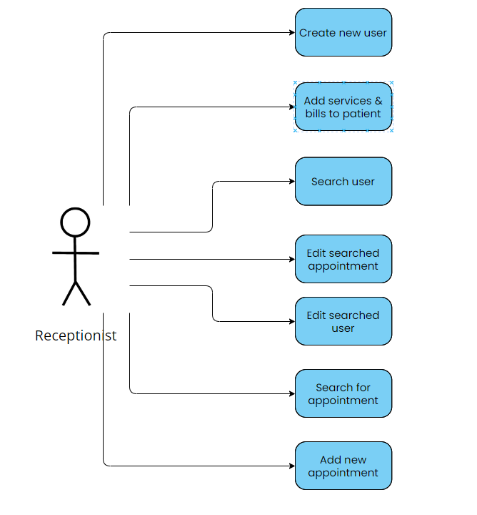

**Actor**: Receptionist

**Use Cases**: Create New User, Search for User, Edit Searched User, Add New Appointment, Search for Appointment, Edit Searched Appointment, Add Services to Patient, Generate Bill for Patient

**UCD_03 – Advanced Operations (US_07, US_13, US_14, US_15, US_16, US_17)**

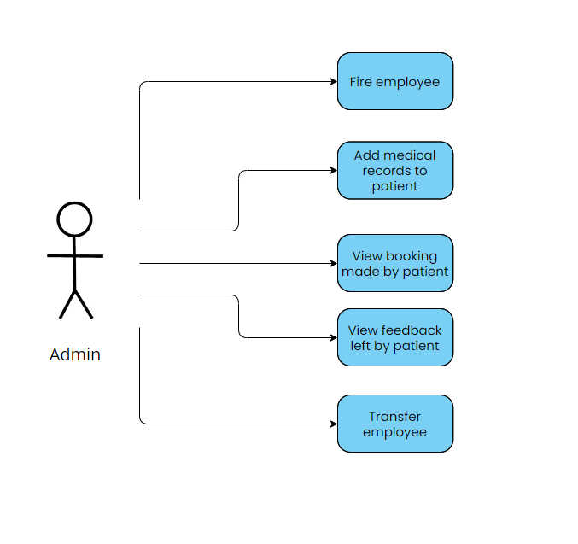

**Actors**: Manager, Administrator

**Use Cases**: Fire Employee, Add Medical Records to Patient, Transfer Employee, Patient Leaves Feedback, Patient Books Appointment, View Feedback Left by Patient

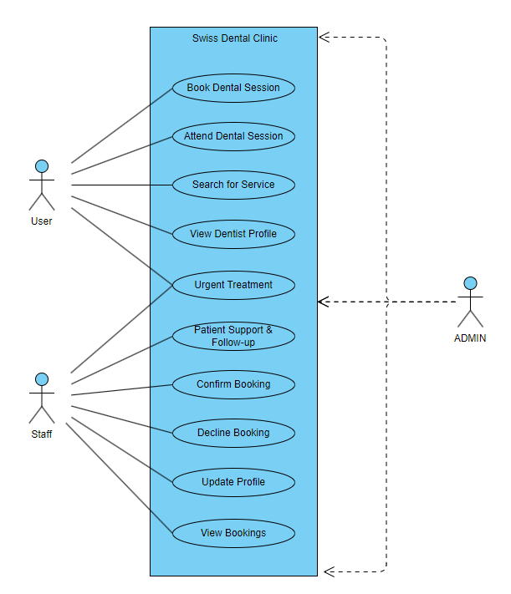

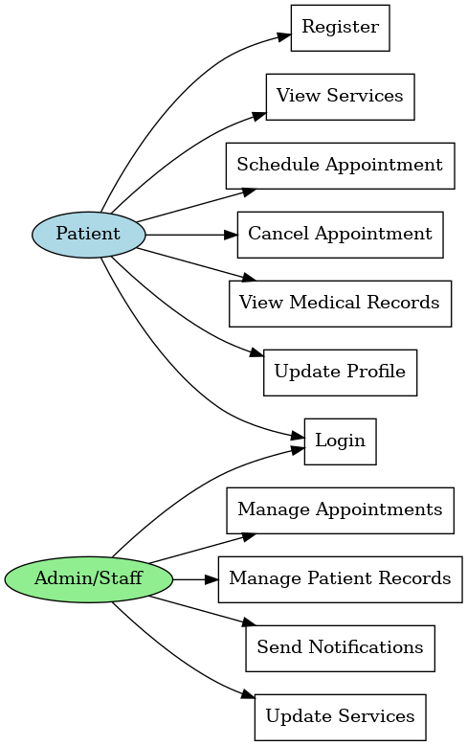

**Data Flow Diagram (DFD):**

The DFD will illustrate how data flows through the system, from appointment scheduling to the storage of patient feedback. It will show the interaction between different functions and how they are connected to the database.

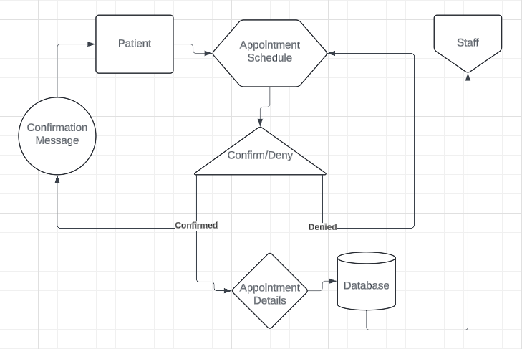

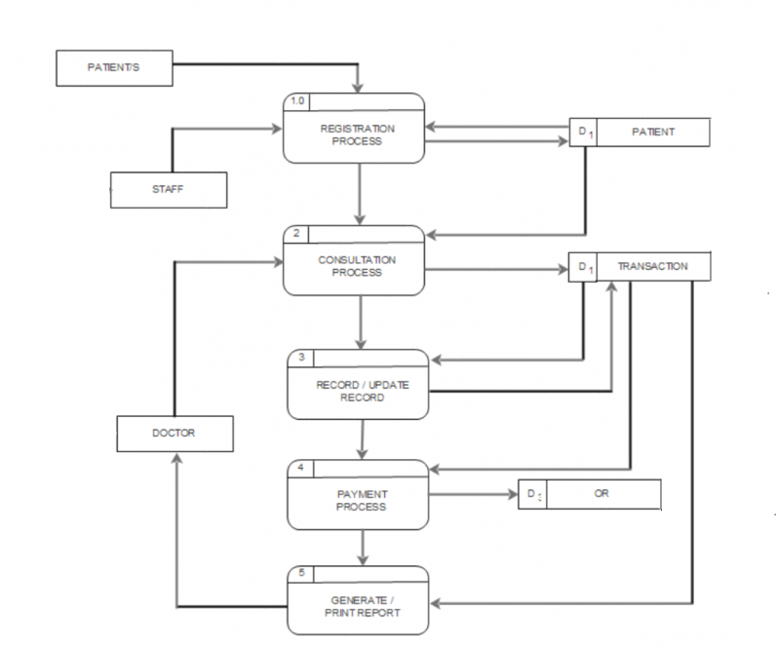

**Context Diagram:**

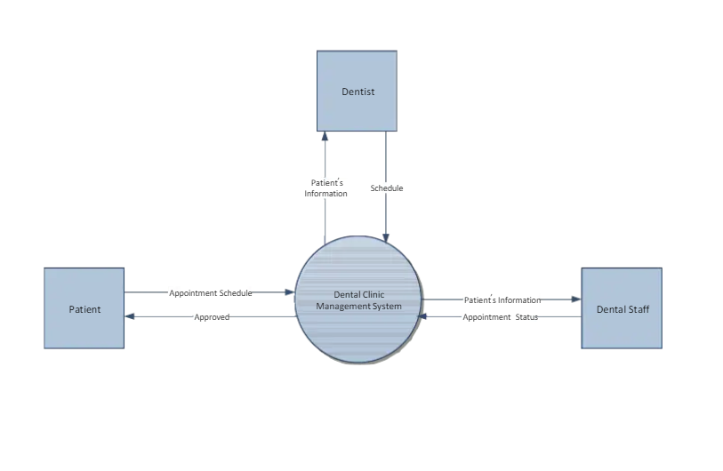

**Entity Relationship Diagram (ERD):**

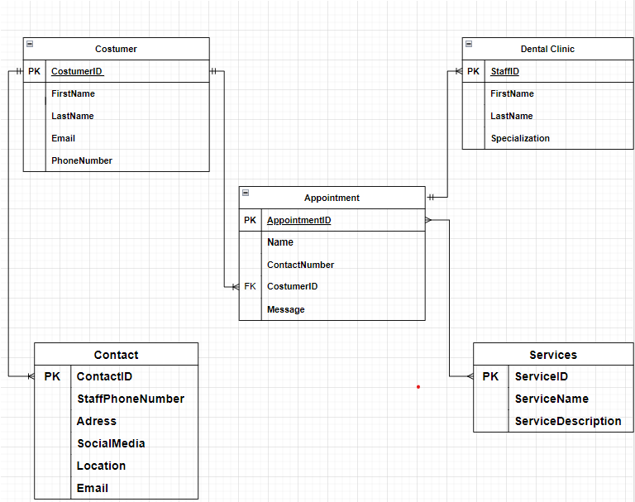

**Flow Diagram:**

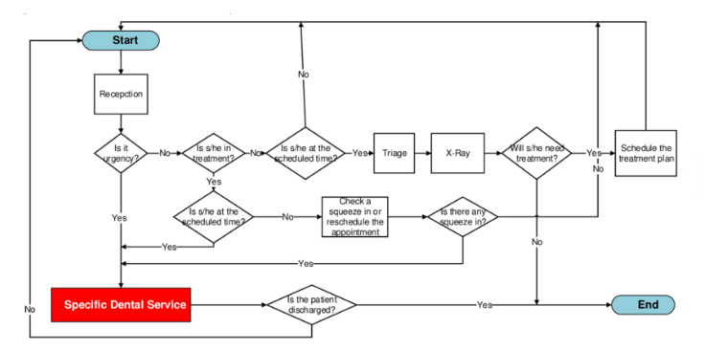

**State Diagram:**

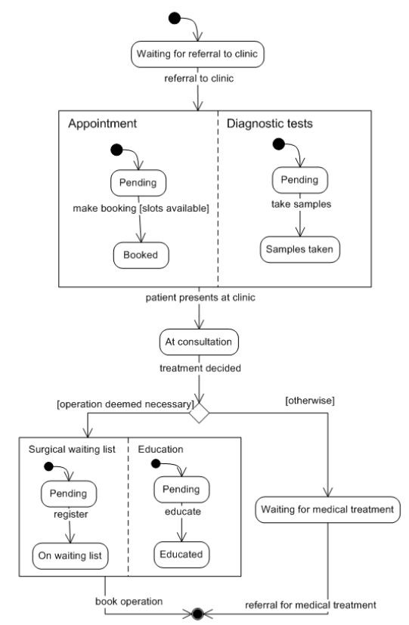

**Sequence Diagram:**

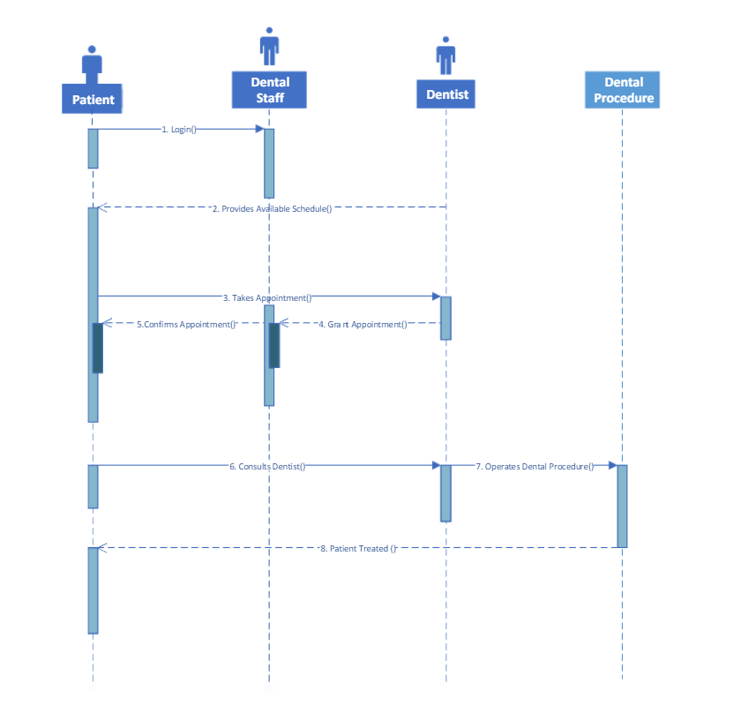

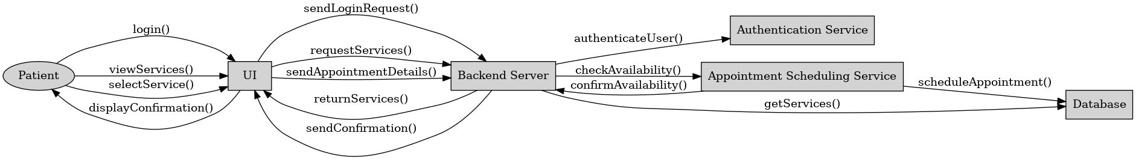

**Class Diagram:**

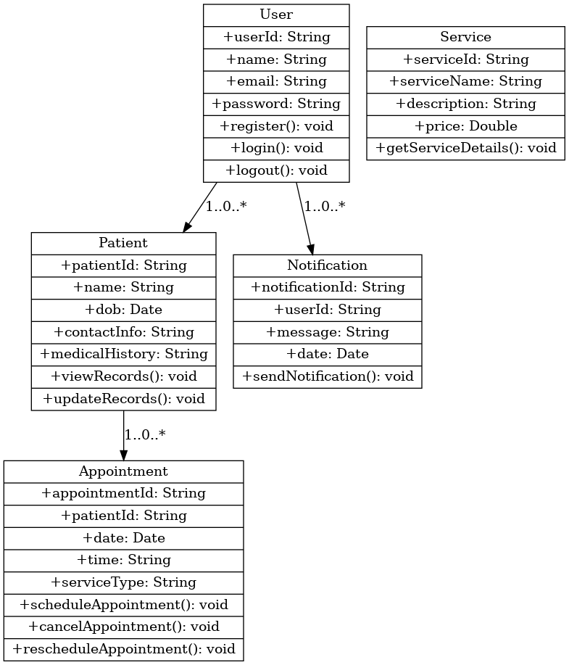

**-UML DIAGRAMS-**

**Deployment Diagram:**

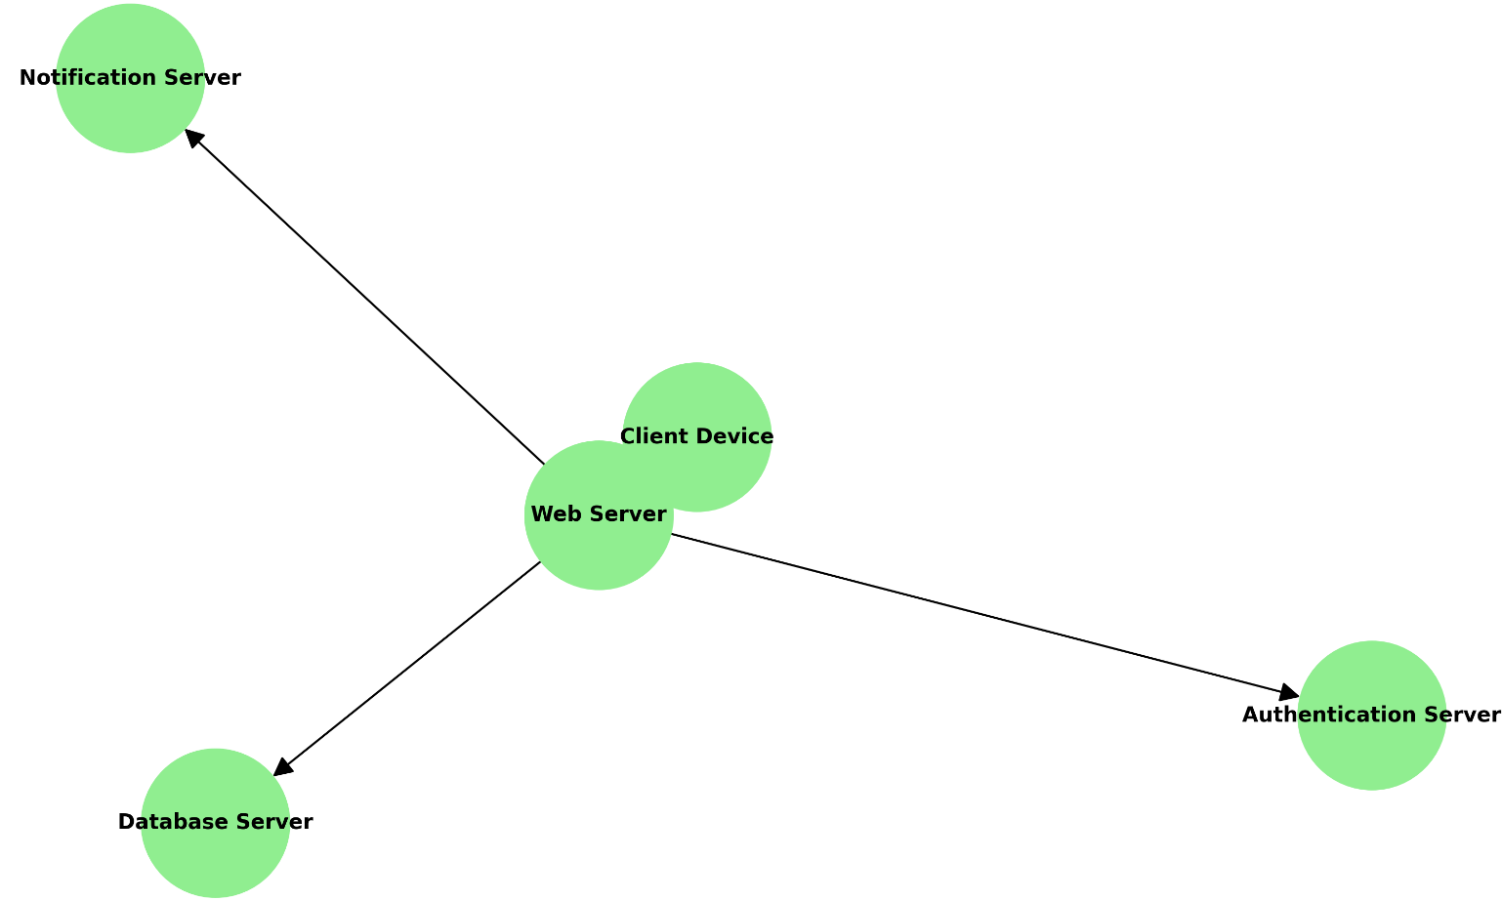

**Component Diagram:**

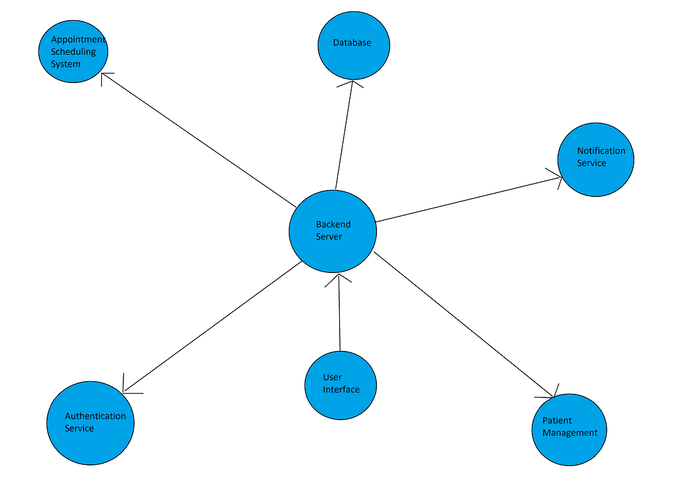

**Communication Diagram:**

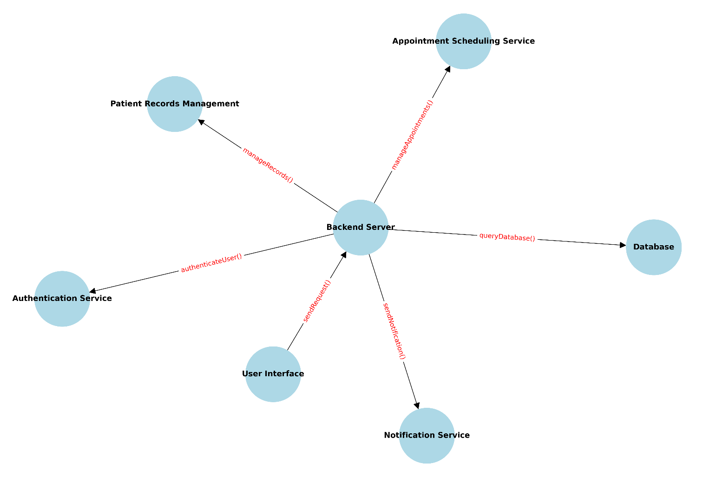

**Data Dictionary:**

The data dictionary will provide detailed information about the data used in the system, including data types, formats, and relationships between different data elements. It will serve as a reference for understanding the data flow and structure of the database:

Patient:

* Patient ID: Unique identifier for each patient.
* Name: Full name of the patient.
* Contact Number: Phone number of the patient.
* Email: Email address of the patient.

Appointment:

* Appointment ID: Unique identifier for each appointment.
* Date: Scheduled date of the appointment.
* Time: Scheduled time of the appointment.
* Status: Current status of the appointment (e.g., confirmed, canceled).

Staff:

* Staff ID: Unique identifier for each staff member.
* Name: Full name of the staff member.
* Role: Role of the staff member (e.g., dentist, receptionist).
* Qualifications: Academic and professional qualifications of the staff member.
* Specialties: Areas of specialization for the staff member.

Service:

* Service ID: Unique identifier for each service.
* Name: Name of the service.
* Description: Brief description of the service.

This structure helps ensure that the requirements are well-organized and that each function and data element is clearly defined for both the development and testing phases.

By organizing the requirements in this hierarchical manner and providing a data flow diagram and data dictionary, we can ensure clarity and coherence in the design and development of the web application.

|  |  |  |  |
| --- | --- | --- | --- |
| Description of Attributes | | | |
| Entity Name | Attribute Name | Description | Constraints |
| Patient | ID | Serve as primary key | Int (11)  Auto_increment  Primary key |
| fullName | Patient’s first name | Varchar(255) |
| Email | Patient’s email | Varchar(255) |
| contactNumber | Patients Contact Number | Int(11) |

|  |  |  |  |
| --- | --- | --- | --- |
| Description of Attributes | | | |
| Entity Name | Attribute Name | Description | Constraints |
| Staff | ID | Serve as primary key | Int (11)  Auto_increment  Primary key |
| fullName | Staff full name | Varchar (225) |
| Role | Staff Role in the Clinic | Varchar(255) |
| Qualifications | Staff qualifications | Varchar(255) |
| Specialties | Staff specialties | Varchar(255) |

|  |  |  |  |
| --- | --- | --- | --- |
| Description of Attributes | | | |
| Entity Name | Attribute Name | Description | Constraints |
| Appointment | ID | Serve as a primary key | Int (11)  Auto_increment  Primary key |
| Date | Date of appointment | Varchar (255) |
| Time | Time of appointment | Varchar (255) |
| Status | Status of appointment | Varchar (255) |

|  |  |  |  |
| --- | --- | --- | --- |
| Description of Attributes | | | |
| Entity Name | Attribute Name | Description | Constraints |
| Service | ID | Service ID | Int (11)  Auto_increment  Primary key |
| Name | Service Name | Varchar(255) |
| Description | Service Description | LongChar |

**Additional Comments**

When putting together this Requirements Specification, we mixed and matched different ways of organizing things. This way, we made sure the requirements fit the system we're working on just right. Think of it like customizing a recipe to get the flavor you want.

In our experience, the tools and methods we use to write down requirements work best when they match up with how we've decided to organize things. For example, if we're dealing with a system that acts differently depending on whether it's in normal, training, or emergency mode, using state charts or finite state machines can be super helpful. They give us a clear picture of what the system should do in each state, which is great for understanding and planning.

If our system is based on real-world things, like in a clinic management system where we have patients, appointments, and staff, using object-oriented analysis can make a lot of sense. It lets us model the system in a way that mirrors real life, which can make it easier to wrap our heads around.

When the main focus is on specific features or services the system provides, organizing requirements around stimulus-response sequences can be a smart move. This approach helps us spell out exactly how the system should react to different inputs, making sure every feature works just right.

And if none of the other ways of organizing things seem to fit, breaking down the system's functions into a hierarchy based on common inputs, outputs, or data access can be a solid backup plan. We can use data flow diagrams and data dictionaries to show how different functions and data pieces fit together, giving us a big-picture view of the system's setup.

To sum it up, picking the right way to organize things and the right tools to use is key to putting together a Requirements Specification that's both clear and useful. It's all about finding the best fit for the system we're working on, so we can set it up for success.