Olympic Games Data Analysis
Data Analytics Project Proposal — Milestone Submission
Ilir Pajo
Part 1: Preparing for Your Project Proposal
- Client :
SportsStats is a sports analysis firm partnering with local news and elite personal trainers to provide “interesting” insights to help their partners. Insights could be patterns/trends highlighting certain groups/events/countries, etc. for the purpose of developing a news story or discovering key health insights.
- Dataset:
Olympics Dataset - 120 years of data
This dataset contains two tables :
Name | Colums
Athlete_events.csv | ID -INTEGER  Name-STRING  Sex-STRING  Age-STRING  Height-STRING  Weight-String  Team-STRING  NOC-STRING  YEAR-INTEGER  Season-STRING  City-STRING  Sport-STRING  Event-STRING  Medal-STRING
noc_regions.csv | NOC-STRING  Region-STRING  Notes-STRING
The dataset has historical data spanning 120 years of the Olympic Games. It covers all Summer and Winter Games held during this period, including the athletes who participated, the sports and events they competed in, and the full competition history of each athlete, including whether or not they won a medal.

Why I chose this dataset
I chose this dataset because analyzing it can help national teams understand why some countries perform better than others. It can also show what could be done to improve both individual and team performance. By analyzing the data, we can reach conclusions and findings, which are explored in more detail later in this document.
- Describe the steps you took to import and clean the data.
1. Importing the data
I uploaded the Olympic dataset (CSV file) to BigQuery as a new table. I used schema auto-detect, then checked the number of rows, column names, and data types.
2. Handling missing values
Missing values were stored as the text “NA”, so BigQuery did not read them as NULL. I converted “NA” to NULL in Age, Height, Weight, and Medal. Before removing duplicates, the missing values were:
- Age: 9,474 (3.5%)
- Height: 60,171 (22%)
- Weight: 62,875 (23%)
I kept the missing values in Age, Height, and Weight and excluded them only from the analyses that needed them.
3. Marking athletes with no medal
In the Medal column, NULL means the athlete did not win a medal. I replaced these values with “No Medal” so that medalists and non-medalists can be compared. After cleaning, 229,959 rows (85%) are marked “No Medal”. This is expected and not a data quality issue.
4. Removing duplicates
I found 678 groups of records with the same athlete, Games, and event. I removed exact duplicate rows using SELECT DISTINCT, which reduced the dataset from 271,116 to 269,731 rows.
5. Creating a clean view
I saved the cleaned data as a view called olympics_clean, so the original table stays unchanged. All later analysis uses this view.
6. Final check
After cleaning, the missing values were: Age 9,315 (3.0%), Height 58,814 (22%), and Weight 61,527 (23%). The numbers are slightly lower than before because duplicates were removed.

- Initial exploration of the data
Top 10 Country with highest medal won
SELECT
n.region AS country,
COUNTIF(Medal='No Medal') AS cnt_of_medals
FROM `olympic-games-data-analysis.olympicsAnalysis.athlete_events_cleaned` AS ath JOIN `olympic-games-data-analysis.olympicsAnalysis.noc_regions` AS n
ON ath.NOC=n.NOC
GROUP BY n.region
ORDER BY cnt_of_medals DESC LIMIT 10;
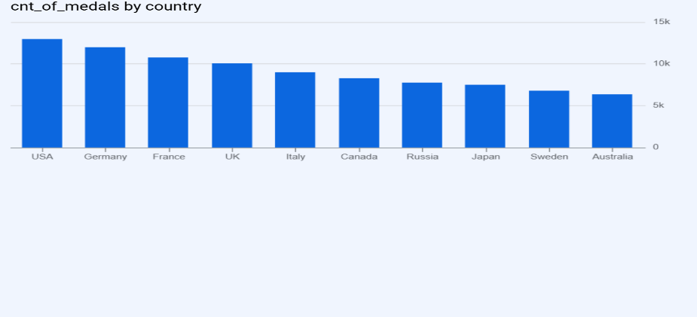
To measure participation over time, I counted the unique athletes (by ID) in each Games, separated by Summer and Winter. I then identified the editions with the highest and lowest attendance.

WITH participants_per_year AS (
SELECT
Year,
Season,
COUNT(DISTINCT ID) AS nr_of_participants
FROM `olympic-games-data-analysis.olympicsAnalysis.athlete_events_cleaned`
GROUP BY Year, Season
)

(SELECT 'Highest' AS type, Year, Season, nr_of_participants
FROM participants_per_year
ORDER BY nr_of_participants DESC
LIMIT 1)
UNION ALL
(SELECT 'Lowest' AS type, Year, Season, nr_of_participants
FROM participants_per_year
ORDER BY nr_of_participants ASC
LIMIT 1);
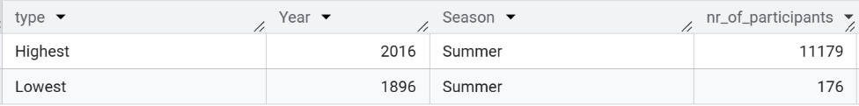

Most decorated Athlet
WITH decorated_athlet AS (
SELECT *
FROM `olympic-games-data-analysis.olympicsAnalysis.athlete_events_cleaned`
WHERE Medal !="No Medal")
,most_decorated_athlets AS (
SELECT
Name,
COUNT(Medal) AS nr_of_medals
FROM decorated_athlet
GROUP BY Name
ORDER BY nr_of_medals DESC
LIMIT 1
)

SELECT
d.Name,d.Year,d.Season,
COUNTIF(d.Medal='Gold') AS gold_medals,
COUNTIF(d.Medal='Silver') AS Silver_medals,
COUNTIF(d.Medal='Bronze') AS Bronze_medals,
COUNT(Medal) AS total
FROM decorated_athlet AS d JOIN most_decorated_athlets AS md ON d.Name=md.Name
GROUP BY d.Name,d.Year,d.Season
ORDER BY d.Name,d.Year,d.Season ;

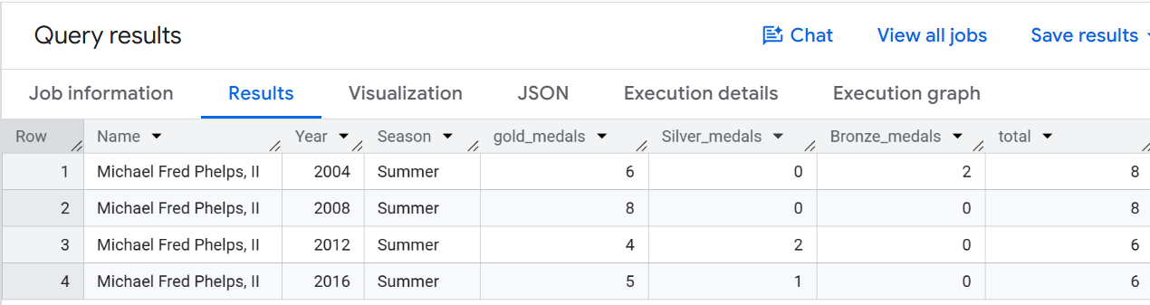

- Proposed Normalized ERD
The original dataset is Denormalized with one table , athlete_events_cleaned. Below is a proposed Normalized ERD that separates it into related tables. The central table, Participations, links Athletes, Countries, Games, and Events. Sports are linked to Events. Age, Height, Weight, and Medal stay in Participations because they change from one Games to another.
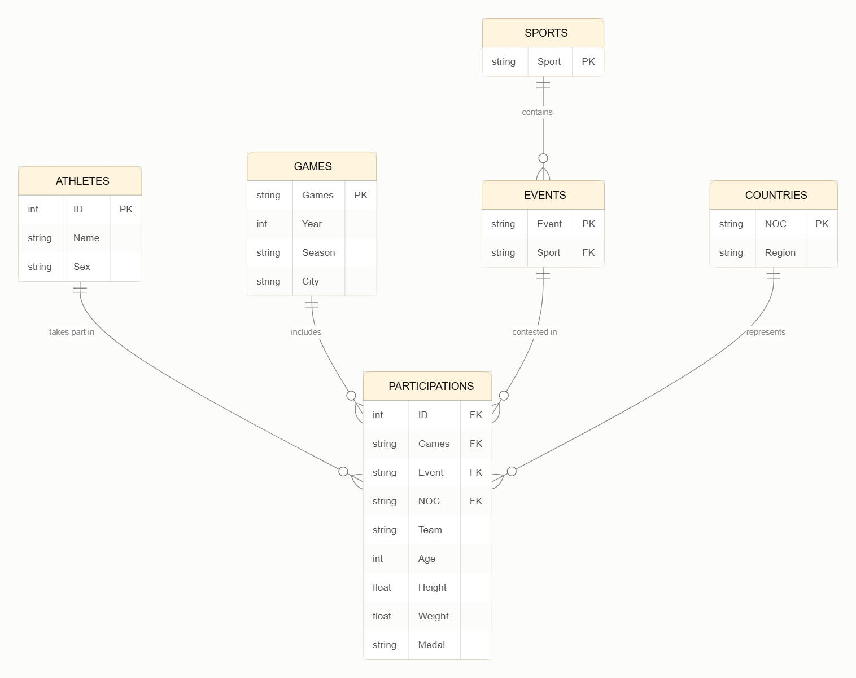

Part 2: Develop Your Project Proposal
- Project Description
This project analyzes 120 years of Olympic Games data to understand how participation and performance have changed over time. It looks at the growth in athletes and sports, the rise of female participation, the advantage of host countries, the role of tradition in winning medals, and the link between physical attributes and success. The data was cleaned and analyzed in BigQuery using SQL, and the main trends are shown through simple charts. The findings could help national teams and coaches understand why some countries perform better and how to improve both individual and team results. They may also interest sports federations, Olympic committees, and sports analysts who plan programs and investments. Finally, sports fans, students, and journalists can use the results to better understand the history of the Games.

- Questions to Ask
- Participation and growth
How has the number of participating athletes changed over the 120 years?
Which Games had the highest and lowest participation, and why (e.g., boycotts, wars)?
How has the number of sports and events expanded over time?
- Gender representation
How has the ratio of male to female athletes changed over time?
When did women’s participation begin in each sport?
Is the gender gap closing in both Summer and Winter Games?
- Medals and performance
Which athletes are the most decorated in Olympic history?
What percentage of participants actually win a medal?
Do host countries perform better when hosting than in other years?
Which countries dominate specific sports?

- Initial Hypotheses
- H1: Growth in participation. The number of athletes at the Games has increased since 1960, and this growth is positively correlated with the increase in the number of sports and events offered in each edition.
- H2: Female participation. The number and proportion of female athletes has increased over time, with the share of women growing in most editions since 1900 and approaching parity with men in recent Games.
- H3: Tradition and medals. Countries with a long history of winning medals in a specific sport (e.g., medals in at least 5 previous editions) are more likely to win medals in that sport again than countries with no prior medal history.
- H4: Host country advantage. Host countries win significantly more medals in the year they host the Games than in the editions immediately before and after
- H5: Physical attributes and success. Medalists in sports such as basketball and swimming are taller on average than non-medalists in the same sport.
- Data Analysis Approach
Step 1: Data understanding and cleaning
- Inspect the structure of the dataset
- Handle missing values
- Replace missing values in Medal with “No Medal” so that non-medalists can be analyzed.
- Check for duplicates and for inconsistencies in NOC code
Step 2: Exploratory Data Analysis (EDA)
- Analyze the distribution of key variables (age, height, weight) overall and by sport.
- Count athletes, countries, sports, and events per edition.
- Visualize trends over time using line charts, bar charts, and histograms.
Step 3: Hypothesis testing by analysis
Step 4: Interpretation and limitations
- Compare the results with the initial hypotheses and state whether each is supported or rejected.
- Note limitations: missing data, changes in country borders and NOC codes, team events counting multiple medals for one result, and external factors not in the dataset (population, budget).

Milestone 2: Descriptive Stats
1. Descriptive statistics and why
- Row counts and duplicates. I checked the size of the data before and after removing duplicates, so repeated rows would not inflate athlete and medal counts. The dataset went from 271,116 to 269,731 rows.
SELECT ID, Games, Event, COUNT(*) AS cnt
FROM `olympic-games-data-analysis.olympicsAnalysis.athlete_events`
GROUP BY ID, Games, Event
HAVING cnt > 1;

- Missing values (count and %). I checked Age, Height, Weight, and Medal to know which columns can be trusted. Age is missing in about 3% of records, Height in 22%, and Weight in 23%.
SELECT
COUNTIF(Age = 'NA') AS missing_age,
ROUND((COUNTIF(Age = 'NA')/COUNT(*))*100,1) AS percentage_of_misingvalue_age,
COUNTIF(Height = 'NA') AS missing_height,
ROUND((COUNTIF(Height = 'NA')/COUNT(*))*100,1) AS percentage_of_misingvalue_Height,
COUNTIF(Weight = 'NA') AS missing_weight,
ROUND((COUNTIF(Weight = 'NA')/COUNT(*))*100,1) AS percentage_of_misingvalue_Weight,
COUNTIF(Medal = 'NA') AS no_medal,
ROUND((COUNTIF(Medal = 'NA')/COUNT(*))*100,1) AS percentage_of_misingvalue_Medal,
FROM `olympic-games-data-analysis.olympicsAnalysis.athlete_events`;

- Share of “No Medal”. About 85% of records have no medal, so most participations do not end with a medal.
- Unique athletes, events, and sports per Games. These measure how big each edition is and how the program grew (H1).
- Change and % change from the previous edition. I used these because the question is about growth over time, not only totals. They also show where numbers drop.
WITH growth_in_events AS (
SELECT
Season,
Year,
COUNT(DISTINCT Event) AS number_of_events
FROM `olympic-games-data-analysis.olympicsAnalysis.athlete_events_cleaned`
GROUP BY Season,Year
ORDER BY Season,Year)
SELECT
Season,
Year,
number_of_events ,
LAG(number_of_events) OVER w AS previous_nr_of_events,
number_of_events - LAG(number_of_events) OVER w AS change,
ROUND(
SAFE_DIVIDE( number_of_events - LAG(number_of_events) OVER w,
LAG(number_of_events)OVER w)*100,1) AS prc_change FROM growth_in_events
WINDOW w AS (PARTITION BY Season ORDER BY Year)
ORDER BY Season, Year;

- Correlation. I used it for H1 to test whether the number of athletes moves together with the number of events and sports.
WITH per_edition AS (
SELECT
Season,
Year,
COUNT(DISTINCT ID) AS athletes,
COUNT(DISTINCT Event) AS events,
COUNT(DISTINCT Sport) AS sports
FROM `olympic-games-data-analysis.olympicsAnalysis.athlete_events_cleaned`
WHERE Year >= 1960
GROUP BY Season, Year
)

SELECT
Season,
ROUND(CORR(athletes, events), 2) AS corr_athletes_events,
ROUND(CORR(athletes, sports), 2) AS corr_athletes_sports
FROM per_edition
GROUP BY Season;

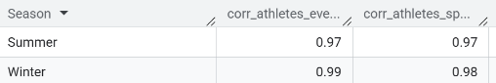
- Female-to-male ratio and % women. These show gender balance better than raw counts (H2).
SELECT
Season ,
Year,
ROUND(SAFE_DIVIDE(COUNTIF(Sex='F'),COUNT(Sex)),2)*100 AS ratio,
ROUND(SAFE_DIVIDE(COUNTIF(Sex='M'),COUNT(Sex)),2)*100 AS ratio
FROM `olympic-games-data-analysis.olympicsAnalysis.athlete_events_cleaned`
GROUP BY Season,Year
ORDER BY Season,Year;

- Medal counts per athlete. I used gold, silver, bronze, and total medals to find the most decorated athletes.
SELECT
ath.Name,
noc.region,
ath.Sex,
COUNTIF(ath.Medal='Gold') AS gold_medals,
COUNTIF(ath.Medal='Silver') AS Silver_medals,
COUNTIF(ath.Medal='Bronze') AS Bronze_medals,
COUNTIF(ath.Medal!='No Medal') AS total
FROM `olympic-games-data-analysis.olympicsAnalysis.athlete_events_cleaned` AS ath JOIN `olympic-games-data-analysis.olympicsAnalysis.noc_regions` AS noc ON ath.NOC=noc.NOC
WHERE ath.Medal!='No Medal'
GROUP BY ath.Name,noc.region,ath.Sex
ORDER BY total DESC, gold_medals DESC, Silver_medals DESC, bronze_medals DESC
LIMIT 10;
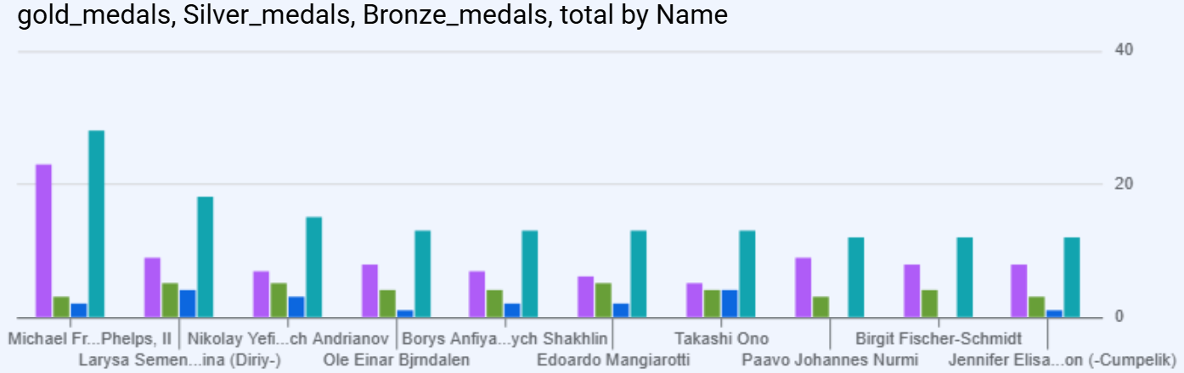
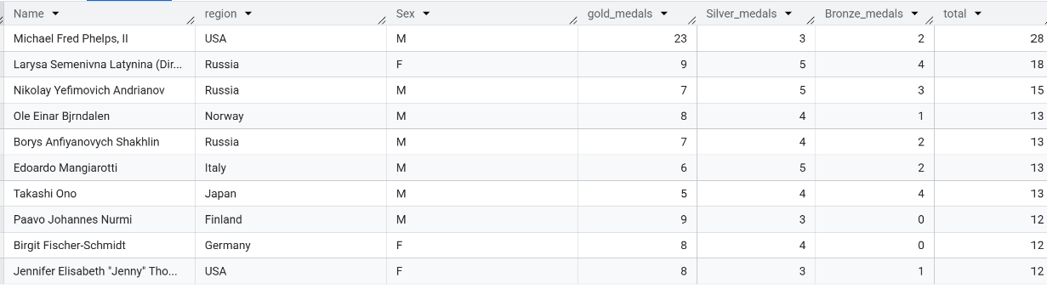

3. Hypotheses proved or disproved
- H1 (growth in participation): supported. Athletes are strongly correlated with the number of events and sports since 1960. A limit is that correlation does not prove cause, since both grew over time, and there are only 15 editions per season.
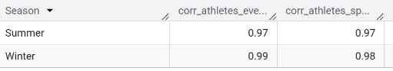
- H2 (female participation): supported, with limits. The share of women increased in most editions, but not in all, and parity has not been reached.
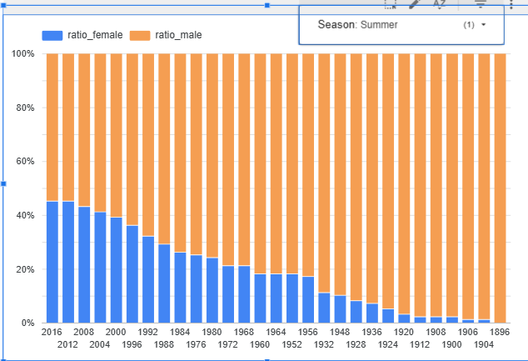
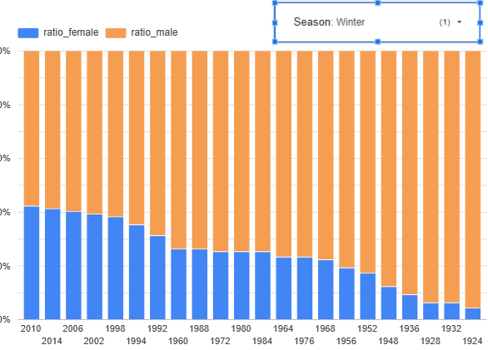
- H3 is supported. Countries with 5 or more previous medal editions in a sport won a medal in 63.9% of cases, compared with 40.8% for countries with 1-4 prior medal editions and 7.3% for countries that had entered the sport before without winning. Countries entering a sport for the first time won in 14.6% of cases, which is higher than the previous group, probably because strong countries often join newly added sports. Medals were counted once per country, sport, and edition, so team sports are not inflated. The result shows that tradition is strongly linked to winning, but it does not prove it is the cause: larger and richer countries tend to have both a long history and more athletes, and the dataset has no population or budget data.
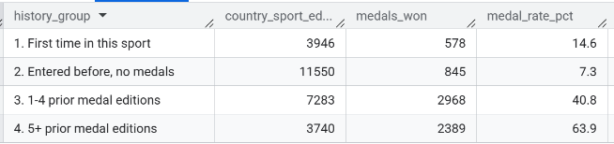
- H4 is supported. Host countries won more medals in their hosting year than in the previous edition in 44 of 48 cases (92%), and had their highest total of the three editions in 36 of 46 comparable cases (78%). The typical gain was 17 medals at the Summer Games and 3 at the Winter Games. Medals were counted once per country, event, and edition. Ten hosts were exceptions, such as France in 1924 and the USA in 1996. Percentage changes are not reliable for countries with very few earlier medals, so I used absolute changes and medians. The 1980 and 1984 boycotts probably inflated the results of the USSR and the USA. The data does not show why hosts win more, and it does not compare them with the growth of other countries.
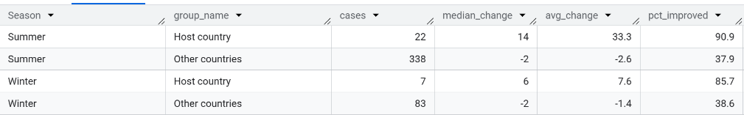
- H5 is partly supported. Medalists were taller than non-medalists in basketball and swimming, for both men and women. The differences were about 3 cm in swimming (men and women), 3.6 cm in men’s basketball, and only 0.8 cm in women’s basketball, which is practically negligible. Each athlete was counted once per Games and sport, and men and women were compared separately. Height is missing for about 22% of athletes, mostly in early Games, and team members are all counted as medalists, so the result describes athletes with data. The data does not show whether height causes success or whether stronger programs simply select taller athletes.
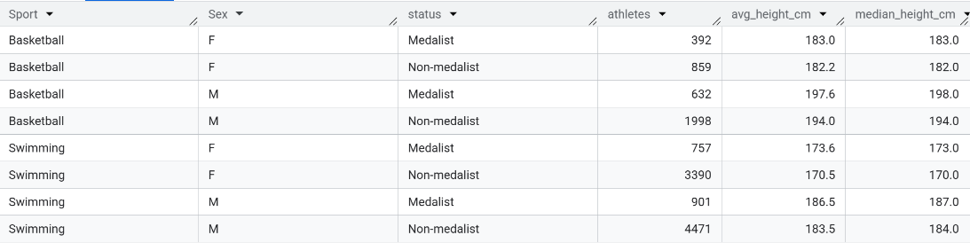

Milestone 3: Dive Deeper
Correlation 1: athletes vs. events and sports (Pearson, 1960 onwards)
I measured how the number of unique athletes per Games relates to the number of events and sports. The correlation is almost perfect in both seasons, which means editions with a bigger program have clearly more athletes. This does not prove that new events cause more athletes, because both grew over time. With 15 editions per season, the values are indicators, not proof.
Linear regression (athletes on events, 15 editions per season since 1960)
The relationship is strongly linear. Each additional event is associated with about 41 more athletes at the Summer Games and about 29 more at the Winter Games. The intercepts have no practical meaning, since no Games had zero events. The model should only be used within the range observed, because Summer events have been almost flat since 2000 (300 in 2000, 306 in 2016).
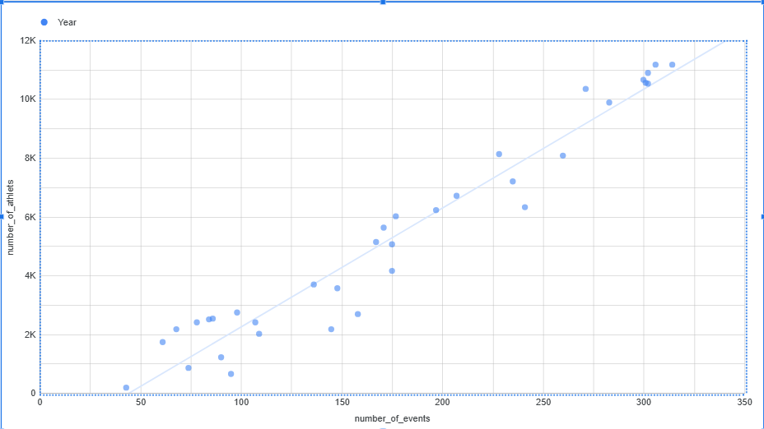

Correlation 2: height vs. winning a medal (same sport and sex)
Medalists are taller than non-medalists in all four groups, and the difference is positive both before and after 1980, so changes over time do not explain it. It is clear in swimming and men’s basketball, but not reliable in women’s basketball (t = 1.4 from 1980 onwards). The data cannot show whether height causes success or whether stronger programs select taller athletes.
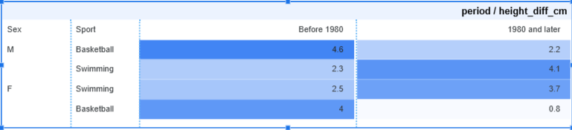
Go Broader
1. What jumps out now
- The Summer program stopped growing after 2000 (300 events in 2000, 306 in 2016), while Winter kept growing (46 events in 1988, 98 in 2014).
- Tradition matters a lot. Countries with 5 or more previous medal editions in a sport won a medal in 63.9% of cases, compared with 7.3% for countries that had entered the sport before without medals.
- Hosts gain a lot. At the Summer Games, hosts gained a median of 14 medals over the previous edition while other countries lost 2, and 90.9% of hosts improved against 37.9% of other countries.
- Small sports are more dominated. Luge has the highest concentration (Germany, 58.1%), while large sports such as wrestling and boxing have leaders with only 12-15%.
- How countries are counted matters. Merging the USSR, Unified Team, and Russia, and the two Germanys, changed the leading country in five sports.

Text analysis
I did not do text analysis or TF-IDF, because the dataset is mostly numeric and categorical. Instead, I looked at counts, ratios, percentage changes, correlations, differences in averages, rankings by edition, sport, and country, and comparisons between groups. The Event column contains text (for example “Men’s” and “Women’s”), which could be used in a simple word count to compare men’s and women’s events if needed.

New Metrics
Metric 1: medal rate by tradition group
medal_rate_pct = country-sport-editions with a medal ÷ all country-sport-editions in the group
I created this metric to test whether tradition helps countries win. It showed a rate of 7.3% for countries that entered a sport without medals, 14.6% for first-time entries, 40.8% for countries with 1-4 prior medal editions, and 63.9% for 5 or more. Medals are counted once per country, sport, and edition, so team sports do not inflate the numbers.
Metric 2: leading country’s share of medals (share_pct)
share_pct = a country’s medals in a sport ÷ all medals in that sport.
I created this metric because raw medal counts cannot be compared between large sports (athletics, 2,939 medals) and small ones (luge, 129). The share puts dominance on one scale, from 58.1% in luge to 11.7% in sailing, and shows where medals are concentrated in few countries and where they are spread out.

Recommendations and Actions

Recommendations
1. Build long-term programs in a few sports instead of spreading resources thin.
Countries with 5 or more previous medal editions in a sport won a medal in 63.9% of cases, compared with 7.3% for countries that had entered the sport before without winning. Tradition is strongly linked to success, so steady investment in selected sports looks more effective than short-term efforts across many.
2. Newer programs should consider sports where medals are spread across many countries.
In large sports such as wrestling (15.0%), boxing (12.0%), and sailing (11.7%), the leading country holds only a small share of medals. In small sports such as luge (58.1%, Germany) or badminton (38.1%, China), a few countries dominate, so breaking in is harder.
3. Host countries should prepare for a large gain, and plan for the edition after.
At the Summer Games, hosts gained a median of 14 medals over the previous edition, while other countries lost 2. Hosts improved in 90.9% of cases, compared with 37.9% of other countries. The gain is not guaranteed (France in 1924, USA in 1996), and in many cases medals dropped in the next edition (for example Greece, from 16 to 4 in 2008), so hosts should have a plan to keep investing afterwards.
4. Use height as one factor in talent selection, not the only one.
Medalists were about 3 cm taller in swimming (men and women) and 3.6 cm taller in men’s basketball. In women’s basketball, the difference was too small to be reliable (0.8 cm). Height should be combined with technical and physical tests, and not be used alone.
5. Federations should keep supporting women’s participation.
Women made up about 45% of Summer athletes in 2016 and about 41% of Winter athletes in 2014. Parity has not been reached, and the share dropped in some editions (for example Summer 1936 and Winter 1964), so growth needs steady support.
6. Plan athlete numbers around the number of events.
Athletes and events are strongly linked (R² = 0.93 Summer, 0.98 Winter), with about 41 more athletes per new event in the Summer Games. Summer events have been almost flat since 2000 (300 to 306), so large growth in participation should not be expected without new events.

Actions

Who | Action | Based on
National teams | Pick 2-3 priority sports and fund them for several Games in a row | H3: tradition (63.9% vs 7.3%)
National teams | Compare the competition in each sport using the leader’s share before choosing where to invest | Share of medals by sport
Host organizers | Enter a full team in every sport, and prepare a post-Games investment plan | H4: median +14 medals (Summer)
Coaches and scouts | Add height benchmarks by sport and sex to talent identification, next to technical tests | H5: swimming and men’s basketball
Sports federations | Keep adding women’s events and development programs, and track the share of women every cycle | H2: 45% (Summer 2016), 41% (Winter 2014)
Olympic committees | Use the events-to-athletes relationship when planning venues, housing, and budgets
Next steps for the analysis
- Add population, GDP, or sports budget data to separate tradition from country size.
- Repeat the host test by decade and for countries that hosted the Winter Games.
- Analyze BMI by sport and sex, to see where body mass matters beyond height.
- Compare women’s events with women athletes by sport.

