Compaction
At Fraunhofer IWKS, pre-sintering was done in the FAST/SPS device HP-D10 (FCT Systeme GmbH, Germany), using a standard FAST/SPS graphite die (graphite type R7710, SGL Carbon GmbH, Germany) with inner diameter of 10 mm and graphite foil with a thickness of 0.35 mm (SGL Carbon, SIGRAFEX). The mould was filled with 5 g of MQU F powder resulting in a 16 mm high close packed powder column (calculated tap density ca. 51 %).
Based on the experimental results obtained during the hot deformation (described in detail later in this article) it was found out that residual porosity of the pre-sintered samples has negative impact on the microstructure and therefore has to be avoided. Due to the limitation of the graphite tool set on the maximum applied pressure, it was decided to gradually increase the compaction temperature till full dense samples without grain grown is obtained. On Fig xx samples compacted at 700°C, 725°C and 750°C are presented. As shown on Fig xx (a) at 700°C the sample has ca. 90% density, melt spun flakes are mostly aligned, however some misalignment but no grain grow is observed. The sample compacted at 725°C (Fig xx. (b)) is practically full dense with nearly 100 % density, the melt spun flakes are well aligned in whole sample volume and grain grow is not observed. The sample compacted at 750°C (Fig xx. (c)) is also full dense sample, but that abnormal grain grow can be clearly seen on the melt spun flakes boundaries. Based on these results, the compaction temperature was set to be 725°C. The
FAST/SPS cycles were done as follow: The contact pressure of 38 MPa was applied while the sample was heated up to 725°C with heating rate of 75 K/min. During the dwell time of 60 s the pressure was increased from 38 to 45 MPa. After processing the height of the pre-sintered pellets was found to be ca. 8 mm, which corresponds to a density of 100 %. The density of 7.62 g/cm3 determined by the Archimedis method (Sutorius Quintix224-1CEU balance with YDK03 option) is in a good agreement with the density of 7.63 g/cm3 given by the manufacturer [ref. ?].

Figure 5 shows the microstructure of a pre-sintered sample at 700°C 725°C and 750°C where the powder flakes of the starting powder are still clearly visible. Due to low pre-sintering temperature, growth of the primary grains (see Figure 1c) and formation of transient liquid phase was avoided reliably [Maccari 2023].
Deformation
The second attempt done at Fraunhofer IWKS is based on the conventional hot deformation of anisotropic Nd-Fe-B magnets by using SPS technique. Therefore, samples were pre-sintered firstly by FAST/SPS to nearly theoretical density. It needs to be emphasized that in this case the higher density was achieved due to the increased temperature and not pressure. However, the, by precise temperature selection the melt spun flaks were well aligned while grain growth was avoided. For hot-deformation in the FAST/SPS device, ∅ 10 mm samples were placed in a ∅ 20 mm graphite tool (SGL Carbon, SIGRAFINE R7710). The pre-sintered samples were sandblasted and sharp edges were removed to avoid damaging of the graphite pressing tools (see Fig. xx).
Hot deformation was done in the FAST/SPS device HP-D10 (FCT Systeme GmbH, Germany). A graphite foil (SGL Carbon, SIGRAFEX) with a thickness of 0.35 mm with additional centring ring made of the same graphite foil was used to ensure the correct placement of the specimen, (see Fig. xx). The processing parameter for the deformation were optimized in a way the desired microstructure is obtained without to activate the grain grow process. Based on literature data (ref. Diss Simon), the deformation temperature was set to be 750°C (25°C over the compaction temperature of 725°C). The pre -load of 10 MPa (minimum required for the device) was applied during the sample was heated up to 600°C with 75 C/min. During the next step the sample was heated up to 750°C with 75 C/min and pressure was increased to 50 MPa. The pressure was further kept at 50 MPa during the dwell time of 60 s at 750°C and the sample colling (see Table xx).
The sample (HDS501) obtained with those deformation parameters had final diameter of 19 mm which means the deformation was not fully completed. Therefore, the sample was not well formed at the edge, where cracks were still visible. Consequently, alignment of melt spun grains was very inhomogeneous in the outer part, while homogeneous in the centre.
To complete the deformation and improve the microstructure (alignment of melt spun grains) the pressure during the dwell time of 60 s at 750°C was further increased to 60 MPa (HDS60x), 70 MPa (HDS70x) and (HDS80x) and kept constant during the sample colling.
The increasing the applied pressure significantly improved the alignment of melt spun grains but at the same time enhanced the grain grow process (due to better heat exchange?). Further deformation experiments were done by varying the heating rate (50 to 100 °C/min) and the dwelling temperature (see Table xx). Based on the observed microstructure (see Fig. xx) the best results are obtained with heating rate of 75 °C/min and pressure of 70 MPa during dwell time of 60 s at 750°C.

Table 2. FAST/SPS parameters used for hot deformation of almost dense Nd-Fe-B samples (750°C, 70 MPa, 1 min). Deformation and densification in relation to change of pressure, temperature, and heating rate.
Sample code | Heating rate [K/min] | Max. temperature  [°C] | Pressure  [MPa] | Hold time  [s] | Height Reduction  [%] | Relative Density  [%]
HDS 501 | 75 | 750 | 50 | 60 | 70 | 100
HDS 601 | 75 | 750 | 60 | 60 | 73 | 100
HDS 701 | 75 | 750 | 70 | 60 | 75 | 100
HDS 702 | 100 | 750 | 70 | 60 | 75 | 100
HDS 703 | 50 | 750 | 70 | 60 | 75 | 100
HDS 801 | 75 | 750 | 80 | 60 | 75 | 100
HDS 802 | 75 | 725 | 80 | 60 | 75 | 100
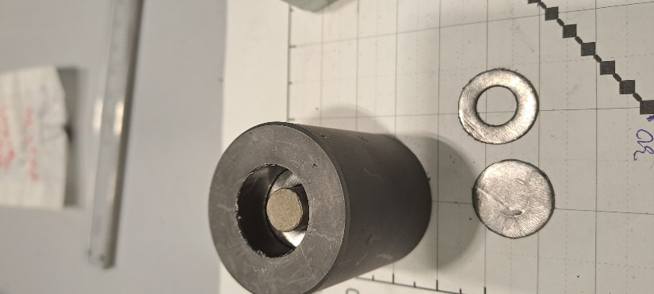
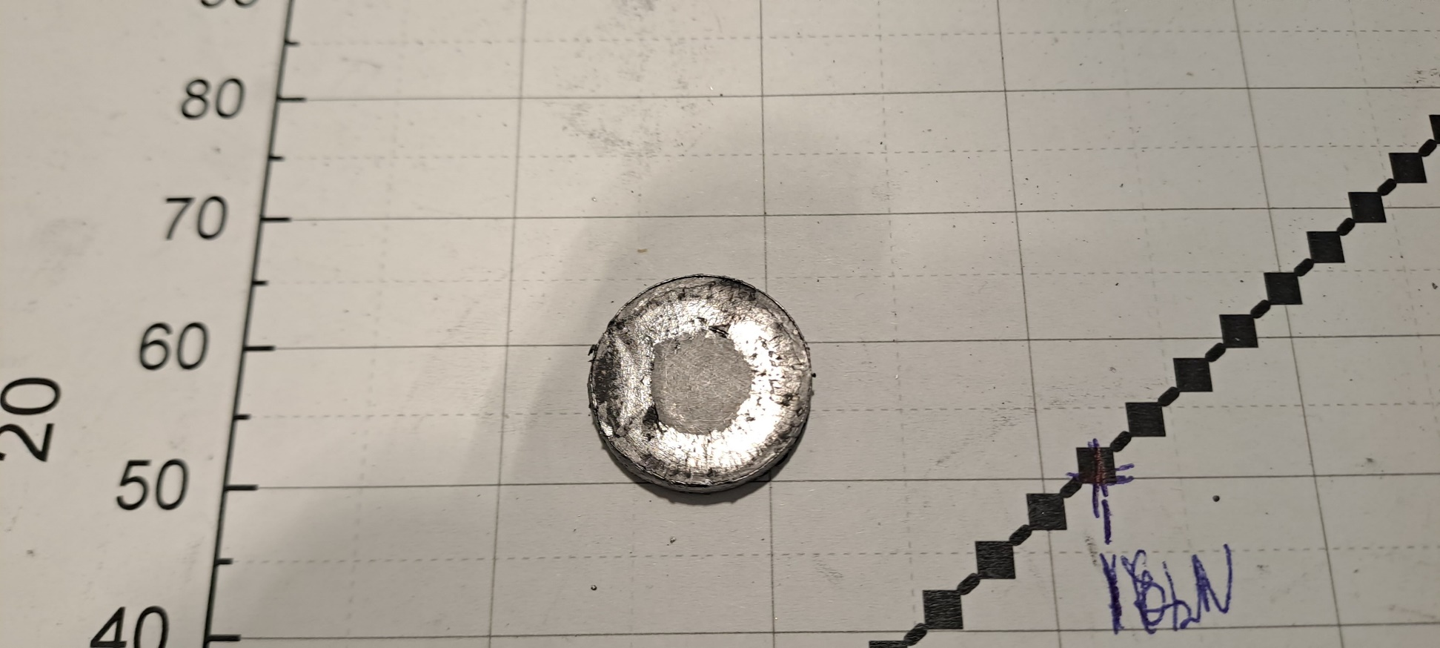
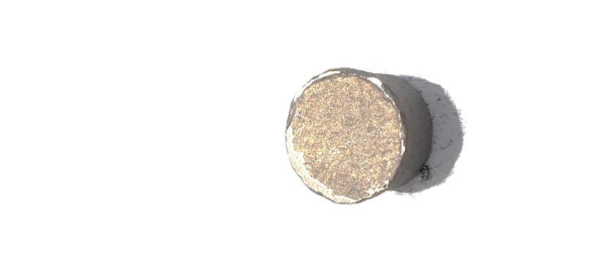
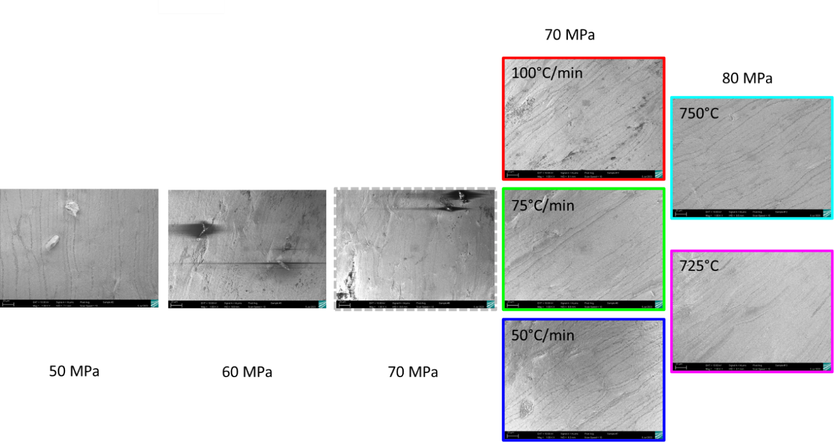

Table 4: Height reduction, coercivity H_{cJ}, remanence B_{r} and energy product (BH)_{max} of Nd-Fe-B magnets processed by different field assisted sintering technologies starting from MQU-F powder in all cases. Results of this work are benchmarked with related results from literature. As reference, properties of MQU-F powder and a commercial magnet from WILO, Germany are shown (n.a. = not available).

Reference | Manufacturing route | Starting powder | Height reduction [%] | H_{cJ}  [kA⋅m⁻¹] | B_{r}  [T] | (BH)_{max}  [kJ⋅m⁻³]
This work  IWKS | FAST/SPS  (725°C, 48 MPa, 60s) | MQU-F | 50 | 1660 | 0.84
This work  IWKS | FAST/SPS +  Hot deformation via FAST/SPS  (750°C, 70 MPa, 60s) | MQU-F | 75 | 1180 | 1.38
This work  IWKS | FAST/SPS +  Hot deformation via FAST/SPS  (750°C, 70 MPa, 60s) | MQU-F | 50 | 1438 | 1.22

