Compaction
At Fraunhofer IWKS, pre-sintering was done in the FAST/SPS device HP-D10 (FCT Systeme GmbH, Germany), using a standard FAST/SPS graphite die (graphite type R7710, SGL Carbon GmbH, Germany) with inner diameter of 10 mm and graphite foil with a thickness of 0.35 mm (SGL Carbon, SIGRAFEX). The mould was filled with 5 g of MQU-F powder resulting in a 16 mm high close packed powder column (calculated tap density ca. 51 %).
Based on the experimental results obtained during the hot deformation (described in detail later in this article) it was found out that residual porosity of the pre-sintered samples has negative impact on the microstructure and therefore should be avoided. Due to the limitation of the graphite tool set on the maximum applied pressure, the compaction temperature was gradually increased, while keeping the pressure at 50 MPa, aiming to obtain fully dense samples without significant grain grown. On Fig. 5 samples compacted at 700°C, 725°C and 750°C are presented. As shown on Fig. 5 (a) at 700°C the sample has ca. 90% density, melt spun flakes are mostly aligned and no grain grow is observed. The sample compacted at 725°C (Fig. 5 (b)) is fully dense with the melt spun flakes well aligned in whole sample volume and grain grow not observed. The sample compacted at 750°C (Fig. 5 (c)) is also fully dense, but abnormal grain grow can be seen on the melt spun flakes boundaries. Based on these results, the compaction temperature was set to be 725°C. The optimal parameters for the FAST/SPS cycles were selected as follow: The contact pressure of 38 MPa was applied while the sample was heated up to 725°C with heating rate of 75 K/min. During the dwell time of 60 s the pressure was increased from 38 to 45 MPa. After processing the height of the pre-sintered pellets was found to be ca. 8 mm, which corresponds to a density of 100 %, as determined by the Archimedes’ method (Sartorius Quintix224-1CEU balance with YDK03 option).

Figure 5 shows the microstructure of a pre-sintered sample at 700°C 725°C and 750°C where the powder flakes of the starting powder are still clearly visible. Due to low pre-sintering temperature, growth of the primary grains (see Figure 1c) and formation of transient liquid phase was avoided reliably [Maccari 2023].
Deformation
The second attempt done at Fraunhofer IWKS is based on the conventional hot deformation of anisotropic Nd-Fe-B magnets by using SPS technique. Therefore, samples were hot compacted firstly by FAST/SPS to nearly theoretical density, based on the optimized parameters as described previously – 725°C and XXX MPa pressure. For hot deformation in the FAST/SPS device, the ∅ 10 mm samples were placed in a ∅ 20 mm graphite tool (SGL Carbon, SIGRAFINE R7710). Prior the hot deformation, the hot compacted samples were sandblasted and sharp edges were removed to avoid damaging of the graphite pressing tools (see Fig. xx).
Hot deformation was done in the FAST/SPS device HP-D10 (FCT Systeme GmbH, Germany). A graphite foil (SGL Carbon, SIGRAFEX) with a thickness of 0.35 mm with additional centring ring made of the same graphite foil was used to ensure the centralized placement of the specimen and to guarantee homogeneous deformation, (see Fig. xx). The processing parameters for the deformation were optimized aiming to obtain fibre texture while avoiding abnormal/excessive grain growth. Based on literature data (ref. Diss Simon), the deformation temperature was set to be 750°C (25°C above the compaction temperature). The pre -load of 10 MPa (minimum required for the device) was applied during the sample was heated up to 600°C with 75 C/min. During the next step the sample was heated up to 750°C with 75 C/min and pressure was increased to 50 MPa. The pressure was further kept at 50 MPa during the dwell time of 60 s at 750°C followed by cooling, in which the power was switched off (see Table xx).
The sample (HDS501) obtained with those deformation parameters, had final diameter of 19 mm, meaning that the deformation was not fully completed considering the 20 mm diameter of the graphite die used in the process. Therefore, the sample was not well formed at the edge, where cracks were visible. Consequently, the degree of alignment was inhomogeneous at the outer part while homogeneous in the centre.
To complete the deformation and improve the microstructure (texture) the pressure during the dwell time of 60 s at 750°C was further increased to 60 MPa (HDS60x), 70 MPa (HDS70x) and 80 MPa (HDS80x), being kept constant during the sample colling.
By increasing the applied pressure, a significant improvement on the alignment was obtained, however enhanced the grain grow process was observed (due to better heat exchange?). Further deformation experiments were done by varying the heating rate (50 to 100 °C/min) and the dwelling temperature (see Table xx). Based on the observed microstructure (see Fig. xx), the best results are obtained with heating rate of 75 °C/min and pressure of 70 MPa during dwell time of 60 s at 750°C, since it resulted in a microstructure with well aligned grains with fine microstructure.

Table 2. FAST/SPS parameters used for hot deformation of almost dense Nd-Fe-B samples (750°C, 70 MPa, 1 min). Deformation and densification in relation to change of pressure, temperature, and heating rate.
Sample code | Heating rate [K/min] | Max. temperature  [°C] | Pressure  [MPa] | Hold time  [s] | Height Reduction  [%] | Relative Density  [%]
HDS 501 | 75 | 750 | 50 | 60 | 70 | 100
HDS 601 | 75 | 750 | 60 | 60 | 73 | 100
HDS 701 | 75 | 750 | 70 | 60 | 75 | 100
HDS 702 | 100 | 750 | 70 | 60 | 75 | 100
HDS 703 | 50 | 750 | 70 | 60 | 75 | 100
HDS 801 | 75 | 750 | 80 | 60 | 75 | 100
HDS 802 | 75 | 725 | 80 | 60 | 75 | 100
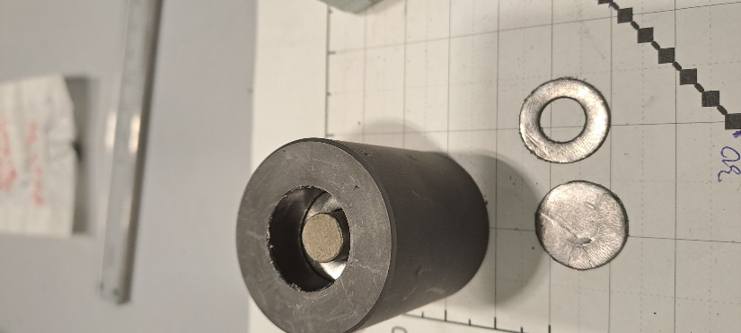
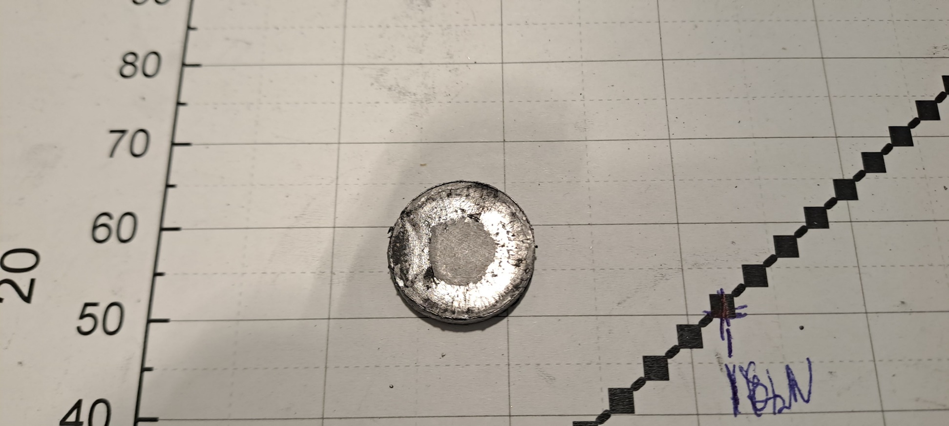
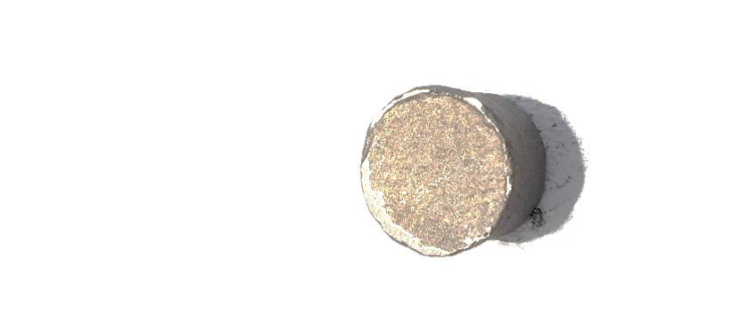
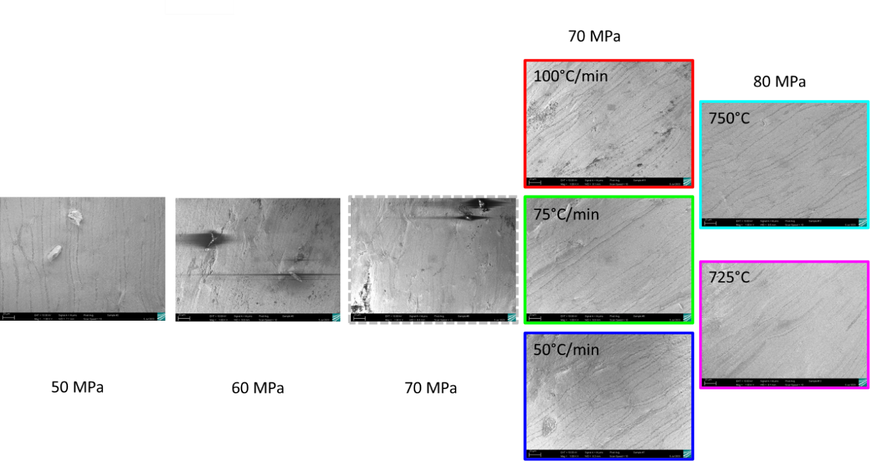
Effect of not fully dense samples

