2.3 Hot-compaction of dense compacts for SPT
Hot-compaction of MQU-F was performed in FAST/SPS device HP-D10 (FCT Systeme GmbH, Germany), using a standard FAST/SPS graphite die (graphite type R7710, SIGRAFINE, SGL Carbon GmbH, Germany) with an inner diameter of 10 mm. A graphite foil with a thickness of 0.35 mm (type SIGRAFLEX, SGL Carbon GmbH, Germany) was inserted in the mold. Then, the mold was filled with 5 g of MQU-F powder, resulting in a 16 mm tall close-packed powder column (calculated tap density in the mold ca. 51 %).

Based on the experimental results obtained during the hot deformation (described in detail later in this manuscript), it was found out that residual porosity of the pre-sintered samples has negative impact on the microstructure evolution. Therefore, full densification of the pre-sintered compacts was aspired in this experimental series.
Due to the limitations of the graphite tool maximal pressure of 50 MPa can be applied during the process. Usually, to ensure good densification and formability while hot compaction of nanocrystalline Nd-Fe-B powder at such low pressure requires elevated temperatures, higher than the melting point of the grain boundary phase. However, the temperature should be kept below 800°C, as heat excess triggers the abnormal grain growth, as shown by Hioki [Hioki 2021]. To define the optimal temperature, we carried out a simple displacement test, where hot compaction was performed under continuous heating up to 750°C, heating rate of 75°C/min and contact pressure of 38 MPa. As it can be seen on Fig 3a) the optimal temperature lies in the range 650 to 750°C, where the grain boundary phase is molten, a transient liquid phase forms and acts as a lubricant supporting the densification and alignment process [Grieb 1992]. Based on those results was decided to perform the hot compaction process at 700°C with ramping rate of 75 K⋅min⁻¹. Only contact pressure (3 kN or 38 MPa) was applied during the heating step.
During the dwell time of 60 s at 700°C, the pressure was increased to 50 MPa. In Figure 3 b, d, samples pre-sintered at 700°C and 725°C are presented. In this temperature range, a transient liquid phase forms, as in the melting of the Nd-rich grain boundary, As shown in Figure 3a, at 700°C the sample has ca. 90% density, melt spun flakes are mostly aligned and no grain growth is observed (not visible in this magnification). The sample compacted at 725°C (Figure 3b) is fully dense with the melt spun flakes well aligned in whole

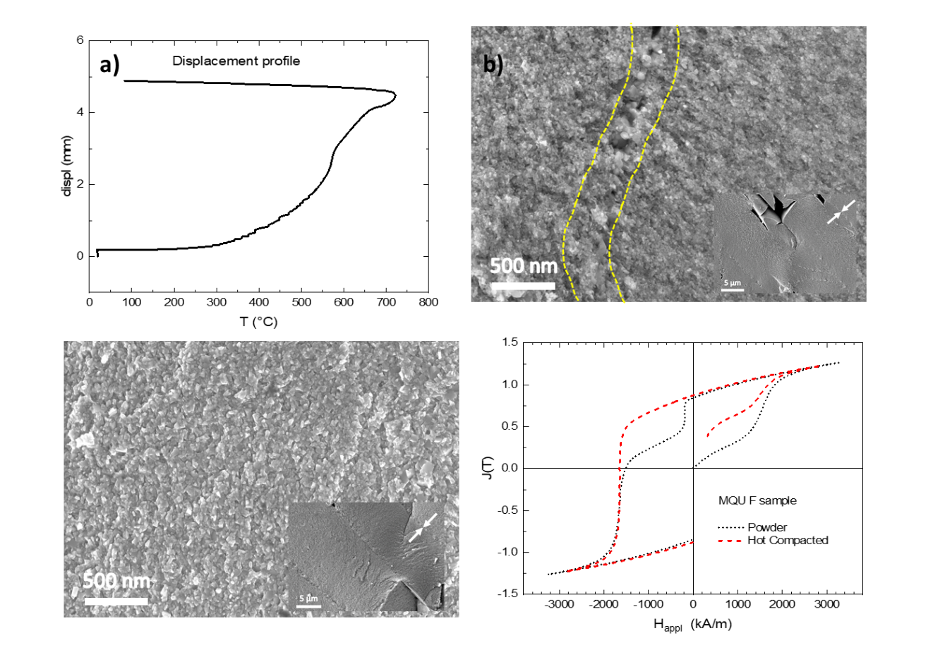
Figure 1 a) Displacement profile of the of a test sample, compacted under 38 MPa as described in the text. b-e) SEM micrograph of fracture surface of a Nd-Fe-B sample pre-sintered by FAST/SPS from melt-spun MQU-F powder processed with heating rate of 75 K⋅min⁻¹, a pressure of 45 MPa and a dwelling time of 60 s at maximum temperature: b,c) at 700°C, the sample has 90% of the theoretical density, dotted line indicates the areas where porosity is visible; d,e) at 725°C, the sample has > 99% of the theoretical density, all ribbons are aligned, no grain coarsening and misalignment is visible, isotropic nanocrystalline microstructure is preserved; f) Magnetic properties of the MQU F powder as loose powder and as hot compacted @ 725°C.

To obtain fully dense samples without significant grain growth, dwell time at maximum temperature was kept at 60 s. In Figure 3, samples pre-sintered at 700°C, 725°C and 750°C are presented.

