TASK 1
a) ALICE 900 1000 - 100 = 900
-BOB 600 500+100 = 600

-b) Because it is one logical operation
c) money disappears , database becomes inconsisten.

TASK 2
a) 1000 - 500 = 500
b ) Alice balance after Rollaback
c) Wrong amount entered and Logical mistake in code

TASK 3
A) Alice 900 bob 500 wally 850
b) because operation SAVEPOINT after ROLLBACK
c) Allows partial rollback inside a large transaction.

TASK 4
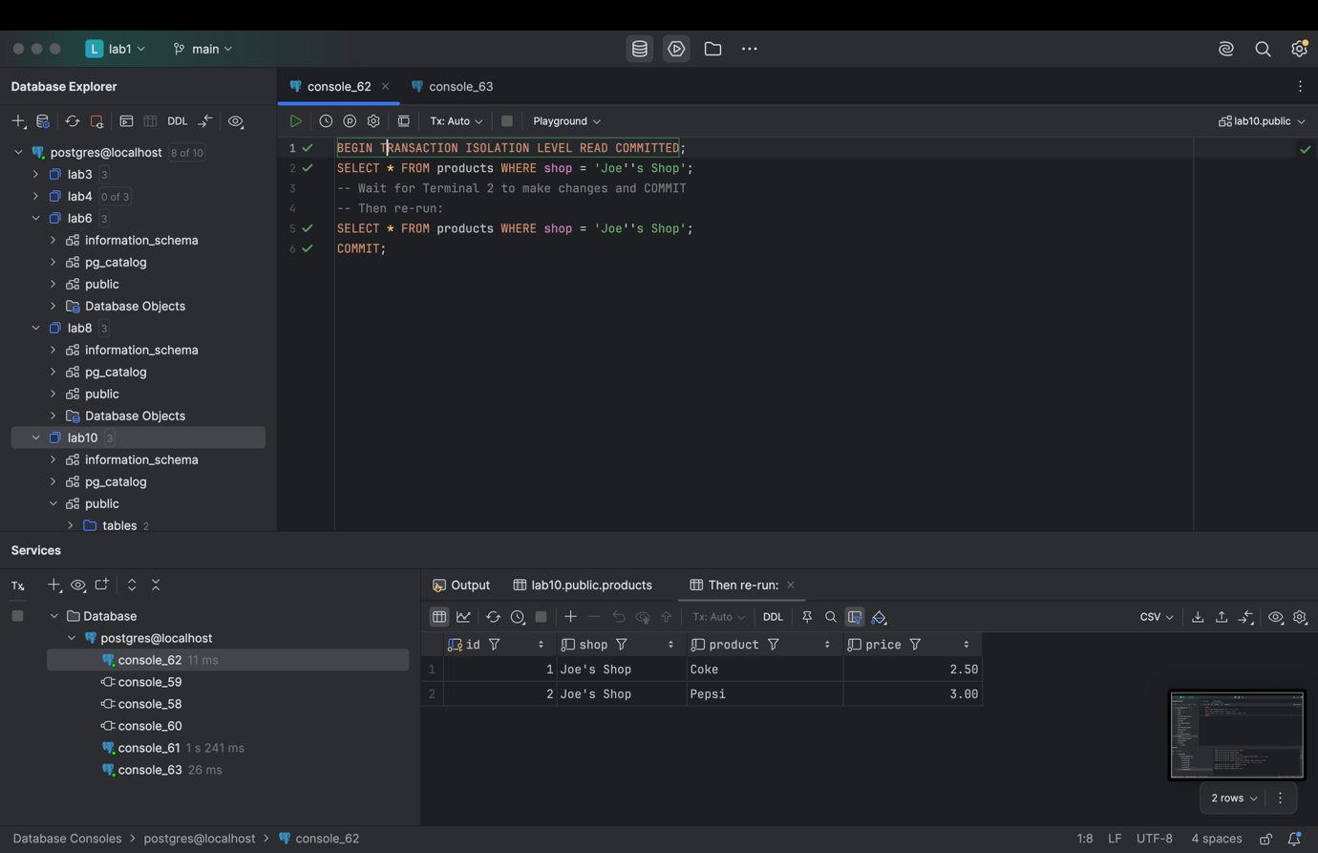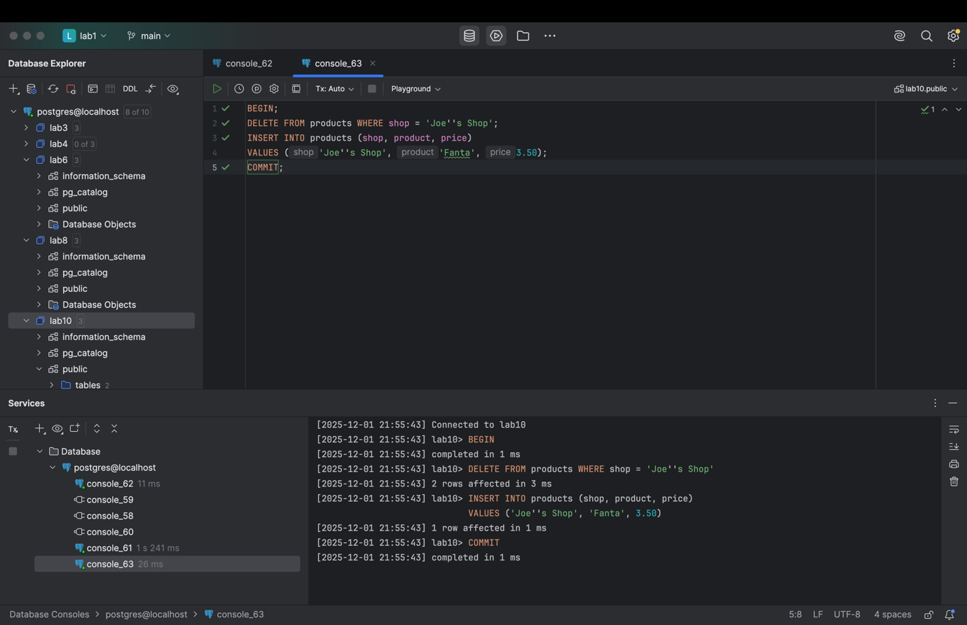

TASK 5
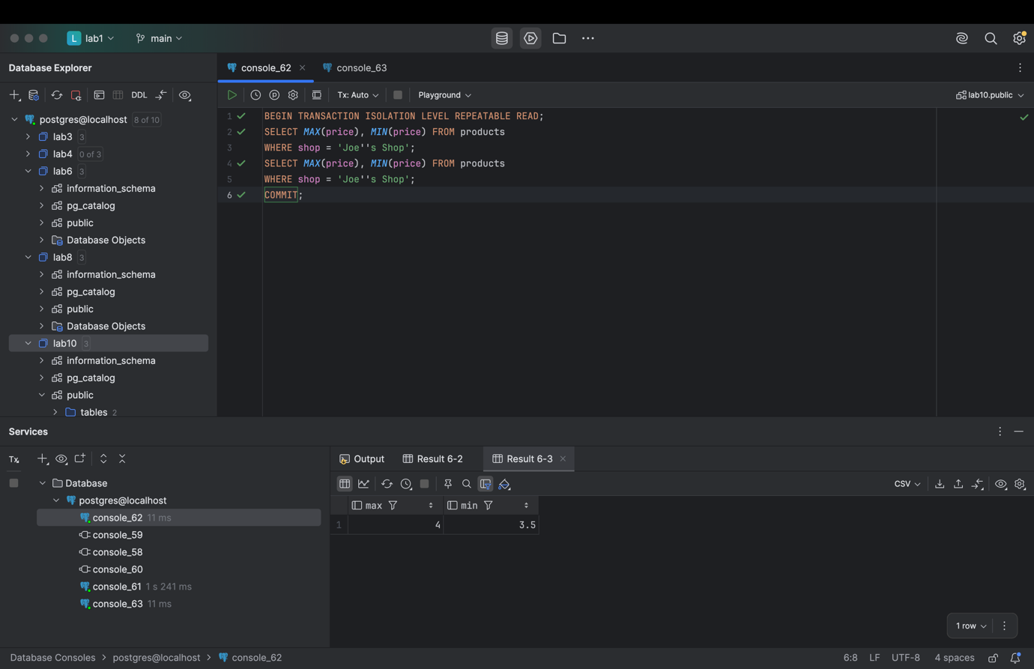

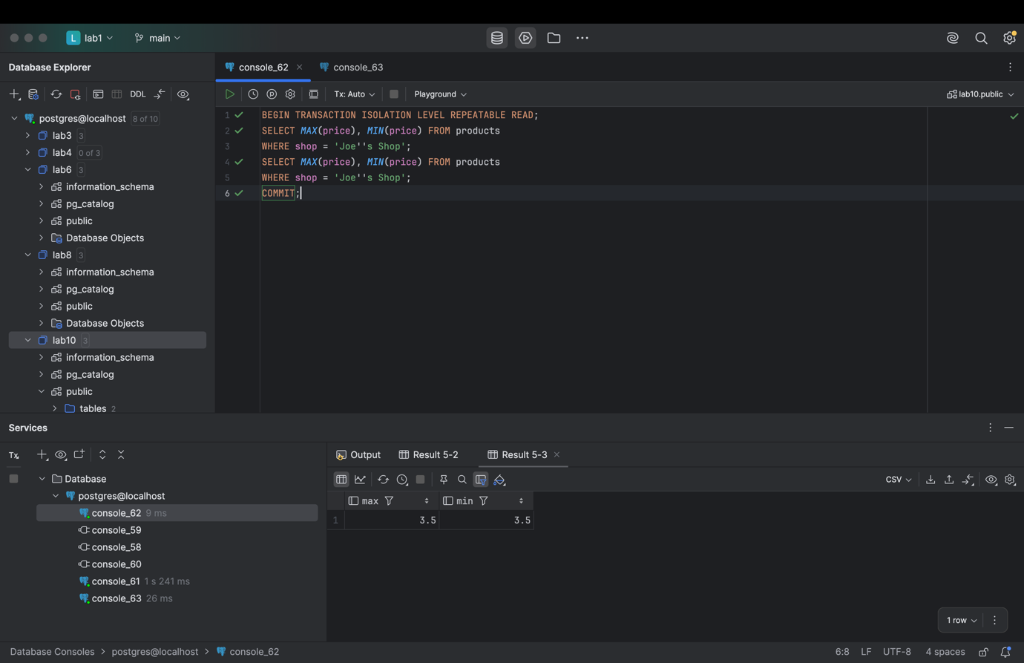

‘

TASK 6
