Task 1.1

Superkeys : EMPLD , SSN , Email , EMPLD NAME , SSN DEPARTMENT , EMAIL SALARUY

CANDIDATE KEYS: EMPLD, SSN, EMIAIL primary key: EmpID, because it is stable and simple

Phone: not unique, so not a key.

Registration Primary Key: StudentID, CourseCode, Section, Semester, Year

Additional Candidate Keys: none

Task 1.2

Student.AdvisorID → Professor.ProfID (M:1, NULLABLE)

Student.Major → Department.DeptCode (M:1, NOT NULL or NULLABLE per rules)

Professor.Department → Department.DeptCode (M:1, NOT NULL)

Course.DepartmentCode → Department.DeptCode (M:1, NOT NULL)

Department.ChairID → Professor.ProfID (1:1 role, NULLABLE)

Enrollment.StudentID → Student.StudentID (M:1, NOT NULL)

Enrollment.CourseID → Course.CourseID (M:1, NOT NULL)

Enrollment PK: (StudentID, CourseID, Semester) recommended

TASK 2.1

Patient(PatientID, Name, Birthdate, Address, Insurance, Phone*)

Doctor(DoctorID, Name, OfficeLocation, Phone*, Specialization*)

Department(DeptCode, DeptName, Location)

Room(DeptCode, RoomNo) – weak entity (depends on Department)

Appointment(AppointmentID, DateTime, Purpose, Notes, PatientID FK, DoctorID FK)

Prescription(PrescriptionID, DateIssued, DoctorID FK, PatientID FK)

Medication(MedicationID, Name, Description)

Prescription_Medication(PrescriptionID, MedicationID, Dosage, Instructions) – bridge table

Relationships

Patient – Appointment – Doctor (**M:N via Appointment**)

Doctor – Department (**N:1**)

Department – Room (**1:N**, weak entity)

Prescription – Patient (**N:1**)

Prescription – Doctor (**N:1**)

Prescription – Medication (**M:N via Prescription_Medication**)

Keys:

PatientID, DoctorID, DeptCode, (DeptCode+RoomNo), AppointmentID, PrescriptionID, MedicationID

Bridge PK: (PrescriptionID, MedicationID)

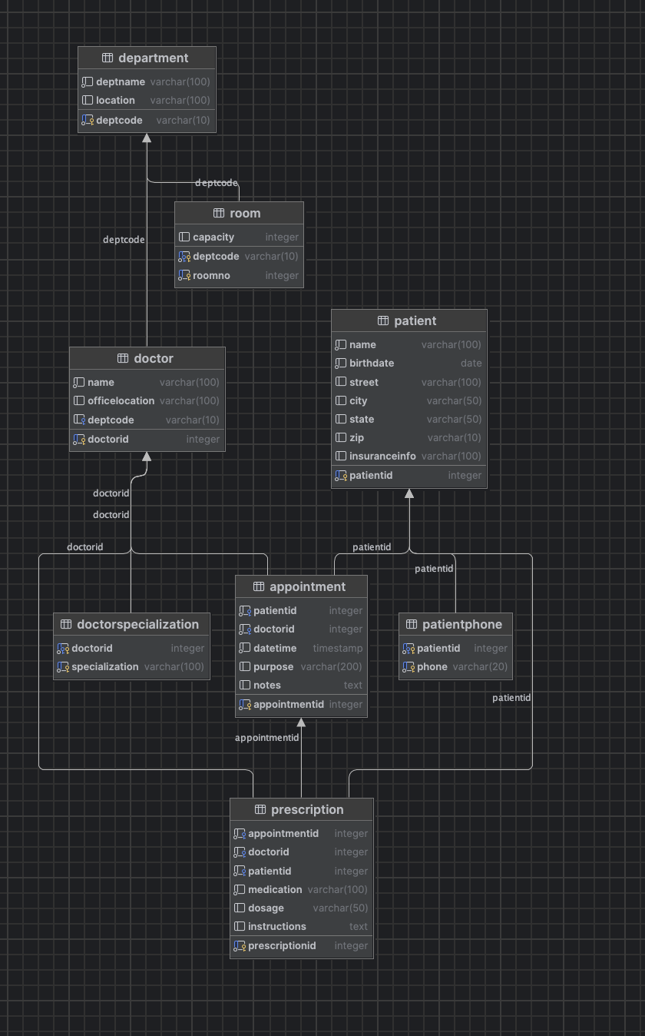

Task 2.2 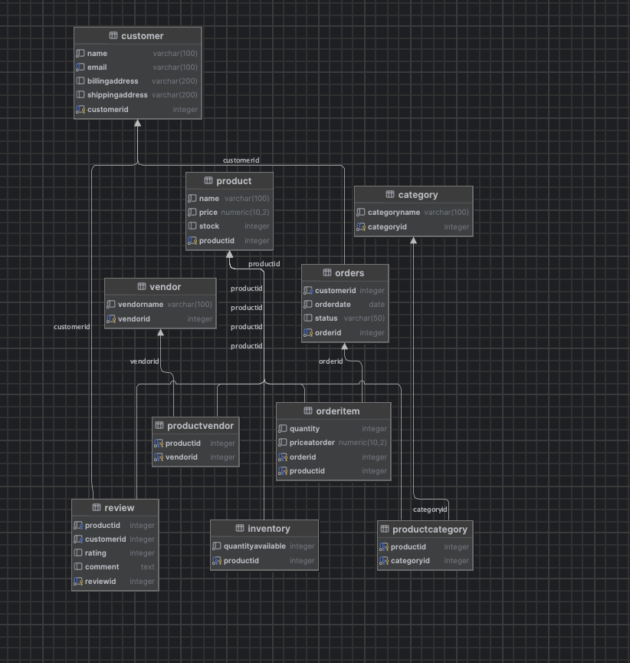

Task 4. 1

Student(StudentID, StudentName, StudentMajor)

Project(ProjectID, ProjectTitle, ProjectType, SupervisorID)

Supervisor(SupervisorID, SupervisorName, SupervisorDept)

StudentProject(StudentID, ProjectID, Role, HoursWorked, StartDate, EndDate)

Task 4.2

Decomposition to BCNF

Student(StudentID, StudentMajor)

Course(CourseID, CourseName)

Instructor(InstructorID, InstructorName)

Room(Room, Building)

CourseSection(CourseID, TimeSlot, InstructorID, Room)

Enrollment(StudentID, CourseID, TimeSlot)

Task 5

4 “Find all students who are officers in the Computer Science Club.”

“List all events scheduled for next week with their room reservations.”

“Show all clubs advised by faculty members from the Mathematics Department.”